A new frontier in craft brewing: exploring life beyond (barley) hulls?

An update from Barley World
http://barleyworld.org/

Brewing malt-forward beers using malt made from naked barley is something a few adventurous craft brewers are starting to explore. We’ve got two stories on tap – let us know what’s on in your neighborhood.

Buck Naked Golden Ale at Breakside Brewing. Portland, Oregon. December 2017: This exploratory beer was brewed by Natalie Baldwin and Ben Edmunds using 120 lbs. Buck Naked malt and 30 lbs. of 10.0777 malt, both from the Barley World malt house, and “a little” Briess C20L. 10.0777 is an experimental covered winter 2-row. Rice hulls were used for filtration. The beer - 4.95 ABV, 18 IBU - was described as “crackery, sweet malt, lemongrass, hop spice”. Barley World tasters were enchanted.
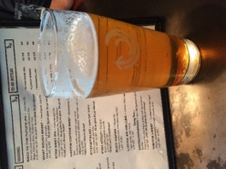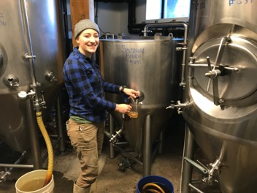
Buck Naked Golden Ale and Natalie Baldwin, brewer. Breakside Brewing, Portland, Oregon.

Deviation 010 lager at Modist Brewing. Minneapolis, Minnesota. September 2017: “Deviation 010 is a smooth, full-flavored lager brewed with CDC Clear malt, lightly hopped with Denali, Huell Melon, and Bravo, and then fermented with our house lager strain. It’s lightly fruity, bready, drinkable, and clocks in at 5.5% ABV. It’s good. Come and try it.” The CDC Clear malt was produced by Rahr Malting of Shakopee, Minnesota.
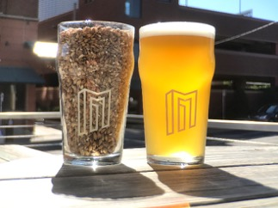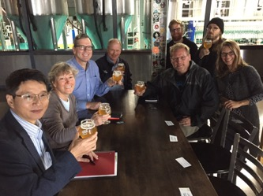
CDC Clear malt, the beer, and enthusiastic maltsters, brewers, and researchers.

Why the interest in naked barley malts? Naked malts potentially have a lot to offer – new flavor frontiers, higher malt extract, higher efficiencies, and direct access to colored barley grain.

Background on naked barley: Naked barley has historically been consumed by humans as a food product, and there is a rich culinary history – notably in the Himalayas and North Africa. In recent years there has been a worldwide resurgence of interest in naked barley foods based, in part, on its beta glucan content. Beta glucan is a soluble dietary fiber and barley food products can carry a health claim if they are > 4% grain beta glucan. However, brewers are not interested in high wort beta glucan, due to resulting filtration issues. Reasonable, naturally occurring levels of grain beta glucan can meet dietary fiber needs and keep brewers happy. For example, Buck has ~ 4% grain beta glucan, the Buck malt was 208 ppm wort beta glucan, and run-off was fine.
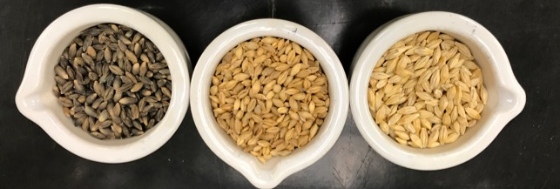
Naked and covered barley. From left to right: BB99 (naked), Buck (naked), and Full Pint (covered).

Naked malting barley breeding and availability: There is a renewed focus on breeding naked barleys specifically for malt. The University of Saskatchewan has led with the way – they developed CDC Clear, which was used in the Modist beer. OSU recently released Buck Naked Barley, and new naked malting types developed for organic farming systems are on the way, thanks to the USDA-NIFA-OREI grant (http://barleyworld.org/orei-project).
- Buck Naked Barley is being grown in increase blocks as part of the OREI project in OR, WA, and NY. This grain has potential for those with 1-barrel systems to work with OSU to schedule mini-malts for the 2018 crop. The initial commercial production in Oregon (2018 crop), may allow for forward contracting.
- CDC Clear will also be grown in increase blocks as part of the OREI project in OR, MN, and WI in the spring of 2018. Like Buck, this can provide opportunities for research pilot malting. Rahr Malting is working with commercial production of CDC Clear – contact them for malt availability.
- Home brewers can access Barley World Buck Naked Malt at Corvallis Brewing Supply.
http://www.lickspigot.com/

Take homes:
Stay tuned for developments and keep in touch. Distillers and brewers take note! Perhaps it is time for a Reinheitsgebot-compliant Hefe (Hefegerste)? Or a naked whiskey?

For more information please contact Patrick Hayes (Patrick.m.hayes@oregonstate.edu)

Special thanks to Scott Fisk the maltster of Barley World), Laura Helgerson, and Brigid Meints for assistance in preparing this report.

