Barley Contributions to Beer Flavor
October 1, 2012

Ryan Graebner, Alfonso-Cuesta-Marcos, Patrick Hayes
Dept. Crop and Soil Science
Oregon State University
Corvallis, OR 97331
Patrick.m.hayes@oregonstate.edu

Rationale:
The goal of this project is to assess, in a preliminary fashion, if there are positive beer flavor attributes that have been lost during the recent history of intensive barley breeding for specific beer styles.
We hypothesized that if there are positive flavor attributes, a good starting point would be in a very diverse collection of barley genetic resources, rather than in contemporary breeding material.

Procedures:
Under the auspices of the USDA-NIFA Triticeae Coordinated Agricultural Project (T-CAP) the Oregon State University Barley Project grew the USDA World Core Collection of barley (n = 2062 accessions) at Corvallis, Oregon for the purposes of mapping genes determining resistance to diseases. The entire collection has been genotyped with 9,000 Single Nucleotide Polymorphisms (SNPs). The phenotype and genotype data are integrated through a procedure known as Genome Wide Association Scanning (GWAS) to locate genes of interest. In this project, we are leveraging these genetic resources and genotype data to assess beer flavor.
We selected 709/2062 accessions (not including repeated check varieties) based on resistance to diseases (notably scald and stripe rust). These selections were harvested, threshed, and weighed. Grain protein, test weight, and grain plumpness have been measured on most accessions that produced over 250g. The 250g amount was proposed as a cut-off based on the minimum amount of grain required for malting and brewing. As detailed in the Results section, sampling the maximum amount of genetic diversity may require using accessions that had yields somewhat less than 250g (e.g. a minimum of 235g).
The plan is that each cooperating brewer (currently New Glarus and Sierra Nevada) will test 50 samples, enabling us to screen between 85 and 99 accessions, depending on how many accessions are malted at both breweries and how many contemporary check varieties are used. The accessions to be malted and brewed will be chosen using principal component analyses as well as phenotypic data (2-row or 6-row, hulled or hull-less, color) in order to retain as much of the original diversity as possible.

Results:
Principal Coordinate Analysis of the genotype data reveals abundant genetic diversity in the entire collection (Figure 1a) and in the harvested subset (Figure 1b). Also shown are the subset of accessions with > 250g (Figure 1c) and the subset of accessions proposed for malting and brewing (Figure 1d).
The seed weights of the harvested accessions range from 43g to 711g (Figure 2), with 452 having over 250 grams (the minimum Sierra Nevada and New Glarus indicated would be required for sensory assessment; Figure 1c). However, as is apparent in comparing the PCA plots, less genetic diversity will be sampled with the 250g cut-off. Therefore, we propose a 235g cut-off. This would requires using one accession that is 235g.
Grain protein content measured from 7.0-14.0% (Figure 3).
Test weight measured from 36.0-58.5 lbs/bushel (Figure 4).
Grain plumpness measured from 2-99.2% plump on a 6/64" screen, with the distribution strongly skewed towards higher plumpness (Figure 5).

Conclusions on characterization:
- Selected accessions are representative of the genetic diversity in the full collection, provided we include one accession with 235g.
- There is sufficient seed for sensory assessment of at least 452 accessions (at the 250g level).
- Most grain physical property values are within the range where malt data should be reasonable.

A proposal for selecting samples for malting and brewing:
Due to seed limitations, it will not be possible to do sensory evaluations on the same accessions at both breweries for the entire subset. However, nine accessions yielded over 500g, so several or all of these accessions could be brewed at both sites, allowing for assessing the repeatability of detecting novel flavor between breweries. An additional four accessions have been selected that yielded between 456g and 500g and could potentially be shared between the two breweries. These would greatly increase the genetic diversity of the shared accessions, adding validity to our comparison between breweries, but would require us to further lower our minimum yield to 228g.
We also have repeated samples of a check grown with the world core – the variety Full Pint. Full Pint has a North American two-row malt profile. However, no flavor or brewing data are available on Full Pint at this time. Use of Full Pint could assist in assessing effects of the Corvallis environment, and let us compare the results of a “standard” variety between breweries. Alternatively, another option would be to use the same seed source of a variety familiar to both brewers – e.g. Metcalfe, Kendall, or (?). This seed source would not be Corvallis, since we did not grow any standard spring two-row malt types in this experiment.
Data on proposed selections are shown in the first worksheet of the attached Excel file. Data on all harvested accessions and on the full World Core are shown in the second and third worksheets.
Proposed selections for malting and brewing: The first worksheet shows the 85 accessions that would fill the 50 accession/brewery maximum set by Sierra Nevada and New Glarus (72 unique accessions + (13 accessions brewed by both breweries)*2 + (1 check brewed by both breweries)*2 = 100). To select these accessions, we first identified the land races in this data set. Next, we used principal component analyses, agronomic data (size, disease ratings, protein levels, etc.), and country of origin to remove similar accessions from the subset. Finally, we added accessions to the subset from non-land races (accessions from cultivars, breeding programs, and accessions of unknown origin), and from accessions that yielded less than 250g, that would help maximize genetic diversity. We believe that this is a reasonable representation of the total genetic diversity in the original 2062 lines (Figure 1D), when considering our limitations on yield and the number of accessions that can be malted. Hull-less varieties were excluded from this selection, because they could present a major confounding factor, given our small sample size.
Next steps:
1. Do we continue to pursue involvement with other brewers?
2. Will we use this selection of 85 accessions? If so, are there any proposed substitutions?
3. Where will the accessions be malted?

A) B)
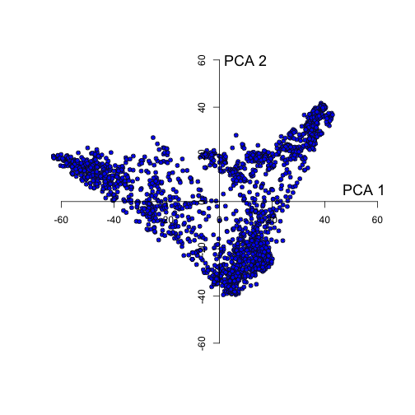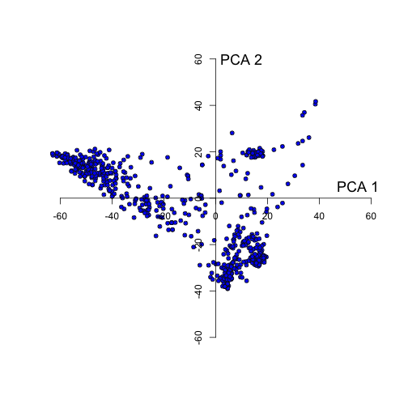
C) D)
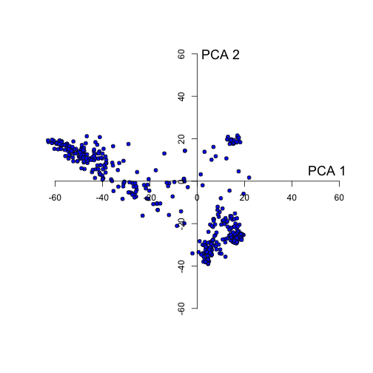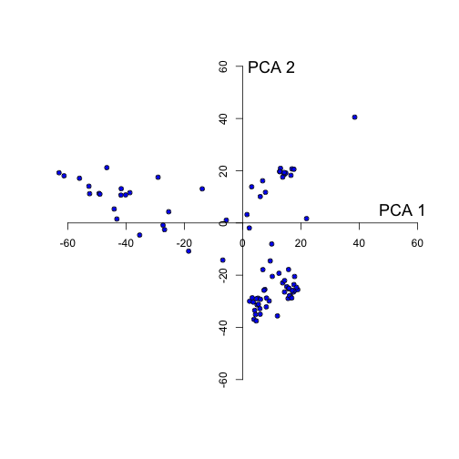
Figure 1. Principal Component Analysis of A) the complete barley world core collection, B) accessions harvested in 2012 for the Barley Contributions to Beer Flavor project, C) harvested accessions with a minimum of 250g, and D) the subset of 85 accessions to be considered for malting. Principal components were calculated using genotypic information from 9,000 SNPs.

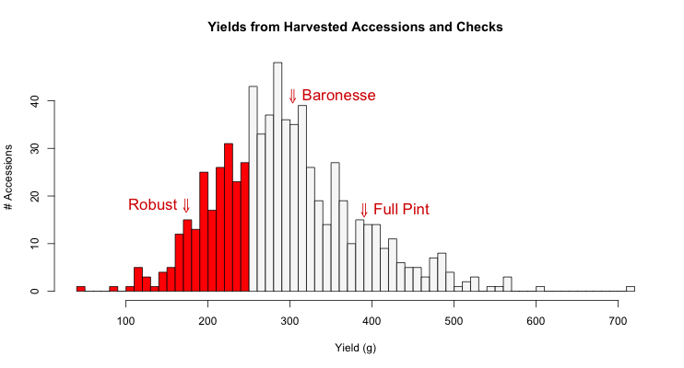
Figure 2. Grain yields (g) of individual single rows of barley world core accessions harvested at Corvallis, Oregon in 2012 for the Barley Contributions to Beer Flavor project. The check varieties are Robust (6-row, malt), Baronesse (2-row feed), and Full Pint (2-row malt).
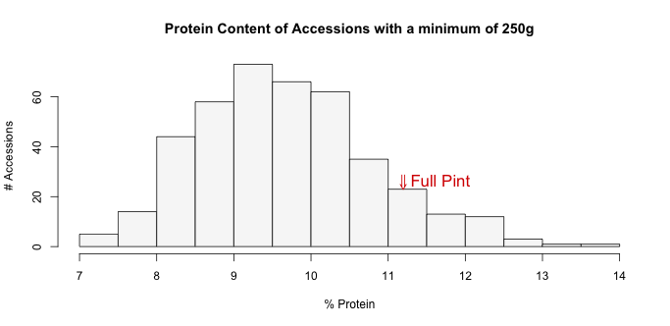
Figure 3. Protein content of accessions with the 250g minimum required for sensory analysis. Colored varieties were excluded from this graph, because the Near Infrared (NIR) spectrometer was unable to accurately measure protein on these accessions. If knowing protein content for colored accessions is critical to sensory analysis, we may be able to determine it using other methods.
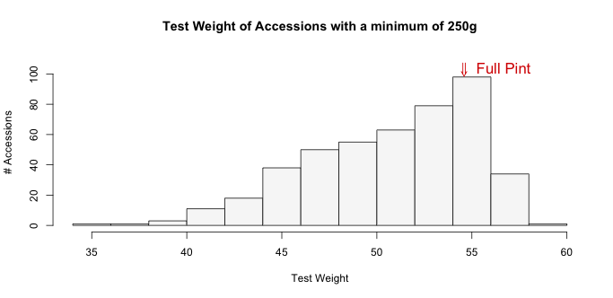
Figure 4. Test weight of accessions with the minimum 250g required for sensory analysis, in lbs/bushel.
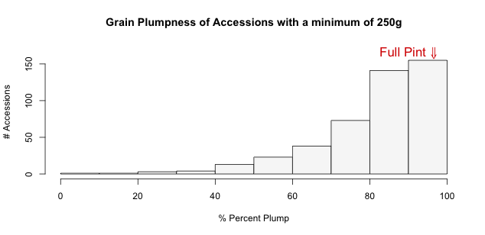
Figure 5. Grain plumpness of accessions with the minimum 250g required for sensory analysis. "% Plump" represents the per cent of grain that did not pass through a 6/64" screen.

