Homework # 2
20 points possible

The length of the barley “spike” (inflorescence) may be under genetic control. Your assignment is to determine if spike length shows qualitative Mendelian inheritance or quantitative inheritance that defies simple Mendelian analysis.

Digital images of spikes in the Oregon Wolfe Barley population are shown at http://barleyworld.org/oregonwolfe/images. Please forgive the advertisements - collateral damage from using flickr.
    - For this assignment, choose the n = 82 Hordeum bulbosum-derived doubled haploid (DH) population – the “OWB Hb Phenotypes” hyperlink. These doubled haploids are not numbered consecutively, but there are 82 of them.
    - Plan ahead and take a few minutes to become familiar with viewing these images.
    - Note the “ruler” in each image. You can use this to determine the length of the spike. When measuring the spike length, measure from the first to the terminal floret - do not count stem or awn. Some spikes are curved – just ignore the curve and assume length is from base to tip of the spike. Keep it simple – express your measurement to the nearest whole centimeter. See the data scoring sheet at the end of this assignment for examples.
    - You assignment is to measure the head length of each doubled haploid.

- Fill in the attached scoring sheet (appended to this assignment) with the DH number and spike length. 3 points for full data sheet and reasonable numbers

- Draw (or use Excel to make) a frequency distribution showing spike length. In your histogram, be sure to indicate the phenotype of each of the parents. 4 points. Can be hand-drawn. 3 points in parents are not shown
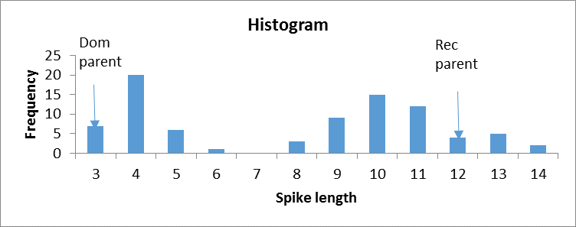

- Which term best describes this frequency distribution?
  - Qualitative (Discontinuous)
  - Quantitative (Continuous). 2 points: Full credit given for either, plus one point if qualitative chosen. It is a bimodal (discontinuous) distribution suggesting qualitative inheritance. But we can see how a person might say there are two continuous distributions. The point is quantitative scales can be used to measure traits that show Mendelian inheritance.
- Mendel (and many after him) was able to classify some traits as ‘qualitative” even though they measured the traits using a quantitative scale. The key thing is to describe, in sufficient detail, the rationale behind the classification and the exact way that it was done.
Follow their examples, and classify spike length as “long” and “short”.

Briefly describe your criteria for “short” and for “long”. Short spikes are 3 to 6 cm. Long spikes are 8 to 14 cm. 2 points Different folks may have slightly different scores. Full credit given for reasonable numbers.
- How many loci do you hypothesize are responsible for determining spike length in this population? One locus is determining spike length. 2 points

- Calculate a chi square to test your hypothesis regarding the number of loci that determine spike length in this population – fill in the following table. Note: Parents are NOT used for calculating the chi square test.

Phenotype | # Observed (O) | # Expected (E) | O - E | (O-E)²/E
Short | 33 | 41
Long | 49 | 41
Totals | 82 | 82

- Calculated X² = __3.84___ ; df = __1___ ; probability = __0.07724_____
3 points Depending on the scoring, the answers to this question can vary slightly. Key thing is that they are calculated correctly
- Do you accept or reject your hypothesis?
Accept hypothesis that observed = expected. Alleles at one locus determine spike length in this population. 2 points
- How many alleles are segregating at the locus that you have determined are responsible for spike length in this population?
Two alleles are segregating. 2 points

OWB doubled haploid # | Length (cm)
Dominant (Dom) parent | 3
Recessive (Rec) parent | 12
2 | 4
3 | 5
4 | 8
6 | 6
7 | 10
8 | 4
9 | 13
10 | 4
11 | 4
12 | 10
13 | 9
14 | 3
16 | 11
17 | 13
18 | 9
19 | 10
20 | 3
21 | 14
23 | 4
24 | 3
25 | 5
26 | 10
28 | 3
29 | 14
30 | 4
31 | 13
32 | 4
33 | 10
34 | 11
35 | 9
36 | 9
37 | 8
38 | 4
39 | 4
40 | 4
41 | 3
42 | 11
43 | 10
44 | 11
45 | 12
46 | 9
47 | 9
48 | 11
49 | 4
51 | 4
52 | 13
53 | 3
54 | 10
55 | 11
56 | 11
57 | 4
59 | 10
60 | 5
61 | 4
63 | 5
64 | 10
65 | 10
66 | 11
67 | 4
68 | 11
69 | 9
70 | 10
72 | 4
73 | 9
74 | 10
75 | 10
76 | 11
77 | 4
78 | 10
79 | 9
81 | 9
82 | 12
83 | 4
84 | 8
85 | 10
86 | 11
87 | 11
89 | 5
90 | 12
91 | 13
92 | 5
93 | 4
94 | 4

