Making histograms (phenotypic frequency distributions) using Excel

This demonstration uses data from the Oregon Wolfe Barley population. The data set is available at http://wheat.pw.usda.gov/ggpages/maps/OWB/. This example uses just one of the phenotype data sets (floret number) as an example. The example is based on the full population of doubled haploids: anther culture (AC) plus Hordeum bulbosum (H.b.).
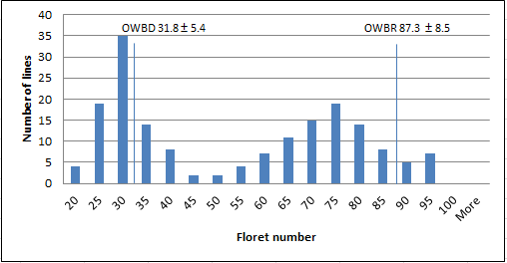
- Download the data set in Excel format.
- Be sure that the Analysis ToolPak add-in is installed on your computer. To our knowledge, this add-in is NOT available for MAC users. This example uses Windows 2010. Other versions may have the Analysis ToolPak add-in.
  - To determine if the Analysis ToolPak is available on your computer, click the “Data” tab.
  - If you see “Data Analysis” on the far right of the toolbar, you are all set.
  - If you do not see “Data analysis” you need to load it.
    - On the “File” Tab click “Options”.
    - Click on “Add-Ins”. Click on “Go” next to Manage at the bottom.
    - Check the Analysis ToolPak and click “Ok”.
- Go to the Excel data file.
  - In the example, column C has the “raw” phenotype data.
  - Column D indicates the bins you wish to have in your figure. In the example, the bins increase by five. You can elect to make smaller or larger groupings.
  - To generate frequencies for each bin, click on “Data analysis” and then “Histogram”.
  - The input range is column C (including the label in row 1). The bin range is column D, (including the label in row 1). Do not include the parents at the bottom.
  - Check the “Labels” box.
  - Under Output options you can choose a location on the same page for the output or you can choose a new worksheet or a new workbook.
  - Check the “Chart Output”.
  - Click OK – you have a simple histogram!
- By clicking on the chart the “Chart Tools” tab will open and you can change axis labels, graph titles, and add information about the parents.
  - To label parents, insert a text box. Group each text box with the graph to ensure they stay positioned above the correct spot.

