Fall-planted barley trials
Morrow County, Oregon
2015 and 2016 Harvests
Preliminary report
March, 2017

Larry Lutcher, Scott Fisk, Patrick Hayes, Karl Rhinhart
Department of Crop and Soil Science
Oregon State University

Experiments were conducted over a two-year period at the Starvation and Jepsen Farms in Morrow County, Oregon.
The barleys tested were commercial or pre-commercial. They cover a spectrum of types and end-uses, as shown in Table 1.
Table 1. Descriptions of six winter barley varieties and one experimental selection (TCFW6-033) grown at the Jepson and Starvation Farms, Morrow County Oregon. 2015 and 2016 harvests.
Variety/  Selection | Grain  type | Awn  type | Head  type | Growth  Habit | Principal end use | Origin
Alba | Covered | Standard | 6-row | Winter | Feed/Malt | Oregon State University
Buck | Naked | Standard | 6-row | Winter | Food/Malt | Oregon State University
Glacier | Covered | Standard | 2-row | Winter | Feed | Tri-State Seeds/KWS (Germany)
P-954 | Covered | Standard | 6-row | Facultative | Feed | University of Nebraska – Lincoln
Strider | Covered | Standard | 6-row | Winter | Feed | Oregon State University
TCFW6-033 | Covered | Standard | 6-row | Facultative | Feed | Oregon State University
Verdant | Covered | Hooded | 6-row | Winter | Forage | Oregon State University

There was complete winter survival in all trials.
Overall, the top yielding variety was Glacier, as shown in Tables 2 – 5. This two row variety had top yields, good test weight, and good kernel plumpness. The 6-row covered varieties with standard awn type had good yields but were not competitive with Glacier for test weight or kernel plumpness. Verdant, a hooded type, is intended for forage rather than grain production. Buck – a naked barley – did surprisingly well. Its yield and test weight are more appropriately compared to wheat than to barley.

Table 2. Agronomic performance of fall-planted barley at Starvation Farms, 2015
Table 3. Agronomic performance of fall-planted barley at Starvation Farms, 2016

Table 4. Agronomic performance of fall-planted barley at the Jepsen Farm, 2015
Table 5. Agronomic performance of fall-planted barley at the Jepsen Farm, 2016

Aerial view - Jepsen Farm fall-planted barley plots 2016.
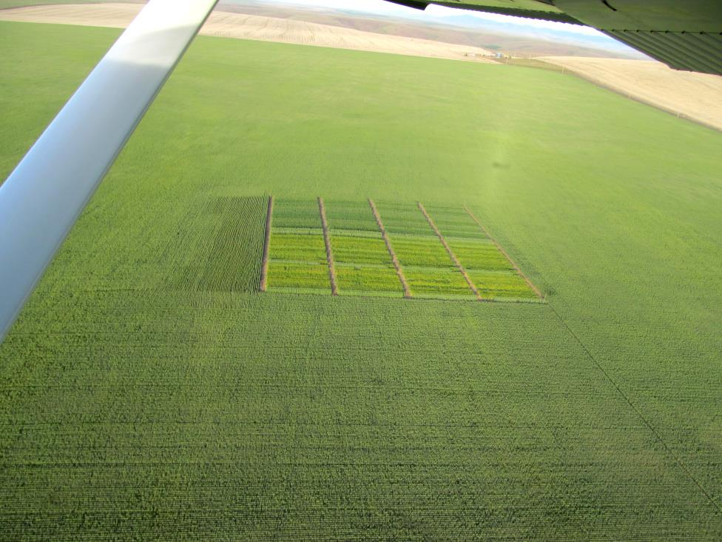

Ground view - Starvation Farms fall-planted plots. 2016
