Stripe rust NACA report, 2016 harvest.
The barley leaf rust screening trial
Corvallis, OR; Davis, CA; Pullman, WA; and Mt Vernon, WA
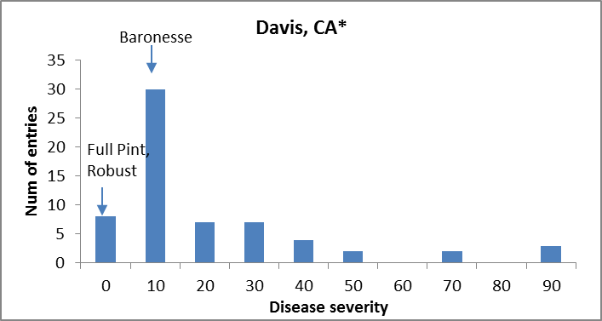

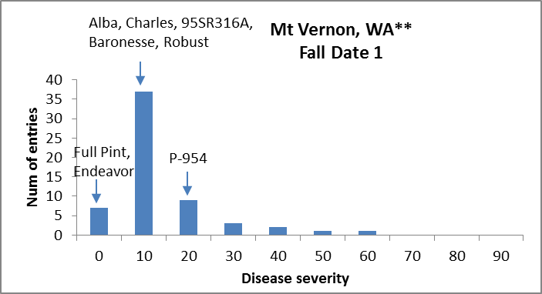

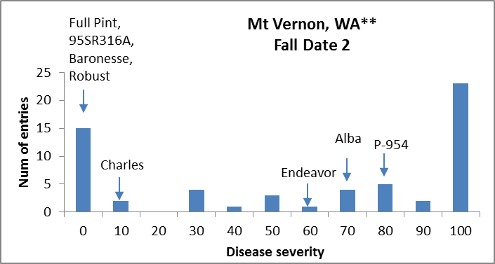

* @ Davis, CA only three checks included.
** @ Mt Vernon, WA trials were not replicated.

BSRST - ANOVA

Davis, CA
Df Sum Sq Mean Sq F value Pr(>F)
Line 61 1.87279 0.0307014 5.3281 3.233e-10 ***
Rep 1 0.01242 0.0124173 2.1550 0.1472
Residuals 61 0.35149 0.0057622
---
Signif. codes: 0 ‘***’ 0.001 ‘**’ 0.01 ‘*’ 0.05 ‘.’ 0.1 ‘ ’ 1
H_{b} = 0.81

