Analyses of Stripe rust and Leaf rust data
Corvallis, OR; Davis, CA; Mt. Vernon and Pullman, WA / 2016-2017.

2016
Stripe rust:
Corvallis, OR – one evaluation, disease severity.

Phenotypic frequency distribution: Effective epidemic development. Checks behaving as expected.

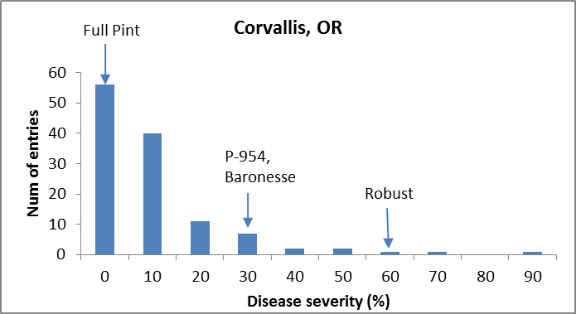

ANOVAs: Significant differences due to genotype. High heritability.
Response: Log(Sev)
Df Sum Sq Mean Sq F value Pr(>F)
Line 120 1.69418 0.0141182 8.2674 <2e-16 ***
Rep 1 0.00134 0.0013359 0.7823 0.3782
Residuals 120 0.20492 0.0017077
---
H² = 0.87

GWAS: Significant associations of markers with phenotype on 5H (~ 576992804 bp, marker: SCRI_RS_240005)

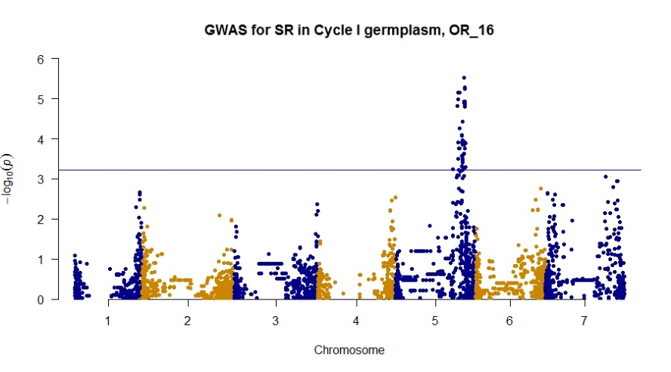

UC Davis – Two evaluations, disease severity at each rating

Disease severity
Phenotypic frequency distributions: Increase in disease severity over time. Checks behaving as expected.

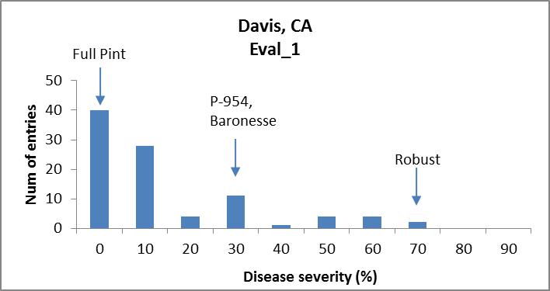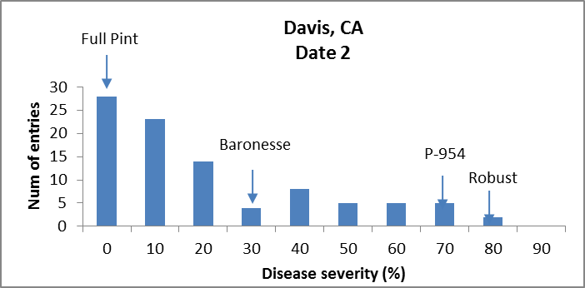

ANOVAs: Significant differences due to genotype. Moderate heritabilities.
Eval_1
Response: Log(Sev)
Df Sum Sq Mean Sq F value Pr(>F)
Line 93 2.05362 0.022082 4.5686 1.330e-12 ***
Rep 1 0.08135 0.081348 16.8303 8.756e-05 ***
Residuals 93 0.44951 0.004833
H² = 0.78

Eval_2
Response: Log(Sev)
Df Sum Sq Mean Sq F value Pr(>F)
Line 93 2.81104 0.030226 4.5771 1.257e-12 ***
Rep 1 0.05730 0.057298 8.6766 0.004072 **
Residuals 93 0.61415 0.006604
H² = 0.78

GWAS: Significant associations of markers with phenotype on 5H (Eval1: ~ 521145781 bp, marker: BOPA1_9745-628; Eval2: ~ 533551381, marker: SCRI_RS_233239 )

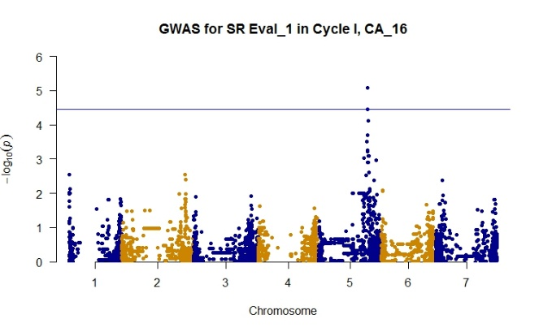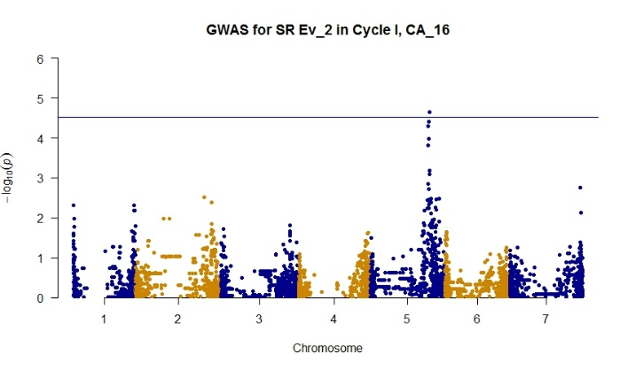

Mt. Vernon, WA – Spring-planted trial – One evaluation of disease severity.

Phenotypic frequency distribution: Effective epidemic development in first evaluation of spring trial, with checks behaving as expected.
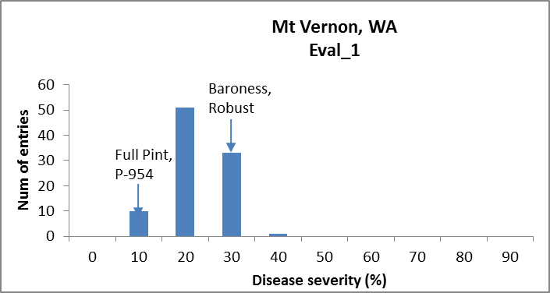

ANOVAs: Not possible due to un-replicated assessment.

GWAS: No significant association between markers and phenotype.

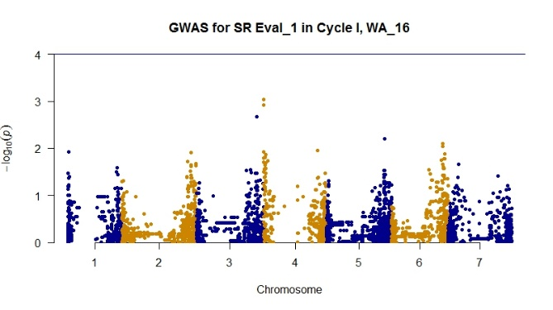

Leaf rust: Effective epidemics of leaf rust observed at Davis and Mt. Vernon.

UC Davis

Phenotypic frequency distributions: Effective epidemic development, with checks behaving as expected.

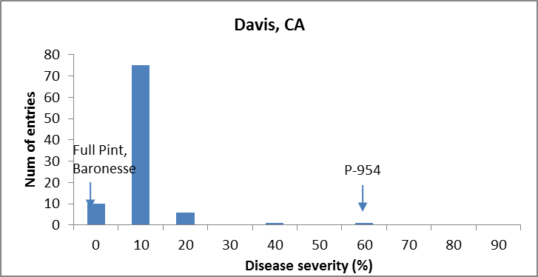

ANOVAs: Significant differences due to genotype. High heritability.

Response: Log(Sev)
Df Sum Sq Mean Sq F value Pr(>F)
Line 93 0.41129 0.0044225 4.3326 6.489e-12 ***
Rep 1 0.00240 0.0024035 2.3546 0.1283
Residuals 93 0.09493 0.0010208
H² = 0.76

GWAS: No significant association between markers and phenotype. Trend on 7H
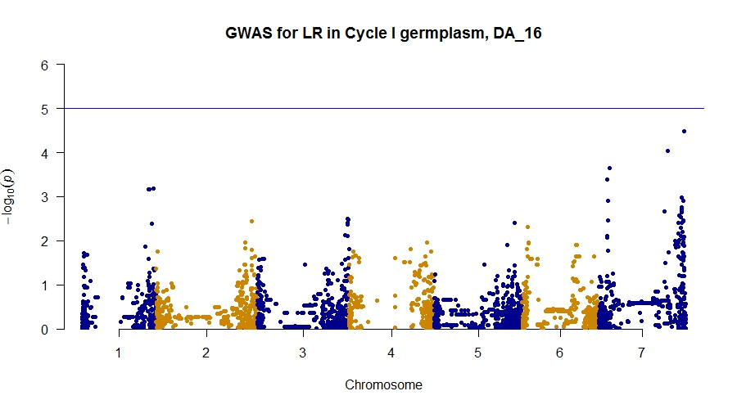

Mt. Vernon, WA – 1 date
Phenotypic frequency distributions: Effective epidemic development. Some checks moving from tolerant to susceptible.

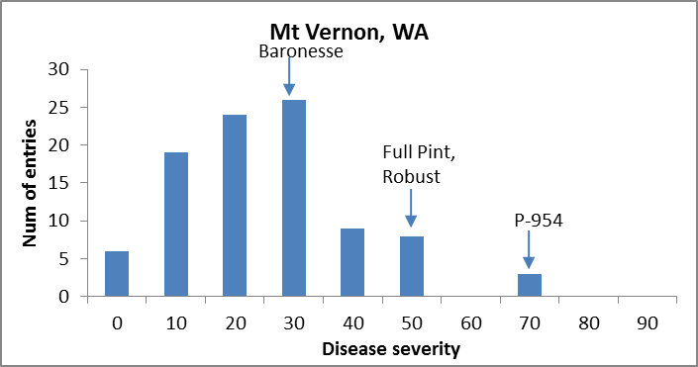

ANOVAs:
Not possible due to un-replicated assessment.

GWAS: Significant association of markers with phenotype on 7H (~634620797 bp, marker: BOPA1_6868-595)

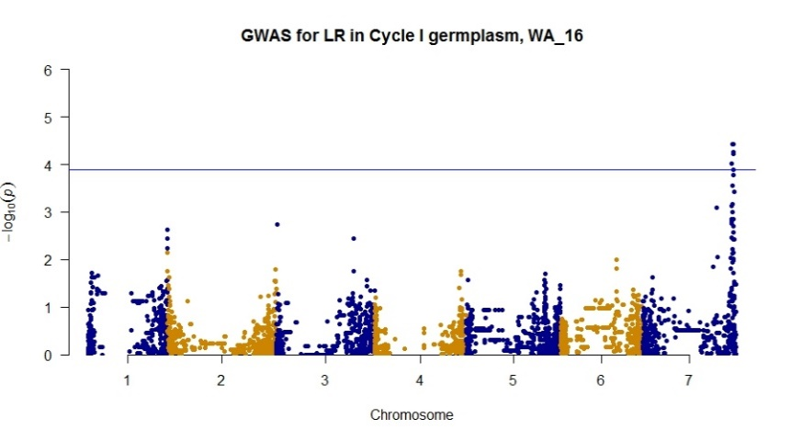

2017

Stripe rust:
Corvallis, OR –
No epidemic development, no data

UC Davis – Three evaluations – disease severity at each rating. Checks behaving as expected

Disease severity
Phenotypic frequency distributions: Increase in disease severity over time.
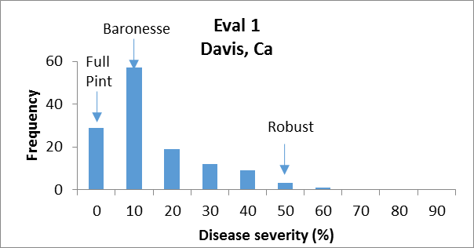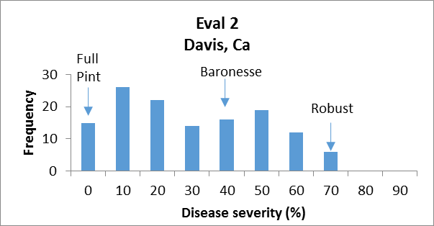
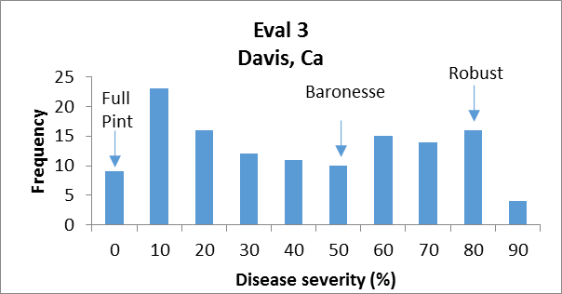

ANOVAs: Significant differences due to genotype. High heritabilities.

Eval_1
Response: Sev(%)
Df Sum Sq Mean Sq F value Pr(>F)
Line 126 1.55893 0.0123725 8.2399 <2e-16 ***
Rep 1 0.00286 0.0028593 1.9043 0.17
Residuals 128 0.19220 0.0015015
Signif. codes: 0 ‘***’ 0.001 ‘**’ 0.01 ‘*’ 0.05 ‘.’ 0.1 ‘ ’ 1
H² = 0.87

Eval_2
Response: Sev(%)
Df Sum Sq Mean Sq F value Pr(>F)
Line 126 3.1972 0.025375 10.907 < 2.2e-16 ***
Rep 1 0.2980 0.297988 128.084 < 2.2e-16 ***
Residuals 128 0.2978 0.002327
Signif. codes: 0 ‘***’ 0.001 ‘**’ 0.01 ‘*’ 0.05 ‘.’ 0.1 ‘ ’ 1
H² = 0.90

Eval_3
Response: Sev(%)
Df Sum Sq Mean Sq F value Pr(>F)
Line 126 4.7359 0.037586 14.935 < 2.2e-16 ***
Rep 1 0.0733 0.073305 29.128 3.17e-07 ***
Residuals 128 0.3221 0.002517
Signif. codes: 0 ‘***’ 0.001 ‘**’ 0.01 ‘*’ 0.05 ‘.’ 0.1 ‘ ’ 1
H² = 0.93

GWAS: No significant associations of markers with phenotypes. Trends on 4H and 5H.
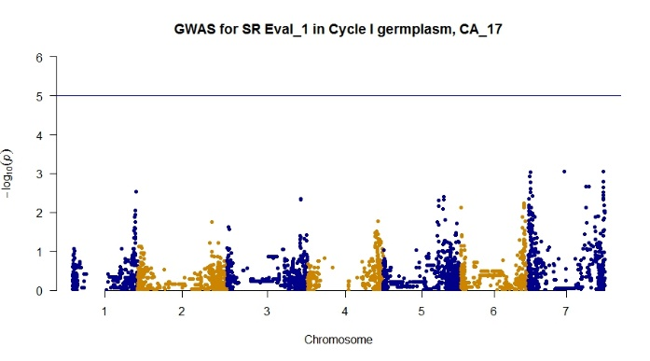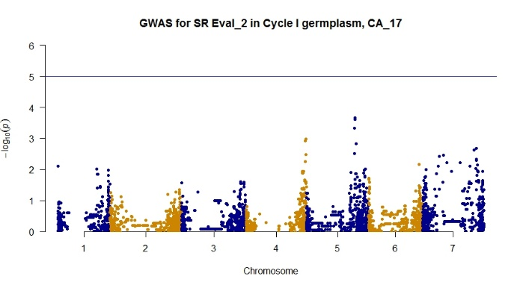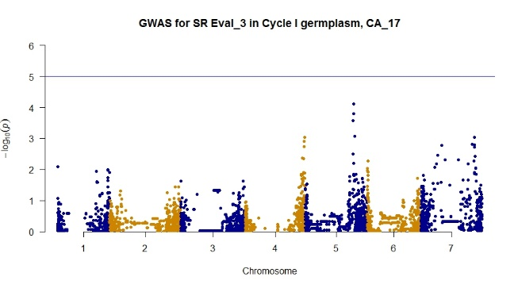

Mt. Vernon, WA – Limited epidemic development. Checks behaving as expected in most of locations and times

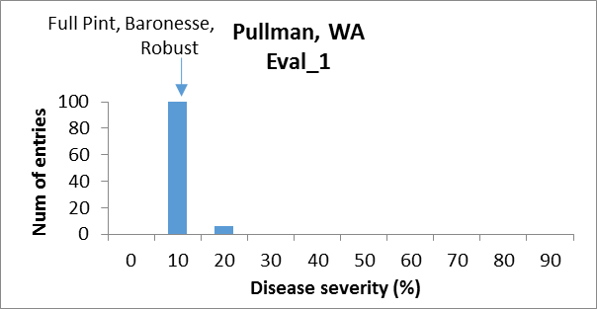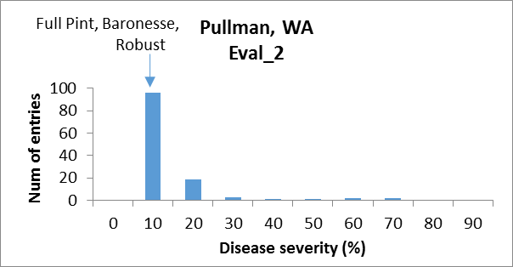

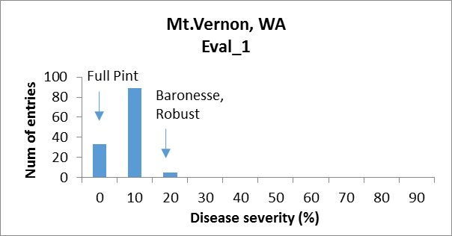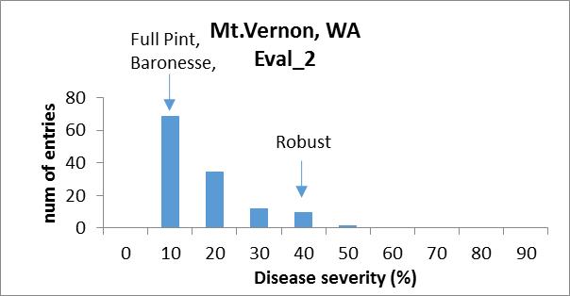

ANOVA:
Not possible – un-replicated assessment.

GWAS: No significant association of markers with phenotypes.
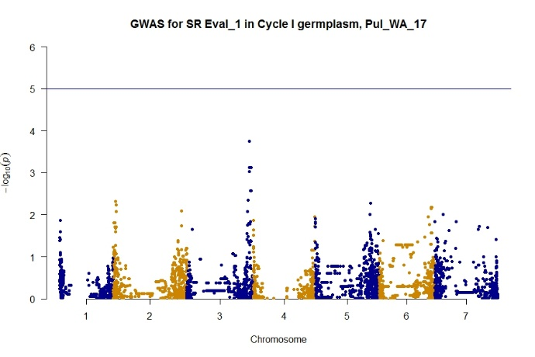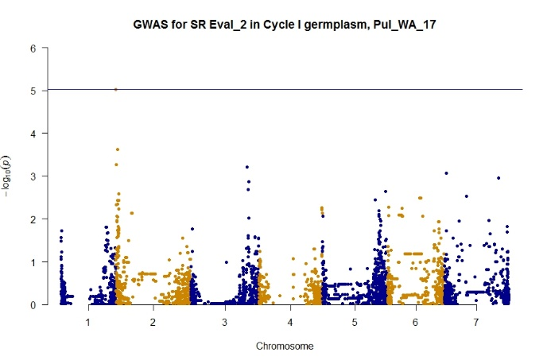

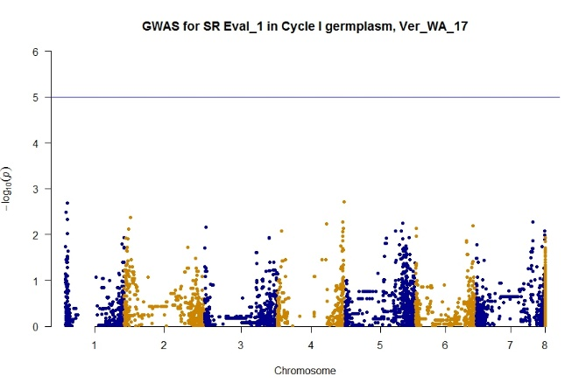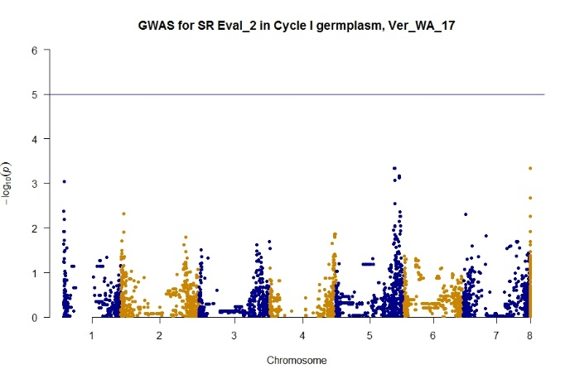
Leaf rust:
No disease reported in this year.

Combined analysis of 2016, 2017
Stripe Rust data

Disease severity
Phenotypic frequency distribution: Effective distribution of the disease. Checks behaving as expected across different environments.

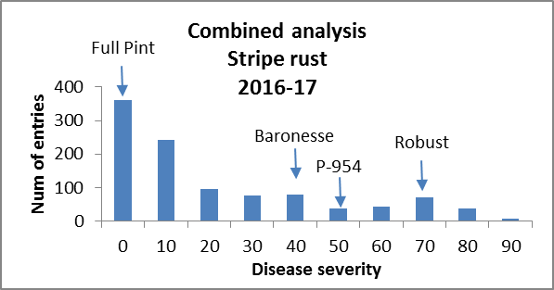

ANOVA:
Models:
BLUP_SR: SR ~ 1 + (1 | Lines) + (1 | Loc) + (1 | Year) + (1 | Rep) + (1 |
BLUP_SR: Lines:Year)
BLUP_SR_lines: SR ~ Lines + (1 | Loc) + (1 | Year) + (1 | Rep) + (1 | Lines:Year)
Df AIC BIC logLik deviance Chisq Chi.Df Pr(>Chisq)
BLUP_SR 7 8799.3 8834 -4392.7 8785.3
BLUP_SR_lines 122 8722.3 9327 -4239.2 8478.3 306.99 115 < 2.2e-16 ***
---
Signif. codes: 0 ‘***’ 0.001 ‘**’ 0.01 ‘*’ 0.05 ‘.’ 0.1 ‘ ’ 1

H2 = 0.61

GWAS: Significant associations of markers with phenotype on 5H (~525964746 bp, marker: SCRI_RS_191145).
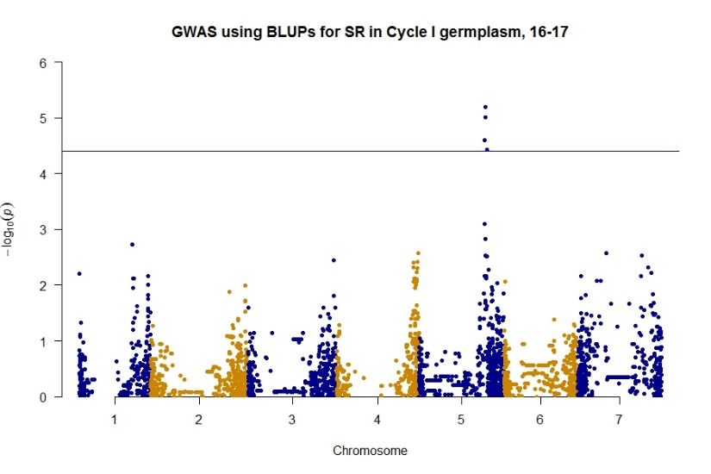
Combined analysis of 2016
Leaf Rust data

Disease severity
Phenotypic frequency distribution: Effective distribution of the disease. Checks behaving as expected across different environments. Some checks moving from tolerant to moderate susceptible
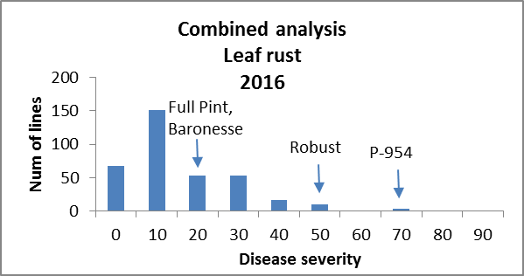

ANOVAs:
Models:
BLUP_LR: LR ~ 1 + (1 | Lines) + (1 | Loc) + (1 | Rep) + (1 | Lines:Loc)
BLUP_LR_lines: LR ~ Lines + (1 | Loc) + (1 | Rep) + (1 | Lines:Loc)
Df AIC BIC logLik deviance Chisq Chi.Df Pr(>Chisq)
BLUP_LR 6 1944.9 1966.4 -966.45 1932.9
BLUP_LR_lines 94 1958.8 2296.3 -885.38 1770.8 162.13 88 2.569e-06 ***
---
Signif. codes: 0 ‘***’ 0.001 ‘**’ 0.01 ‘*’ 0.05 ‘.’ 0.1 ‘ ’ 1
H² = 0.17

GWAS: Significant associations of markers with phenotype on 7H in two sites (~ 625633406 bp, marker: BOPA2_12_31374; ~522444718 bp, marker: SCRI_RS_122512).
