Regional trial
Stripe rust report, 2017
Davis, CA
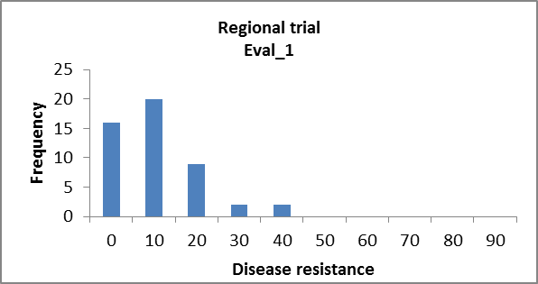
Analysis of Variance Table
Response: Log1
Df Sum Sq Mean Sq F value Pr(>F)
Line 48 0.37091 0.007727 2.5488 0.0007662 ***
rep 1 0.13663 0.136631 45.0667 2.025e-08 ***
Residuals 48 0.14552 0.003032
---
Signif. codes: 0 ‘***’ 0.001 ‘**’ 0.01 ‘*’ 0.05 ‘.’ 0.1 ‘ ’ 1
H²: 0.60

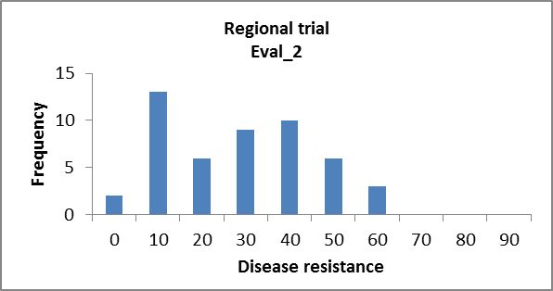
Analysis of Variance Table
Response: Log2
Df Sum Sq Mean Sq F value Pr(>F)
Line 48 0.83075 0.01731 3.5598 1.111e-05 ***
rep 1 0.52175 0.52175 107.3145 7.875e-14 ***
Residuals 48 0.23337 0.00486
---
Signif. codes: 0 ‘***’ 0.001 ‘**’ 0.01 ‘*’ 0.05 ‘.’ 0.1 ‘ ’ 1
H²: 0.71

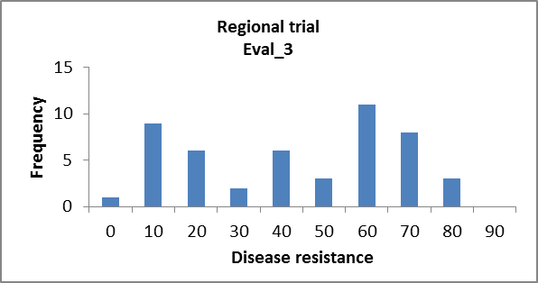
Analysis of Variance Table
Response: Log3
Df Sum Sq Mean Sq F value Pr(>F)
Line 48 1.47373 0.030703 8.8409 2.247e-12 ***
rep 1 0.25145 0.251447 72.4044 3.787e-11 ***
Residuals 48 0.16669 0.003473
---
Signif. codes: 0 ‘***’ 0.001 ‘**’ 0.01 ‘*’ 0.05 ‘.’ 0.1 ‘ ’ 1
H²: 0.88

