Analyses of Stripe rust using Infection Type (IT)
Davis, CA; Mt. Vernon and Pullman, WA / 2016-2017

2016

Stripe rust:
UC Davis – Two evaluations, disease infection type at each rating
Infection Type
Phenotypic frequency distributions: Increase in infection type over time. Checks behaving as expected.

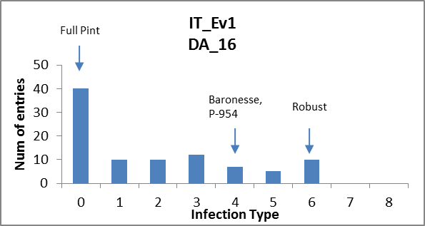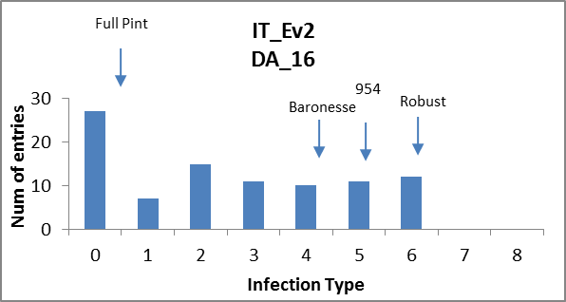

ANOVAs: Significant differences due to genotype. High heritabilities.
Eval_1
Response: Log_IT_E1
Df Sum Sq Mean Sq F value Pr(>F)
Line 93 30.9210 0.33248 3.4769 3.041e-09 ***
Rep 1 1.0131 1.01308 10.5943 0.001583 **
Residuals 93 8.8932 0.09563
H² = 0.71
Eval_2
Response: Log_IT_E2
Df Sum Sq Mean Sq F value Pr(>F)
Line 93 32.550 0.35001 3.8632 1.748e-10 ***
Rep 1 0.678 0.67786 7.4819 0.007464 **
Residuals 93 8.426 0.09060
H² = 0.74
GWAS: Significant associations of markers with phenotype on 5H (Eval1_2: ~ 520992168 bp, marker: BOPA1_9745-628)

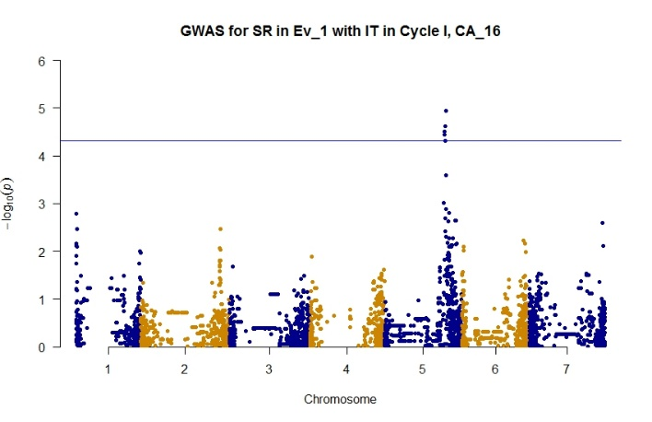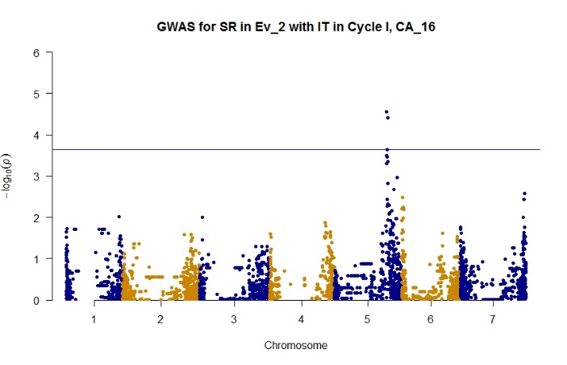
Mt. Vernon, WA – Spring-planted trial – One evaluation of disease severity.
Phenotypic frequency distribution: Effective epidemic development in first evaluation of spring trial, with checks behaving as expected.

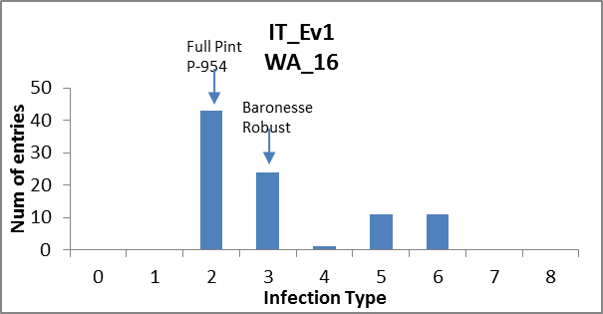
ANOVAs: Not possible due to un-replicated assessment.
GWAS: No significant association between markers and phenotype.
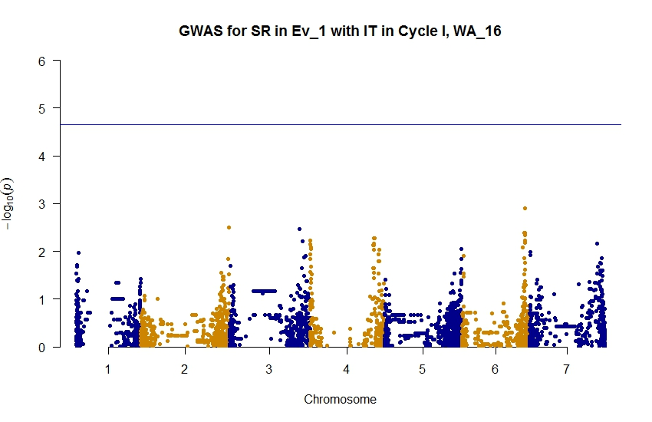
2017

Stripe rust:
UC Davis – Three evaluations –Infection type at each rating. Checks behaving as expected
California 2017
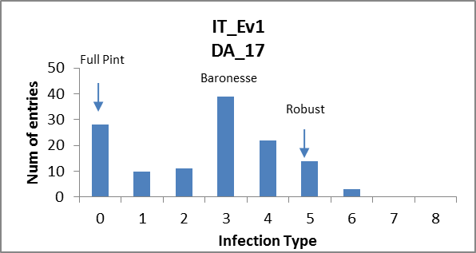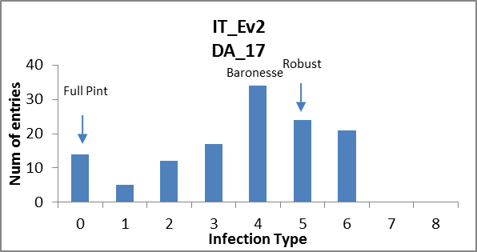
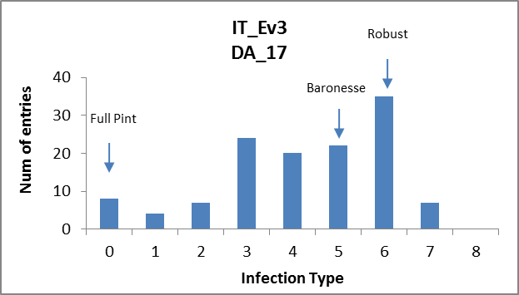
ANOVAs: Significant differences due to genotype. High heritabilities.
Eval_1
Response: Log_IT_E1
Df Sum Sq Mean Sq F value Pr(>F)
Line 126 37.405 0.296861 7.6693 < 2e-16 ***
Rep 1 0.175 0.175078 4.5231 0.03539 *
Residuals 126 4.877 0.038708
H² = 0.86

Eval_2
Response: Log_IT_E2
Df Sum Sq Mean Sq F value Pr(>F)
Line 126 30.4564 0.24172 8.1804 < 2.2e-16 ***
Rep 1 0.6197 0.61974 20.9735 1.103e-05 ***
Residuals 126 3.7231 0.02955
H² = 0.87
Eval_3
Response: Log_IT_E3
Df Sum Sq Mean Sq F value Pr(>F)
Line 126 25.3910 0.201516 7.4625 < 2e-16 ***
Rep 1 0.1365 0.136540 5.0564 0.02627 *
Residuals 126 3.4025 0.027004
H² = 0.86

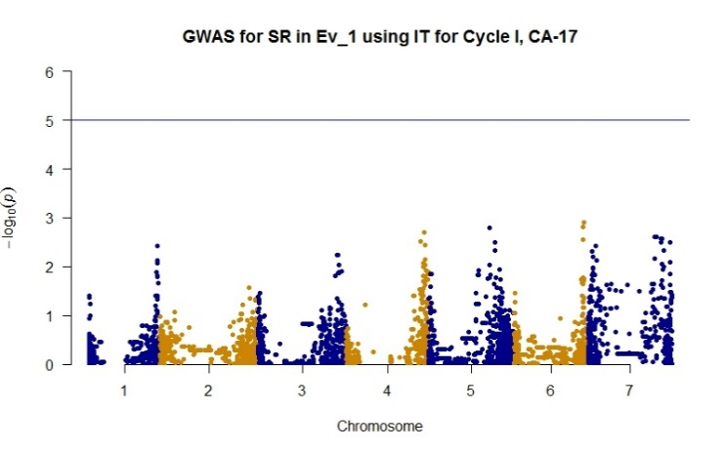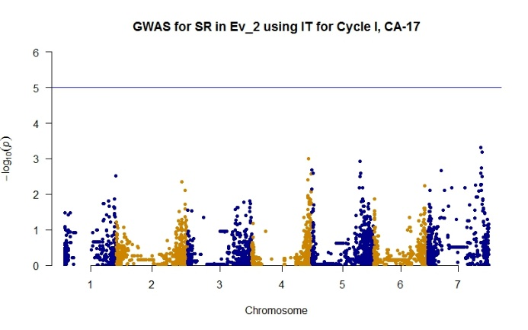
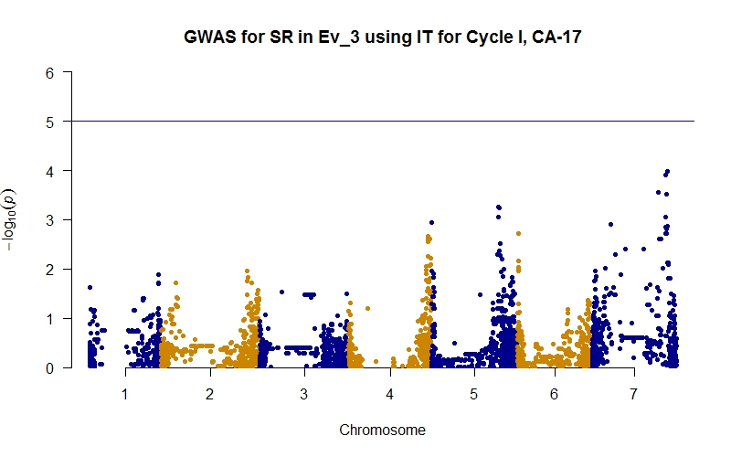
Mt. Vernon, WA – Two evaluations in two locations – infection type at each rating. Checks behaving as expected. Limited epidemic development.
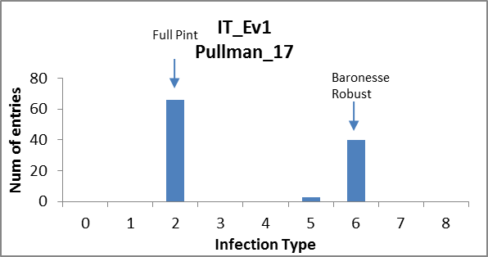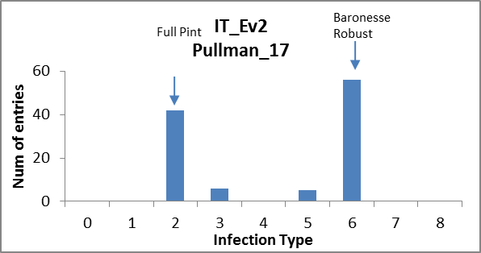

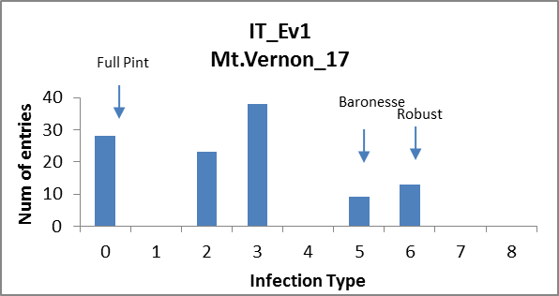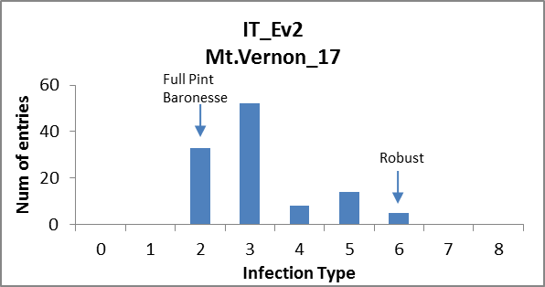

ANOVA:
Not possible – un-replicated assessment.

GWAS: No significant association of markers with phenotypes. Trend on 5H in Evaluation 2, Mt.Vernon

