2015 Oktoberfest Flavor Report
Dustin Herb, Patrick Hayes, and the Barleyworld crew
Rahr Update: The internship at Rahr Malting Co. continues. All of the Oregon Promise selections from three Oregon environments have been micro-malted and full malt analysis completed. Differences in modification were detected between the three environments with highest beta-glucan levels in samples from environment 3, allowing us to dig into beta-glucan related questions including: 1) environmental/production factors effecting beta-glucan levels, 2) beta-glucan effect on water uptake, and 3) flavor impact of high beta-glucan in barley. Experimental design in underway… suggestions always welcome.
Nano-brewing of 125 Oregon Promise samples has begun! Twelve samples are brewed each day with a control. We have currently brewed all samples from 1st environment and have started on the 2nd environment samples. The brewing is expected to take three weeks, then two weeks for fermentation, and two weeks for bottle conditioning. Sensory and GC-MS on samples will begin 2nd week of November.
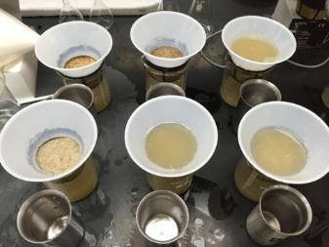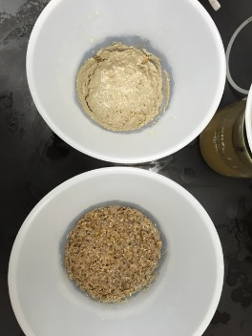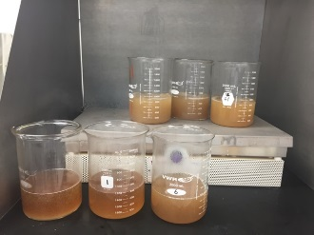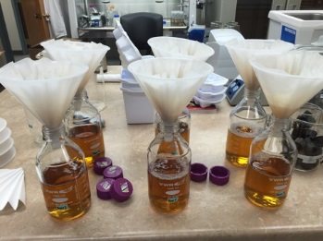
News: Ripples turning to waves with Pat’s presentation on barley flavor at the Master Brewers of America Association. Full presentation posted at Barleyworld.org!
Dustin will be presenting on the past, present, and future of the flavor project at the Farmer Brewer Winter Workshop hosted by Valley Malt in January!
Progress on the OSU malt lab continues… the mini-malter is home and analytical equipment donated from Rahr!
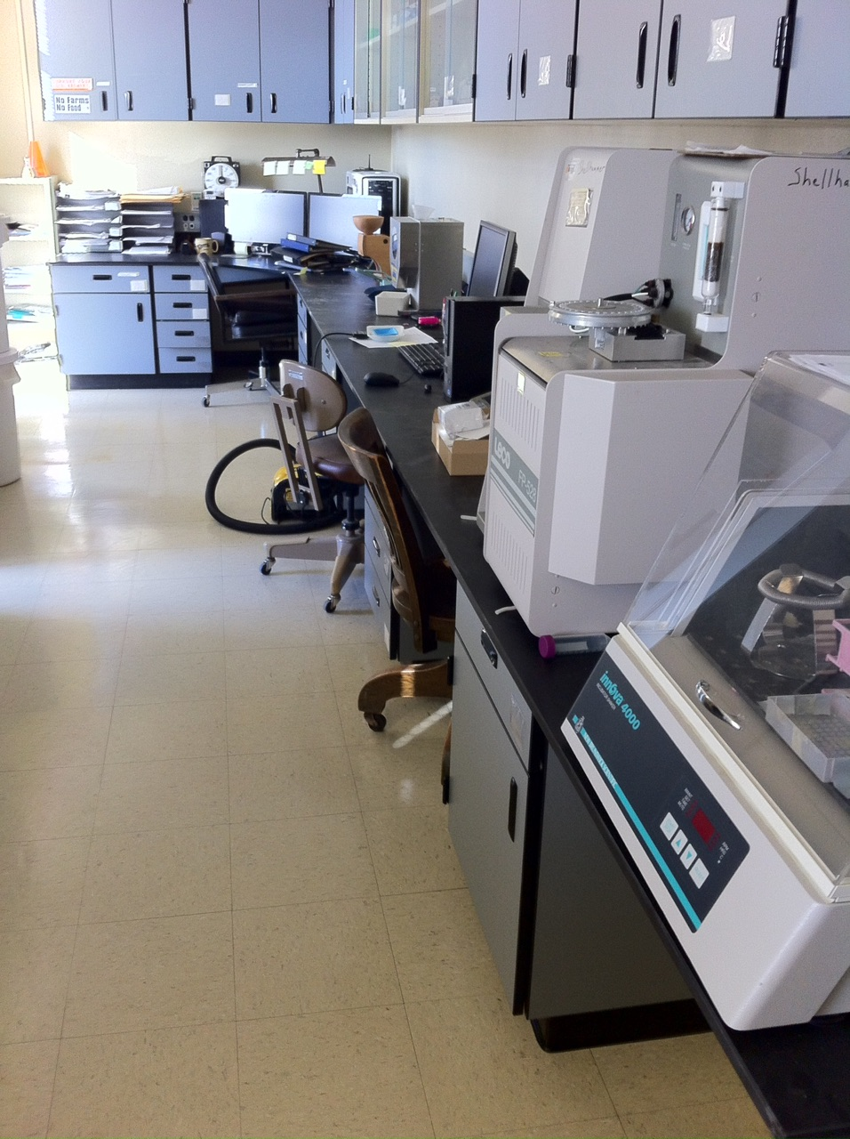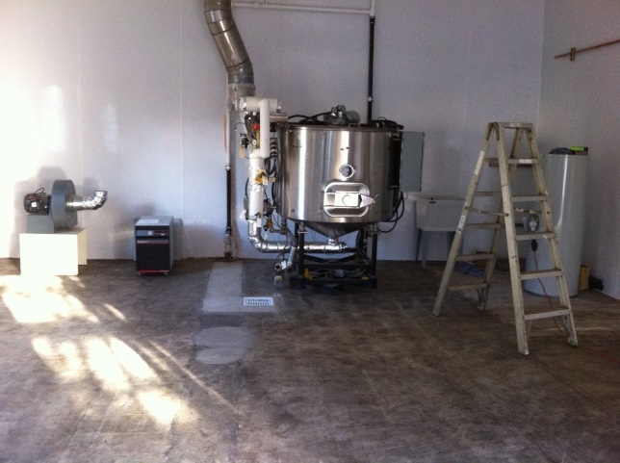

Everyone is welcome to visit the OSU Barley Project at any time
Thank you for your continued support!

