Winter Barley Forage: Options for the Maritime Pacific Northwest
Brook Brouwer¹, Thomas Youngquist², Caitlin P.Youngquist^{1,2}, Patrick Hayes³, Steve Lyon¹ and Stephen Jones¹
¹Dep. of Crop and Soil Science, Northwestern Washington Research and Extension Center, Washington State Univ., 16650 State Route 536, Mount Vernon, WA 98273; ²Circle Y Farms, LLC., 17761 Kamb Rd., Mount Vernon, WA 98273; ³Dep. of Crop and Soil Science, Oregon State Univ., Crop Science Building, 3050 SW Campus Way, Corvallis, OR 97331

Abstract
Winter barley has the potential to provide growers with an additional forage option in the maritime Pacific Northwest. During the 2012-13 growing season two winter barley varieties were grown in a certified organic small plot forage and grain yield trial and a conventionally managed field-scale trial. Forage yield of both varieties were comparable when grown in replicated plots and forage quality was superior to reference values. Grain yield of Alba was significantly higher than Verdant. Verdant is preferred for forage production due to the absence of awns. Growers interested in having the option of forage or grain harvest may consider growing Alba, however if used for forage it should be harvested prior to heading due to its awns.

Introduction
Flexibility in cropping systems is essential in the maritime Pacific Northwest due to the complexity of crop rotations, animal forage needs and variable weather conditions. Early spring harvest of an annual forage crop could allow for planting a second crop in late May or early June. The high cost of livestock feed has increased interest in locally produced alternatives. In the event of stand loss due to heavy winter precipitation, forage harvest may be desirable to control weeds and capture some economic return from damaged fields, when potential profit from harvesting grain would no longer justify keeping the field in production. Alternatively, if spring weather prevents timely forage harvest, or if grain is preferred, having the option of a summer grain harvest may be desirable. The utility of small grains for forage harvest has been described in various regions, however no previous small grain forage trials have been conducted in western Washington (Darby et al. 2011; Van Keuren and Underwood 1990). Winter barley is a useful rotation crop in the maritime Pacific Northwest, and an improved understanding of how this crop can be utilized for forage will help inform variety selection and harvest decisions.

‘Alba’ and ‘Verdant’ (released by the Oregon Agricultural Experiment Station in 2012 and 2011 respectively) are commercially available winter barley varieties well adapted to production in the maritime Pacific Northwest. Verdant is a six row hooded winter forage variety with excellent resistance to barley stripe rust (incited by Puccinia striiformis f. sp. hordei) and moderate resistance to scald (incited by Rhynchosporium commune). Alba is a six row awned winter barley with a high grain yield potential and excellent resistance to both stripe rust and scald. Both varieties were evaluated for forage yield and quality and grain yield at WSU Mount Vernon during the 2012-2013 growing season. Alba grain feed quality was also measured. The grain quality of Verdant was not measured because this variety is primarily grown for forage. Field evaluations were conducted at the Washington State University Northwestern Washington Research and Extension Center, Mount Vernon, WA.

Methods
Organic Plot Trial Management: The trial was planted following a spring planted cover crop of ‘Austrian Winter Pea’. Based on measurements of biomass and percent tissue nitrogen prior to incorporation it was estimated that the cover crop could contribute 127 lbs of plant-available nitrogen per acre, (Sullivan and Andrews 2012). The field was disked to incorporate pea cover crop on July 24 and the field was chisel plowed and cultivated the week prior to planting on October 25. Plots (4ft x 9ft) were seeded at a rate of 120 lbs/acre using a modified Allis-Chalmer’s tractor with cone planter equipped with a double disc openers set on 6-inch spacing. Plots were planted in a randomized complete block design with three replicates of each harvest date x variety combination.

Organic Plot Trial Harvest and Quality Assessment: To estimate forage yield and quality at heading, plots were cut two inches above the soil surface and the total wet biomass was weighed on May 22. A representative sub sample from each harvested plot was dried (24 hrs at 112 F) and submitted to a lab for feed quality analysis (Soiltest Farm Consultants, Moses Lake, WA). To measure grain yield, plots were harvested with a Hege plot combine (Hege Equipment, Colwich, KS), a subsample from each Alba plot was submitted for feed quality analysis (Soiltest Farm Consultants, Moses Lake, WA).

Conventional Field Trial Management: Fields were disked, chisel plowed and cultivated prior to planting. Half-acre plots of Alba and Verdant were seeded in adjacent fields on October 11 and October 25 respectively. On March 27 the following herbicides were applied: Axial (16.5 oz/acre), Maestro (1 pint/acre), Harmony extra (1/2 oz/acre). In the spring the Verdant field was fertilized with 50 lbs N/acre Urea (46-0-0) and 50 lbs N/acre custom blend (26-7-9-8) and the Alba field was fertilized at rate of 107 lbs N/acre custom blend (46-0-0, 18-46-0, 0-0-22 K-Mag).

Conventional Field Harvest and Quality Assessment: Fields were mowed one week following heading for Alba and at heading for Verdant (May 17), raked (May 19), baled and then wrapped (May 21). After harvest, two bales from each field were weighed to estimate wet weight harvested, and multiple cores were taken from three Alba and three Verdant bales to estimate silage quality after ensiling for three months. Dry weight yield was estimated based on the average percent moisture of the silage samples and the wet weight of the bales harvested from each field. Feed acceptability was compared by feeding bales of Verdant and Alba side by side to a herd of beef cattle and noting preference.

Results and Discussion
Organic Forage and Grain Quality: When harvested at heading, Alba had a dry forage yield and quality comparable to Verdant (Table 1). Alba had significantly higher grain yield (Table 2). In this trial forage quality was superior to reference barley silage values and Alba grain feed quality compared favorably with reference barley feed values, except crude protein, which was about 1% lower (Stanton and LeValley 2010).

Conventional Field Yield and Quality: This trial demonstrated the feasibility of harvesting barley for forage as wrapped silage bales in the maritime Pacific Northwest (Figures 1-4). Estimated dry matter yield was considerably higher for Alba (Table 3), however this is likely due to differences in planting date and management between the two fields. The stand of the Verdant field was reduced due to heavy rainfall and waterlogging immediately following planting. Verdant had superior silage quality, which could be attributed to differences in the growth stage of the harvested fields. All measurements of quality were equivalent or superior to reference values for barley silage (Stanton and LeValley 2010). In observational feeding trials the cattle preferred Verdant, this is likely due to the presence of awns in the Alba forage, which can irritate cattle and highlights the importance of harvesting Alba at an early growth stage.

Conclusions
Winter barley varieties Alba and Verdant produced acceptable yields and quality when grown in well-drained conventional and certified organic trials. Stand loss due to soil saturation immediately following planting reduced the forage yield of Verdant and demonstrates the importance of planting winter barley in well-drained soils. Verdant is preferred for forage production due to the absence of awns, however it produced less grain. Growers interested in having the option of forage or grain harvest may consider growing Alba, however forage harvest should be timed prior to heading.

Acknowledgements
The authors would like to acknowledge the assistance of Ron Dralle, Dan Gorton and Colin Curwen-McAdams in conducting field trials and Dr. Susan Kerr for assistance with feed quality reference values. Funding for this research was provided by the Port of Skagit and the Clif Bar Family Foundation-Seed Matters Fellowship in Organic Plant Breeding.

References:
Darby, H., R. Madden, E. Cummings, A. Gervais, and P. Halteman. 2011. “Spring Cereal Graon Forage Trials”. University of Vermont Extension. http://www.uvm.edu/extension/cropsoil/wp-content/uploads/2010SpringGrains.pdf.

Stanton, T.L., and S. LeValley. 2010. “Feed Composition for Cattle and Sheep.” Colorado State University Extension Fact Sheet No. 1.615. http://www.ext.colostate.edu/pubs/livestk/01615.pdf.

Sullivan, D.M., and N.D. Andrews. 2012. “Estimating Plant-Available Nitrogen Release From Cover Crops.” Oregon State University Extension PNW636. http://ir.library.oregonstate.edu/xmlui/bitstream/handle/1957/34720/pnw636.pdf.

Van Keuren, R.W., and J.F. Underwood. 1990. “Emergency and Supplemental Crops for Forage.” Ohio State University Extension AGF-019-90 http://ohioline.osu.edu/agf-fact/0019.html.

Table 1. Forage yield and quality of Alba and Verdant grown in a certified organic trial at WSU Mount Vernon, WA, 2013. ^{t} Reference barley values from Stanton and LeValley (2010).
Cultivar |  | Dry Matter Forage Yield | Crude Protein | ADF | NDF | TDN |  | Net Energy Maintenance | Net Energy Gain
 |  | Tons acre⁻¹ | % | % | % | % | Mcal lb⁻¹ |  | Mcal lb⁻¹
Reference Barley Silage^{t} |  |  | 10 | - | - | 50 | 0.49 |  | 0.12
Alba Forage |  | 3.7 | 11 | 34 | 52 | 62 | 0.86 |  | 0.54
Verdant Forage |  | 3.5 | 12 | 37 | 53 | 60 | 0.81 |  | 0.50
p-value |  | 0.79 | 0.95 | 0.09 | 0.64 | 0.10 | 0.09 |  | 0.11

Table 2. Grain yield and quality of Alba and Verdant grown in a certified organic trial at WSU Mount Vernon, WA, 2013. ^{t} Reference barley values from Stanton and LeValley (2010).
Cultivar |  | Grain Yield | Crude Protein | ADF | NDF | TDN | Net Energy Maintenance | Net Energy Gain
 |  | Tons acre⁻¹ | % | % | % | % | Mcal lb⁻¹ | Mcal lb⁻¹
Reference Barley Grain^{t} |  |  | 12 | 7 | 20 | 83 | 0.89 | 0.60
Alba Grain |  | 3.0 | 10 | 6 | 16 | 92 | 1.38 | 0.94
Verdant Grain |  | 1.7 | - | - | - | - | - | -
p-value |  | 0.01

Table 3. Forage yield and quality of Alba and Verdant grown in a conventionally managed field scale trial at WSU Mount Vernon, WA, 2013. ^{t} Reference barley values from Stanton and LeValley (2010).
Cultivar |  | Dry Matter Forage Yield | Crude Protein | ADF | NDF | TDN |  | Net Energy Maintenance | Net Energy Gain
 |  | Tons acre⁻¹ | % | % | % | % | Mcal lb⁻¹ |  | Mcal lb⁻¹
Reference Barley Silage^{t} |  |  | 10 | - | - | 50 | 0.49 |  | 0.12
Alba Silage |  | 2.9 | 10.4 | 33.8 | 55.4 | 62.5 | 0.86 |  | 0.55
Verdant Silage |  | 1.4 | 11.5 | 31.8 | 47.9 | 64.7 | 0.90 |  | 0.58

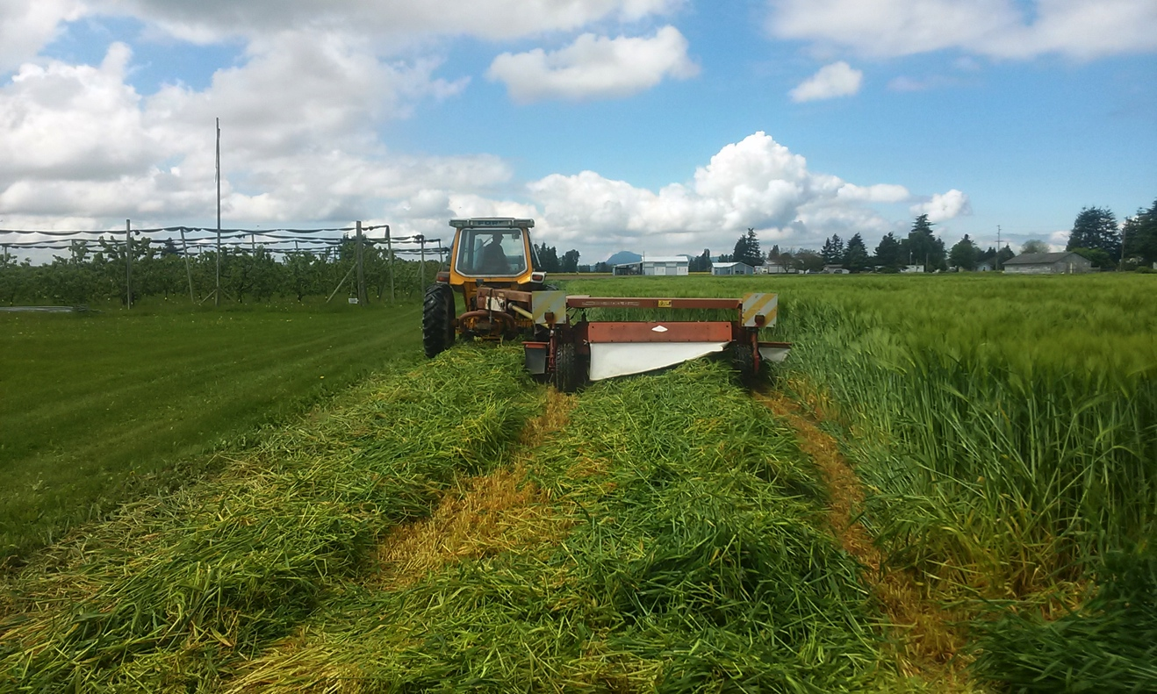
Figure 1. Mowing Alba field May 17, 2013 at WSU Mount Vernon, WA

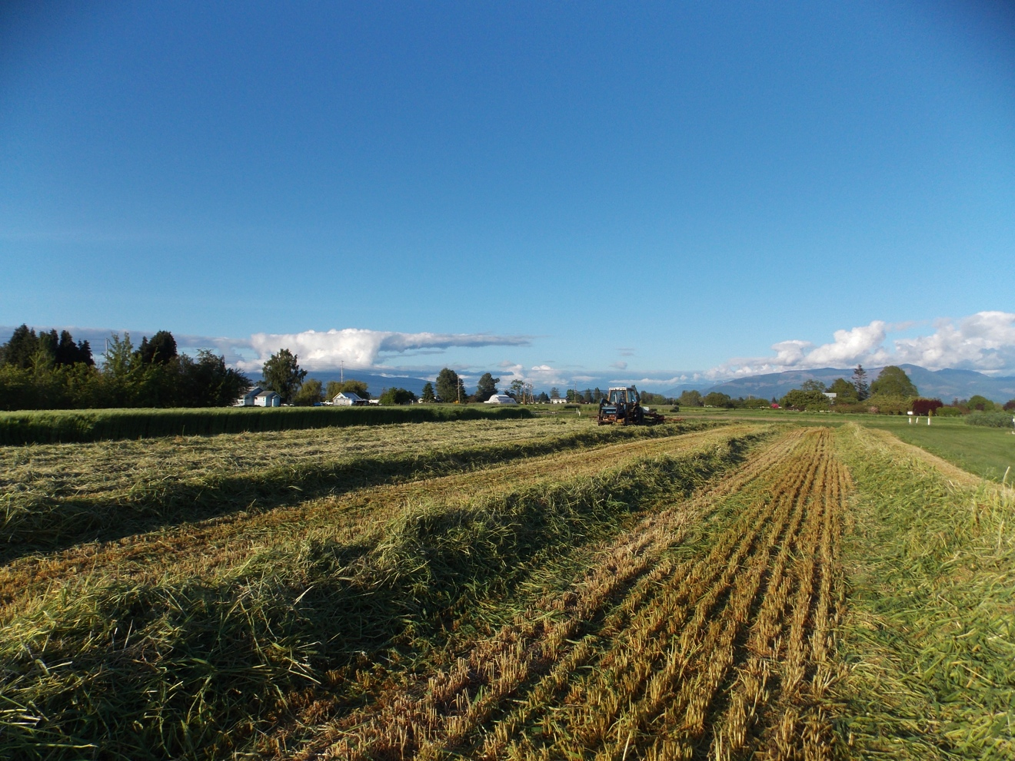
Figure 2. Raking Alba field May 19, 2013 at WSU Mount Vernon, WA

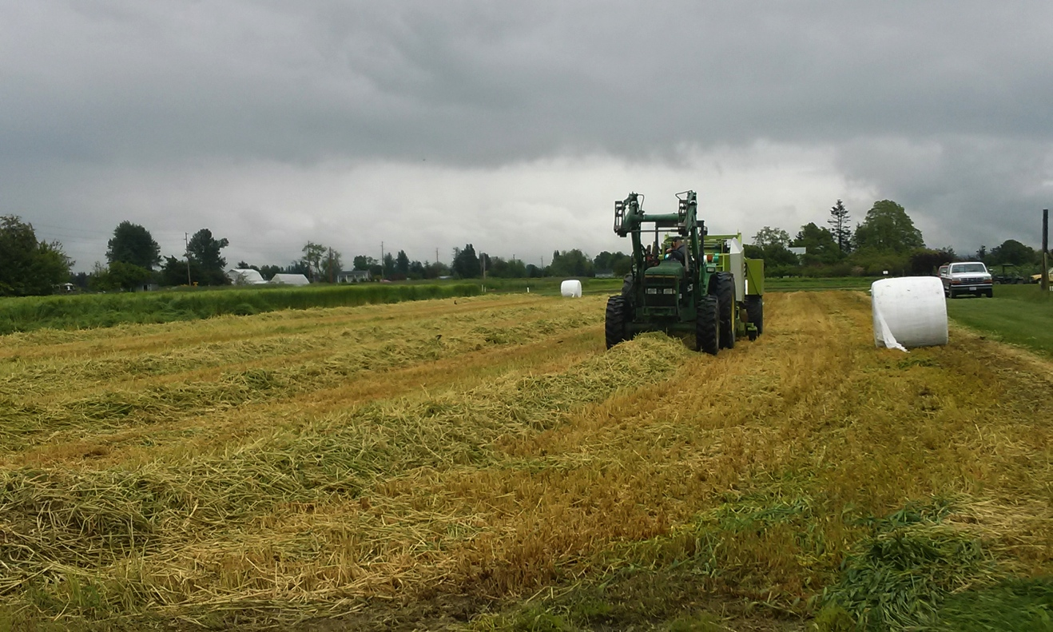
Figure 3. Baling Alba field May 21, 2013 at WSU Mount Vernon, WA

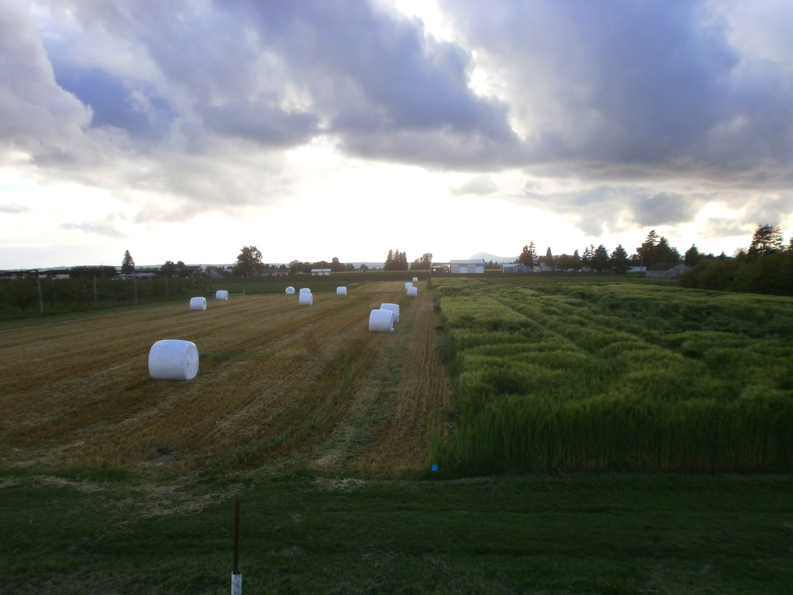
Figure 4. Harvest Alba field on left adjacent to unharvest stand on right, May 21, 2013 at WSU Mount Vernon, WA

