Flavor Report
April, 2017

Flavor Papers update: I know you are all waiting for the final and definitive flavor papers. But hang on.....we’re still tweaking and polishing. It will be worth the wait, so please work on building that thirst for true flavor facts....Here’s a graphical taste of what GenStat software and our collaborations with those top shelf statistical geneticists in Spain (Ignacio) and Scotland (Bill) can brew up.
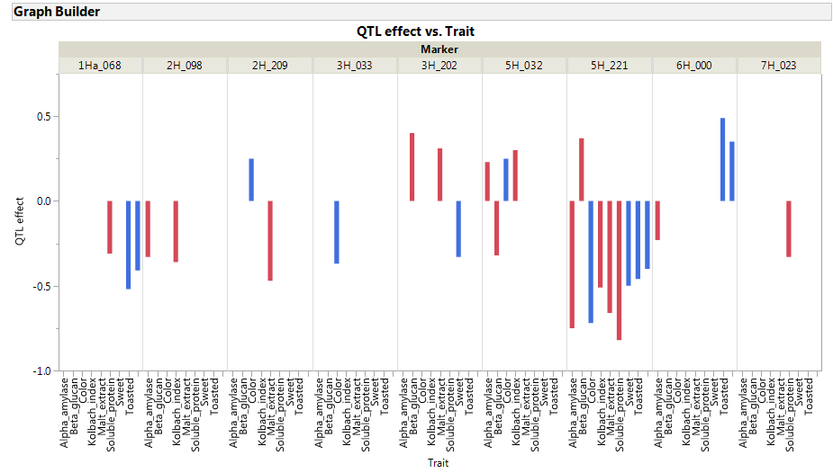
Take-home: there are regions of the barley genome where there are genes affecting just flavor traits, regions where there are genes affecting just malting quality traits, and regions where there are genes simultaneously affecting flavor and malting quality traits. Lots to talk about at CBC and beyond!
The Flavor Fields Forever trial is going into the ground....Lebanon and Madras (Oregon that is) are planted – check out the planting video on Instagram at #barleyworld.
Flavor Pack it is and will be - recognizing that membership will evolve: Your votes and guidance on this topic much appreciated. Many thanks to John Mallet and Bell’s for being there from the beginning and on through 2015. Next time you see John, buy him a flavorful pint and thank him for his generous support and enthusiasm. Given the opportunities and challenges ahead, your active recruitment of new Flavor Pack members is essential. Tell them what we have done, what we are doing, and what we would like to do – together. Then please put them in touch with me for details on how to make it happen.
Favorite topic: Barley flavor now in print and infiltrating a Wheat Magazine - page 11. http://www.owgl.org/wp-content/uploads/2011/07/April-2017-OW-Web-Copy.pdf

Barley Day: Corvallis, OR (or environs). May 18, in the PM. Come see flavor in the making and your contributions at work!

Cheers!!!!

Pat and the Barley (Flavor) Team

