**November 2015 Flavor Report**

**Dustin Herb, Patrick Hayes, and the OSU Barley Project**

***New Glarus update:*** Oregon Promise agronomic and random selections (2014 crop) have been nano-brewed and flavor-profiled at New Glarus Brewing Co. Results reveal unique flavors in both agronomic and random selections. The sensory descriptors for particularly exciting lines are shown in the table below, along with malting quality and agronomic data. Please see the Holiday Special Report posted at ww.barleyworld.org for all data. These exciting lines identified by New Glarus, plus the parents, are at the top of the list for inclusion in field trials in 2015.

***Rahr update:*** The Oregon Promise doubled haploids grown at three Oregon locations in 2015 (Corvallis, Lebanon, Madras; 125 samples in total) have been nano-brewed and bottled. Nano-brew sensory and GC-MS analysis will be performed starting December 7th. High beta-glucan samples are currently being re-malted and will be brewed December 1st. Nano-brew sensory of those samples will be finished the week of January 3rd.

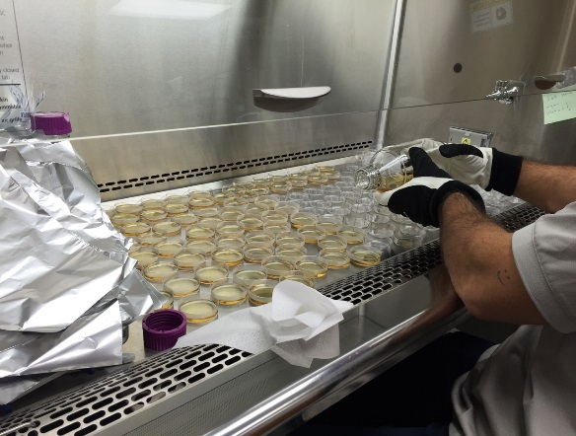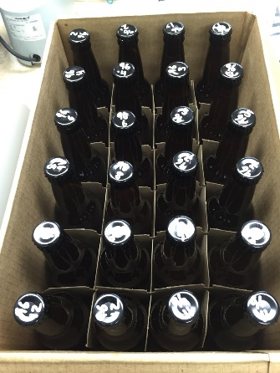

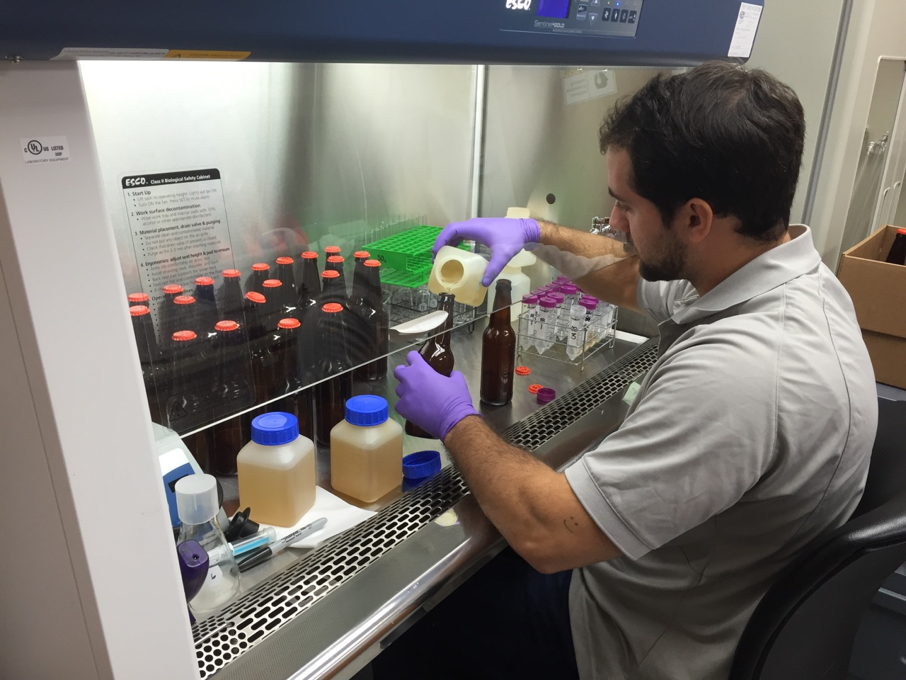

The Rahr projects will enable assessment of 1) genotype x environment interaction for beer flavor (same doubled haploids grown at 3 locations), 2) beer flavor difference between under-modified and well-modified malts in regards to high beta-glucans (same doubled haploids malted/brewed differently), 3) assessment of the presence and effect of water uptake and/or dormancy on beer flavor, and the development of optimized malting protocols for this research germplasm.

***BOBB update:*** Malting at Big Sky Malting of Building the Oregon Barley Brand (BOBB) project samples (high-, medium-, and low-nitrogen rates; 5 varieties; 3 locations; 4 replications) has begun and pico-brewing will start soon. Flavor assessment of beers will be performed by the Beer Judge Certification Program (BCJP) participants AND additional panels, such as Flavor 6-pack members. **Interested?**

Full Pint and Copeland BOBB samples will be malted, brewed, and assessed by sensory panels (each variety under-modified, modified, and over-modified) at the CMBTC. **Beer will be available for sensory with the Flavor 6-Pack…. Interested?**

***News:*** Dustin will be travelling to the Farmer Brewer Winter Workshop (FBWW) with Valley Malt to present on the past, present, and future of the OSU flavor project. Looking forward to seeing any/all of you there.

A flavor project abstract has been submitted for presentation at the International Barley Genetics Symposium (IBGS) annual meeting in June.

***Everyone is welcome to visit the OSU Barley Project at any time.***

***Cheers!***

