Stripe rust NACA report, 2016 harvest.
The barley stripe rust screening trial
Corvallis, OR; Davis, CA; Pullman, WA; and Mt Vernon, WA

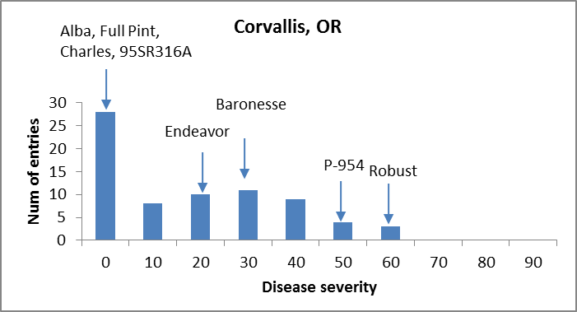

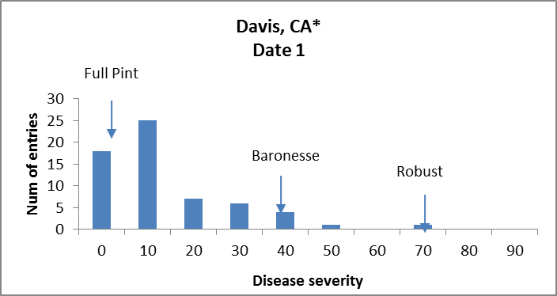

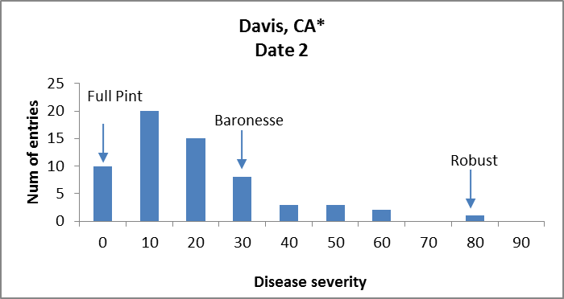

* @ Davis, CA only three checks included.
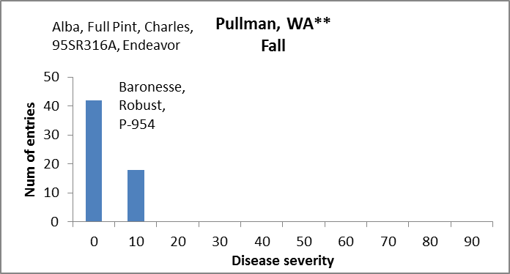

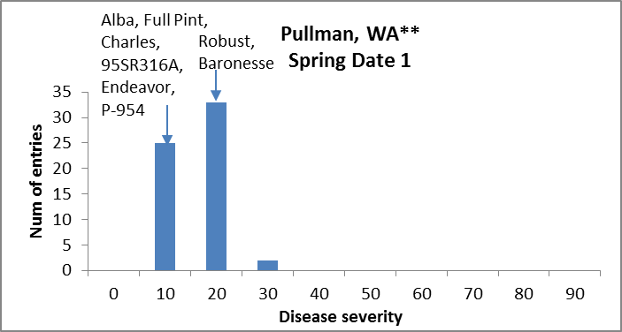

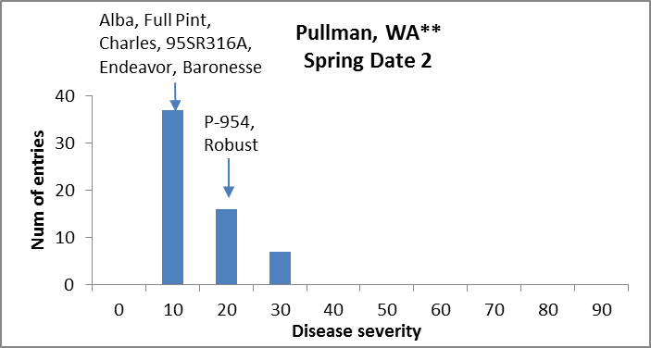

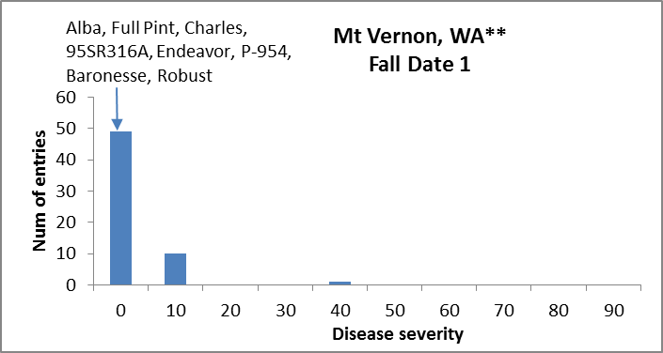

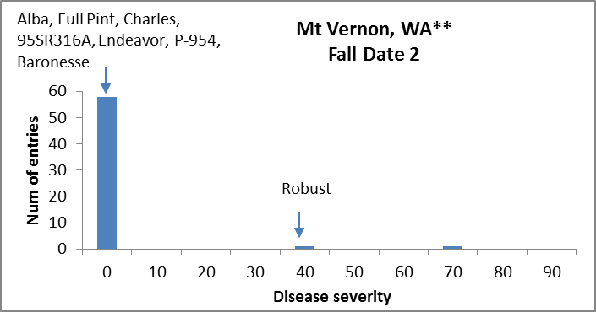

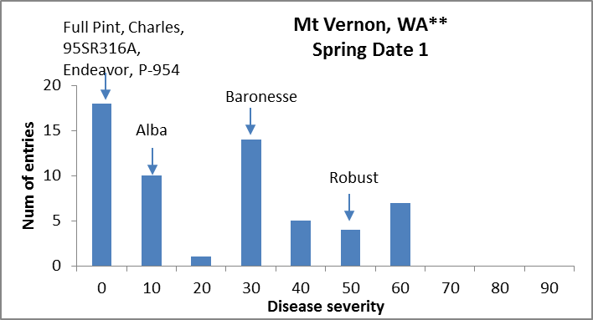

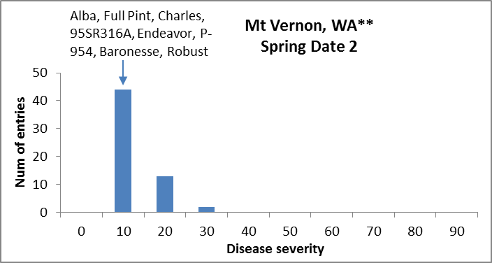

** All WA trials were not replicated.

BSRST - ANOVAS

Corvallis, OR
Df Sum Sq Mean Sq F value Pr(>F)
Line 72 1.76406 0.0245009 6.4230 4.133e-15 ***
Rep 1 0.00006 0.0000553 0.0145 0.9044
Residuals 82 0.31279 0.0038146
---
Signif. codes: 0 ‘***’ 0.001 ‘**’ 0.01 ‘*’ 0.05 ‘.’ 0.1 ‘ ’1
H_{b} = 0.84

Davis, CA Date 1
Df Sum Sq Mean Sq F value Pr(>F)
Line 62 0.90702 0.014629 2.340 0.000509 ***
Rep 1 0.06313 0.063132 10.098 0.002315 **
Residuals 62 0.38762 0.006252
---
Signif. codes: 0 ‘***’ 0.001 ‘**’ 0.01 ‘*’ 0.05 ‘.’ 0.1 ‘ ’1
H_{b} = 0. 57

Davis, CA Date 2
Df Sum Sq Mean Sq F value Pr(>F)
Line 62 1.13936 0.018377 2.1454 0.001548 **
Rep 1 0.09767 0.097673 11.4027 0.001271 **
Residuals 62 0.53108 0.008566
---
Signif. codes: 0 ‘***’ 0.001 ‘**’ 0.01 ‘*’ 0.05 ‘.’ 0.1 ‘ ’1
H_{b} = 0.53

