Stripe rust NACA report, 2016 harvest
The multi-rust resistance Cycle 1 population
Corvallis, OR; Davis, CA; Pullman and Mt Vernon, WA

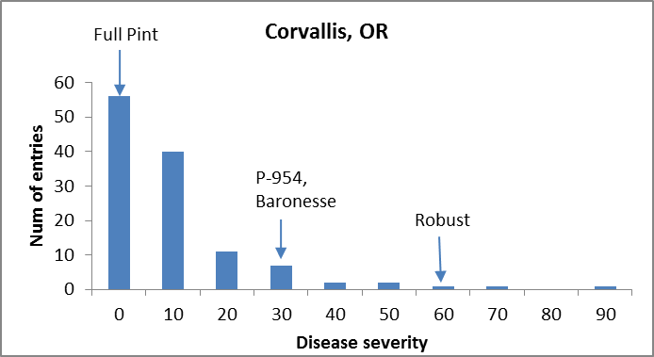

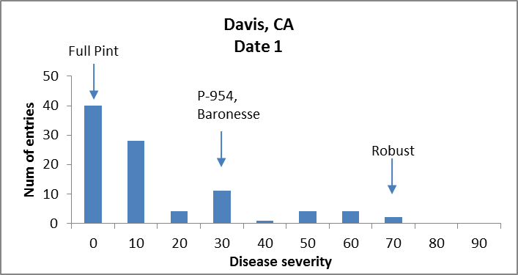

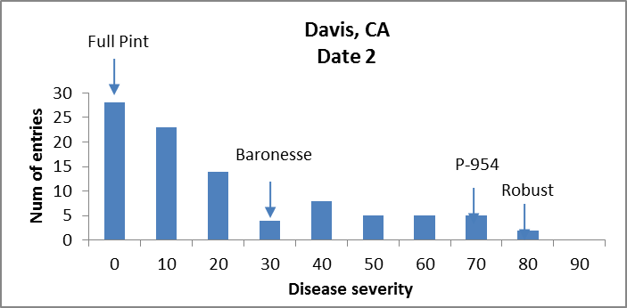
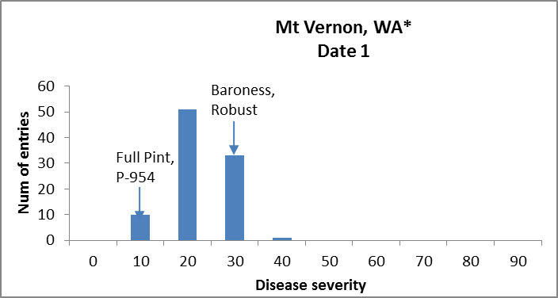

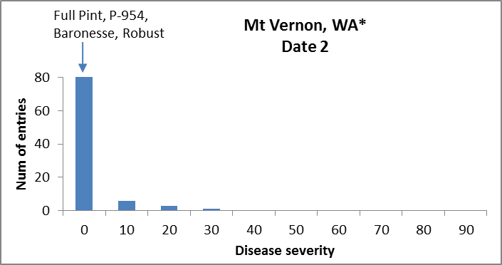

* @ Mt Vernon, WA trials were not replicated.

Multi-rust – ANOVAS

Corvallis, OR
Df Sum Sq Mean Sq F value Pr(>F)
Line 120 1.69418 0.0141182 8.2674 <2e-16 ***
Rep 1 0.00134 0.0013359 0.7823 0.3782
Residuals 120 0.20492 0.0017077
---
Signif. codes: 0 ‘***’ 0.001 ‘**’ 0.01 ‘*’ 0.05 ‘.’ 0.1 ‘ ’
H_{b} = 0.87

Davis, CA Date 1
Df Sum Sq Mean Sq F value Pr(>F)
Line 93 2.05362 0.022082 4.5686 1.330e-12 ***
Rep 1 0.08135 0.081348 16.8303 8.756e-05 ***
Residuals 93 0.44951 0.004833
---
Signif. codes: 0 ‘***’ 0.001 ‘**’ 0.01 ‘*’ 0.05 ‘.’ 0.1 ‘ ’
H_{b} = 0.78

Davis, CA Date 2
Df Sum Sq Mean Sq F value Pr(>F)
Line 93 2.81104 0.030226 4.5771 1.257e-12 ***
Rep 1 0.05730 0.057298 8.6766 0.004072 **
Residuals 93 0.61415 0.006604
---
Signif. codes: 0 ‘***’ 0.001 ‘**’ 0.01 ‘*’ 0.05 ‘.’ 0.1 ‘ ’1
H_{b} = 0.78

