AMBA-LTT Report

Javier Hernandez, Tanya Filichkin, Scott Fisk, Laura Helgerson, and Patrick Hayes*

P. Stephen Baenziger, Lucia Gutierrez Jamie Sherman, Kevin Smith, Mark Sorrells, and Eric Stockinger

* all OSU (OR); UNL-Lincoln (NE), UW-Madison (WI), MSU (MT), UMN, Cornell (NY), OSU-Wooster (OH)

Rationale:
Climate change is making spring-planted barley production a challenge. Fall planting is an attractive approach because in many environments, fall-planted crops can achieve greater water use efficiency and escape late season heat stress. However, low temperature tolerance (LTT) is required for many of these fall-planted environments. Winter growth habit germplasm, which is sensitive to vernalization, is usually used for fall-planting because it can achieve maximum LTT. Because facultative types can have the same LTT as winter types, they can be fall-planted. Because they are not vernalization sensitive, they can be spring planted. This flexibility in planting date can be an advantage. Malting quality adds value to barley. Without the malting premium, it can be unprofitable to raise barley.

Objective:
This project was directed at developing germplasm with maximum LTT and facultative growth habit in genetic backgrounds with potential of achieving malting quality.

The germplasm:
Winter and facultative parents were selected from the TCAP-LTT panel and crossed with winter and facultative advanced lines and varieties. Doubled haploids were produced from these crosses. Only the 382 2-rows were selected for continued assessment.

LTT and VRN sensitivity phenotyping:
LTT was assessed as winter survival (WS) on a plot basis in field trials at six locations during the (2017/18 and 2018/19) growing seasons. A Type II augmented design with one replication was used at all locations. Thunder (tested as 10.077) was the winter and primary check. Lightning, (tested as DH130910) was the facultative and secondary check. Full Pint was spring and tertiary check. For vernalization sensitivity, lines were evaluated for vernalization requirement under greenhouse conditions by planting each line without exposure to cold treatment (vernalization). Days to flowering was evaluated in all lines. Lines that did not flowered 150 days after planting, were scored as winter and assigned a value of 150.

Disease assessment procedures:
Disease susceptibility was measured using severity for the principal diseases present at Corvallis, OR. A Randomized Complete Block Design with two replications and three checks – Thunder, Lightning, and Full Pint was used. Severity (Sev) was scored as percentage of leaf area infected with stripe rust (incited by Puccinia striiformis f. sp. hordei). Natural infection was supplemented with artificial inoculation. Disease severity was scored, as percent of plot canopy infected, for scald (SC, incited by Rhynchosporium commune) and (LR, incited by Puccinia hordei).

Data:
Please see https://barleyworld.org/low-temperature

Funding:
Support provided by American Malting Barley Association for facultative growth habit, low temperature tolerance and malting quality research.

This report:
In this report, we provide information and interpretation for WS, BSR and other diseases across locations evaluated

AMBA-LTT 2018 – Nebraska, New York and Virginia data

Winter survival in Nebraska (NB), New York (NY), and Virginia (VA)

Phenotypic frequency distributions
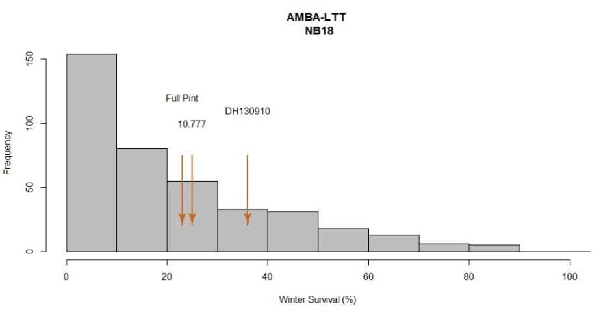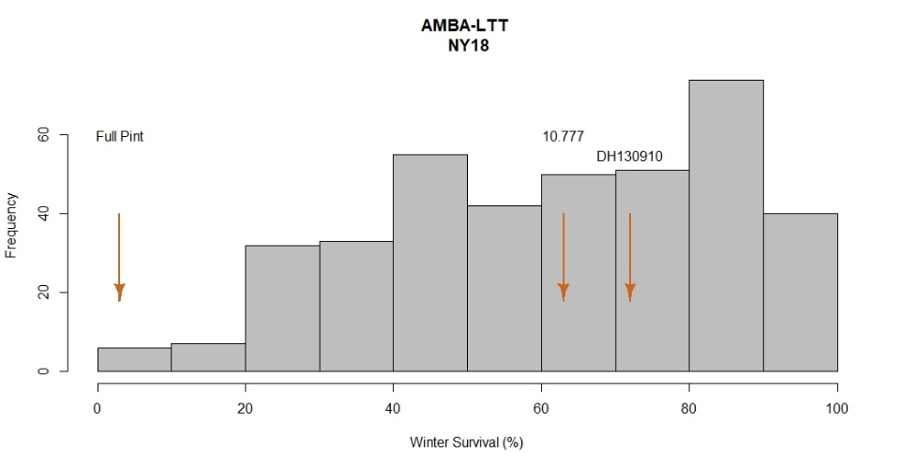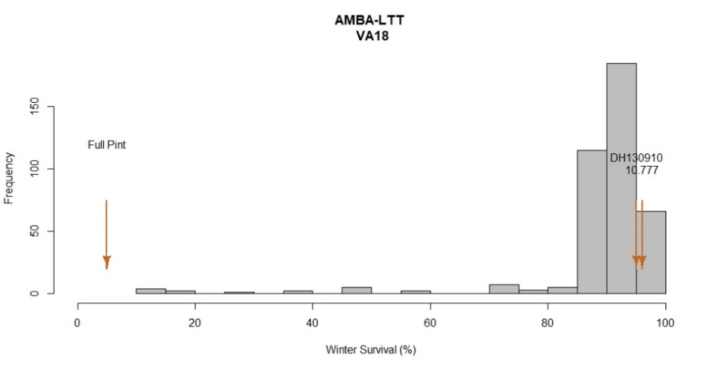

AMBA-LTT 2018 – Oregon data
Reaction to BSR, SC and LR at the adult plant stage; Corvallis, OR

Phenotypic frequency distributions

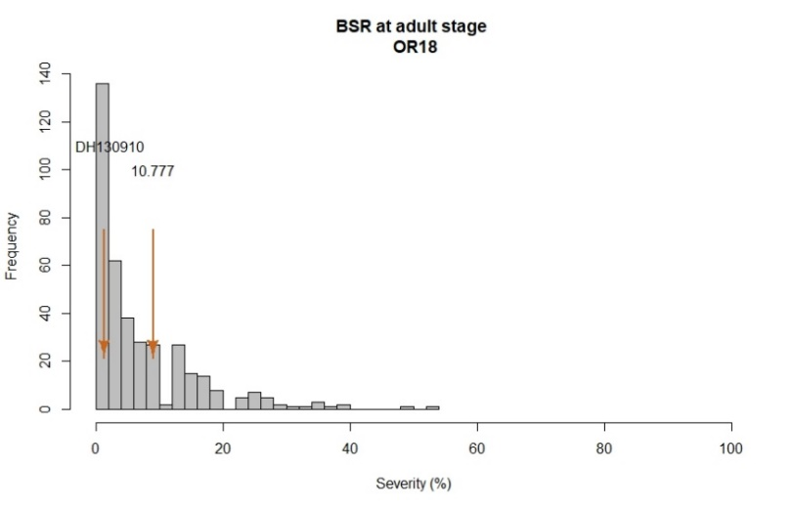
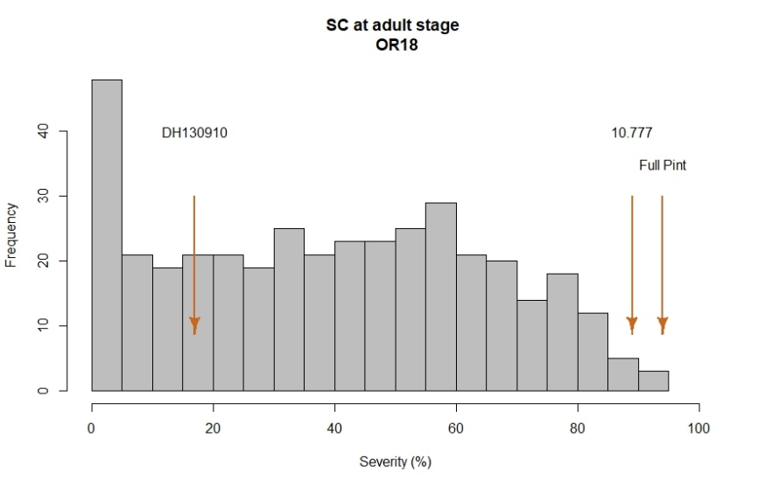
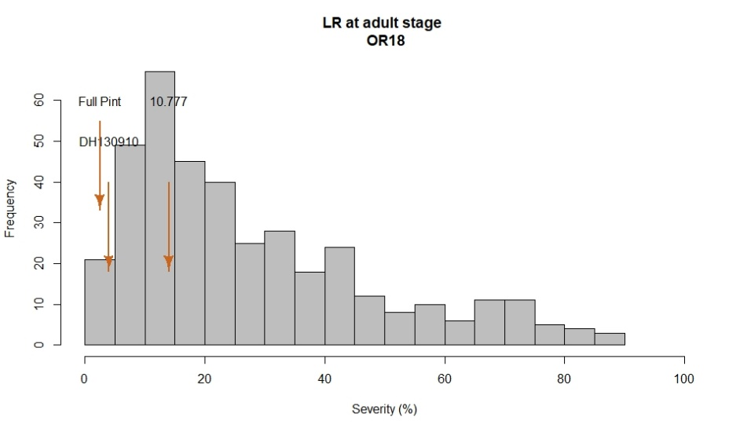

VRN sensitivity under greenhouse conditions

Phenotypic frequency distributions
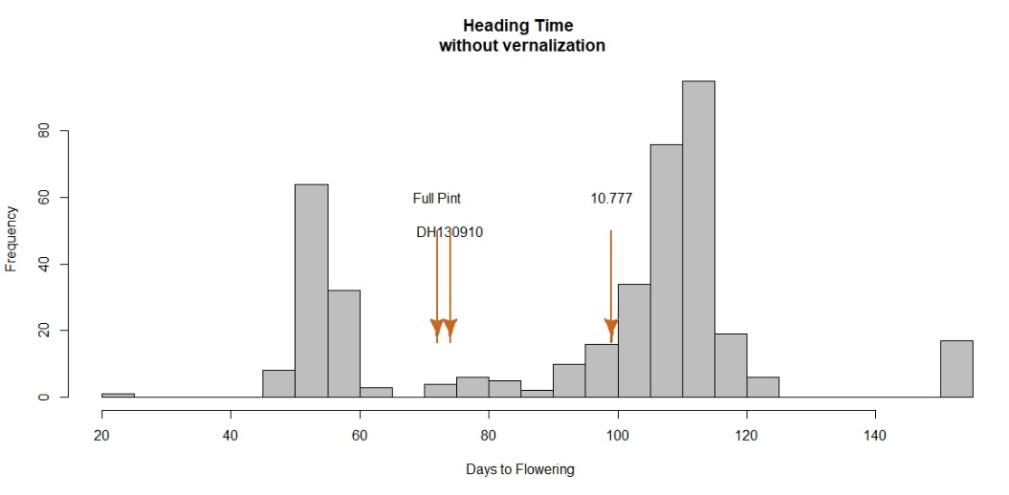

2018 Field Evaluations
Winter survival
In the 2017/18 season, two out of six locations were not informative (0% and 100% surviving in MN and OR, respectively). In one location (OH) almost all lines survived the winter, so there was limited variation. Histograms are based on sites that were informative for WS (NY, NB, and VA). At all locations, Lightning (Facultative), Full Pint (Spring), and Thunder (Winter) were used as checks and exhibited a range of WS values.

The spring check Full Pint exhibited the lowest WS values across test sites. The facultative check Lightning, and the winter check Thunder exhibited high survival values across locations. There was greater phenotypic variation in the NB and NY data than in the VA data. There were progeny with higher levels of WS than Lightning and Thunder.

Vernalization sensitivity
Flowering time in lines without vernalization was recorded in the whole population under greenhouse conditions during 2018. Based on frequency distribution plot, two groups of lines were observed. The first group is comprised of lines with flowering times between 40 to 70 days after planting. Within this group, both checks Full Pint (spring) and Lightning (facultative) showed similar flowering times: 72 and 74 days respectively. The second group included lines with flowering times between 70 and 125 days after planting. The winter check Thunder flowered 99 days after planting. Lines that did not flower during the evaluation frame time were scored as flowering at 150 days.

Disease resistance
The frequency distribution for BSR was skewed to the left meaning a large number of lines exhibited low severity values. Checks Thunder and Lightning had low severity, with 9.1 and 1.3%, respectively. 291 lines had disease severities of 10% or less, whereas just 4 lines were rated with severity values > to 40%.

There was variation for SC with 50% of lines having severity values ranging from 17.5 to 60.0%. Checks Full Pint and Thunder were susceptible, with severities of 94 and 89%, respectively. Lightning was moderately resistant with a severity of 17.7%. For LR, observed with 50% of lines exhibiting severity values between 12.5 and 40%. Full Pint was the most resistant, with a severity of 2.5%, followed by Lightning with 4% and Thunder with 14.1%.

Analysis of variance for BSR, SC and LR

BSR OR18
Severity Date 1
Df Sum Sq Mean Sq F value Pr(>F)
Line 382 60167 157.5 1.977 2.12e-11 ***
Rep 1 2376 2375.7 29.826 8.53e-08 ***
Residuals 382 30428 79.7
---
Signif. codes: 0 ‘***’ 0.001 ‘**’ 0.01 ‘*’ 0.05 ‘.’ 0.1 ‘ ’ 1

SC OR18
Severity Date 1
Df Sum Sq Mean Sq F value Pr(>F)
Line 382 499481 1308 3.467 < 2e-16 ***
Rep 1 16102 16102 42.700 2.04e-10 ***
Residuals 382 144050 377
---
Signif. codes: 0 ‘***’ 0.001 ‘**’ 0.01 ‘*’ 0.05 ‘.’ 0.1 ‘ ’ 1

LR OR18
Severity Date 1
Df Sum Sq Mean Sq F value Pr(>F)
Line 382 323335 846 3.737 <2e-16 ***
Rep 1 18329 18329 80.929 <2e-16 ***
Residuals 382 86517 226
---
Signif. codes: 0 ‘***’ 0.001 ‘**’ 0.01 ‘*’ 0.05 ‘.’ 0.1 ‘ ’ 1

Correlation of VRN sensitivity and WS across sites
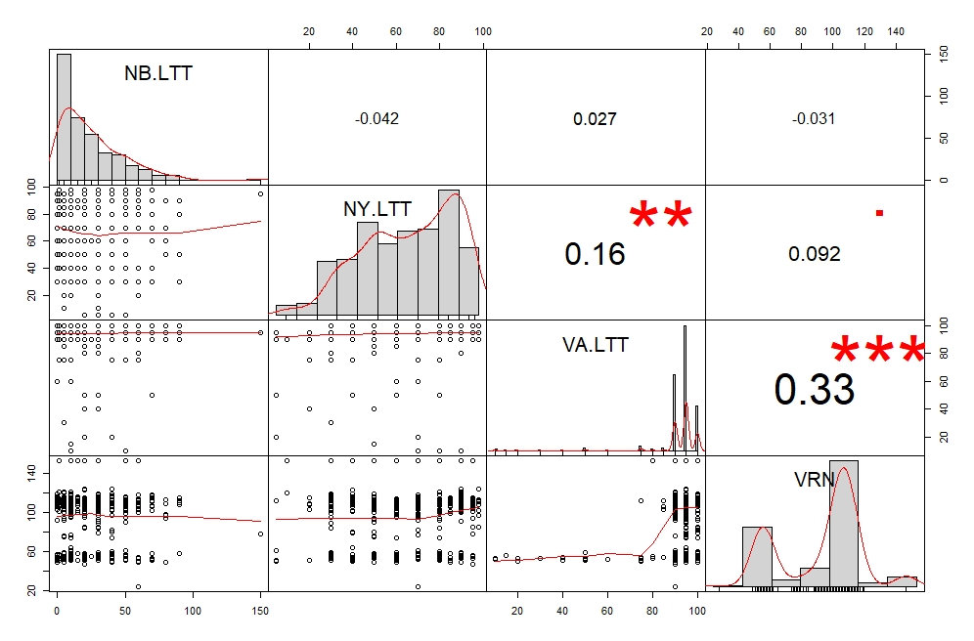

Correlation between BSR, SC, and LR in Corvallis, OR.
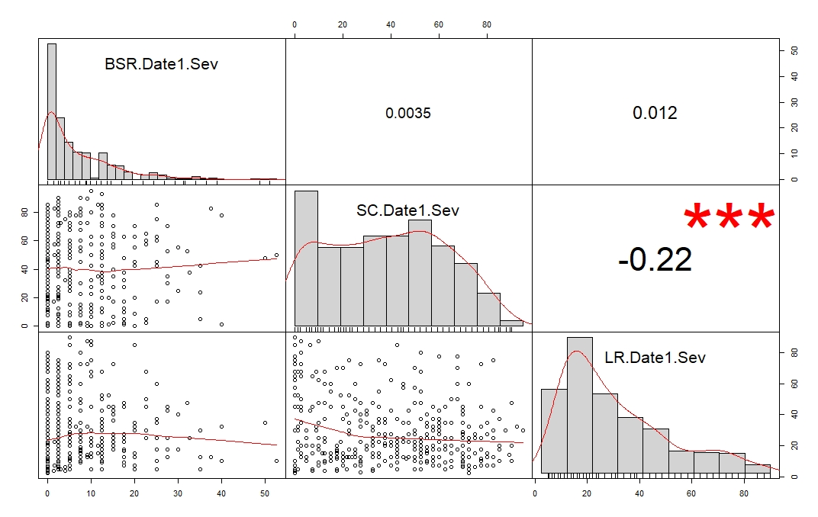

LSD test for diseases

Please see LSD test AMBA-LTT at https://barleyworld.org/barley-stripe-rust-bsr
AMBA-LTT 2019 – Wisconsin, Montana and Ohio

Winter survival in Wisconsin (WI), Montana (MT), and Ohio (OH)

Phenotypic frequency distributions

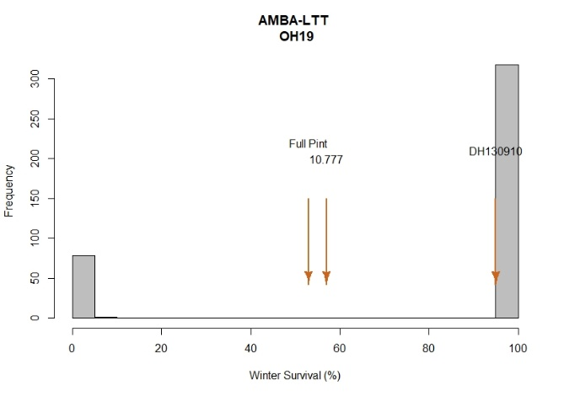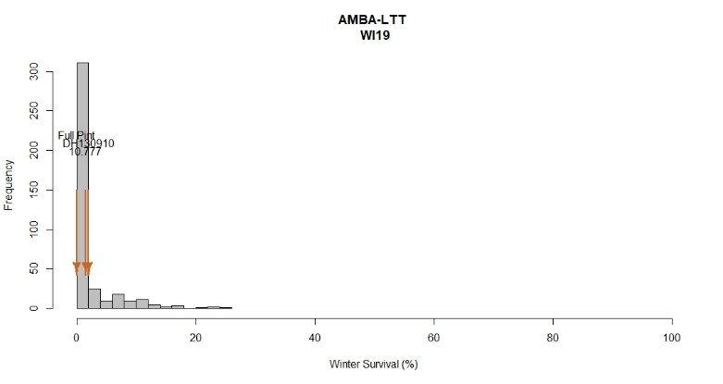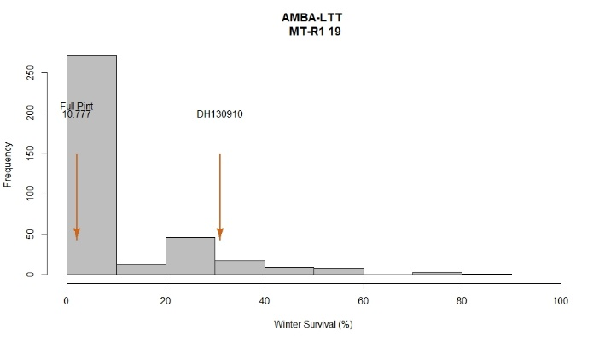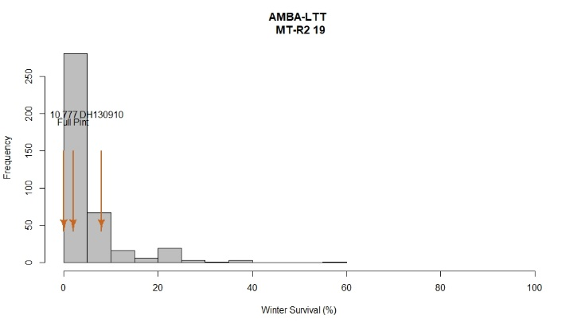

AMBA-LTT 2018 – Oregon data

Reaction to BSR, SC and LR at adult plant stage; Corvallis, OR

Phenotypic frequency distributions

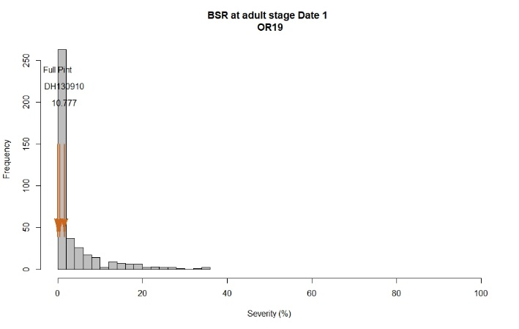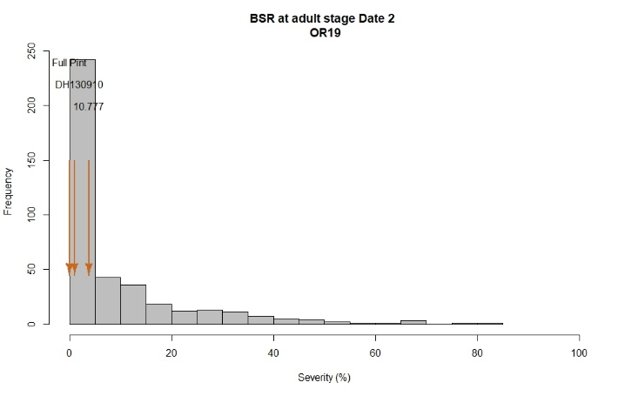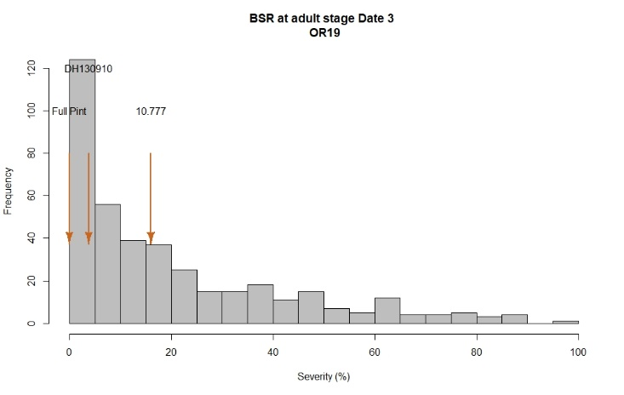
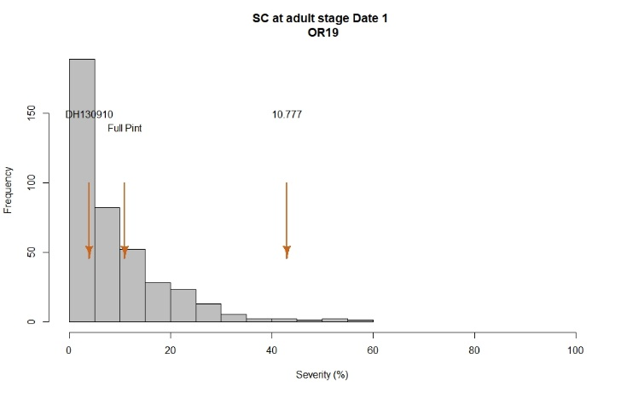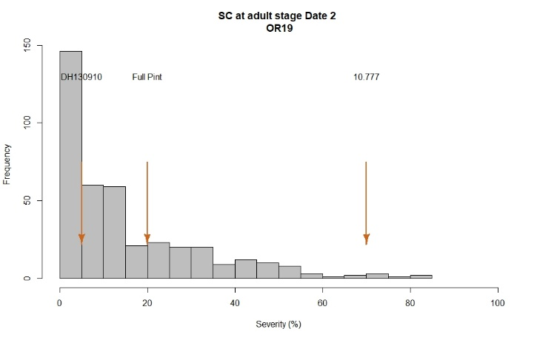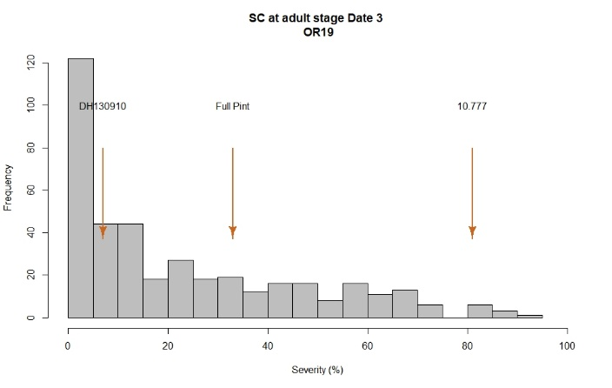
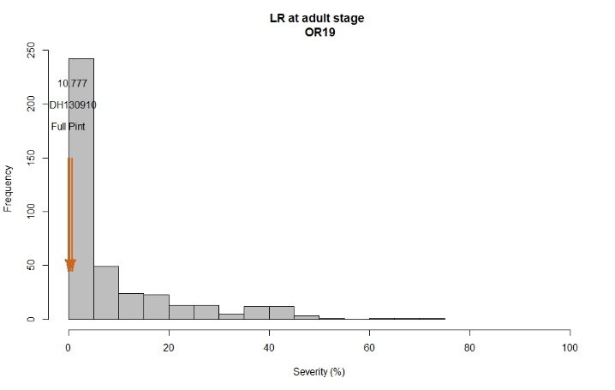

2019 Field Evaluations

Winter survival
The nurseries for low temperature tolerance were evaluated using winter survival as the percentage of plants that survived winter on a plot basis. During the 2018/19 season, three out of six locations were not informative (0% surviving MN/NB and 100% surviving OR). Histograms are based on sites that were informative for WS (WI, OH, and MT). At all locations, Lightning (Facultative), Full Pint (Spring), and Thunder (Winter) were used as checks and exhibited a range of WS.

The spring check Full Pint exhibited the lowest WS values across tested sites. The facultative variety Lightning and the winter variety Lightning varied in survival across test sites. Analyzing separately these three locations, WI and MT exhibited phenotypic variation among tested lines. OH was split into two groups, 100% survival and lines with WS between 0-5%. Among tested sites, there were lines exhibiting higher WS scores compared to checks Lightning and Thunder.

Disease resistance
The barley stripe rust nurseries were evaluated using severity in Corvallis, OR. Severity was scored as percentage of leaf area affected with stripe rust in a plot basis. Disease notes were taken after all plots reached end of heading.

At Corvallis, a range of phenotypic variation was observed among lines and across dates.
Histogram for BSR was slightly skewed to the left, meaning a large number of lines exhibiting low severity values at this location. Checks Full Pint, Thunder and Lightning exhibited low severity values with 0, 16 and 0.5%, respectively.

A total of 219 lines exhibited 10% or less disease severity, whereas 82 lines were rated with severity values > to 40%. 50% of lines at this location exhibited severity values between 4-32.5%.

Scald (SC) and Leaf Rust (LR) were evaluated at Corvallis during 2018/19 season. The AMBA-LTT trial exhibited a variation for SC with 50% of lines exhibiting severity values ranging from 4 to 40%. Checks Full Pint and Thunder exhibited susceptible values of 33 and 81%, respectively. Lightning was moderate resistant with severity of 7.7%. For LR, a moderately spread of data was observed, as 291 lines exhibited values < than 10% and 50% of lines exhibited severity values between 0 and 12.5%. All checks exhibited 0% of severity.

Analysis of variance for BSR, SC and LR
BSR OR19
Severity Date 1
Df Sum Sq Mean Sq F value Pr(>F)
Line 395 30999 78.48 2.206 4.3e-15 ***
Rep 1 154 153.79 4.323 0.0382 *
Residuals 395 14052 35.57
---
Signif. codes: 0 ‘***’ 0.001 ‘**’ 0.01 ‘*’ 0.05 ‘.’ 0.1 ‘ ’ 1
Severity Date 2
Df Sum Sq Mean Sq F value Pr(>F)
Line 395 156535 396.3 3.421 < 2e-16 ***
Rep 1 1073 1073.3 9.266 0.00249 **
Residuals 395 45754 115.8
---
Signif. codes: 0 ‘***’ 0.001 ‘**’ 0.01 ‘*’ 0.05 ‘.’ 0.1 ‘ ’ 1
Severity Date 3
Df Sum Sq Mean Sq F value Pr(>F)
Line 395 379994 962 4.689 < 2e-16 ***
Rep 1 10943 10943 53.340 1.56e-12 ***
Residuals 395 81039 205
---
Signif. codes: 0 ‘***’ 0.001 ‘**’ 0.01 ‘*’ 0.05 ‘.’ 0.1 ‘ ’ 1

SC OR19
Severity Date 1
Df Sum Sq Mean Sq F value Pr(>F)
Line 395 75454 191.02 3.706 <2e-16 ***
Rep 1 26 26.18 0.508 0.476
Residuals 395 20358 51.54
---
Signif. codes: 0 ‘***’ 0.001 ‘**’ 0.01 ‘*’ 0.05 ‘.’ 0.1 ‘ ’ 1
Severity Date 2
Df Sum Sq Mean Sq F value Pr(>F)
Line 395 226902 574.4 4.081 <2e-16 ***
Rep 1 343 342.7 2.435 0.119
Residuals 395 55601 140.8
---
Signif. codes: 0 ‘***’ 0.001 ‘**’ 0.01 ‘*’ 0.05 ‘.’ 0.1 ‘ ’ 1
Severity Date 3
Df Sum Sq Mean Sq F value Pr(>F)
Line 395 430127 1088.9 3.724 < 2e-16 ***
Rep 1 2213 2213.4 7.570 0.00621 **
Residuals 395 115494 292.4
---
Signif. codes: 0 ‘***’ 0.001 ‘**’ 0.01 ‘*’ 0.05 ‘.’ 0.1 ‘ ’ 1

LR OR19
Severity Date 1
Df Sum Sq Mean Sq F value Pr(>F)
Line 395 142320 360.3 2.936 <2e-16 ***
Rep 1 527 526.9 4.293 0.0389 *
Residuals 395 48482 122.7
---
Signif. codes: 0 ‘***’ 0.001 ‘**’ 0.01 ‘*’ 0.05 ‘.’ 0.1 ‘ ’ 1

Correlation of VRN sensitivity and WS across sites

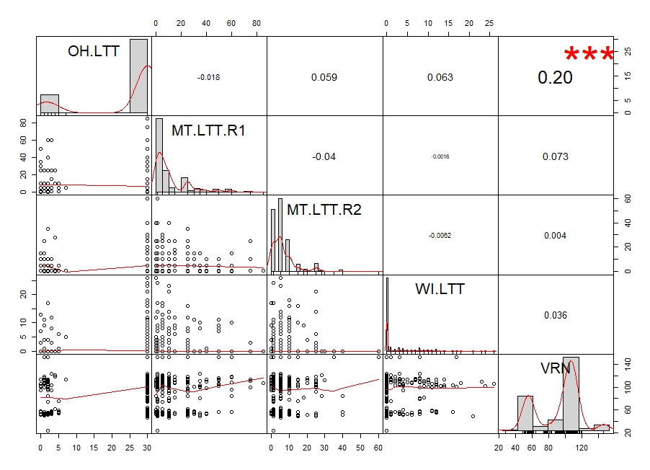

Correlation among dates for BSR, SC and LR
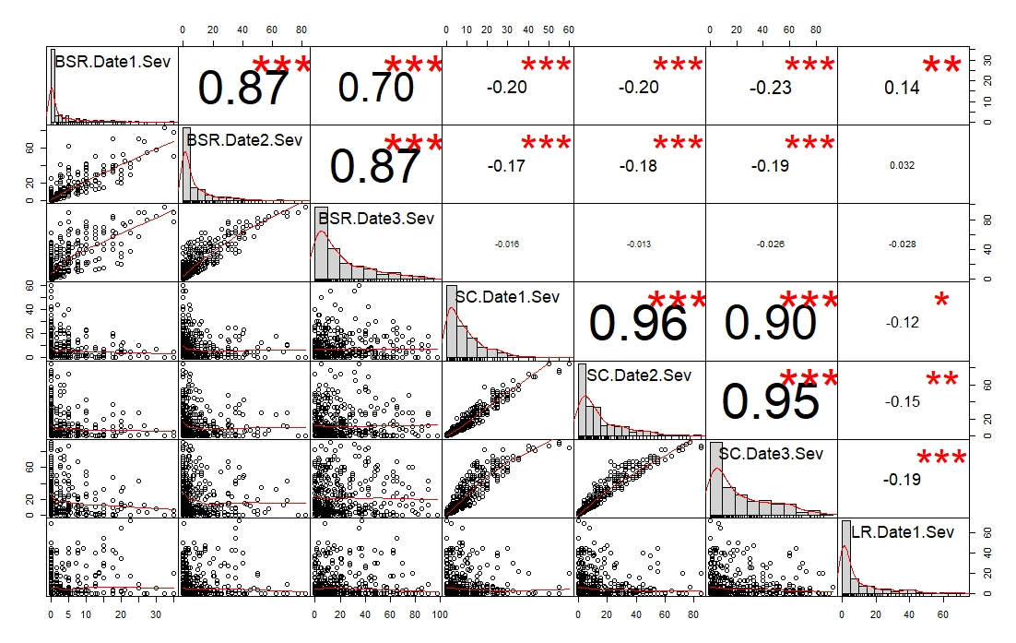

LSD test for dates and diseases

Please see LSD test AMBA-LTT at https://barleyworld.org/barley-stripe-rust-bsr
BLUPs for WS across locations

The best linear unbiased predictions (BLUPs) for each line across six locations – Nebraska, New York, and Virginia in 2018; and Ohio, Montana and Wisconsin in 2019 - for winter survival, expressed as percentage (%) of lines that survived the winter in a plot basis, were obtained and plotted in the following histogram. A range of phenotypic variation was observed among lines when all environments were included in the same model. The facultative check Lightning exhibited the highest surviving rate with 43.2%, followed by Thunder with 40.2% and Full Pint (35.2%). The heritability for winter survival was 5%. This low value was due to the large variation in winter survival across the test sites: 65% of the total phenotypic variation was attributed to environments.

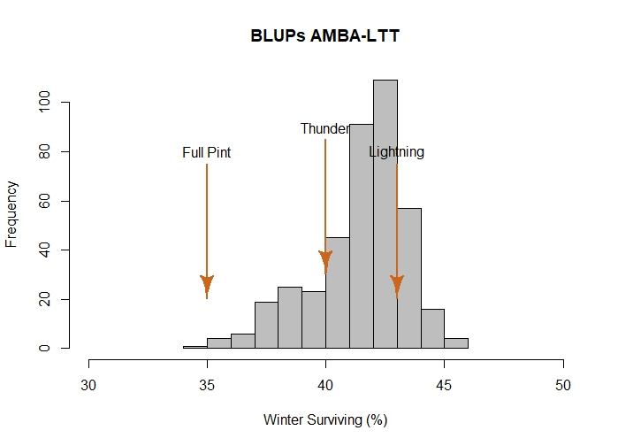

BLUPs for BSR across environments (OR18 and OR19)

The best linear unbiased predictions (BLUPs) for each line across two environments - Corvallis 2018 and Corvallis 2019 - for disease severity at adult plant stage, expressed as
percentage (%) of leaf area affected with barley stripe rust were obtained and plotted in a histogram distribution graphic. A range of phenotypic variation was observed among lines when both environments were included in the same model. The checks Lightning and Full Pint showed the lowest severity values with 6.2% and 4.5%, respectively. The check Thunder showed a slightly higher severity, at 13%. A total of 265 lines exhibited severity values ≤ 15% whereas just seven lines were rated with severity ≥ 40%. The heritability of adult plant resistance was 49%.

Histogram BLUPs

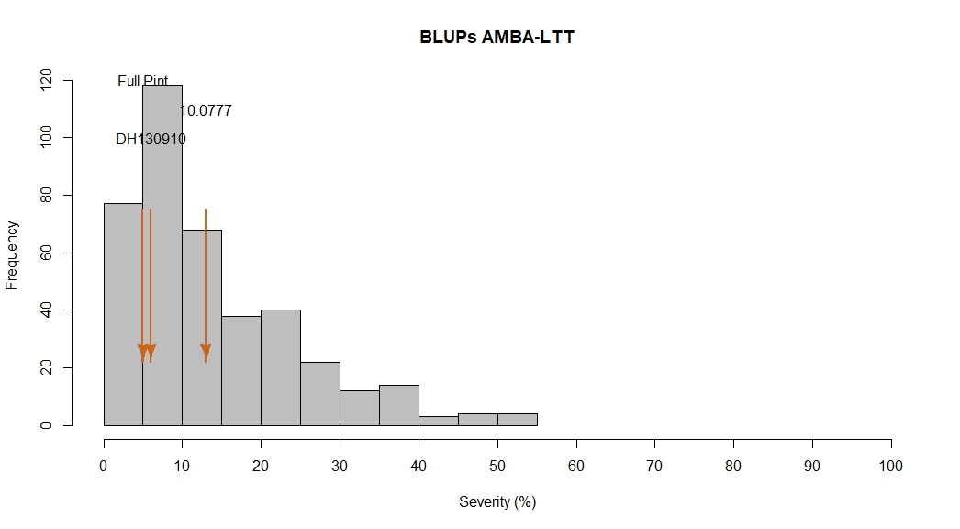

$$H^{2}=0.49$$

