The Barley Stripe Rust Screening Trial (BSRST)

Javier Hernandez, Tanya Filichkin, Scott Fisk, Laura Helgerson, and Patrick Hayes
BarleyWorld. Oregon State University. Corvallis, Oregon, USA.

Germplasm:
The BSRST, in addition to screening current and potential varieties, is a useful monitoring system: by the inclusion of long-term checks, changes in pathogen virulence that affect adult plant resistance can be detected. The BSRST is organized by OSU (with support from the USDA-ARS) via solicitation of accessions from public breeding programs in California, Idaho, Oregon, and Washington. Winter, facultative, and spring growth habit accessions are phenotyped for adult plant resistance at Corvallis, Oregon and Davis, California. It is possible to test germplasm of the three growth habits in fall-planted experiments due to the unique and balancing climatic conditions at Corvallis and Davis. Temperatures at Corvallis are rarely low enough to cause injury to spring growth habit types but they are low enough at Davis to ensure sufficient vernalization of winter growth habit types. In Washington State, simultaneous field testing of the three growth habits is not possible: spring and winter/facultative types are tested in spring-planted and fall-planted trials, respectively. All three growth habits can be tested for seedling resistance under controlled environment conditions.

Stripe rust (and other diseases) - assessment procedures:
Barley stripe rust (BSR, incited by Puccinia striiformis f.sp. hordei) is a serious disease of barley throughout the world. In the US, it is endemic in cooler, wetter areas of the west coast. However, there are an increasing number of reports of stripe rust on barley from other parts of the US and the world. Therefore, continued progress in screening for resistance in current, new, and potential varieties is warranted.

Disease susceptibility was measured for the principal diseases using severity and/or infection type present at Corvallis, OR and Davis, CA. Severity (Sev) was scored as percentage of leaf area affected with the disease on a plot basis, whereas infection type (IT) was recorded according the scale proposed by McNeal et al. (1971). Rust nurseries were evaluated for adult plant resistance to BSR using infection type and severity at Davis, CA and severity at Corvallis, OR. A Randomized Complete Block Design with two replications and five checks – Baronesse, P-954, Thoroughbred, Full Pint and Robust - was used. Natural infection was supplemented with artificial inoculation. Notes on other diseases were recorded as they were present in this trial. In this data set, we also provide information on scald (SC, incited by Rhynchosporium commune), leaf rust (LR, incited by Puccinia hordei) and powdery mildew (PM, incited by Blumeria graminis f. sp. hordei). All diseases were evaluated using severity on a plot basis.

Data:
Please see https://barleyworld.org/barley-stripe-rust-bsr

Fundings:
Support provided by USDA-ARS-NACA 58 2050 6 005 for stripe rust and stem rust research.

This report:
In this report, we provide information and interpretation for BSRST across all locations evaluated.

BSRST 2016 – Oregon and California data

Reaction to barley stripe rust (BSR), powdery mildew (PM) and leaf rust (LR) at adult plant stage; Corvallis, OR and Davis, CA

Histogram distribution for dates and sites

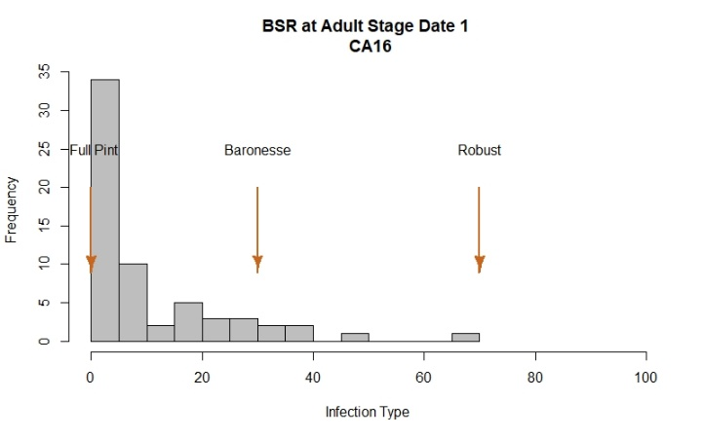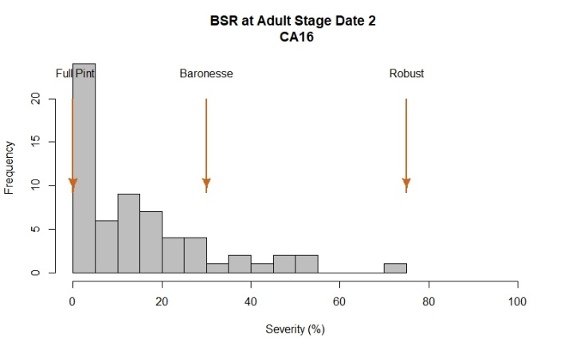

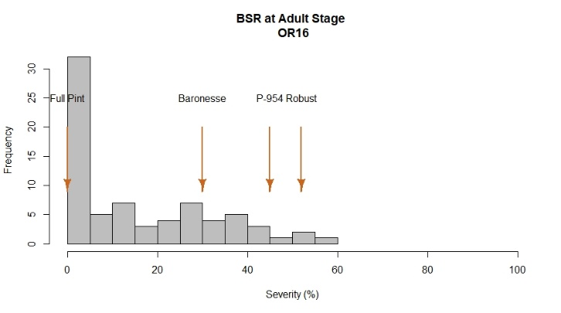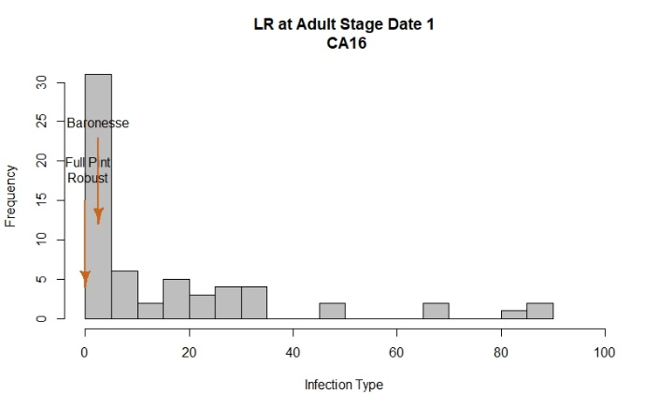

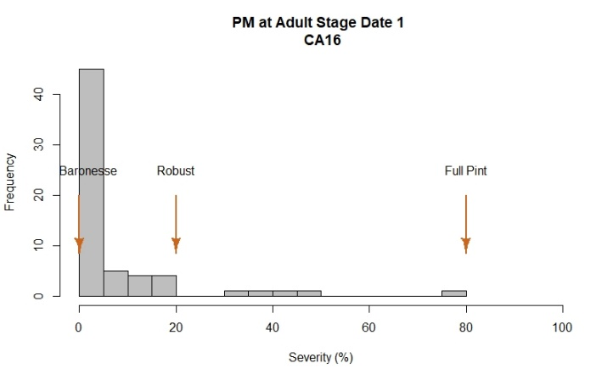

2016 Field Evaluations

The barley stripe rust nurseries were evaluated using severity and infection type at Davis and severity at Corvallis. At Davis, disease notes were taken two times during the growing season at a 10 day interval. At Corvallis, one evaluation was performed once flowering was finished.

Davis and Corvallis exhibited a similar phenotypic variation among lines, based on histogram plots. At both locations, Full Pint, Baronesse, and Robust were used as common checks and exhibited a range of severity values as expected. An extra check, P-954 was used only at Corvallis.

Controls evaluated at Corvallis exhibited a range of stripe rust severities, however, they did not pass the 60%. Robust, P-954 and Baronesse showed the highest severity values with 52%, 45% and 30%, respectively. The resistant check Full Pint had the lowest value of 0%. A total of 31 lines showed 5% or lower severity values whereas 11 lines were rated with severity values > 40%. 50% of lines at this location exhibited severity values between 0-30%.

At Davis, a range of phenotypic variation was observed among lines and across dates. Controls Full Pint, Baronesse and Robust exhibited severity values of 0, 30 and 75%, respectively. 50% of lines in this trial exhibited severity values between 5-25%.

Leaf rust (LR) and Powdery mildew (PM) were evaluated at Davis during this season. Although BSRST exhibited variation for LR, most lines exhibited low severity values (0-25%). Checks Full, Baronesse, and Robust had less than 5% severity for this disease. Powdery mildew was also assessed but a low range on severity values were observed in this location. Full Pint exhibited the highest severity with 80%.

Analysis of variance for BSR, PM and LR

BSR OR16
Severity
Df Sum Sq Mean Sq F value Pr(>F)
Line 72 43278 601.1 5.003 4.4e-11 ***
Rep 1 0 0.0 0.000 1
Residuals 72 8650 120.1
---
Signif. codes: 0 ‘***’ 0.001 ‘**’ 0.01 ‘*’ 0.05 ‘.’ 0.1 ‘ ’ 1

BSR CA16
Severity Date 1
Df Sum Sq Mean Sq F value Pr(>F)
Line 62 25398 409.7 2.392 0.000378 ***
Rep 1 1238 1238.3 7.232 0.009189 **
Residuals 62 10616 171.2
---
Signif. codes: 0 ‘***’ 0.001 ‘**’ 0.01 ‘*’ 0.05 ‘.’ 0.1 ‘ ’ 1
Severity Date 2
Df Sum Sq Mean Sq F value Pr(>F)
Line 62 34289 553.0 2.309 0.000607 ***
Rep 1 2534 2533.5 10.578 0.001853 **
Residuals 62 14849 239.5
---
Signif. codes: 0 ‘***’ 0.001 ‘**’ 0.01 ‘*’ 0.05 ‘.’ 0.1 ‘ ’ 1

LR CA16
Severity Date 1
Df Sum Sq Mean Sq F value Pr(>F)
Line 61 66788 1094.9 5.513 1.56e-10 ***
Rep 1 488 488.0 2.457 0.122
Residuals 61 12114 198.6
---
Signif. codes: 0 ‘***’ 0.001 ‘**’ 0.01 ‘*’ 0.05 ‘.’ 0.1 ‘ ’ 1

PM CA16
Severity Date 1
Df Sum Sq Mean Sq F value Pr(>F)
Line 61 26561 435.4 2.003 0.00374 **
Rep 1 800 800.2 3.681 0.05973 .
Residuals 61 13262 217.4
---
Signif. codes: 0 ‘***’ 0.001 ‘**’ 0.01 ‘*’ 0.05 ‘.’ 0.1 ‘ ’ 1

Correlation among dates and sites for BSR, LR and PM
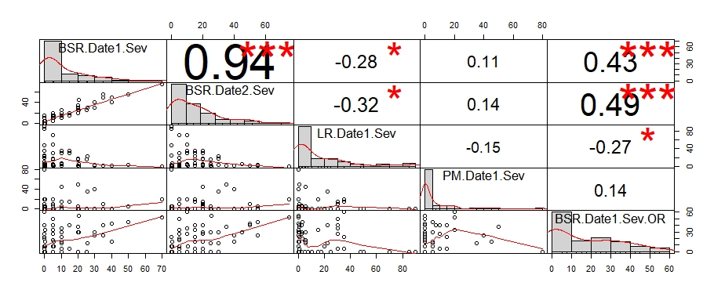

LSD test for BSR, LR, PM; Corvallis, OR, and Davis, CA

 | Line | BSR.Date1.Sev | BSR.Date2.Sev | LR.Date1.Sev | PM.Date1.Sev | BSR.Date1.Sev.OR
1 | 05ARS561-208 | 5 | 10 | 70 | 0 | 0
2 | 05ARS561-216 | 0 | 0 | 90 | 0 | 0
3 | 05ARS561-346 | 0 | 0 | 90 | 0 | 0
4 | 05ARS561-42 | 0 | 0 | 47.5 | 0 | 0
5 | 07MWA-201 | 5.5 | 15 | 1 | 0 | 15
6 | 07MWA-202 | 0.5 | 0.5 | 0.5 | 5 | 7.5
7 | 07MWA-203 | 0 | 5 | 1 | 10 | 5
8 | 07MWA-204 | 0 | 5 | 3 | 0 | 20
9 | 07MWA-206 | 0.5 | 0.5 | 7.5 | 0 | 0
10 | 09WA-203.21 | 40 | 50 | 0.5 | 0 | 42.5
11 | 09WA-228.13 | 35 | 55 | 0.5 | 0 | 25
12 | 1-4 | 5 | 5 | 5.5 | 0 | 17.5
13 | 1-6 | 25 | 25 | 15.5 | 0 | 0
14 | 10.0777 | 5 | 5 | 30 | 0 | 50
15 | 10.086 | 5 | 20 | 17.5 | 0 | 0
16 | 10.115 | 20 | 25 | 1 | 0 | 0
17 | 10.1151 | 20 | 20 | 15.5 | 0 | 0
18 | 10.1986 | 10 | 15 | 7.5 | 0 | 0
19 | 10WA-106.18 | 30 | 40 | 0.5 | 40 | 25
20 | 10WA-106.20 | 20 | 35 | 1 | 50 | 37.5
21 | 10WA-111.23 | 10 | 25 | 5.5 | 5 | 12.5
22 | 10WA-131.16 | 10 | 20 | 5.5 | 45 | 15
23 | 11D648 | 5 | 15 | 15 | 20 | 32.5
24 | 11D657 | 0 | 15 | 22.5 | 0 | 40
25 | 11D668 | 5 | 20 | 30 | 10 | 27.5
26 | 11D698 | 5 | 10 | 50 | 0 | 0
27 | 11D745 | 0 | 10 | 35 | 20 | 60
28 | 11D787 | 0 | 5 | 20 | 0 | 7.5
29 | 11ID643 | 10 | 15 | 30 | 15 | 5
30 | 11ID659 | 10 | 15 | 35 | 15 | 22.5
31 | 11ID768 | 15 | 20 | 35 | 15 | 5
32 | 11WA-103.13 | 40 | 40 | 0.5 | 0 | 15
33 | 11WA-107.4 | 35 | 50 | 1 | 10 | 40
34 | 11WA-107.58 | 50 | 55 | 3 | 5 | 45
36 | 95SR316A | NA | NA | NA | NA | 0
37 | Alba | NA | NA | NA | NA | 0
38 | Baronesse | 30 | 30 | 2.5 | 0 | 30
39 | Buck | 5 | 5 | 2.5 | 0 | 0
40 | Charles | NA | NA | NA | NA | 0
41 | DH 10.1044 | 0 | 0 | 1 | 0 | 22.5
42 | DH120228 | 0 | 10 | 5 | 0 | 0
43 | DH120276 | 5 | 5 | 0.5 | 0 | 7.5
44 | DH120412 | 20 | 20 | 1 | 5 | 30
45 | DH130004 | 20.5 | 45 | 5.5 | 0 | 30
46 | DH130718 | 20 | 30 | 17.5 | 0 | 0
47 | DH130939 | 0 | 5 | 10.5 | 0 | 0
48 | Endeavor | NA | NA | NA | NA | 15
49 | Full Pint | 0 | 0 | 0 | 80 | 0
50 | Line 40 | 0 | 0 | 85 | 0 | 0
51 | Line 72 | 5 | 5 | 70 | 0 | 0
52 | P-954 | NA | NA | NA | NA | 45
53 | Robust | 70 | 75 | 0 | 20 | 52.5
54 | STANFARM | 10 | 10 | 30.5 | 0 | 35
55 | UC1255 | 15 | 15 | 30 | 15 | 40
56 | UC1256 | 10 | 25 | 0.5 | 0 | 30
57 | UC1317 | 0.5 | 5 | 0 | 20 | 32.5
58 | UC1351 | 0 | 0 | 0 | 5 | 0
59 | UC1383 | 0.5 | 0.5 | 0 | 5 | 15
60 | UC1385 | 5 | 20 | 2.5 | 7.5 | 40
61 | UC1401 | 20.5 | 25.5 | 0 | 0 | 55
62 | UC1404 | 5.5 | 10.5 | 0.5 | 0 | 7.5
63 | UC1405 | 0 | 0 | 0 | 5 | 7.5
64 | UC1408 | 0 | 5 | NA | 0 | 27.5
65 | UC1409 | 5 | 10 | 2.5 | 0 | 27.5
66 | UC1410 | 0 | 0 | 2.5 | 0 | 0
67 | UC933 | 0 | 0 | 25 | 0 | 0
68 | UC969 | 25.5 | 30 | 22.5 | 35 | 12.5
 | LSD | 26.15 | 30.93 | 28.17 | 29.48 | 21.84

BSRST 2017 – California data

Reaction to BSR at adult plant stage; Davis, CA

Histogram distribution across dates

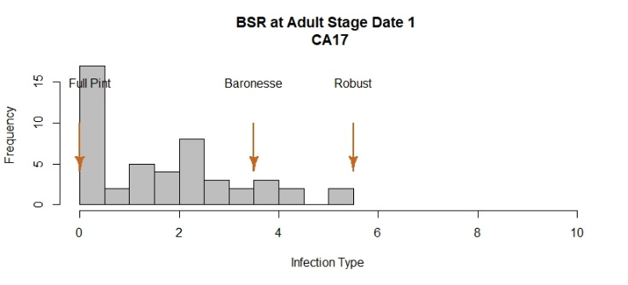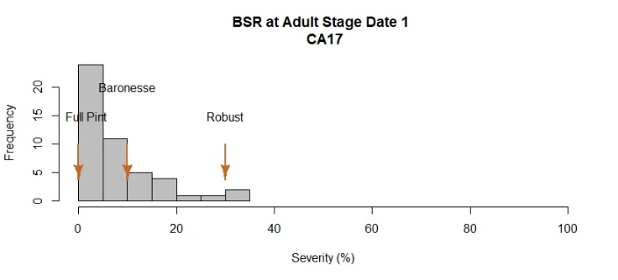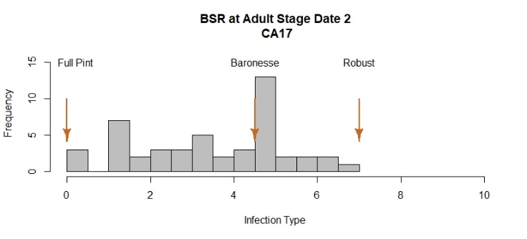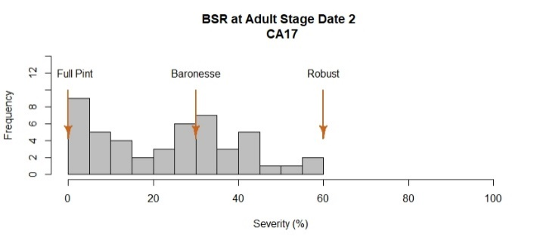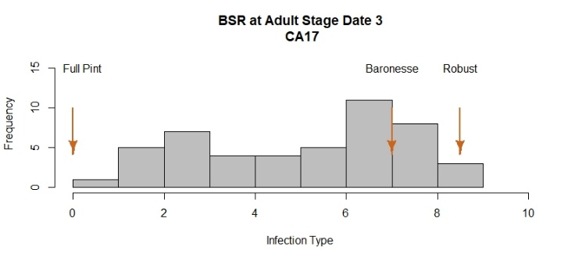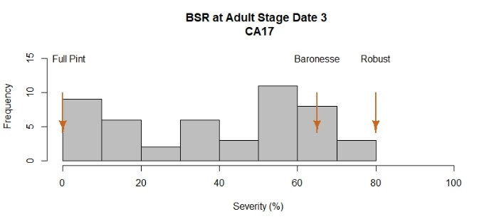

2017 Field Evaluations
The barley stripe rust nursery was evaluated using severity and infection type at Davis, CA. Location at Corvallis was unrated as the field was flooded. At Davis, disease notes were taken three times during the growing season at a 10 day interval.

At Davis, a large range of phenotypic variation among lines and across dates was observed, based on histogram plots. At this location, Full Pint, Baronesse, and Robust were used as checks and exhibited a range of severity values as expected. Robust showed the highest infection type/severity values with 8.5/80%. The resistant check Full Pint had the lowest values with 0/0.0%.

Infection type: A total of 13 lines showed symptoms of disease infection ≤ 3 whereas 18 lines were rated with infection type > 7 values similar to susceptible checks. 50% of lines at this location exhibited infection type values between 3-7.

Severity: 50% of lines in this trial exhibited severity values between 20-60%. As observed in the histogram distribution, 11 lines are showing a value of 15% or lower for BSR severity and 28 exhibited severities > 40%.

Analysis of variance for BSR

BSR CA17
Infection Type Date 1
Df Sum Sq Mean Sq F value Pr(>F)
Line 47 248.74 5.29 2.338 0.00216 **
Rep 1 90.09 90.09 39.795 9.18e-08 ***
Residuals 47 106.41 2.26
---
Signif. codes: 0 ‘***’ 0.001 ‘**’ 0.01 ‘*’ 0.05 ‘.’ 0.1 ‘ ’ 1
Severity Date 1
Df Sum Sq Mean Sq F value Pr(>F)
Line 47 8166 173.7 2.457 0.00128 **
Rep 1 2926 2926.0 41.374 5.95e-08 ***
Residuals 47 3324 70.7
---
Signif. codes: 0 ‘***’ 0.001 ‘**’ 0.01 ‘*’ 0.05 ‘.’ 0.1 ‘ ’ 1
Infection Type Date 2
Df Sum Sq Mean Sq F value Pr(>F)
Line 47 294.96 6.28 4.022 2.40e-06 ***
Rep 1 170.67 170.67 109.382 7.39e-14 ***
Residuals 47 73.33 1.56
---
Signif. codes: 0 ‘***’ 0.001 ‘**’ 0.01 ‘*’ 0.05 ‘.’ 0.1 ‘ ’ 1

Severity Date 2
Df Sum Sq Mean Sq F value Pr(>F)
Line 47 25650 546 2.714 0.000422 ***
Rep 1 18150 18150 90.270 1.63e-12 ***
Residuals 47 9450 201
---
Signif. codes: 0 ‘***’ 0.001 ‘**’ 0.01 ‘*’ 0.05 ‘.’ 0.1 ‘ ’ 1
Infection Type Date 3
Df Sum Sq Mean Sq F value Pr(>F)
Line 47 489.6 10.42 6.561 8.76e-10 ***
Rep 1 108.4 108.38 68.256 1.04e-10 ***
Residuals 47 74.6 1.59
---
Signif. codes: 0 ‘***’ 0.001 ‘**’ 0.01 ‘*’ 0.05 ‘.’ 0.1 ‘ ’ 1
Severity Date 3
Df Sum Sq Mean Sq F value Pr(>F)
Line 47 52333 1113 7.336 1.19e-10 ***
Rep 1 11267 11267 74.234 3.12e-11 ***
Residuals 47 7133 152
---
Signif. codes: 0 ‘***’ 0.001 ‘**’ 0.01 ‘*’ 0.05 ‘.’ 0.1 ‘ ’ 1

Correlation among dates for BSR
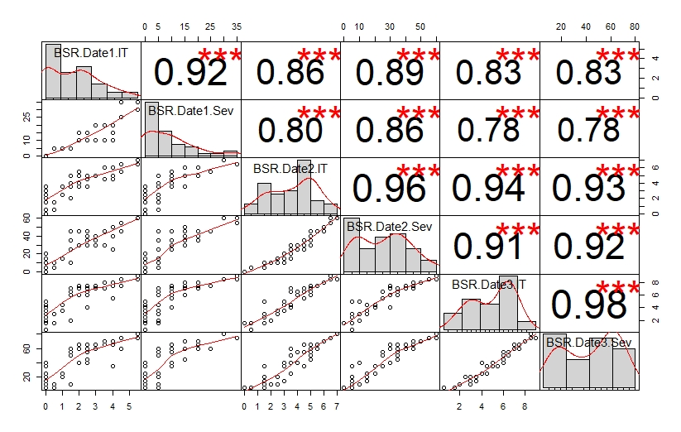

LSD test for BSR; Davis, CA

 | Line | BSR.Date1.IT | BSR.Date1.Sev | BSR.Date2.IT | BSR.Date2.Sev | BSR.Date3.IT | BSR.Date3.Sev
1 | 08ARS012-79 | 1.5 | 5 | 5 | 45 | 7 | 60
2 | 08ARS028-20 | 2 | 10 | 5.5 | 45 | 7.5 | 65
3 | 08ARS112-75 | 3.5 | 20 | 6 | 45 | 8 | 70
4 | 08ARS116-91 | 2 | 10 | 4 | 30 | 6 | 40
5 | 10WA-117.17 | 2.5 | 10 | 5 | 35 | 6.5 | 55
6 | 10WA-117.24 | 2.5 | 10 | 4.5 | 35 | 6.5 | 55
7 | 11ID718 | 2.5 | 10 | 5 | 35 | 6 | 55
8 | 11WA-107.36 | 2.5 | 15 | 5 | 35 | 6 | 45
9 | 11WA-107.43 | 4.5 | 25 | 5.5 | 45 | 7.5 | 60
10 | 11WA-107.58 | 3 | 20 | 5 | 35 | 7 | 60
11 | 12WA-105.2 | 2.5 | 15 | 5 | 40 | 7 | 60
12 | 12WA-105.4 | 2.5 | 10 | 3.5 | 30 | 4 | 40
13 | 12WA-120.14 | 3 | 20 | 5 | 40 | 7.5 | 65
14 | 12WA-120.17 | 2.5 | 15 | 5 | 45 | 7.5 | 60
15 | 12WA-120.23 | 2.5 | 10 | 5 | 35 | 7 | 65
16 | 2Ab04-X01084-27 | 2 | 15 | 3.5 | 30 | 7 | 60
17 | 2Ab07-X031098-31 | 4 | 20 | 5 | 40 | 7.5 | 65
18 | 2Ab08-X05M010-65 | 5.5 | 35 | 6.5 | 60 | 9 | 75
19 | 2Ab08-X05M010-82 | 4.5 | 35 | 6.5 | 55 | 8.5 | 75
20 | 2Ab09-X06F058HL-31 | 2 | 10 | 5 | 30 | 7 | 60
21 | Abed Binder 2 | 4 | 10 | 4.5 | 25 | 5.5 | 35
22 | Astrix | 0 | 0 | 3 | 15 | 3.5 | 15
23 | Bancroft | 0 | 0 | 2 | 10 | 2 | 10
24 | Baronesse | 3.5 | 10 | 4.5 | 30 | 7 | 65
25 | Big o | 0 | 0 | 0 | 0 | 1.5 | 5
26 | DH120228 | 0 | 0 | 3 | 10 | 5 | 40
27 | DH120304 | 1.5 | 5 | 5 | 35 | 6 | 50
28 | DH120412 | 1.5 | 5 | 4 | 25 | 6.5 | 55
29 | DH130004 | 0 | 0 | 1.5 | 5 | 3 | 15
30 | DH130718 | 0 | 0 | 1.5 | 5 | 3 | 10
31 | DH130735 | 1.5 | 5 | 2 | 10 | 2 | 10
32 | DH130765 | 0 | 0 | 1.5 | 5 | 3 | 20
33 | DH130910 | 1 | 5 | 3.5 | 15 | 4.5 | 25
34 | DH130935 | 0 | 0 | 2.5 | 10 | 3 | 10
35 | DH130939 | 0 | 0 | 1.5 | 5 | 5 | 35
36 | Emir | 0 | 0 | 1.5 | 5 | 1.5 | 5
37 | Full Pint | NA | NA | NA | NA | NA | NA
38 | Heils Franken | 0 | 0 | 3.5 | 20 | 4 | 25
39 | Hiproly | 1.5 | 5 | 3.5 | 25 | 6.5 | 50
40 | I 5 | 0 | 0 | 3 | 20 | 4.5 | 35
41 | Mazurka | 0 | 0 | 2.5 | 15 | 3 | 20
42 | Robust | 5.5 | 30 | 7 | 60 | 8.5 | 80
43 | Topper | 4 | 15 | 6 | 50 | 8 | 70
44 | Trumpf | 0 | 0 | 1.5 | 5 | 2.5 | 20
45 | UC 1360 | 3 | 10 | 5 | 30 | 7.5 | 65
46 | UC 1390 | 0.5 | 5 | 0.5 | 5 | 1.5 | 5
47 | UC Tahoe.UC 1409 | 1 | 5 | 2.5 | 15 | 3.5 | 20
48 | UC1410 | 0 | 0 | 0.5 | 5 | 0.5 | 5
49 | Varanda | 0.5 | 5 | 1.5 | 10 | 3 | 10
 | LSD | 3.02 | 16.91 | 2.51 | 28.5 | 2.53 | 24.78

BSRST 2018 – Oregon and California data

Reaction to BSR at adult plant stage; Corvallis, OR and Davis, CA

Histogram distribution across dates and sites

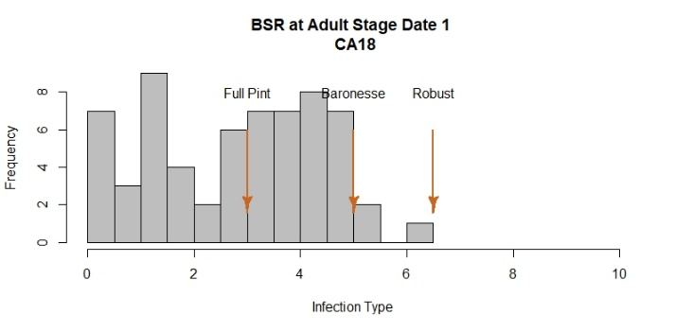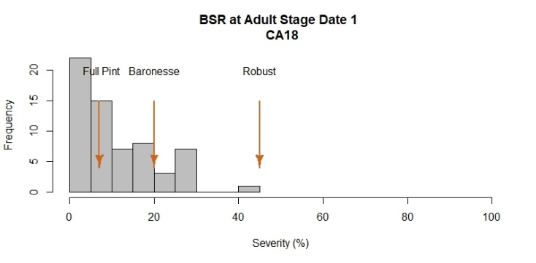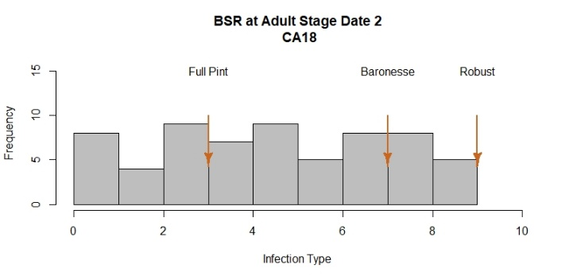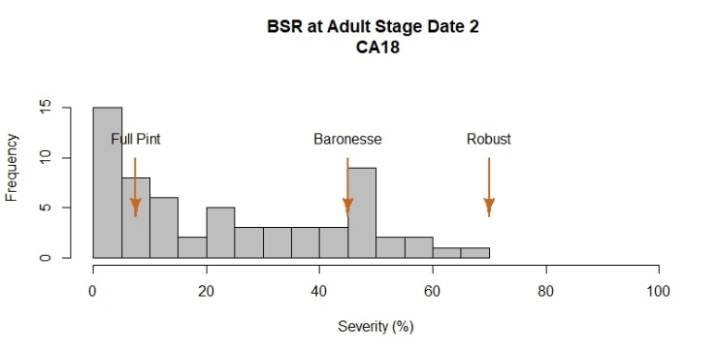
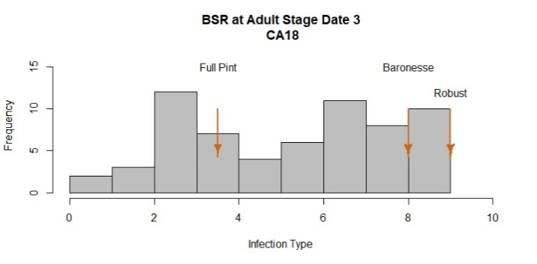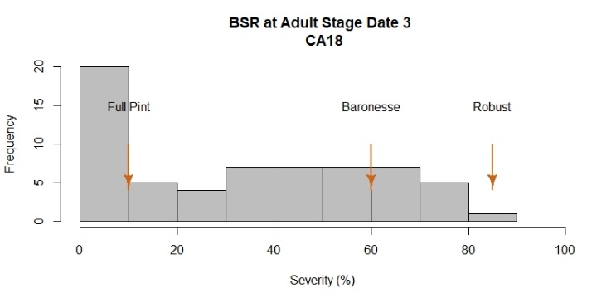

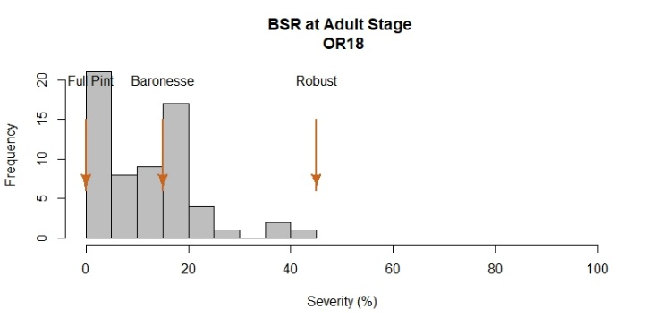

2018 Field Evaluations

The barley stripe rust nurseries were evaluated using severity and infection type at Davis and severity at Corvallis. At Davis, disease notes were taken three times during the growing season at a 10 day interval. At Corvallis, one evaluation was performed after flowering was finished.

Davis exhibited a larger range of phenotypic variation among lines compared to Corvallis, based on histogram plots. At both locations, Full Pint, Baronesse, and Robust were used as checks and exhibited a range of severity values as expected.

At Corvallis, controls exhibited a range of stripe rust severities, however, they did not pass 45%. Robust showed the highest severity value with 45%. The resistant check Full Pint had the lowest value with 0.0%. A total of 13 lines did not show symptoms of disease infection whereas just four lines were rated with severity values similar to susceptible checks (> 30%). 50% of lines at this location exhibited severity values between 2.5-17.5%.

At Davis, a range of phenotypic variation was observed among lines and across dates. The susceptible check Robust showed the highest infection type/severity values with 9/85%. The resistant check Full Pint had the lowest values with 3.5/10%.

Infection type: A total of 13 lines showed symptoms of disease infection ≤ 3 whereas 26 lines were rated with infection type ≥ 7 values similar to susceptible checks. 50% of lines at this location exhibited infection type values between 3-8.

Severity: 50% of lines in this trial exhibited severity values between 10-60%. As observed in the histogram distribution, 23 lines had severities < 15% and 31 exhibited severities > 40%.

Analysis of variance for BSR

BSR OR18
Severity Date 1
Df Sum Sq Mean Sq F value Pr(>F)
Line 62 13375 215.73 13.140 <2e-16 ***
Rep 1 45 44.64 2.719 0.104
Residuals 62 1018 16.42
---
Signif. codes: 0 ‘***’ 0.001 ‘**’ 0.01 ‘*’ 0.05 ‘.’ 0.1 ‘ ’ 1

BSR CA18
Infection Type Date 1
Df Sum Sq Mean Sq F value Pr(>F)
Line 62 358.5 5.78 3.941 1.07e-07 ***
Rep 1 49.5 49.53 33.759 2.32e-07 ***
Residuals 62 91.0 1.47
---
Signif. codes: 0 ‘***’ 0.001 ‘**’ 0.01 ‘*’ 0.05 ‘.’ 0.1 ‘ ’ 1
Severity Date 1
Df Sum Sq Mean Sq F value Pr(>F)
Line 62 13093 211.2 3.523 8.38e-07 ***
Rep 1 1572 1571.6 26.223 3.19e-06 ***
Residuals 62 3716 59.9
---
Signif. codes: 0 ‘***’ 0.001 ‘**’ 0.01 ‘*’ 0.05 ‘.’ 0.1 ‘ ’ 1
Infection Type Date 2
Df Sum Sq Mean Sq F value Pr(>F)
Line 62 855.6 13.801 13.49 <2e-16 ***
Rep 1 1.6 1.556 1.52 0.222
Residuals 62 63.4 1.023
---
Signif. codes: 0 ‘***’ 0.001 ‘**’ 0.01 ‘*’ 0.05 ‘.’ 0.1 ‘ ’ 1
Severity Date 2
Df Sum Sq Mean Sq F value Pr(>F)
Line 62 52686 849.8 5.548 9.73e-11 ***
Rep 1 3 3.2 0.021 0.886
Residuals 62 9497 153.2
---
Signif. codes: 0 ‘***’ 0.001 ‘**’ 0.01 ‘*’ 0.05 ‘.’ 0.1 ‘ ’ 1
Infection Type Date 3
Df Sum Sq Mean Sq F value Pr(>F)
Line 62 775.9 12.514 10.86 < 2e-16 ***
Rep 1 12.1 12.071 10.48 0.00194 **
Residuals 62 71.4 1.152
---
Signif. codes: 0 ‘***’ 0.001 ‘**’ 0.01 ‘*’ 0.05 ‘.’ 0.1 ‘ ’ 1
Severity Date 3
Df Sum Sq Mean Sq F value Pr(>F)
Line 62 86644 1397.5 12.53 < 2e-16 ***
Rep 1 1334 1334.1 11.96 0.000988 ***
Residuals 62 6916 111.5
---
Signif. codes: 0 ‘***’ 0.001 ‘**’ 0.01 ‘*’ 0.05 ‘.’ 0.1 ‘ ’ 1

Correlation among dates and locations for BSR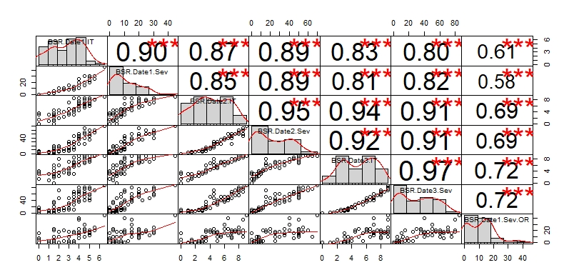

LSD test for BSR; Corvallis, OR and Davis, CA

 | Line | BSR.Date1.IT | BSR.Date1.Sev | BSR.Date2.IT | BSR.Date2.Sev | BSR.Date3.IT | BSR.Date3.Sev | BSR.Date1.Sev.OR
1 | 05ARS561-208 | 1 | 2.5 | 1 | 2.5 | 1 | 2.5 | 0
2 | 05ARS748-270 | 1.5 | 2.5 | 3.5 | 15 | 6 | 35 | 20
3 | 06ARS617-25 | 2 | 10 | 4.5 | 15 | 8 | 70 | 17.5
4 | 06ARS633-3 | 3 | 7.5 | 3.5 | 15 | 4.5 | 25 | 17.5
5 | 07ARS518-13 | 1.5 | 2.5 | 1.5 | 2.5 | 3 | 5 | 2.5
6 | 08ARS012-79 | 4 | 15 | 8.5 | 50 | 9 | 80 | 37.5
7 | 08ARS028-20 | 3.5 | 10 | 8.5 | 45 | 8.5 | 65 | 15
8 | 08ARS112-75 | 4 | 25 | 7.5 | 50 | 8 | 70 | 17.5
9 | 08ARS116-91 | 3.5 | 10 | 3 | 10 | 3 | 10 | 0
10 | 08ARS601-11 | 1.5 | 2.5 | 4.5 | 20 | 5 | 30 | 22.5
11 | 08ARS632-5 | 4 | 10 | 6.5 | 40 | 7 | 40 | 40
12 | 1_4 | 0 | 0 | 0 | 0 | 3 | 10 | 15
13 | 10.0777 | 3.5 | 7.5 | 4.5 | 30 | 7 | 60 | 17.5
14 | 10.1154 | 1 | 2.5 | 1 | 2.5 | 3 | 5 | 0
15 | 10.1492 | 1.5 | 5 | 0 | 0 | 0 | 0 | 0
16 | 10.1986 | 0 | 0 | 0 | 0 | 1.5 | 2.5 | 0
17 | 10WA-106.18 | 4 | 20 | 7 | 45 | 8 | 65 | 7.5
18 | 10WA-106.20 | 4.5 | 20 | 8.5 | 65 | 9 | 75 | 10
19 | 10WA-107.8 | 5 | 30 | 8.5 | 60 | 9 | 80 | 20
20 | 11WA-102.23 | 4.5 | 20 | 6.5 | 50 | 6.5 | 50 | 22.5
21 | 11WA-105.13 | 1 | 2.5 | 3 | 5 | 3 | 7.5 | 2.5
22 | 11WA-107.36 | 3 | 15 | 7 | 25 | 7 | 45 | 17.5
23 | 11WA-107.43 | 4.5 | 30 | 8 | 55 | 9 | 80 | 17.5
24 | 11WA-107.58 | 4.5 | 30 | 7 | 40 | 8 | 60 | 20
25 | 11WA-110.1 | 3.5 | 10 | 5 | 25 | 5.5 | 35 | 15
26 | 12WA-120.14 | 4 | 15 | 6 | 35 | 6 | 35 | 22.5
27 | 12WA-120.23 | 4 | 15 | 4.5 | 25 | 7 | 60 | 15
28 | 12WA-120.8 | 3.5 | 10 | 5 | 30 | 6 | 40 | 17.5
29 | 13WA-126.3 | 3.5 | 12.5 | 5 | 25 | 5.5 | 25 | 2.5
30 | 13WA-141.10 | 5 | 20 | 7.5 | 50 | 7.5 | 55 | 20
31 | 13WA-146.3 | 4.5 | 20 | 7 | 50 | 8 | 60 | 10
32 | 2Ab08-X05M010-65 | 5 | 30 | 8 | 50 | 8 | 55 | 17.5
33 | 2Ab08-X05M010-82 | 4 | 20 | 5.5 | 35 | 7 | 50 | 12.5
34 | 2Ab09-X06F058HL-31 | 5 | 30 | 8 | 50 | 9 | 75 | 15
35 | Baronesse | 5 | 20 | 7 | 45 | 8 | 60 | 15
36 | Buck | 2 | 5 | 2 | 5 | 2.5 | 5 | 0
37 | Butta 12 | 5.5 | 30 | 8 | 55 | 9 | 70 | 25
38 | DH120304 | 2 | 5 | 3.5 | 7.5 | 3.5 | 12.5 | 10
39 | DH130910 | 0 | 0 | 0 | 0 | 3.5 | 10 | 5
40 | DH130939 | 0 | 0 | 3.5 | 7.5 | 4 | 17.5 | 7.5
41 | DH133783 | 1.5 | 5 | 1 | 2.5 | 3 | 7.5 | 0
42 | DH140088 | 1.5 | 2.5 | 1.5 | 5 | 2 | 5 | 5
43 | DH140322 | 4.5 | 15 | 6 | 40 | 7 | 50 | 30
44 | DH140394 | 1.5 | 2.5 | 3 | 5 | 3 | 5 | 10
45 | DH140490 | 2.5 | 10 | 4 | 12.5 | 4.5 | 15 | 20
46 | Full Pint | 3 | 7.5 | 3 | 7.5 | 3.5 | 10 | 0
47 | Kardia | 4.5 | 20 | 8 | 50 | 8.5 | 65 | 17.5
48 | Robust | 6.5 | 45 | 9 | 70 | 9 | 85 | 45
49 | STRKR | 4.5 | 15 | 5.5 | 25 | 6.5 | 40 | 10
50 | UC 1390 | 3 | 7.5 | 3 | 10 | 3 | 10 | 0
51 | UC 1410 | 0 | 0 | 1.5 | 2.5 | 1.5 | 2.5 | 0
52 | UC Tahoe | 3 | 7.5 | 5 | 30 | 5 | 30 | 10
53 | UCB9K 26 | 0 | 0 | 3 | 5 | 3 | 5 | 0
54 | UCB9K 27 | 0 | 0 | 0 | 0 | 3 | 5 | 0
55 | UCB9K 37 | 5 | 22.5 | 6 | 35 | 7 | 40 | 15
56 | UCB9K 40 | 2.5 | 7.5 | 2.5 | 7.5 | 3.5 | 7.5 | 2.5
57 | UCB9K 6 | 5.5 | 25 | 8 | 60 | 9 | 70 | 20
58 | UCB9K 65 | 5 | 27.5 | 6.5 | 50 | 7 | 45 | 12.5
59 | UCB9K 72 | 1.5 | 5 | 2.5 | 7.5 | 2.5 | 10 | 0
60 | UCB9K 74 | 2 | 5 | 4.5 | 20 | 6 | 45 | 17.5
61 | UCB9K 76 | 3.5 | 7.5 | 4 | 15 | 6.5 | 50 | 17.5
62 | UCB9K 78 | 1.5 | 5 | 3.5 | 12.5 | 4 | 20 | 2.5
63 | UCB9K 96 | 3 | 7.5 | 3 | 10 | 3.5 | 15 | 2.5
 | LSD | 2.42 | 15.47 | 2.05 | 24.74 | 2.14 | 21.11 | 8.09

BSRST 2019 – Oregon and California data

Reaction to BSR at adult plant stage; Corvallis, OR and Davis, CA.

Histograms across sites

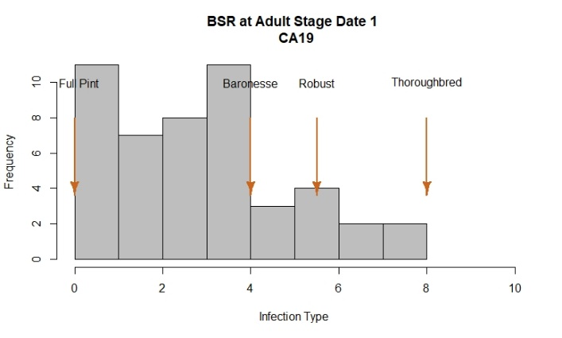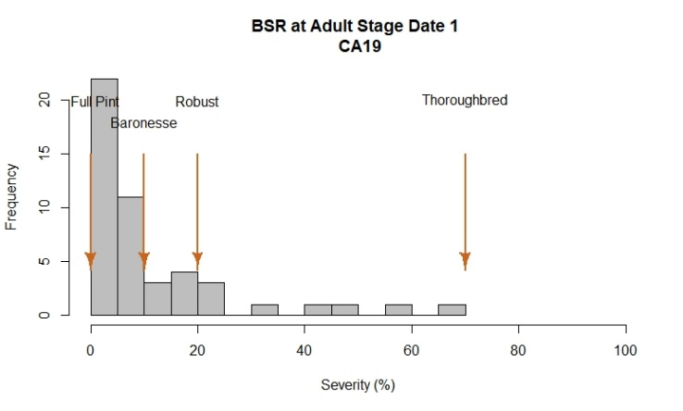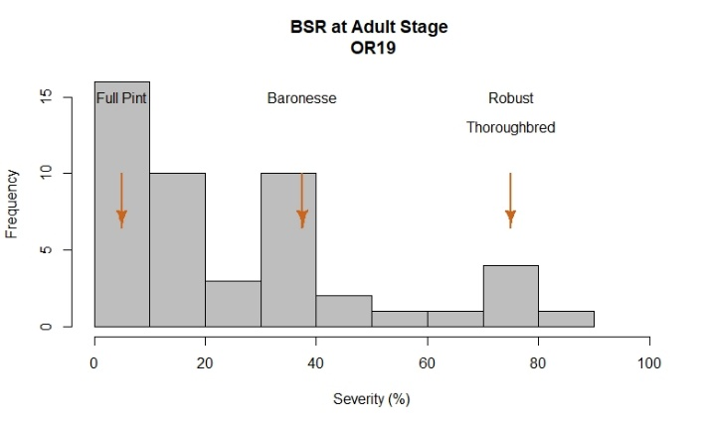
2019 Field Evaluations

The barley stripe rust nurseries were evaluated using severity and infection type at Davis and severity at Corvallis. At both locations, disease notes were taken once flowering was finished.

Corvallis exhibited a similar range of phenotypic variation among lines compared to Davis, based on histogram plots. At both locations, Full Pint, Baronesse, Thoroughbred, and Robust were used as checks and exhibited a range of severity values as expected.

At Corvallis, susceptible checks Robust and Thoroughbred showed the highest severity values, both with 75%. The resistant check Full Pint had the lowest value with 5%. Just nine lines showed symptoms of disease severity ≤ 5% whereas 20 lines were rated with severity values ≥ 30%. 50% of lines at this location exhibited severity values between 7.5-37.5%.

At Davis, checks Full Pint, Baronesse, Thoroughbred, and Robust exhibited values of 0, 10, 70 and 20% for severity and 0, 4, 5.5, and 8, for infection type, respectively.

Infection type: A total of 46 lines showed symptoms of disease infection ≤ 3 whereas just two lines were rated with infection type > 7 values similar to susceptible checks. 50% of lines at this location exhibited infection type values ranging from 1.5 to 4.

Severity: 50% of lines in this trial exhibited severity values between 2.5-17.5%. As observed in the histogram distribution, 36 lines had severities ≤ 15% and just four lines exhibited severities > 40%.

Analysis of variance for BSR

BSR OR19
Severity Date 1
Df Sum Sq Mean Sq F value Pr(>F)
Line 47 50873 1082.4 45.74 < 2e-16 ***
Rep 1 250 250.3 10.57 0.00212 **
Residuals 47 1112 23.7
---
Signif. codes: 0 ‘***’ 0.001 ‘**’ 0.01 ‘*’ 0.05 ‘.’ 0.1 ‘ ’ 1

BSR CA19
Infection Type Date 1
Df Sum Sq Mean Sq F value Pr(>F)
Line 47 424.6 9.035 7.455 8.92e-11 ***
Rep 1 2.0 2.042 1.685 0.201
Residuals 47 57.0 1.212
---
Signif. codes: 0 ‘***’ 0.001 ‘**’ 0.01 ‘*’ 0.05 ‘.’ 0.1 ‘ ’ 1
Severity Date 1
Df Sum Sq Mean Sq F value Pr(>F)
Line 47 23960 509.8 12.711 3.04e-15 ***
Rep 1 83 82.5 2.057 0.158
Residuals 47 1885 40.1
---
Signif. codes: 0 ‘***’ 0.001 ‘**’ 0.01 ‘*’ 0.05 ‘.’ 0.1 ‘ ’ 1

Correlation among sites for BSR
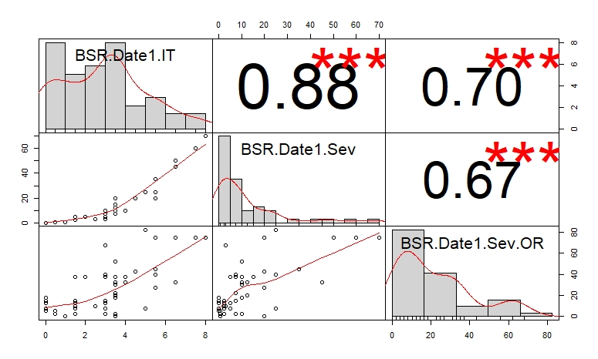

LSD test for BSR; Corvallis, OR and Davis, CA

 | Line | BSR.Date1.IT | BSR.Date1.Sev | BSR.Date1.Sev.OR
1 | 05ARS561-208 | 1.5 | 2.5 | 2.5
2 | 05ARS748-270 | 2 | 5 | 37.5
3 | 05ARS849-15 | 3 | 3 | 67.5
4 | 06ARS617-25 | 5.5 | 20 | 27.5
5 | 07ARS518-13 | 0.5 | 0.5 | 2.5
6 | 1_4 | 4.5 | 20 | 42.5
7 | 10.0655 | 3.5 | 10 | 30
8 | 10.0777 | 3.5 | 10 | 52.5
9 | 10.1154 | 3.5 | 7.5 | 2.5
10 | 10.1492 | 3.5 | 20 | 0
11 | 10.1986 | 1 | 0.5 | 0
12 | 10ARS191-3 | 4 | 10 | 32.5
13 | 10ARS313-1007 | 5 | 25 | 82.5
14 | 10ARS313-490 | 6.5 | 50 | 75
15 | 11ARS162-4 | 1.5 | 2.5 | 10
16 | AB09BG11HL-1 | 7.5 | 60 | 75
17 | Alba | 3 | 10 | 2.5
18 | ARS278-35 | 5.5 | 35 | 45
19 | ARS84-27 | 2.5 | 3 | 10
20 | ARS98-31 | 6.5 | 45 | 32.5
21 | Baronesse | 4 | 10 | 37.5
22 | Buck | 3 | 5 | 7.5
23 | Butta 12 | 5.5 | 25 | 40
24 | DH120304 | 3.5 | 12.5 | 32.5
25 | DH130910 | 3.5 | 10 | 17.5
26 | DH130939 | 3.5 | 12.5 | 20
27 | DH133783 | 5 | 25 | 7.5
28 | DH140088 | 3 | 5 | 12.5
29 | DH140394 | 1.5 | 2.5 | 15
30 | DH140490 | 3 | 7.5 | 37.5
31 | Full Pint | 0 | 0 | 5
32 | Robust | 5.5 | 20 | 75
33 | STRKR | 3 | 7.5 | 15
34 | Thoroughbred | 8 | 70 | 75
35 | UC 1390 | 0 | 0 | 7.5
36 | UC 1410 | 0 | 0 | 5
37 | UC Tahoe | 3.5 | 7.5 | 22.5
38 | UCB9K 26 | 3 | 7.5 | 40
39 | UCB9K 27 | 0 | 0 | 12.5
40 | UCB9K 40 | 0 | 0 | 7.5
41 | UCB9K 62bis | 0 | 0 | 17.5
42 | UCB9K 65bis | 1.5 | 5 | 37.5
43 | UCB9K 73 | 0.5 | 0.5 | 5
44 | UCB9K 78 | 1.5 | 2.5 | 12.5
45 | UCB9K 79 | 0 | 0 | 12.5
46 | UCB9K 90 | 0 | 0 | 15
47 | UCB9K 98 | 3.5 | 15 | 37.5
48 | UCB9K24 | 1.5 | 2.5 | 7.5
 | LSD | 2.21 | 12.74 | 9.7

BSRST 2020 – Oregon and California data

Reaction to BSR and SC at adult plant stage; Corvallis, OR and Davis, CA

Histogram distribution across dates and sites

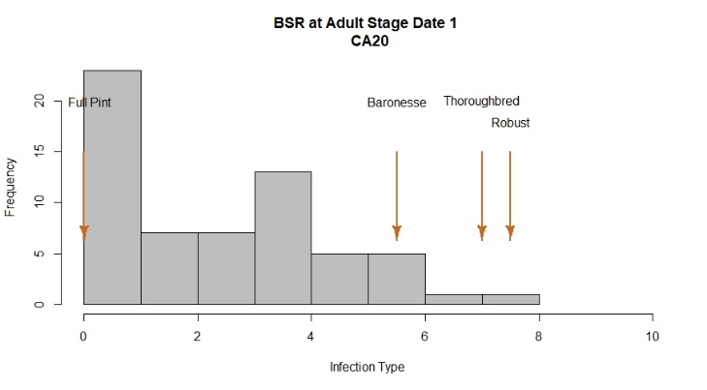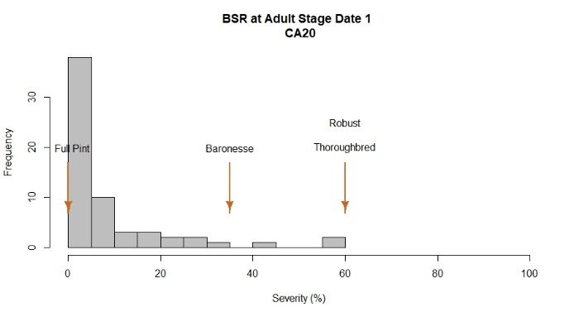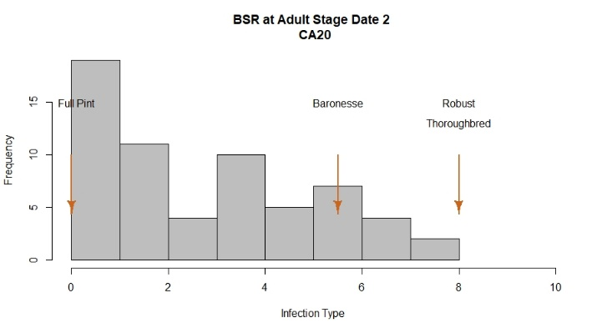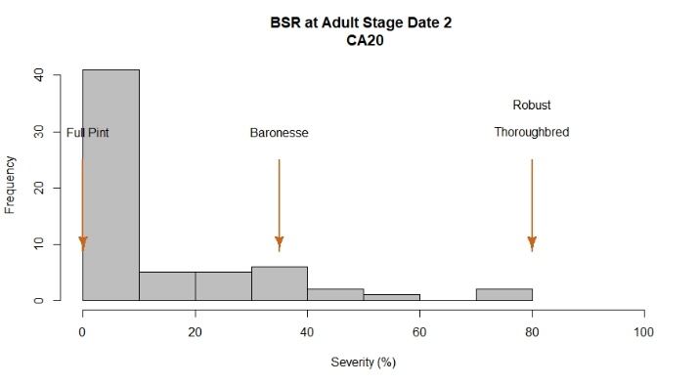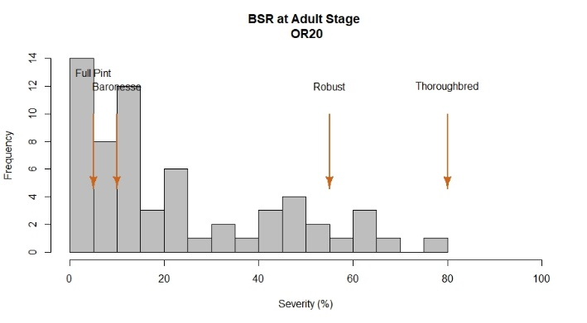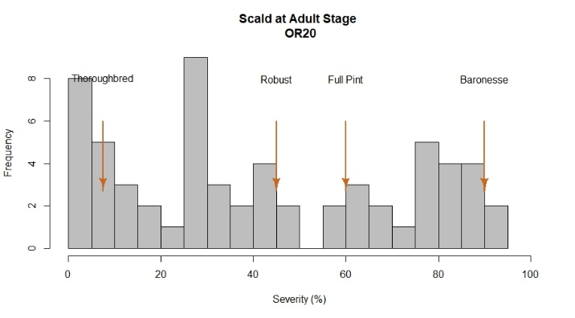

2020 Field evaluations
The barley stripe rust nurseries were evaluated using severity and infection type at Davis and severity at Corvallis. At Davis, disease notes were taken two times during the growing season at a 10 day interval. At Corvallis, one evaluation was performed after flowering was finished.

Corvallis exhibited a larger phenotypic variation among lines compared to Davis, based on histogram plots. At both locations, Full Pint, Baronesse, Thoroughbred and Robust were used as common checks and exhibited a range of severity values as expected.

At Corvallis, Robust and Thoroughbred showed the highest severity values with 55% and 80%, respectively. The resistant check Full Pint had the lowest value with 5%. A total of 22 lines showed ≤ 10% of disease severity whereas 15 lines were rated with severity ≥ 40%. 50% of lines at this location exhibited severity values between 7.5-37.5%.

At Davis, a range of phenotypic variation was observed among lines and across dates. Controls Robust and Thoroughbred showed the highest infection type/severity values with both having 8/80%. The resistant check Full Pint had the lowest values with 0/0.0%.

Infection type: A total of 34 lines showed symptoms of disease infection type ≤ 3 whereas just three lines were rated with infection type > 7, similar to susceptible checks. 50% of lines at this location exhibited infection type values between 0-5.

Severity: 50% of lines in this trial exhibited severity values between 0-25%. As observed in the histogram, 44 lines had severities < 15% and 8 lines exhibited severities > 40%.

Scald (SC) was evaluated at Corvallis during this season. The BSRST trial exhibited a large variation for this trait with 50% of lines exhibiting severity values ranging from 15 to 75%. Checks Full Pint and Baronesse exhibited susceptible values of 60 and 90%, respectively.

Analysis of variance for BSR and SC
BSR OR20
Severity Date 1
Df Sum Sq Mean Sq F value Pr(>F)
Line 61 54102 886.9 11.181 <2e-16 ***
Rep 1 136 136.3 1.718 0.195
Residuals 61 4839 79.3
---
Signif. codes: 0 ‘***’ 0.001 ‘**’ 0.01 ‘*’ 0.05 ‘.’ 0.1 ‘ ’ 1

SC OR20
Severity Date 1
Df Sum Sq Mean Sq F value Pr(>F)
Line 61 112996 1852.4 15.8 <2e-16 ***
Rep 1 0 0.0 0.0 1
Residuals 61 7150 117.2
---
Signif. codes: 0 ‘***’ 0.001 ‘**’ 0.01 ‘*’ 0.05 ‘.’ 0.1 ‘ ’ 1

BSR CA20
Infection Type Date 1
Df Sum Sq Mean Sq F value Pr(>F)
Line 61 591.7 9.700 7.655 9.26e-14 ***
Rep 1 0.2 0.202 0.159 0.691
Residuals 61 77.3 1.267
---
Signif. codes: 0 ‘***’ 0.001 ‘**’ 0.01 ‘*’ 0.05 ‘.’ 0.1 ‘ ’ 1
Severity Date 1
Df Sum Sq Mean Sq F value Pr(>F)
Line 61 22644 371.2 4.187 4.25e-08 ***
Rep 1 228 227.6 2.567 0.114
Residuals 61 5408 88.7
---
Signif. codes: 0 ‘***’ 0.001 ‘**’ 0.01 ‘*’ 0.05 ‘.’ 0.1 ‘ ’ 1
Infection Type Date 2
Df Sum Sq Mean Sq F value Pr(>F)
Line 61 718.5 11.778 4.932 1.63e-09 ***
Rep 1 1.8 1.815 0.760 0.387
Residuals 61 145.7 2.388
---
Signif. codes: 0 ‘***’ 0.001 ‘**’ 0.01 ‘*’ 0.05 ‘.’ 0.1 ‘ ’ 1
Severity Date 2
Df Sum Sq Mean Sq F value Pr(>F)
Line 61 45243 741.7 7.469 1.65e-13 ***
Rep 1 0 0.3 0.003 0.957
Residuals 61 6058 99.3
---
Signif. codes: 0 ‘***’ 0.001 ‘**’ 0.01 ‘*’ 0.05 ‘.’ 0.1 ‘ ’ 1

Correlation among sites for BSR and SC
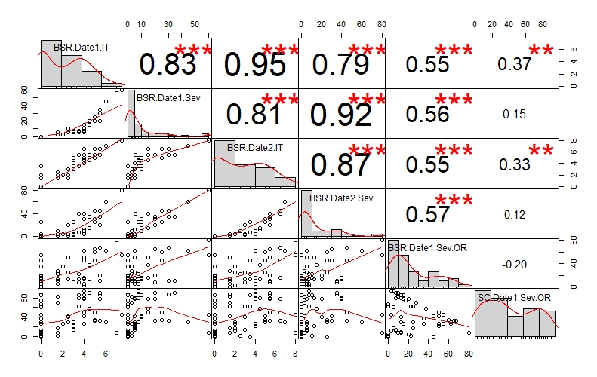

LSD test for BSR and SC; Corvallis, OR and Davis, CA

 | Line | BSR.Date1.IT | BSR.Date1.Sev | BSR.Date2.IT | BSR.Date2.Sev | BSR.Date1.Sev.OR | SC.Date1.Sev.OR
1 | 08ARS509-1 | 3.5 | 7.5 | 3.5 | 7.5 | 22.5 | 62.5
2 | 09WANM-265.12 | 5 | 20 | 5.5 | 30 | 65 | 32.5
3 | 10.1154 | 0 | 0 | 0 | 0 | 0 | 2.5
4 | 10.1492 | 0 | 0 | 0 | 0 | 0 | 5
5 | 10WAN-107.8 | 4 | 7.5 | 4 | 7.5 | 5 | 95
6 | 10WAN-107.9 | 4 | 10 | 4 | 10 | 15 | 85
7 | 10WAN-109.19 | 5 | 25 | 5 | 25 | 60 | 35
8 | 10WAN-109.21 | 5.5 | 30 | 6.5 | 45 | 67.5 | 32.5
9 | 10WAN-118.13 | 4.5 | 15 | 4.5 | 15 | 37.5 | 57.5
10 | 10WAN-127.5 | 5.5 | 20 | 5.5 | 20 | 20 | 77.5
11 | 11ARS162-4 | 1.5 | 2.5 | 1.5 | 2.5 | 10 | 82.5
12 | 11ARS183-9 | 4 | 5 | 4 | 5 | 15 | 77.5
13 | 11ARS191-3 | 4 | 7.5 | 4 | 7.5 | 2.5 | 95
14 | 11ARS809-1 | 4 | 5 | 4 | 5 | 50 | 27.5
15 | 11WAN-114.5 | 0 | 0 | 1.5 | 2.5 | 5 | 87.5
16 | 12ARS314-6 | 0 | 0 | 0 | 0 | 55 | 27.5
17 | 12ARS777-1 | 2 | 2.5 | 2 | 5 | 35 | 27.5
18 | 12ARS777-2 | 4 | 5 | 4 | 5 | 62.5 | 27.5
19 | 12WAN-106.12 | 4 | 7.5 | 4.5 | 12.5 | 12.5 | 80
20 | 12WAN-107.2 | 3 | 5 | 4 | 12.5 | 50 | 22.5
21 | 13ARS537-13 | 5.5 | 30 | 5.5 | 35 | 10 | 87.5
22 | 13ARS537-19 | 4 | 15 | 6.5 | 40 | 15 | 77.5
23 | 2Ab08-X05M10-82 | 3.5 | 7.5 | 3.5 | 7.5 | 12.5 | 85
24 | Alba | 0 | 0 | 0 | 0 | 0 | 0
25 | B9K26 | 0 | 0 | 0 | 0 | 35 | 37.5
26 | B9K40 | 0 | 0 | 0 | 0 | 5 | 5
27 | B9K62 | 0 | 0 | 0 | 0 | 12.5 | 7.5
28 | B9K78 | 0 | 0 | 0 | 0 | 12.5 | 10
29 | B9K79 | 0 | 0 | 0 | 0 | 12.5 | 30
30 | B9K79bis | 0 | 0 | 0 | 0 | 15 | 27.5
31 | B9K90 | 0 | 0 | 0 | 0 | 17.5 | 75
32 | Baronesse | 5.5 | 35 | 5.5 | 35 | 10 | 90
33 | Buck | 0 | 0 | 1.5 | 2.5 | 0 | 62.5
34 | Butta 12 | 4 | 10 | 5 | 30 | 45 | 42.5
35 | Capay | 0 | 0 | 0 | 0 | 0 | 67.5
36 | DH120304 | 0 | 0 | 3.5 | 25 | 45 | 0
37 | DH130910 | 0 | 0 | 0 | 0 | 10 | 7.5
38 | DH133783 | 0 | 0 | 2 | 5 | 2.5 | 12.5
39 | DH140088 | 0 | 0 | 0 | 0 | 20 | 5
40 | DH140963 | 1.5 | 2.5 | 2.5 | 10 | 22.5 | 2.5
41 | DH141132 | 1.5 | 2.5 | 1.5 | 2.5 | 12.5 | 7.5
42 | DH141222 | 0 | 0 | 0 | 0 | 5 | 5
43 | DH141225 | 0 | 0 | 0 | 0 | 7.5 | 12.5
44 | DH142010 | 1.5 | 5 | 2 | 5 | 25 | 17.5
45 | Full Pint | 0 | 0 | 0 | 0 | 5 | 60
46 | Havener (09WA-265.5) | 6 | 45 | 7 | 60 | 62.5 | 30
47 | Ishi | 2.5 | 5 | 2 | 5 | 25 | 30
48 | Julie | 5 | 25 | 6.5 | 45 | 45 | 50
49 | Megs Song (X05013-T1) | 2.5 | 5 | 1.5 | 2.5 | 50 | 42.5
50 | OP424 | 3 | 7.5 | 5 | 25 | 25 | 30
51 | PPWQ | 1.5 | 5 | 1.5 | 5 | 5 | 17.5
52 | Robust | 7.5 | 60 | 8 | 80 | 55 | 45
53 | Schaller | 3.5 | 5.5 | 5.5 | 40 | 7.5 | 80
54 | STRKR | 2.5 | 10 | 3 | 20 | 12.5 | 40
55 | Tahoe | 0 | 0 | 0 | 0 | 2.5 | 45
56 | Tamalpais | 3 | 3 | 3 | 3 | 25 | 62.5
57 | Thoroughbred | 7 | 60 | 8 | 80 | 80 | 7.5
58 | Thunder | 1.5 | 2.5 | 1.5 | 2.5 | 27.5 | 70
59 | Tibetan Purple Hulless | 0 | 0 | 0 | 0 | 15 | 85
60 | UC1280 | 3 | 5 | 3 | 5 | 7.5 | 15
61 | Wintmalt | 4 | 15 | 5.5 | 40 | 50 | 50
62 | X07G26-T35 | 4.5 | 20 | 5.5 | 35 | 7.5 | 90
 | LSD | 2.25 | 18.82 | 3.09 | 19.92 | 17.8 | 21.64

BLUPs across environments (OR16, CA16, CA17, OR18, CA18, OR19, CA19, OR20 and CA20) for BSR

The best linear unbiased predictions (BLUPs) for each line across three environments - Corvallis 2006, Davis 2017 and Davis 2017 - for disease severity at adult plant stage, expressed as
percentage (%) of leaf area affected with barley stripe rust were obtained and plotted in a histogram distribution graphic. A range of phenotypic variation was observed among lines when all environments were included in the same model. The susceptible checks Robust, P-954 and Baronesse showed the highest severities with 64.7%, 46.2% and 34.4%, respectively. The resistant check Full Pint has the lowest severity, at 3.2%. A total of 55 lines exhibited values ≤ 15% whereas 18 lines were rated with severity ≥ 40%. The heritability of adult plant resistance was low (0.26) due to most of lines were tested only one season. Large variability across years and sites is expressed as a low heritability for this trait.

Histogram BLUPs
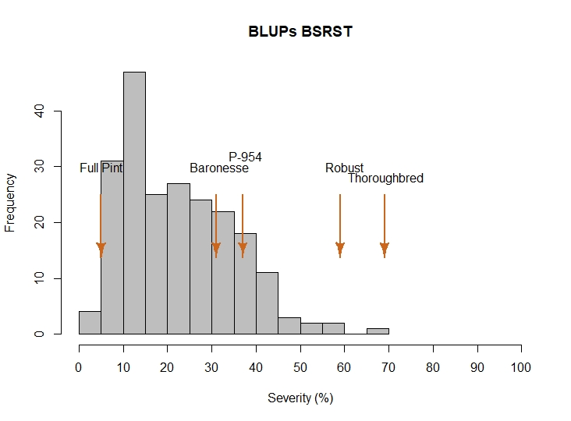
$$H^{2}=0.26$$

BSRST 2021 – Oregon and California data

Reaction to BSR and SC at adult plant stage; Corvallis, OR and Davis, CA

Histogram distribution across dates and sites

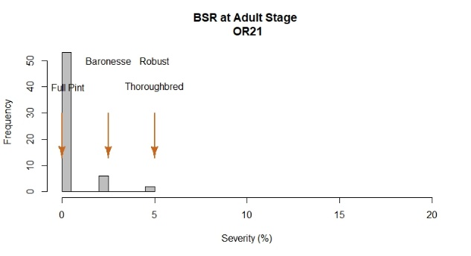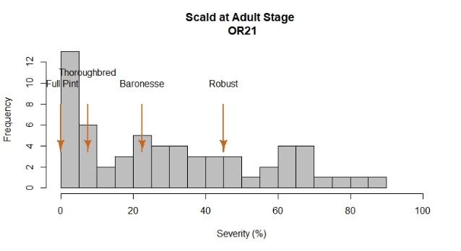

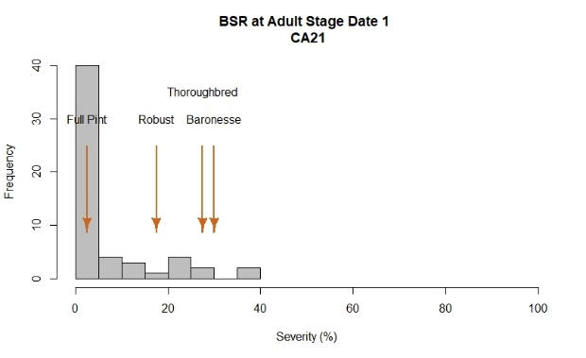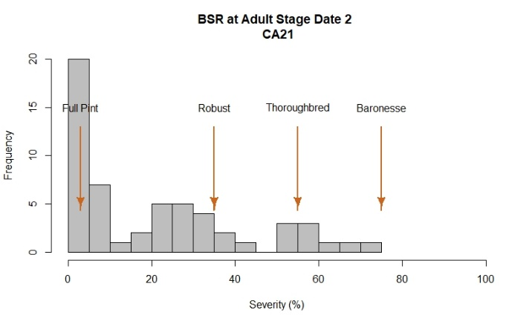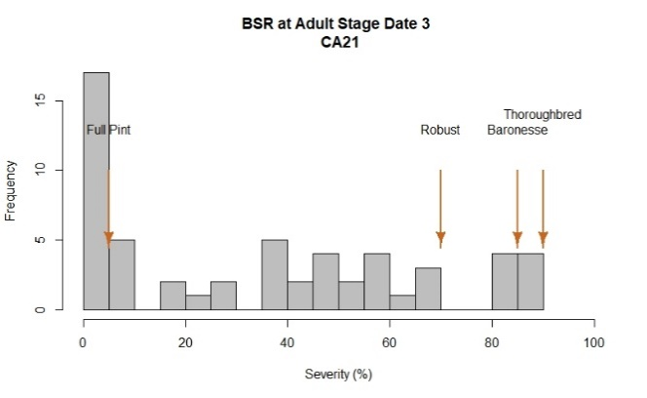

2021 Field evaluations
The barley stripe rust nurseries were evaluated using severity at Davis and Corvallis during 2021. At Davis, disease notes were taken three times during the growing season - at 10-day intervals. At Corvallis, one evaluation was performed, after flowering was finished.

There was greater phenotypic variation at Davis than at Corvallis, as shown in the histograms. At both locations, Full Pint, Baronesse, Thoroughbred and Robust were used as common checks.

At Corvallis, there was a low infection rate was observed among checks. Robust, Baronesse and Thoroughbred, the susceptible checks, exhibited severity values lower than 5%, indicating a low incidence of stripe in this environment. Moreover, more than 90% of the tested lines exhibited a severity value of 2.5% or lower.

Davis data showed a wide range of phenotypic variation among lines and across dates. Controls Baronesse and Thoroughbred showed the highest severity values with 85 and 90% by the end of the third read. The resistant check Full Pint had the lowest severity values (5%).

Severity: At Davis, 40% of the entries in this trial exhibited severity values between 0-10%. As observed in the histogram, 21 lines had severities < 10% and 13 lines exhibited severities > 60%.

Scald (SC) was evaluated at Corvallis during this season, as percent severity on a plot basis. There was substantial disease pressure. The BSRST trial exhibited a large variation for this trait with 50% of lines exhibiting severity values ranging from 7.5 to 47.5%. Checks Baronesse and Robust were among the more susceptible entries, with severities of 22.5 and 45%, respectively.

Analysis of variance for BSR

BSR OR21
Severity
Df Sum Sq Mean Sq F value Pr(>F)
Line 60 152.68 2.545 0.799 0.7986
Rep 1 15.69 15.686 4.923 0.0311 *
Residuals 50 159.31 3.186
---
Signif. codes: 0 ‘***’ 0.001 ‘**’ 0.01 ‘*’ 0.05 ‘.’ 0.1 ‘ ’ 1

Scald OR21
Severity
Df Sum Sq Mean Sq F value Pr(>F)
Line 60 75772 1262.9 8.736 4.22e-13 ***
Rep 1 906 906.0 6.268 0.0156 *
Residuals 50 7228 144.6
---
Signif. codes: 0 ‘***’ 0.001 ‘**’ 0.01 ‘*’ 0.05 ‘.’ 0.1 ‘ ’ 1

BSR CA21
Severity 1
Df Sum Sq Mean Sq F value Pr(>F)
Line 55 11503 209.1 1.734 0.021715 *
Rep 1 2100 2100.2 17.414 0.000108 ***
Residuals 55 6633 120.6
---
Signif. codes: 0 ‘***’ 0.001 ‘**’ 0.01 ‘*’ 0.05 ‘.’ 0.1 ‘ ’ 1

BSR CA21
Severity 2
Df Sum Sq Mean Sq F value Pr(>F)
Line 55 52535 955 3.761 1.14e-06 ***
Rep 1 10089 10089 39.725 5.20e-08 ***
Residuals 55 13968 254
---
Signif. codes: 0 ‘***’ 0.001 ‘**’ 0.01 ‘*’ 0.05 ‘.’ 0.1 ‘ ’ 1

BSR CA21
Severity 3
Df Sum Sq Mean Sq F value Pr(>F)
Line 55 106056 1928.3 6.928 1.17e-11 ***
Rep 1 2286 2286.0 8.213 0.00588 **
Residuals 55 15309 278.3
---
Signif. codes: 0 ‘***’ 0.001 ‘**’ 0.01 ‘*’ 0.05 ‘.’ 0.1 ‘ ’ 1

Correlation among sites for BSR and SC
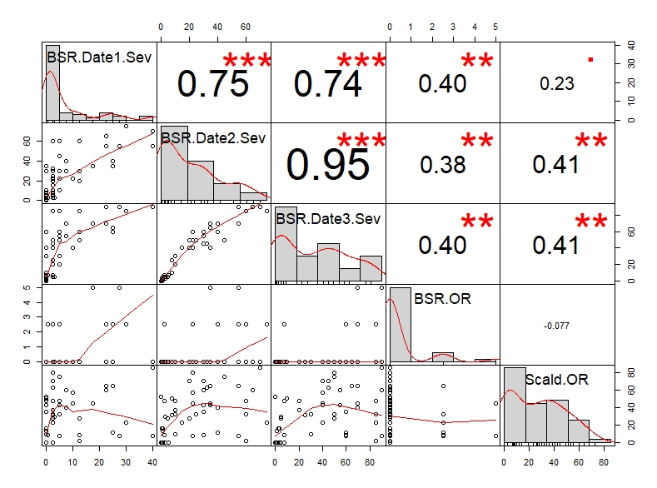

LSD test for BSR and SC; Corvallis, OR and Davis, CA
Entry | Line | BSR OR | Scald OR | BSR Sev1 CA | BSR Sev2 CA | BSR Sev3 CA
1 | Full Pint | 0 | 0 | 2.5 | 3 | 5
2 | Baronesse | 2.5 | 22.5 | 30 | 75 | 85
3 | Robust | 5 | 45 | 17.5 | 35 | 70
4 | Thoroughbred | 5 | 7.5 | 27.5 | 55 | 90
5 | Alba | 0 | 0 | 0 | 0.5 | 0.5
6 | Wintmalt | 2.5 | 7.5 | 5 | 22.5 | 60
7 | DH140963 | 0 | 0 | 0 | 5.5 | 7.5
8 | DH141132 | 0 | 0 | 0 | 3 | 5
9 | DH141222 | 0 | 0 | 0 | 1 | 1
10 | DH141225 | 0 | 0 | 0 | 3 | 3
11 | DH141917 | 0 | 0 | 0 | 1 | 5
12 | DH150683 | 0 | 0 | 0 | 0 | 0
13 | DH170417 | 0 | 0 | 2.5 | 3 | 5
14 | DH131679 | 0 | 0 | 0 | 1 | 3
15 | DH162310 | 0 | 0 | 0 | 0.5 | 3
16 | DH170472 | 0 | 0 | 0 | 0.5 | 1
17 | 13ARS537-13 | 0 | 30 | 3 | 3 | 5
18 | 13ARS537-19 | 0 | 65 | 25 | 35 | 65
19 | 12ARS777-1 | 0 | 9 | 12.5 | 30 | 60
20 | 12ARS777-2 | 0 | 7.5 | 40 | 55 | 90
21 | 11ARS809-1 | 2.5 | 11.5 | 25 | 40 | 60
22 | 11ARS191-3 | 0 | 40 | 7.5 | 40 | 70
23 | 11ARS162-4 | 0 | 50 | 0 | 7.5 | 10
24 | 11ARS183-9 | 0 | 10 | 0 | 10 | 30
25 | 2Ab08-X05M10-82 | 0 | 37.5 | 2.5 | 10 | 20
26 | 12ARS314-6 | 0 | 2.5 | 12.5 | 60 | 85
27 | 11WAM-107.43 | 0 | 47.5 | 5 | 60 | 85
28 | 11WAM-107.58 | 0 | 60 | 7.5 | 30 | 55
29 | 12WAM-120.14 | 0 | 47.5 | 5 | 10 | 20
30 | 12WAM-120.17 | 0 | 42.5 | 0 | 35 | 40
31 | 13WAM-135.3 | 0 | 22.5 | 2.5 | 15 | 40
32 | 13WA-135.26 | 0 | 42.5 | 5 | 30 | 55
33 | 13WAM-136.1 | 2.5 | 32.5 | 2.5 | 60 | 85
34 | 13WAM-136.2 | 0 | 35 | 0 | 30 | 60
35 | 13WA-149.2 | 0 | 31 | 2.5 | 7.5 | 25
36 | 13WAM-149.7 | 0 | 32.5 | 5 | 10 | 30
37 | UC Tahoe | 0 | 27.5 | 2.5 | 5 | 5
38 | UC Capay | 0 | 52.5 | 0 | 0 | 0
39 | Butta 12 | 0 | 27.5 | 12.5 | 20 | 50
40 | UC 1322 | 0 | 32.5 | 2.5 | 25 | 50
41 | B9K62 | 2.5 | 8.5 | 0.5 | 2.5 | 7.5
42 | B9K58 | 0 | 16 | 0 | 0.5 | 2.5
43 | B9K79 | 0 | 16 | 0 | 1 | 3
44 | UC 1280 | 0 | 13.5 | 0 | 1 | 1
45 | UC SCHALLER | 0 | 47.5 | 2.5 | 2.5 | 7.5
46 | Tamalpais | 0 | 47.5 | 0 | 2.5 | 7.5
47 | MT16M00406 | 0 | 70 | 2.5 | 20 | 40
48 | MT17M01908 | 0 | 75 | 5 | 45 | 50
49 | MT17M00302 | 0 | 80 | 2.5 | 22.5 | 50
50 | MT17M05508 | 0 | 62.5 | 2.5 | 32.5 | 45
51 | MT16M00707 | 0 | 57.5 | 10 | 22.5 | 40
52 | Buzz | 0 | 70 | 2.5 | 30 | 45
53 | MT16M07806 | 0 | 45 | 10 | 22.5 | 40
54 | MT16M01705 | 0 | 60 | 22.5 | 65 | 90
55 | MT16H09302 | 0 | 85 | 40 | 70 | 90
56 | MT16F02910 | 2.5 | 65 | 22.5 | 55 | 70
 | LSD | 3.42 | 27.98 | 22 | 32 | 33

