The Barley Stripe Rust Cycle 0

Javier Hernandez, Tanya Filichkin, Scott Fisk, Laura Helgerson, and Patrick Hayes
BarleyWorld. Oregon State University. Corvallis, Oregon, USA.

Germplasm:
The Cycle 0 array is an array of 127 winter and facultative lines from the OSU breeding program, 8 varieties and 4 checks. This panel contains winter, facultative, and spring growth habit accessions that were phenotyped for stripe rust resistance at the adult plant stage at Corvallis, Oregon and Davis, California. It is possible to test germplasm of the three growth habits in fall-planted experiments due to the unique climatic conditions at Corvallis and Davis. Temperatures at Corvallis are rarely low enough to cause injury to spring growth habit types but they are low enough at Davis to ensure sufficient vernalization of winter growth habit types

Stripe rust (and other diseases) - assessment procedures:
Barley stripe rust (BSR, incited by Puccinia striiformis f.sp. hordei) is a serious disease of barley throughout the world. In the US, it is endemic in cooler, wetter areas of the west coast. However, there are an increasing number of reports of stripe rust on barley from other parts of the US and the world. Therefore, continued progress in screening for resistance in current, new, and potential varieties is warranted.

Disease susceptibility was measured for the principal diseases using severity and/or infection type present at Corvallis, OR and Davis, CA. Severity (Sev) was scored as percentage of leaf area affected with the disease on a plot basis, whereas infection type (IT) was recorded according the scale proposed by McNeal et al. (1971). Rust nurseries were evaluated for adult plant resistance to BSR using infection type and severity at Davis, CA and severity at Corvallis, OR. A Randomized Complete Block Design with two replications and four checks – Baronesse, P-954, Full Pint and Robust - was used. Natural infection was supplemented with artificial inoculation. Notes on other diseases were recorded as they were present in this trial.

Data:
Please see https://barleyworld.org/barley-stripe-rust-bsr

Fundings:
Support provided by USDA-ARS-NACA for stripe rust and stem rust research.

This report:
In this report, we provide information and interpretation for Cycle 0 trial across all locations where it was tested.

Cycle 0 2016 – Oregon and California data

Reaction to BSR at adult plant stage; Corvallis, OR and Davis, CA

Histograms across sites

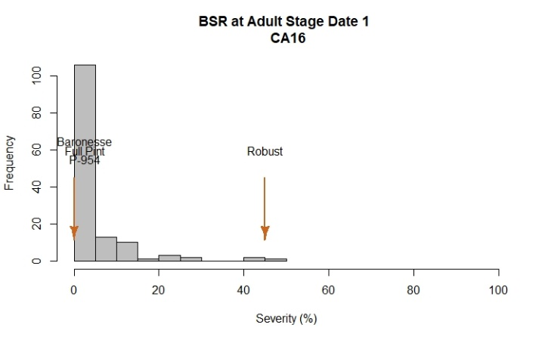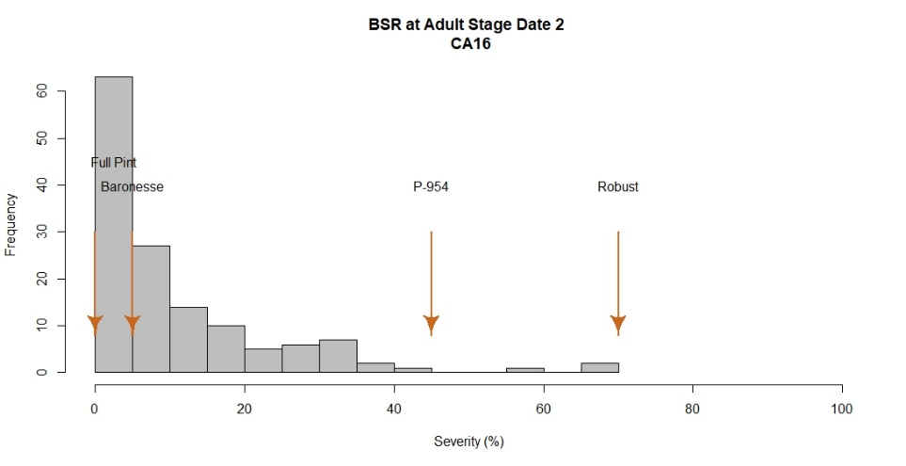
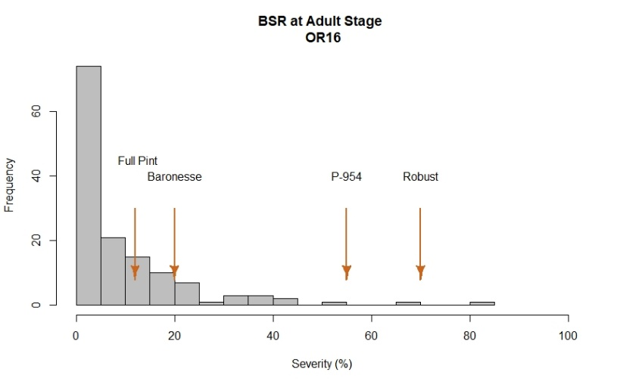
2016 Field Evaluations
The barley stripe rust nurseries were evaluated using severity and infection type at Davis and severity at Corvallis. At Davis, disease notes were taken two times during the growing season at a10 day interval. At Corvallis, one evaluation was performed after flowering was finished.

Davis exhibited a larger phenotypic variation among lines compared to Corvallis, based on histogram plots. At both locations, Robust, Baronesse, P-954 and Full Pint were used as checks and exhibited the expected range of severity values for barley stripe rust.

At Corvallis, Robust and P-954 showed the highest severity values with 70% and 55%, respectively. The resistant check Full Pint had the lowest value with 12.5%. A total of 95 lines showed 10% or less of severity whereas 6 lines were rated with severity values > 40%. 50% of lines at this location exhibited severity values between 0-15%.

At Davis, a range of phenotypic variation was observed among lines and across dates. Controls Robust and P-954 showed the highest severity values with 70% and 45%, respectively. The resistant check Full Pint had the lowest values with 0%.

Severity: 50% of lines in this trial exhibited severity values between 5-15%. As observed in the histogram, 104 lines had severities < 15% and 6 lines exhibited severities > 40%.

Analysis of variance for BSR

BSR OR16
Severity
Df Sum Sq Mean Sq F value Pr(>F)
Line 138 55047 398.9 3.755 3.18e-14 ***
Rep 1 4 4.4 0.041 0.839
Residuals 138 14658 106.2
---
Signif. codes: 0 ‘***’ 0.001 ‘**’ 0.01 ‘*’ 0.05 ‘.’ 0.1 ‘ ’ 1

BSR CA16
Severity Date 1
Df Sum Sq Mean Sq F value Pr(>F)
Line 137 21902 159.87 3.209 1.66e-11 ***
Rep 1 97 97.45 1.956 0.164
Residuals 137 6826 49.82
---
Signif. codes: 0 ‘***’ 0.001 ‘**’ 0.01 ‘*’ 0.05 ‘.’ 0.1 ‘ ’ 1
Severity Date 2
Df Sum Sq Mean Sq F value Pr(>F)
Line 137 49267 360 2.596 2.23e-08 ***
Rep 1 4432 4432 31.991 8.68e-08 ***
Residuals 137 18980 139
---
Signif. codes: 0 ‘***’ 0.001 ‘**’ 0.01 ‘*’ 0.05 ‘.’ 0.1 ‘ ’ 1

Correlation among sites for BSR
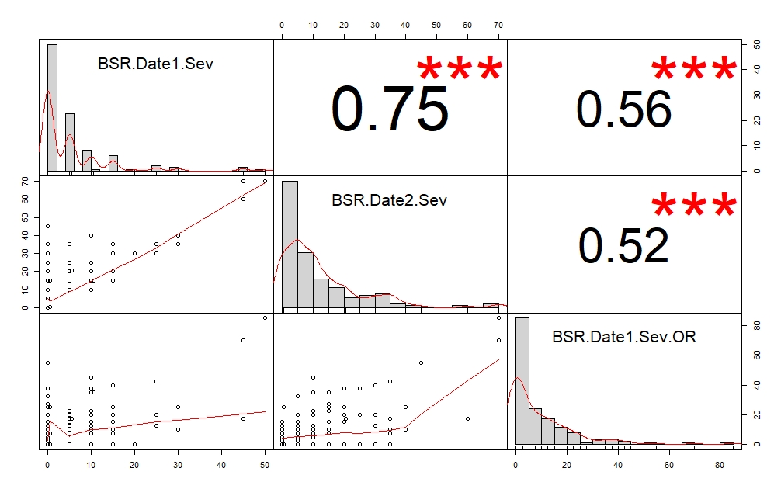

LSD test for BSR; Corvallis, OR and Davis, CA

Line | BSR.Date1.Sev | BSR.Date2.Sev | BSR.Date1.Sev.OR
10.0777 | 15 | 30 | 40
10.086 | 15 | 35 | 7.5
10.0925 | 15 | 20 | 0
11.1124LC | 45 | 60 | 17.5
11.1169LC | 0 | 10 | 0
11.1209LC | 0 | 20 | 0
111113LC | NA | NA | 0
120593 | 5 | 15 | 0
130070LC | 0 | 35 | 0
130208LC | 0 | 0 | 0
130220LC | 5 | 25 | 0
130232LC | 0 | 5 | 2.5
130316LC | 0 | 25 | 0
130332LC | 5.5 | 20.5 | 17.5
Alba | 0 | 0 | 0
Baronesse | 0 | 5 | 20
Buck | 0 | 10 | 0
Charles | 0 | 10 | 0
DH 10.1044 | 0 | 10 | 7.5
DH120036 | 5 | 10 | 5
DH120104 | 0 | 10 | 0
DH120175 | 5 | 10 | 0
DH120178 | 0 | 15 | 15
DH120203 | 5 | 10 | 0
DH120228 | 5 | 5 | 0
DH120232 | 5 | 15 | 0
DH120238 | 5 | 10 | 10
DH120276 | 15 | 15 | 25
DH120293 | 0 | 5 | 2.5
DH120304 | 0 | 20 | 25
DH120412 | 30 | 35 | 10
DH130004 | 10 | 25 | 20
DH130718 | 0 | 5 | 0
DH130735 | 0 | 0 | 0
DH130762 | 0 | 10 | 0
DH130765 | 0 | 30 | 0
DH130910 | 15 | 20 | 0
DH130935 | 5 | 10 | 10
DH130939 | 5 | 10 | 0
DH131038 | 0 | 15 | 27.5
DH131055 | 0 | 5 | 0
DH131064 | 10 | 10 | 35
DH131110 | 25 | 30 | 12.5
DH131127 | 0 | 0 | 5
DH131142 | 0 | 5 | 20
DH131143 | 0 | 10 | 0
DH131184 | NA | NA | 0
DH131191 | 0 | 15 | 0
DH131198 | 0 | 20 | 37.5
DH131207 | 5 | 5 | 0
DH131288 | 0 | 10 | 0
DH131406 | 10 | 40 | 10
DH131433 | 0 | 5 | 15
DH131514 | 0 | 10 | 7.5
DH131569 | 0 | 5 | 7.5
DH131679 | 0 | 5 | 5
DH131738 | 0.5 | 15 | 7.5
DH131742 | 0 | 0 | 0
DH131744 | 5 | 35 | 17.5
DH131759 | 0 | 30 | 0
DH131786 | 15 | 35 | 0
DH131890 | 0 | 10 | 0
DH131892 | 0 | 0 | 0
DH131926 | 10 | 10 | 45
DH131937 | 5 | 15 | 0
DH131995 | 0 | 0 | 0
DH132007 | 0 | 5 | 2.5
DH132020 | 5 | 5 | 0
DH132158 | 0 | 0 | 0
DH133425 | 0 | 0 | 0
DH133967 | 0 | 0 | 0
DH133971 | 5 | 10 | 22.5
DH140083 | 0 | 0 | 0
DH140088 | 5 | 20 | 0
DH140182 | 0 | 0 | 0
DH140184 | 0 | 5 | 15
DH140185 | 10 | 25 | 37.5
DH140189 | 0 | 0 | 7.5
DH140192 | 10 | 10 | 10
DH140288 | 15 | 15 | 10
DH140340 | 5 | 5 | 12.5
DH140958 | 0 | 5 | 0
DH140959 | 0 | 0 | 5
DH140960 | 5 | 10 | 0
DH140963 | 0 | 0 | 7.5
DH140974 | 0 | 5 | 7.5
DH140975 | 50 | 70 | 85
DH140978 | 30 | 40 | 25
DH140980 | 25 | 35 | 42.5
DH140996 | 10 | 10 | 20
DH140997 | 0 | 5 | 0
DH141000 | 5 | 5 | 0
DH141001 | 0 | 0 | 15
DH141003 | 10.5 | 15 | 35
DH141004 | 5 | 5 | 15
DH141005 | 0.5 | 0.5 | 0
DH141011 | 5 | 5 | 12.5
DH141012 | 15 | 15 | 15
DH141015 | 0.5 | 0.5 | 25
DH141077 | 5 | 5 | 20
DH141085 | 10 | 10 | 7.5
DH141117 | 20 | 30 | 0
DH141122 | 5 | 5 | 0
DH141126 | 0 | 35 | 0
DH141129 | 5 | 10 | 0
DH141131 | 0 | 15 | 0
DH141132 | 15 | 20 | 20
DH141144 | 0 | 15 | 0
DH141147 | 0 | 0 | 10
DH141151 | 5 | 5 | 0
DH141152 | 5 | 10 | 7.5
DH141160 | 10 | 10 | 0
DH141161 | 0 | 5 | 0
DH141170 | 5 | 5 | 12.5
DH141173 | 0 | 0 | 2.5
DH141178 | 0 | 5 | 0
DH141179 | 0 | 5 | 0
DH141196 | 0 | 0 | 0
DH141198 | 5 | 5 | 10
DH141204 | 5 | 20 | 0
DH141216 | 0 | 5 | 32.5
DH141217 | 5 | 5 | 12.5
DH141220 | 5 | 5 | 15
DH141221 | 10 | 20 | 15
DH141222 | 0.5 | 0.5 | 25
DH141224 | 0 | 5 | 0
DH141225 | 0 | 0 | 7.5
DH141226 | 10 | 15 | 22.5
DH141364 | 0 | 0 | 10
DH141373 | 10 | 10 | 12.5
DH141375 | 0 | 20 | 0
Endeavor | 5 | 5 | 7.5
Full Pint | 0 | 0 | 12.5
Maja | 0 | 0 | 0
P-954 | 0 | 45 | 55
Robust | 45 | 70 | 70
Strider | 0 | 0 | 0
Verdant | 0 | 0 | 0
Wintmalt | 25 | 30 | 20
LSD | 13.95 | 23.27 | 20.37

BLUPs across environments (OR16 and CA16) for BSR

The best linear unbiased predictions (BLUPs) for each line across two environments – Corvallis and Davis 2016 - for disease severity at adult plant stage, expressed as
percentage (%) of leaf area affected with barley stripe rust were obtained and plotted in a histogram distribution graphic. A range of phenotypic variation was observed among lines when environments were included in the same model. The susceptible checks Robust and P-954 exhibited the highest severity values with 51% and 37%, respectively. The resistant check Full Pint had the lowest severity, at 8%. A total of 109 lines exhibited values ≤ 15% whereas just two lines were rated with severity ≥ 40%. The heritability of adult plant resistance was 0.60.

Histogram BLUPs
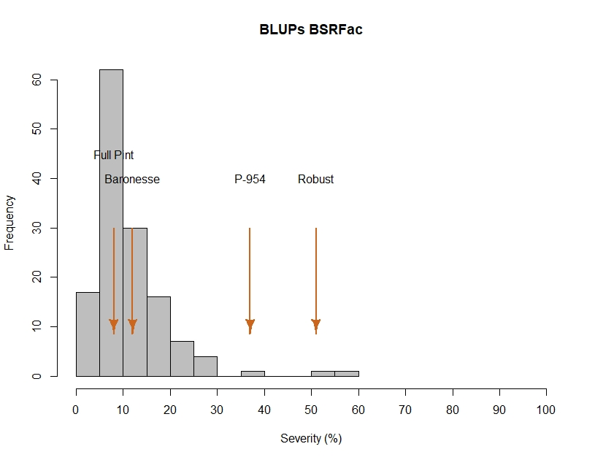
$$H^{2}=0.60$$

