Cycle I Report

Javier Hernandez, Tanya Filichkin, Scott Fisk, Laura Helgerson, and Patrick Hayes
BarleyWorld. Oregon State University. Corvallis, Oregon, USA.

Germplasm:
The Cycle I doubled haploid panel is a germplasm array of 123 doubled haploid lines derived from crosses among parents with resistance to one or more rust diseases (stem, stripe, leaf) and 4 checks. This trial was grown during 2015/16 and 2016/17 seasons at Corvallis, OR and Davis, CA. This report covers stripe rust and leaf rust data generated across all environments.

Stripe rust (and other diseases) - assessment procedures:
Disease susceptibility was measured for the principal diseases using severity and/or infection type present at Corvallis, OR and Davis, CA. Severity (Sev) was scored as percentage of leaf area affected with the disease on a plot basis, whereas infection type (IT) was recorded according the scale proposed by McNeal et al. (1971). Rust nurseries were evaluated for adult plant resistance to barley stripe rust (BSR, incited by Puccinia striiformis f. sp. hordei) using infection type and severity in Davis, CA and as severity in Corvallis, OR.

A Randomized Complete Block Design with two replications and four checks - Baronesse, Robust, P-954 and Full Pint - was used. Natural infection was supplemented with artificial inoculation. Notes on other diseases were recorded as they were present in this trial. In this data set, we also provide information on leaf rust (LR, incited by Puccinia hordei). Leaf rust was evaluated using severity at Davis.

Data:
Please see https://barleyworld.org/barley-stripe-rust-bsr

Publication(s):
Hernandez, J., B.J. Steffenson, T. Filichkin, S.P. Fisk, L. Helgerson, B. Meints, K.J. Vining, D. Marshall, A. del Blanco, X. Chen and P.M. Hayes. 2019. Introgression of rpg4/Rpg5 into barley germplasm provides insights into the genetics of resistance to Puccinia graminis f.sp. tritici race TTKSK and resources for developing resistant cultivars. Phytopathology. 109:1018-1028.

Funding:
Support provided by USDA-ARS-NACAs for stripe rust and stem rust research.

This report:
In this report, we provide additional information and interpretation, with a focus on stripe rust and leaf rust, beyond what was published in Hernandez et al. (2019).

Cycle I 2016 – Oregon and California data

Reaction to BSR and LR at adult plant stage; Corvallis, OR and Davis, CA

Histogram distribution across sites and dates

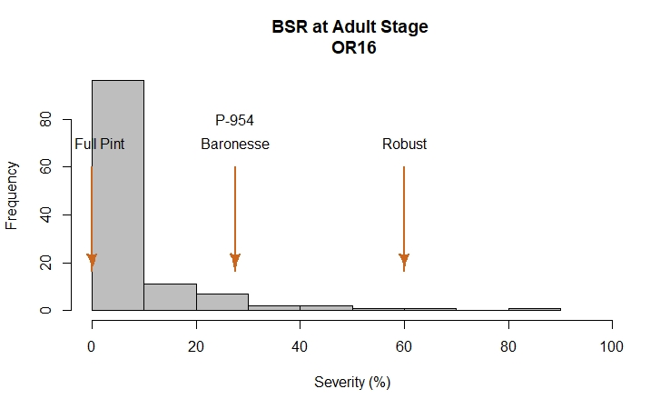
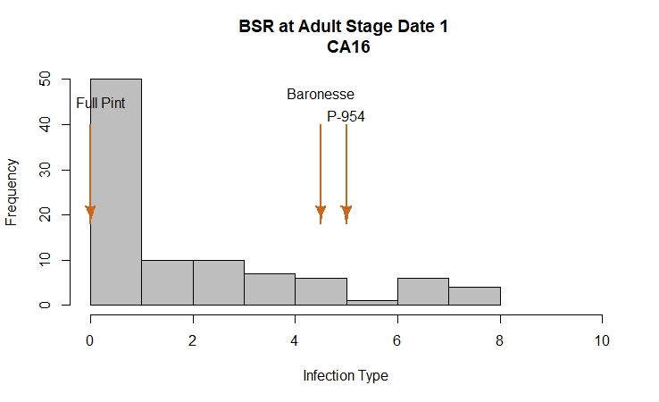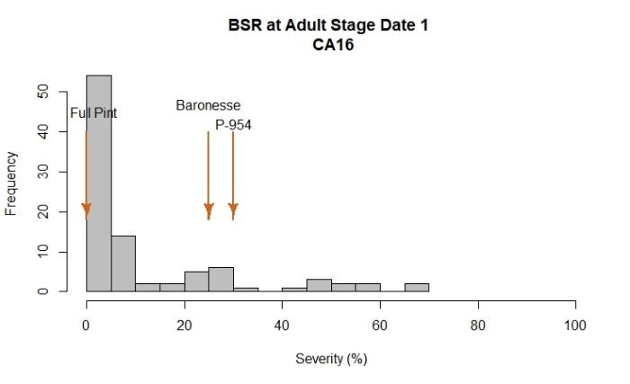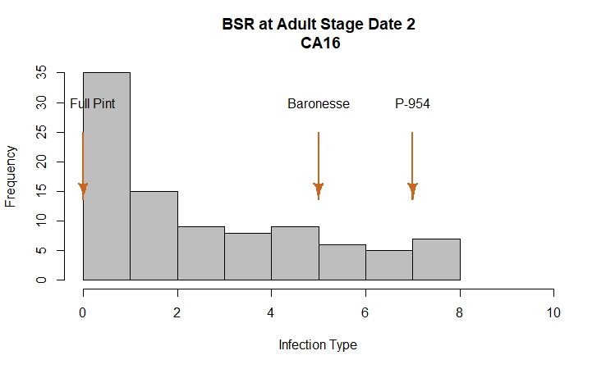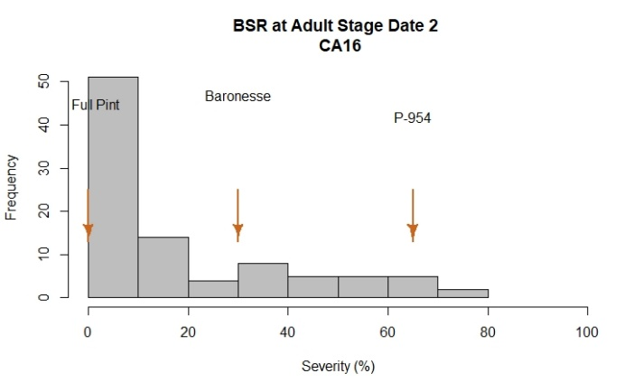
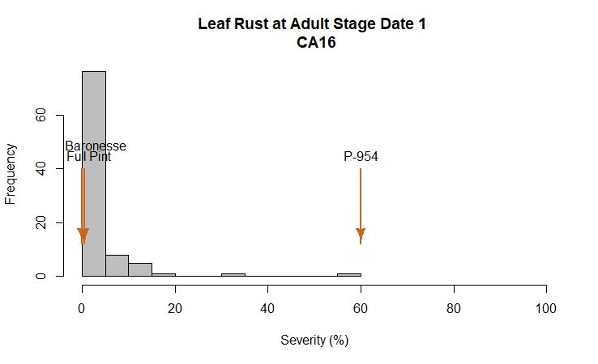

2016 Field Evaluations

The barley stripe rust nurseries were evaluated using severity and infection type at Davis and severity at Corvallis. At Davis, disease notes were taken two times during the growing season at a 10-day interval. At Corvallis, one evaluation was performed after flowering was finished.

Davis exhibited a larger phenotypic variation among lines compared to Corvallis, based on histogram plots. At both locations, P-954, Baronesse, and Full Pint were used as common checks. Robust was only added as check at Corvallis. All checks exhibited the expected range of severity values for barley stripe rust.

At Corvallis, Robust showed the highest severity values with 60%. The resistant check Full Pint had the lowest value with 0.0%. A total of 90 lines did not show symptoms of disease infection whereas just five lines were rated with severity values similar to the susceptible check. 50% of lines at this location exhibited severity values between 2% and 30%.

At Davis, a range of phenotypic variation was observed among lines and across dates. Susceptible checks Baronesse and P-954 showed the highest infection type/severity values with 5/30% and 7/65%, respectively. The resistant check Full Pint had the lowest value with 0/0%.

Infection type: A total of 38 lines had infection types ≤ 3 whereas 11 lines were rated with infection type > 7, similar to the susceptible check P-954. 50% of the lines at this location had infection type values between 0 and 4.5.

Severity: 50% of the lines in this trial exhibited severity values between 0% and 35%. As observed in the histogram, 51 lines had severities < 10% and 18 lines exhibited severities > 40%.

Leaf rust (LR) was evaluated at Davis during this season. The Cycle I population exhibited some variation for this trait with 50% of lines having severity values ranging from 0 to 3%. The P-954 check was susceptible, with 60% severity whereas Full Pint and Baronesse had severities of 0 and 0.5%, respectively.

Analysis of variance for BSR and LR

BSR OR16
Severity
Df Sum Sq Mean Sq F value Pr(>F)
Line 120 49601 413.3 8.073 <2e-16 ***
Rep 1 81 81.0 1.582 0.211
Residuals 120 6144 51.2
---
Signif. codes: 0 ‘***’ 0.001 ‘**’ 0.01 ‘*’ 0.05 ‘.’ 0.1 ‘ ’ 1

BSR CA16
Infection Type Date 1
Df Sum Sq Mean Sq F value Pr(>F)
Line 93 1052.4 11.316 4.604 1.05e-12 ***
Rep 1 29.9 29.920 12.173 0.000743 ***
Residuals 93 228.6 2.458
---
Signif. codes: 0 ‘***’ 0.001 ‘**’ 0.01 ‘*’ 0.05 ‘.’ 0.1 ‘ ’ 1
Severity Date 1
Df Sum Sq Mean Sq F value Pr(>F)
Line 93 61296 659.1 4.469 2.57e-12 ***
Rep 1 2518 2517.8 17.074 7.86e-05 ***
Residuals 93 13714 147.5
---
Signif. codes: 0 ‘***’ 0.001 ‘**’ 0.01 ‘*’ 0.05 ‘.’ 0.1 ‘ ’ 1
Infection Type Date 2
Df Sum Sq Mean Sq F value Pr(>F)
Line 93 1223.3 13.154 4.662 7.21e-13 ***
Rep 1 27.6 27.574 9.772 0.00236 **
Residuals 93 262.4 2.822
---
Signif. codes: 0 ‘***’ 0.001 ‘**’ 0.01 ‘*’ 0.05 ‘.’ 0.1 ‘ ’ 1
Severity Date 2
Df Sum Sq Mean Sq F value Pr(>F)
Line 93 90936 977.8 4.506 2.02e-12 ***
Rep 1 1909 1908.5 8.795 0.00384 **
Residuals 93 20182 217.0
---
Signif. codes: 0 ‘***’ 0.001 ‘**’ 0.01 ‘*’ 0.05 ‘.’ 0.1 ‘ ’ 1

LR CA16
Severity Date 1
Df Sum Sq Mean Sq F value Pr(>F)
Line 92 10679 116.08 5.875 8.29e-16 ***
Rep 1 40 40.20 2.035 0.157
Residuals 91 1798 19.76
---
Signif. codes: 0 ‘***’ 0.001 ‘**’ 0.01 ‘*’ 0.05 ‘.’ 0.1 ‘ ’ 1

Correlation among dates and sites for BSR and LR
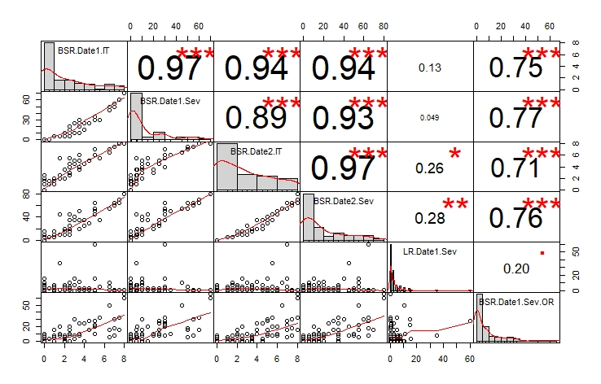

LSD test for BSR and LR; Corvallis, OR and Davis, CA

 | Line | BSR.Date1.IT | BSR.Date1.Sev | BSR.Date2.IT | BSR.Date2.Sev | LR.Date1.Sev | BSR.Date1.Sev.OR
1 | Baronesse | 4.5 | 25 | 5 | 30 | 0.5 | 27.5
2 | DH140030 | 0 | 0 | 1 | 5 | 5 | 0
3 | DH140031 | 0 | 0 | 0 | 0 | 0.5 | 0
4 | DH140032 | 0 | 0 | 0 | 0 | 3 | 0
5 | DH140075 | 0 | 0 | 0 | 0 | 0 | 0
6 | DH140076 | 1 | 5 | 1 | 5 | 0 | 5
7 | DH140077 | 0 | 0 | 0 | 0 | 0.5 | 0
8 | DH140078 | 2 | 10 | 3.5 | 20 | 3 | 0
9 | DH140079 | 0 | 0 | 0 | 0 | 0.5 | 0
10 | DH140080 | 0 | 0 | 0 | 0 | 1 | 0
11 | DH140081 | 6.5 | 50 | 7 | 55 | 5 | 5
12 | DH140123 | 1 | 5 | 2 | 15 | 5 | 15
13 | DH140124 | 2 | 10 | 3.5 | 15 | 1 | 2.5
14 | DH140173 | 1 | 5 | 1 | 5 | 3 | 0
15 | DH140174 | 1.5 | 5.5 | 2.5 | 10 | 1 | 20
16 | DH140176 | 0 | 0 | 0 | 0 | 0 | 0
17 | DH140177 | 4 | 15 | 4.5 | 35 | 3 | 0
18 | DH140179 | 2.5 | 10 | 3 | 10 | 1 | 0
19 | DH140180 | 3 | 10 | 5 | 40 | 15 | 30
20 | DH140211 | 0 | 0 | 1.5 | 5 | 10.5 | 0
21 | DH140212 | 0 | 0 | 0 | 0 | 7.5 | 0
22 | DH140213 | 0.5 | 0.5 | 1 | 5 | 2.5 | 2.5
23 | DH140215 | 1 | 5 | 1.5 | 5 | 1 | 0
24 | DH140268 | 0 | 0 | 0 | 0 | 5 | 2.5
25 | DH140269 | 0 | 0 | 0 | 0 | 3 | 7.5
26 | DH140270 | 5.5 | 30 | 5.5 | 35 | 5 | 32.5
27 | DH140271 | 2.5 | 20 | 3 | 25 | 3 | 10
28 | DH140272 | 2 | 10 | 2 | 10 | 2.5 | 0
29 | DH140273 | 0 | 0 | 0 | 0 | 0.5 | 0
30 | DH140274 | 0 | 0 | 0 | 0 | 1 | 0
31 | DH140275 | 0 | 0 | 0 | 0 | 0 | 0
32 | DH140276 | 0 | 0 | 0 | 0 | 1 | 0
33 | DH140277 | 0 | 0 | 0 | 0 | 0 | 0
34 | DH140278 | 0 | 0 | 0 | 0 | 0.5 | 0
35 | DH140279 | 7 | 50 | 7.5 | 65 | 0.5 | 17.5
36 | DH140280 | 1.5 | 5 | 5.5 | 45 | 35 | 7.5
37 | DH140281 | 0 | 0 | 2.5 | 10 | 15.5 | 2.5
38 | DH140282 | 2 | 5 | 3.5 | 15 | 5.5 | 0
39 | DH140283 | 2.5 | 5 | 2.5 | 15 | 5.5 | 7.5
40 | DH140284 | 0 | 0 | 0 | 0 | 1 | 0
41 | DH140286 | 5 | 30 | 7 | 55 | 15 | 22.5
42 | DH140299 | 0 | 0 | 0 | 0 | NA | 0
43 | DH140324 | 0 | 0 | 2.5 | 10 | 3 | 7.5
44 | DH140325 | 0 | 0 | 0 | 0 | 5 | 0
45 | DH140326 | 0 | 0 | 1.5 | 5 | 3 | 2.5
46 | DH140327 | 6.5 | 45 | 6.5 | 55 | 10.5 | 50
47 | DH140328 | 3.5 | 10 | 4 | 20 | 11 | 10
48 | DH140329 | 1.5 | 5 | 2 | 10 | 0.5 | 10
49 | DH140330 | 2 | 5.5 | 3.5 | 20 | 7.5 | 5
50 | DH140332 | 0 | 0 | 2.5 | 15 | 3 | 0
51 | DH140334 | 1 | 5 | 2 | 15 | 0.5 | 7.5
52 | DH140338 | 8 | 70 | 8 | 80 | 0.5 | 65
53 | DH140339 | 7 | 55 | 7.5 | 65 | 0 | 7.5
54 | DH140361 | 3 | 10 | 4.5 | 35 | 7.5 | 2.5
55 | DH140404 | 0 | 0 | 0 | 0 | 0.5 | 2.5
56 | DH140405 | 5 | 35 | 6 | 50 | 0.5 | 10
57 | DH140406 | 2 | 10 | 2 | 10 | 0.5 | 0
58 | DH140407 | 0 | 0 | 2 | 15 | 3 | 10
59 | DH140409 | 3.5 | 30 | 4 | 35 | 2.5 | 25
60 | DH140410 | 6.5 | 50 | 7 | 55 | 0.5 | 15
61 | DH140412 | 2.5 | 15 | 5.5 | 45 | 0.5 | 20
62 | DH140413 | 3.5 | 30 | 6 | 50 | 3 | 7.5
63 | DH140417 | 3 | 25 | 5 | 35 | 0 | 7.5
64 | DH140419 | 2.5 | 10 | 4.5 | 20 | 0.5 | 0
65 | DH140420 | 2.5 | 10 | 3 | 15 | 10 | 0
66 | DH140421 | 5 | 30 | 6 | 45 | 0 | 20
67 | DH140423 | 0 | 0 | 2.5 | 15 | 0.5 | 2.5
68 | DH140426 | 0 | 0 | 2 | 10 | 1 | 0
69 | DH140430 | 4 | 25 | 4.5 | 25 | 1 | 25
70 | DH140450 | 0 | 0 | 0 | 0 | 0 | 0
71 | DH140452 | 0 | 0 | 0 | 0 | 0.5 | 2.5
72 | DH140453 | 1 | 5 | 1 | 5 | 0.5 | 0
73 | DH140499 | 0 | 0 | 0 | 0 | 2.5 | 0
74 | DH140500 | 7.5 | 60 | 8 | 70 | 0.5 | 15
75 | DH140501 | 0 | 0 | 1.5 | 5 | 0.5 | 0
76 | DH140502 | 7.5 | 60 | 8 | 65 | 0.5 | 32.5
77 | DH140503 | 1 | 5 | 1.5 | 5 | 7.5 | 7.5
78 | DH140504 | 0 | 0 | 0 | 0 | 1 | 0
79 | DH140506 | 3.5 | 25 | 5 | 35 | 0.5 | 10
80 | DH140507 | 0 | 0 | 0 | 0 | 3 | 0
81 | DH140508 | 0 | 0 | 1 | 5 | 2.5 | 0
82 | DH140509 | 4.5 | 25 | 5 | 30 | 2.5 | 15
83 | DH140511 | 1 | 5 | 2 | 10 | 3 | 0
84 | DH140512 | 0.5 | 0.5 | 1.5 | 5.5 | 3 | 2.5
85 | DH140515 | 0 | 0 | 0 | 0 | 1 | 0
86 | DH140516 | 7 | 55 | 7.5 | 60 | 0.5 | 30
87 | DH140638 | 3.5 | 20 | 3.5 | 20 | 0.5 | 7.5
88 | DH140639 | 2.5 | 10 | 4 | 35 | 2.5 | 15
89 | DH140640 | 2 | 10 | 2 | 10 | 7.5 | 7.5
90 | DH140641 | 0 | 0 | 1 | 5 | 0.5 | 0
91 | DH140655 | 0 | 0 | 0 | 0 | 0.5 | 5
92 | Full Pint | 0 | 0 | 0 | 0 | 0 | 0
93 | P-954 | 5 | 30 | 7 | 65 | 60 | 27.5
94 | Robust | 8 | 70 | 8 | 80 | NA | 60
 | LSD | 3.11 | 24.11 | 3.33 | 29.25 | ND | 14.16

Cycle I 2017 – California data

Reaction to BSR at adult plant stage; Davis, CA

Histogram distribution across dates

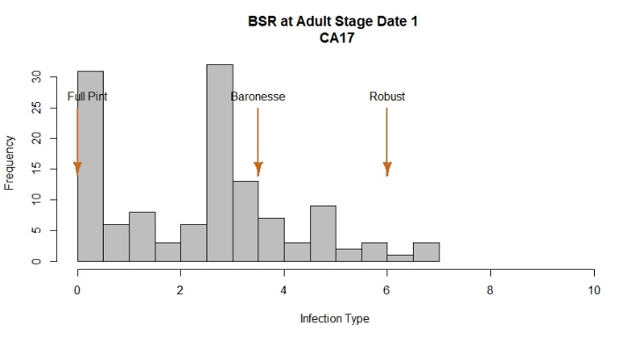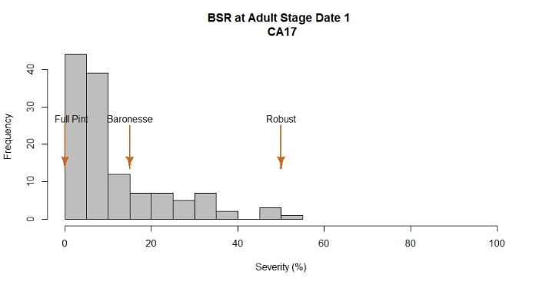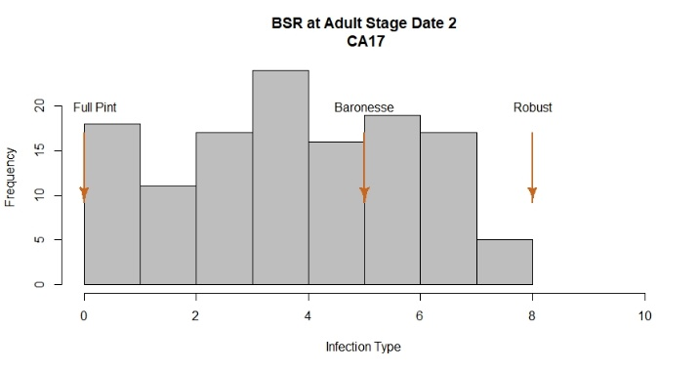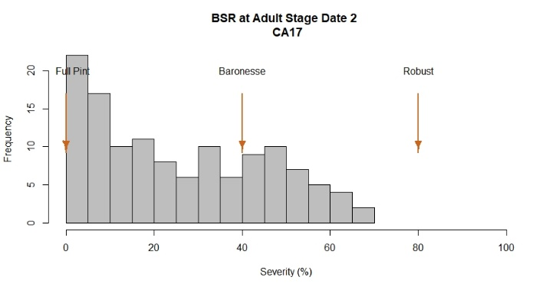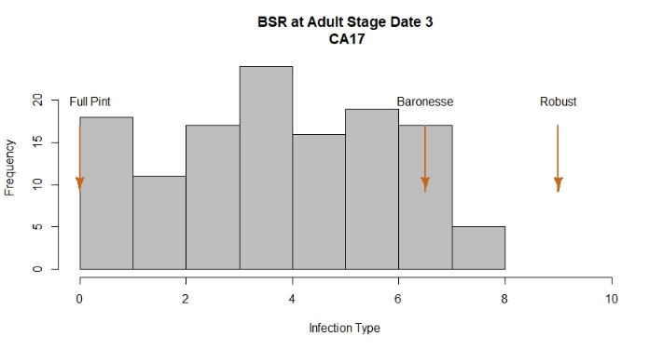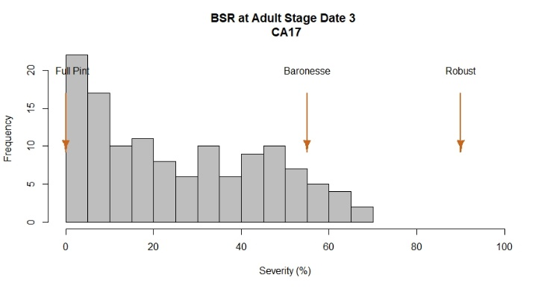

2017 Field Evaluations
The barley stripe rust nursery was evaluated using severity and infection type at Davis, CA. Location at Corvallis was unrated as the field was flooded. At Davis, disease notes were taken three times during the growing season at a 10-day interval.

At Davis, a large range of phenotypic variation among lines and across dates was observed, based on histogram plots. At this location, Robust, Baronesse, and Full Pint were used as checks and exhibited the expected range of severity values for barley stripe rust.

Susceptible checks Robust and Baronesse showed the highest infection type/severity values with 9/90% and 6.5/55%, respectively. The resistant check Full Pint had the lowest value with 0/0%.

Infection type: A total of 21 lines had infection types ≤ 2.5 whereas 46 lines were rated with infection type > 7, similar to the susceptible check Baronesse. 50% of the lines at this location had infection type values between 3 and 7.5.

Severity: 50% of the lines in this trial exhibited severity values between 15% and 65%. As observed in the histogram, 30 lines had severities < 10% and 63 lines exhibited severities > 40%.

Analysis of variance for BSR

BSR CA17
Infection Type Date 1
Df Sum Sq Mean Sq F value Pr(>F)
Line 125 872.7 6.982 12.533 < 2e-16 ***
Rep 1 4.9 4.861 8.726 0.00375 **
Residuals 125 69.6 0.557
---
Signif. codes: 0 ‘***’ 0.001 ‘**’ 0.01 ‘*’ 0.05 ‘.’ 0.1 ‘ ’ 1
Severity Date 1
Df Sum Sq Mean Sq F value Pr(>F)
Line 125 38643 309.15 6.822 <2e-16 ***
Rep 1 170 170.04 3.752 0.055 .
Residuals 125 5664 45.32
---
Signif. codes: 0 ‘***’ 0.001 ‘**’ 0.01 ‘*’ 0.05 ‘.’ 0.1 ‘ ’ 1
Infection Type Date 2
Df Sum Sq Mean Sq F value Pr(>F)
Line 125 1196.0 9.57 10.86 < 2e-16 ***
Rep 1 72.3 72.32 82.05 2.24e-15 ***
Residuals 125 110.2 0.88
---
Signif. codes: 0 ‘***’ 0.001 ‘**’ 0.01 ‘*’ 0.05 ‘.’ 0.1 ‘ ’ 1
Severity Date 2
Df Sum Sq Mean Sq F value Pr(>F)
Line 125 100373 803 8.032 <2e-16 ***
Rep 1 12153 12153 121.555 <2e-16 ***
Residuals 125 12497 100
---
Signif. codes: 0 ‘***’ 0.001 ‘**’ 0.01 ‘*’ 0.05 ‘.’ 0.1 ‘ ’ 1
Infection Type Date 3
Df Sum Sq Mean Sq F value Pr(>F)
Line 125 1765.0 14.120 11.585 < 2e-16 ***
Rep 1 11.1 11.147 9.146 0.00303 **
Residuals 125 152.4 1.219
---
Signif. codes: 0 ‘***’ 0.001 ‘**’ 0.01 ‘*’ 0.05 ‘.’ 0.1 ‘ ’ 1
Severity Date 3
Df Sum Sq Mean Sq F value Pr(>F)
Line 125 178573 1428.6 12.37 < 2e-16 ***
Rep 1 2935 2934.9 25.41 1.59e-06 ***
Residuals 125 14440 115.5
---
Signif. codes: 0 ‘***’ 0.001 ‘**’ 0.01 ‘*’ 0.05 ‘.’ 0.1 ‘ ’ 1

Correlation among dates for BSR
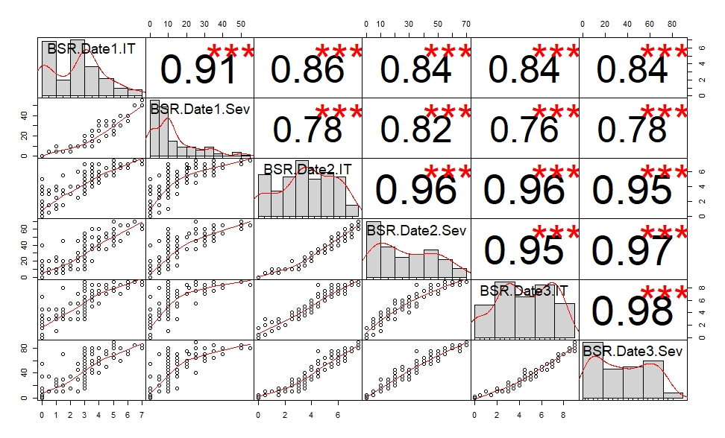

LSD test for BSR; Davis, CA

 | Line | BSR.Date1.IT | BSR.Date1.Sev | BSR.Date2.IT | BSR.Date2.Sev | BSR.Date3.IT | BSR.Date3.Sev
1 | 04_028_36 | 2.5 | 10 | 4 | 25 | 5.5 | 45
2 | 10.0691 | 3 | 10 | 3.5 | 15 | 3.5 | 20
3 | 10.1151 | 3 | 10 | 7 | 55 | 9 | 80
4 | Baronesse | 3.5 | 15 | 5 | 40 | 6.5 | 55
5 | DH140029 | 3 | 10 | 4.5 | 35 | 5.5 | 45
6 | DH140030 | 1 | 5 | 4 | 25 | 4.5 | 30
7 | DH140031 | 1.5 | 5 | 3 | 15 | 3 | 20
8 | DH140032 | 0.5 | 5 | 3 | 10 | 3 | 10
9 | DH140075 | 3 | 15 | 3 | 15 | 3 | 15
10 | DH140076 | 2 | 10 | 3 | 10 | 3 | 15
11 | DH140077 | 1 | 10 | 1 | 10 | 1 | 10
12 | DH140078 | 0.5 | 5 | 1.5 | 10 | 3 | 10
13 | DH140079 | 0 | 0 | 3 | 10 | 3 | 10
14 | DH140080 | 0 | 0 | 1.5 | 5 | 1.5 | 5
15 | DH140081 | 3 | 10 | 4.5 | 35 | 6.5 | 55
16 | DH140123 | 3 | 20 | 7 | 50 | 8.5 | 75
17 | DH140124 | 4 | 30 | 7 | 60 | 8.5 | 80
18 | DH140173 | 3 | 10 | 5 | 30 | 6 | 45
19 | DH140174 | 5 | 25 | 6.5 | 45 | 7.5 | 65
20 | DH140175 | 0 | 0 | 0 | 0 | 0 | 0
21 | DH140176 | 0 | 0 | 0 | 0 | 0 | 0
22 | DH140177 | 3.5 | 25 | 7 | 60 | 8.5 | 80
23 | DH140179 | 2.5 | 10 | 6 | 45 | 7 | 55
24 | DH140180 | NA | NA | NA | NA | NA | NA
25 | DH140210 | 2 | 5 | 4 | 20 | 5.5 | 35
26 | DH140211 | 0 | 0 | 1.5 | 10 | 2.5 | 10
27 | DH140212 | 3 | 10 | 3 | 10 | 3 | 15
28 | DH140213 | 3 | 10 | 4 | 20 | 4 | 30
29 | DH140214 | 3.5 | 20 | 6.5 | 50 | 8.5 | 75
30 | DH140215 | 0 | 0 | 0 | 0 | 1.5 | 5
31 | DH140268 | 3 | 10 | 3.5 | 15 | 4.5 | 30
32 | DH140269 | 3 | 10 | 5.5 | 35 | 6.5 | 55
33 | DH140270 | 4.5 | 35 | 6.5 | 50 | 8.5 | 75
34 | DH140271 | 3 | 10 | 4 | 25 | 4.5 | 45
35 | DH140272 | 3 | 10 | 3 | 10 | 3 | 20
36 | DH140273 | 0 | 0 | 0.5 | 5 | 2 | 10
37 | DH140274 | 0 | 0 | 2 | 10 | 2 | 15
38 | DH140275 | 1 | 5 | 1.5 | 5 | 3 | 10
39 | DH140276 | 0 | 0 | 0 | 0 | 0 | 0
40 | DH140277 | 0 | 0 | 0 | 0 | 1.5 | 5
41 | DH140278 | 2.5 | 10 | 2.5 | 10 | 4 | 30
42 | DH140279 | 7 | 50 | 7 | 60 | 9 | 80
43 | DH140280 | NA | NA | NA | NA | NA | NA
44 | DH140281 | 1.5 | 5 | 1.5 | 5 | 3 | 10
45 | DH140282 | 0.5 | 5 | 0.5 | 5 | 3 | 10
46 | DH140283 | 3.5 | 15 | 4.5 | 35 | 7 | 60
47 | DH140284 | 2 | 10 | 3 | 15 | 3 | 15
48 | DH140285 | 3 | 10 | 3.5 | 15 | 4 | 25
49 | DH140286 | 4 | 15 | 6 | 40 | 7.5 | 60
50 | DH140299 | 3 | 15 | 4.5 | 30 | 6.5 | 45
51 | DH140300 | 3 | 10 | 4 | 20 | 5.5 | 45
52 | DH140324 | 3 | 10 | 3.5 | 20 | 4.5 | 40
53 | DH140325 | 3 | 15 | 4 | 30 | 5.5 | 45
54 | DH140326 | 3 | 15 | 4 | 25 | 5 | 35
55 | DH140327 | 5 | 21.5 | 6.5 | 55 | 8 | 70
56 | DH140328 | 3.5 | 20 | 5 | 35 | 7 | 55
57 | DH140329 | 4 | 25 | 4.5 | 35 | 5.5 | 40
58 | DH140330 | 6 | 40 | 6.5 | 55 | 8 | 70
59 | DH140331 | 3.5 | 20 | 6 | 50 | 7 | 60
60 | DH140332 | 1.5 | 5 | 3.5 | 20 | 4 | 20
61 | DH140334 | 3 | 10 | 4 | 25 | 5 | 30
62 | DH140336 | 1 | 5 | 3.5 | 25 | 4.5 | 30
63 | DH140337 | 3 | 10 | 6 | 50 | 7.5 | 65
64 | DH140338 | 3.5 | 20 | 4.5 | 35 | 8.5 | 75
65 | DH140339 | 3 | 10 | 6 | 45 | 8.5 | 75
66 | DH140361 | 4 | 15 | 5.5 | 45 | 7 | 55
67 | DH140362 | 1 | 5 | 2.5 | 10 | 3.5 | 20
68 | DH140404 | 3 | 10 | 3 | 15 | 4 | 25
69 | DH140405 | 6 | 35 | 7 | 55 | 8.5 | 75
70 | DH140406 | 1.5 | 5 | 3 | 15 | 3.5 | 20
71 | DH140407 | 3.5 | 15 | 4.5 | 35 | 5 | 40
72 | DH140408 | 4 | 35 | 5.5 | 50 | 7.5 | 65
73 | DH140409 | 5.5 | 30 | 6.5 | 45 | 7 | 60
74 | DH140410 | 5 | 35 | 6 | 45 | 7.5 | 65
75 | DH140411 | 0 | 0 | 1.5 | 10 | 3 | 15
76 | DH140412 | 6 | 35 | 7 | 65 | 9 | 75
77 | DH140413 | 4.5 | 20 | 5.5 | 35 | 7 | 50
78 | DH140415 | 5 | 25 | 5.5 | 45 | 7.5 | 70
79 | DH140417 | 4 | 15 | 5 | 40 | 7.5 | 65
80 | DH140418 | 0 | 0 | 0 | 0 | 0.5 | 5
81 | DH140419 | 0 | 0 | 0.5 | 5 | 0.5 | 5
82 | DH140420 | 0 | 0 | 1 | 5 | 2.5 | 10
83 | DH140421 | 1.5 | 5 | 5.5 | 45 | 8 | 70
84 | DH140422 | 0 | 0 | 0 | 0 | 0 | 0
85 | DH140423 | 0 | 0 | 4 | 20 | 4.5 | 35
86 | DH140426 | 5 | 25 | 7 | 55 | 9 | 80
87 | DH140427 | 0 | 0 | 5 | 40 | 6.5 | 55
88 | DH140428 | 5 | 25 | 7.5 | 70 | 9 | 90
89 | DH140429 | 3.5 | 10 | 6.5 | 60 | 8.5 | 80
90 | DH140430 | 3.5 | 10 | 4 | 20 | 6 | 45
91 | DH140450 | 3.5 | 10 | 4.5 | 35 | 7 | 60
92 | DH140451 | 0 | 0 | 3.5 | 15 | 3.5 | 15
93 | DH140452 | 4.5 | 30 | 6.5 | 55 | 8 | 70
94 | DH140453 | 3 | 10 | 6 | 55 | 8 | 70
95 | DH140499 | 1.5 | 5 | 3 | 15 | 4.5 | 30
96 | DH140500 | 5 | 35 | 7.5 | 60 | 9 | 85
97 | DH140501 | 0.5 | 5 | 3.5 | 20 | 4.5 | 35
98 | DH140502 | 7 | 50 | 7.5 | 65 | 9 | 85
99 | DH140503 | 7 | 55 | 7.5 | 65 | 8.5 | 80
100 | DH140504 | 0 | 0 | 3 | 10 | 3 | 15
101 | DH140505 | 5.5 | 40 | 7 | 65 | 8.5 | 80
102 | DH140506 | 3 | 10 | 4 | 25 | 6 | 50
103 | DH140507 | 0 | 0 | 1.5 | 5 | 3 | 10
104 | DH140508 | 3 | 10 | 3.5 | 25 | 5 | 35
105 | DH140509 | 5 | 35 | 6 | 50 | 7.5 | 65
106 | DH140510 | 1.5 | 5 | 1.5 | 10 | 3 | 10
107 | DH140511 | 0 | 0 | 0 | 0 | 0 | 0
108 | DH140512 | 1.5 | 5 | 1.5 | 5 | 3 | 10
109 | DH140515 | 2.5 | 10 | 2.5 | 10 | 3 | 10
110 | DH140516 | 3.5 | 20 | 5.5 | 50 | 8.5 | 75
111 | DH140548 | 3 | 10 | 5 | 40 | 6.5 | 55
112 | DH140549 | 2.5 | 10 | 4 | 20 | 4 | 30
113 | DH140638 | 5 | 30 | 5.5 | 40 | 7.5 | 65
114 | DH140639 | 3.5 | 15 | 6 | 50 | 7.5 | 70
115 | DH140640 | 4 | 30 | 6 | 50 | 7.5 | 60
116 | DH140641 | 0 | 0 | 0 | 0 | 1.5 | 5
117 | DH140642 | 2.5 | 10 | 4 | 30 | 4 | 30
118 | DH140655 | 3 | 10 | 3.5 | 20 | 4.5 | 35
119 | Full Pint | 0 | 0 | 0 | 0 | 0 | 0
120 | Karma | 3 | 10 | 4.5 | 30 | 5 | 35
121 | MC0181-11 | 3 | 10 | 4.5 | 30 | 5.5 | 40
122 | MC0181-31 | 3 | 15 | 6 | 45 | 7.5 | 60
123 | Oscar | 0 | 0 | 2 | 10 | 2 | 10
124 | Robust | 6.5 | 50 | 7.5 | 70 | 9 | 85
125 | SB97197 | 3 | 10 | 3 | 10 | 3 | 20
126 | SH98076 | 0 | 0 | 0 | 0 | 0.5 | 5
127 | Tibet 37 | 0 | 0 | 0 | 0 | 0 | 2.5
128 | TR02272 | 0 | 0 | 0 | 0 | 0 | 2.5
129 | Violetta | 1 | 10 | 2.5 | 20 | 3 | 25
 | LSD | 1.47 | 13.32 | 1.85 | 19.7 | 2.18 | 21.27
BLUPs across environments (OR16, CA16, CA17) for BSR

The best linear unbiased predictions (BLUPs) for each line across three environments - Corvallis 2016, Davis 2016 and Davis 2017 - for disease severity at adult plant stage, expressed as
percentage (%) of leaf area affected with barley stripe rust were obtained and plotted in a histogram distribution graphic. A range of phenotypic variation was observed among lines when all environments were included in the same model. The susceptible checks Robust, P-954 and Baronesse showed the highest severities with 64%, 46% and 34%, respectively. The resistant check Full Pint has the lowest severity, at 3%. A total of 55 lines exhibited values ≤ 15% whereas 18 lines were rated with severity ≥ 40%. The heritability of adult plant resistance was 0.54.

Histogram BLUPs
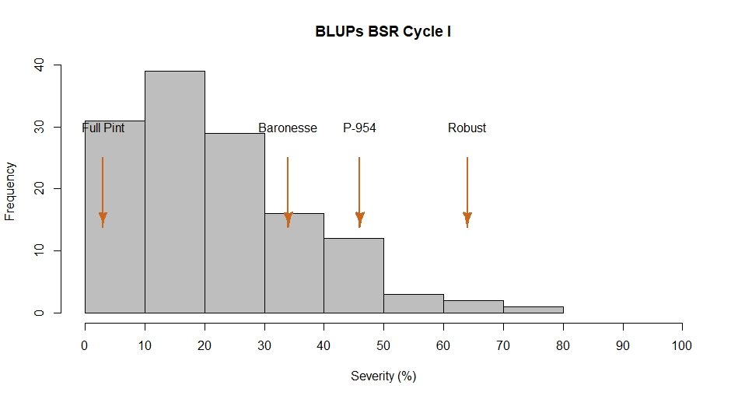
$$H^{2}=0.54$$

