Cycle III Report
2019, 2020 and 2021 harvest seasons
Barley stem rust

Javier Hernandez, Tanya Filichkin, Scott Fisk, Laura Helgerson, and Patrick Hayes
Barley Project. Oregon State University. Corvallis, Oregon, USA

Brian Steffenson. University of Minnesota. St. Paul, MN, USA

Intent and purpose:
This report is intended to summarize analyses of currently available data, point to key findings, and to articulate questions based on these key findings that will be addressed in a forthcoming journal article. These key findings and questions they raise include:

Germplasm:
The Cycle III panel is a germplasm array of 373 doubled haploid lines derived from crosses among 10 parents with resistance to one or more rust diseases (stem, stripe, leaf) and/or scald. The three checks are: Lightning (DH130910), Robust and Thoroughbred. Lightning is resistant to stripe rust and scald; Thoroughbred is susceptible to stripe rust and resistant to scald; Robust is susceptible to stripe rust and scald.

Data sources:
The Cycle III panel, parents, and checks were scored for IT for Puccinia graminis f. sp. tritici race TTKSK in the Biosafety Level 3 Containment Facility at the University of Minnesota (St. Paul, MN) in a randomized complete block design with two replicates and repeated controls. The accession Q81861 was used as resistant control carrying (Rpg1 and rpg4/Rpg5). Hiproly (PI 60693) and PI 532013 were used as susceptible controls. Seeds were planted in the greenhouse and inoculated with stem rust isolate 04KEN156/04 of race TTKSK using urediniospore suspension.

Genotyping
The complete panel was genotyped with the Illumina 50K SNP chip.

Disease assessment procedures:

Stem rust (Puccinia graminis f. sp. tritici): After 12-14 days post inoculation, stem rust IT were assessed based on a 0 to 4 scale. IT were transformed to coefficient of Infection (CI) for association analysis.

General conclusions:

Stem rust
- The checks behaved as expected and there were differences in stem rust reaction at the seedling stage observed in this population.
- No QTLs were detected, suggesting that the limited population size led to a failure to detect the many genes with minor effects determining the phenotype and/or that the genetic variance was swamped by environmental variance.

Next steps
Stem rust
- Facultative and spring habit germplasm in Cycle III will be assessed for adult plant resistance to stem rust, using the QCCC surrogate (Minnesota) and local virulent isolates (WA) and in the USDA African screening nursery.
- Winter habit germplasm in Cycle III will be assessed for adult plant resistance to stem rust in the USDA African screening nursery.

All data:
Please see https://barleyworld.org/barley-stripe-rust-bsr

Publication(s):
In preparation

Funding:
Support provided by USDA-ARS-NACAs for stripe rust and stem rust research.

2021

Phenotypic frequency distributions for stem rust (SR) TTKSK at seedling stage; St Paul, MN. DH130910 = Lightning

The checks behaved as expected in terms of disease response. For coefficient of infection, 14% of the entries exhibited values < 2.7. Within this group, some lines had lower values (more resistance) than the resistant check Q21861. Using General Reaction assessments, 45% of lines, were classified as Resistant to Moderate Resistant for this race.

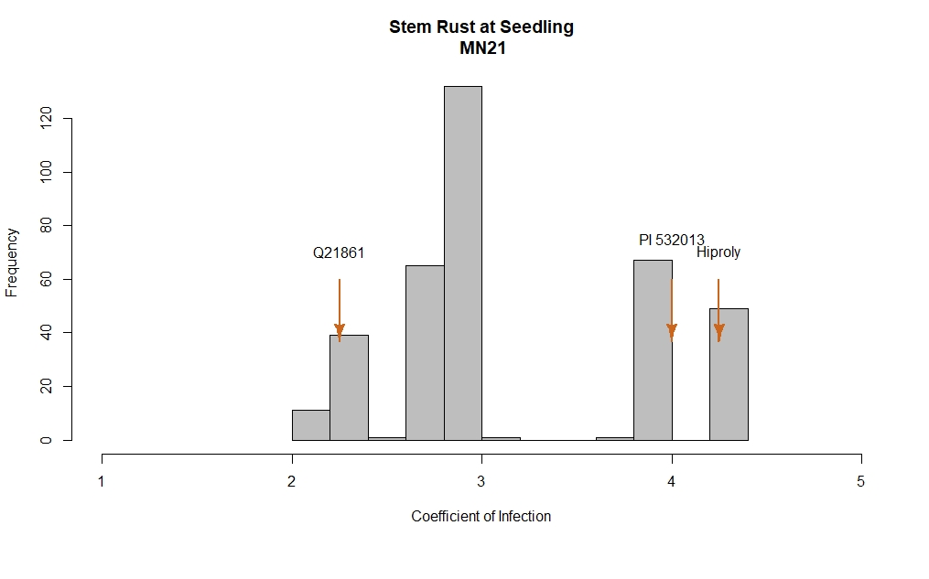

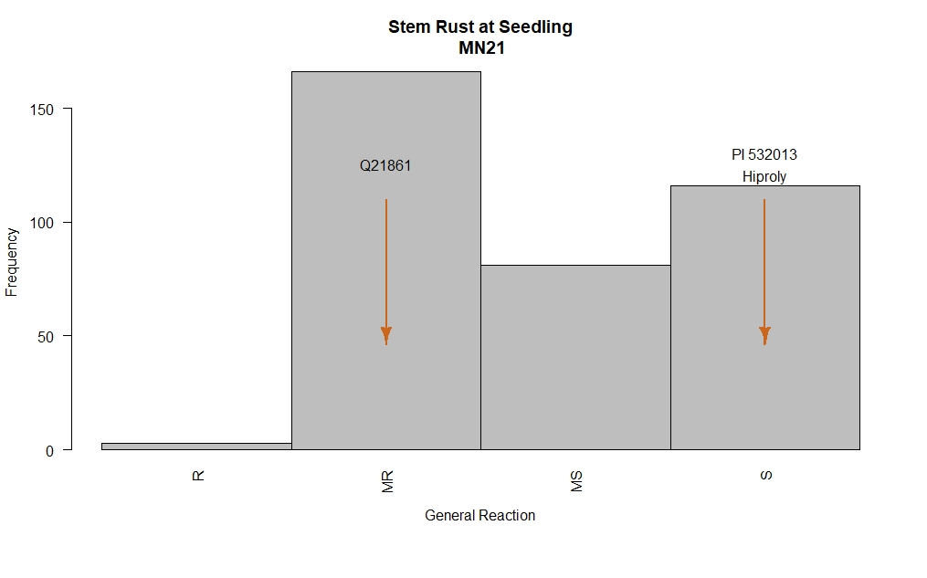

GWAS
No QTLs were detected
