Cycle III Report

Javier Hernandez, Tanya Filichkin, Scott Fisk, Laura Helgerson, Chris Massman, and Patrick Hayes
Barley Project. Oregon State University. Corvallis, Oregon, USA.

Germplasm:
The Cycle III doubled haploid panel is a germplasm array of 373 doubled haploid lines derived from crosses among 10 parents with resistance to one or more rust diseases (stem, stripe, leaf) and checks. This trial was grown in a total of six different environments over the 2018/19, 2019/20, and 2021/22 seasons. This report covers heading date, stem rust (SR), barley stripe rust (BSR), and scald (SC) data generated across all environments.

Stripe rust and scald assessment procedures:
Lines were evaluated for adult plant resistance to barley stripe rust (BSR, incited by Puccinia striiformis f. sp. hordei) using both IT and severity at Davis, CA and only severity at Corvallis, OR. Severity was scored as percentage of leaf area affected with the disease on a plot basis, whereas infection type (IT) was recorded according to McNeal et al. (1971). A Randomized Complete Block Design with two replications and three checks was used. The checks used were DH130910 (released as Lightning), Thoroughbred, and Robust. Natural infection was supplemented with artificial inoculation. Scald (SC, incited by Rhynchosporium commune) was rated as percent severity at Corvallis during the 2019 and 2020 seasons.

Stem rust assessment procedures:
Disease susceptibility was measured for stem rust at seedling and adult stage using severity, IT, and general reaction (GR). At the seedling stage, plants were assessed for their IT on the first leaves using a 0–4 scale. At the adult stage, severity on stems was estimated visually using the modified Cobb scale. IT was also scored on each line using the resistant (R), moderately resistant (MR), moderately susceptible (MS), and susceptible (S) scale as described by Peterson et al. (1948). At the seedling stage, evaluations were made for susceptibility to the stem rust race TTKSK at the Minnesota Agricultural Experiment Station/Minnesota Department of Agriculture Plant Growth Biosafety Level-3 (BSL-3). At the adult stage, the stem rust race QCCJB was used as it is a surrogate race for TTKSK under field conditions. The accessions PI 532013, Hiproly, Chevron, Q21861, Full Pint, DH160733, and DH160754 were used as checks across the different experiments.

Data:
Please see https://barleyworld.org/barley-stripe-rust-bsr

Publication(s):
In preparation

Funding:
Support provided by USDA-ARS-NACAs for stripe rust and stem rust research.

Results:
In this report, we provide data and analyses on stripe rust, scald and stem rust resistance. ,

Cycle III 2019 – Oregon data

Reaction to BSR and SC at adult plant stage; Corvallis, OR

Histogram distribution across dates and diseases
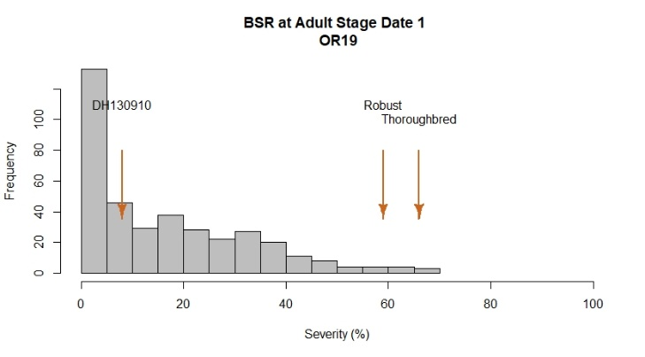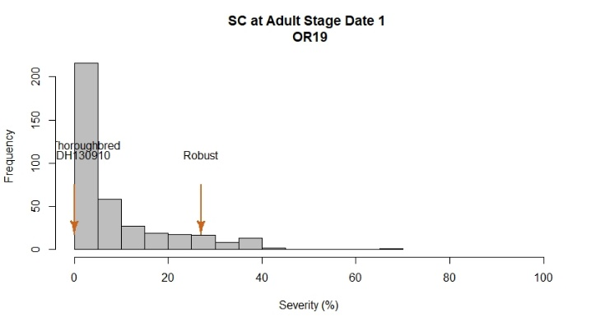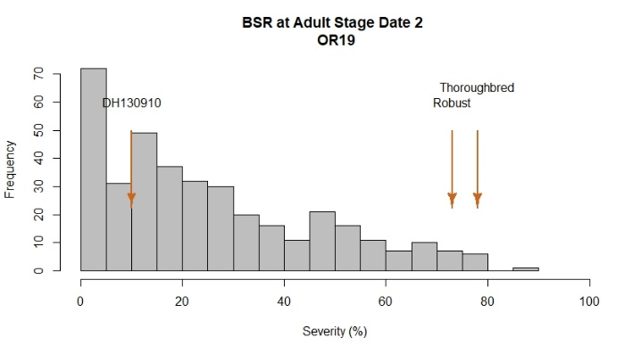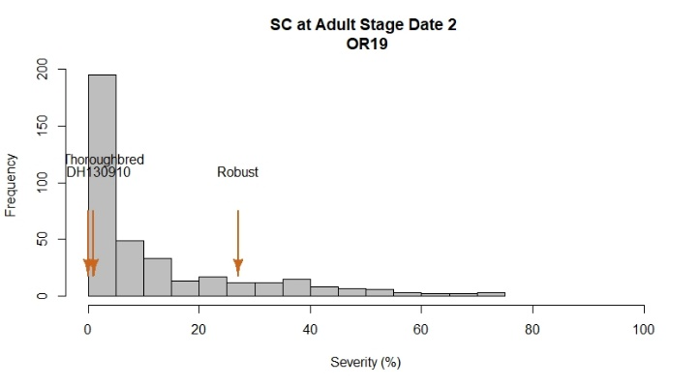

2019 Field Evaluations

In 2019, only data from Corvallis was generated for Cycle III. Severity was recorded twice, with 10 days between ratings. Phenotypic variation among entries was observed with BSR severity ranging from 0% to 90%. All checks exhibited expected severity values. Robust and Thoroughbred showed the highest stripe rust severity values – at 59% and 66%, respectively. The resistant check Lightning had the lowest severity value - 10%. A total of 152 lines had disease severities < 15% and 99 lines were rated with severity values > 40%. 50% of the entries in the panel exhibited severity values between 9-40%.

In terms of SC, severity values ranged from 0% to 75%. 50% of lines exhibited values ranging from 1.5 to 17.5%. The Lightning and Thoroughbred checks had low severities of 1 and 2%, respectively. The Robust check was more susceptible, with a severity of 28%. Under heavy disease pressure, a severity of ~ 90% would be expected for Robust.

Analysis of variance for BSR and SC

BSR OR19
Severity Date 1
Df Sum Sq Mean Sq F value Pr(>F)
Line 373 196657 527.2 6.314 < 2e-16 ***
Rep 1 600 600.1 7.188 0.00767 **
Residuals 373 31144 83.5
---
Signif. codes: 0 ‘***’ 0.001 ‘**’ 0.01 ‘*’ 0.05 ‘.’ 0.1 ‘ ’ 1
Severity Date 2
Df Sum Sq Mean Sq F value Pr(>F)
Line 373 335900 900.5 8.108 <2e-16 ***
Rep 1 229 229.1 2.063 0.152
Residuals 373 41428 111.1
---
Signif. codes: 0 ‘***’ 0.001 ‘**’ 0.01 ‘*’ 0.05 ‘.’ 0.1 ‘ ’ 1

SC OR19
Severity Date 1
Df Sum Sq Mean Sq F value Pr(>F)
Line 373 90739 243.3 2.001 1.68e-11 ***
Rep 1 2976 2976.0 24.483 1.14e-06 ***
Residuals 373 45340 121.6
---
Signif. codes: 0 ‘***’ 0.001 ‘**’ 0.01 ‘*’ 0.05 ‘.’ 0.1 ‘ ’ 1
Severity Date 2
Df Sum Sq Mean Sq F value Pr(>F)
Line 373 202681 543 1.885 6.46e-10 ***
Rep 1 9261 9261 32.131 2.89e-08 ***
Residuals 373 107513 288
---
Signif. codes: 0 ‘***’ 0.001 ‘**’ 0.01 ‘*’ 0.05 ‘.’ 0.1 ‘ ’ 1

Correlation among dates for BSR and SC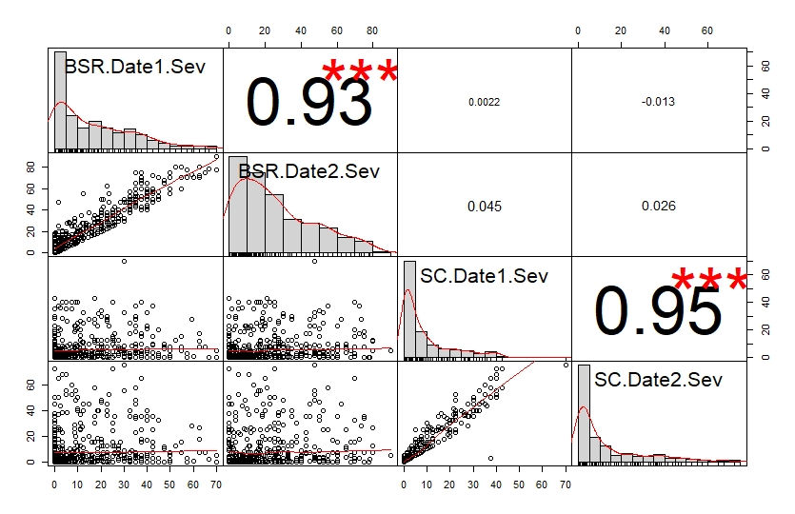

LSD test for dates and diseases

Please see LSD test Cycle III at https://barleyworld.org/barley-stripe-rust-bsr

Cycle III 2020 – Oregon and California data

Reaction to BSR and SC at the adult plant stage; Corvallis, OR and Davis, CA

Histogram distributions across dates and sites

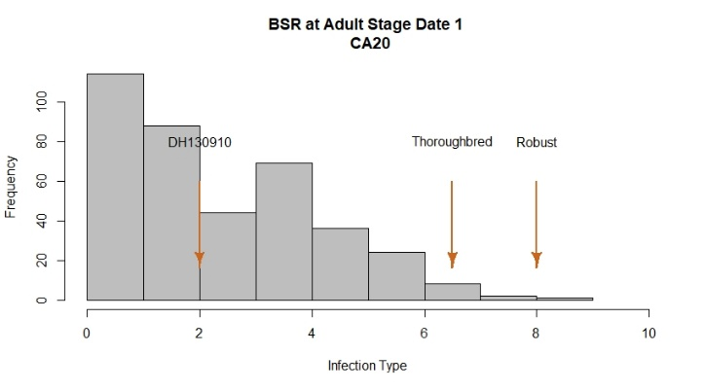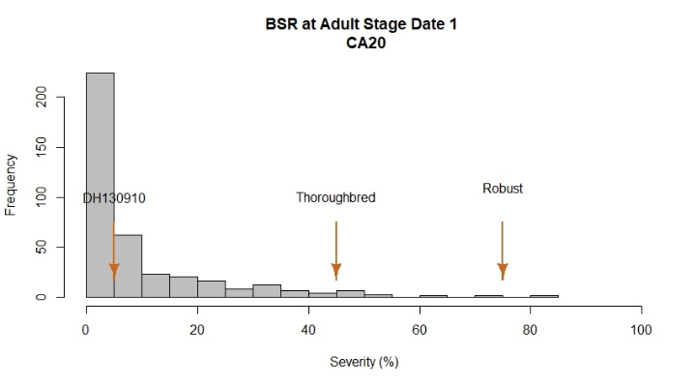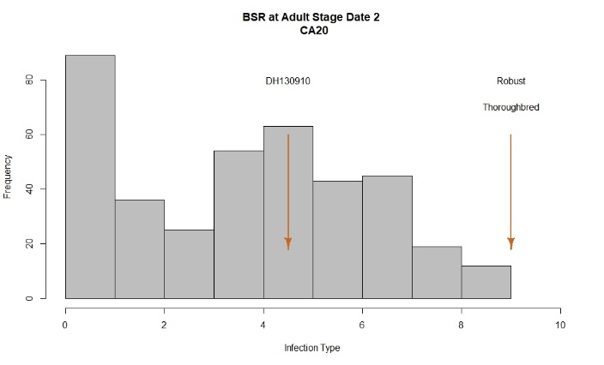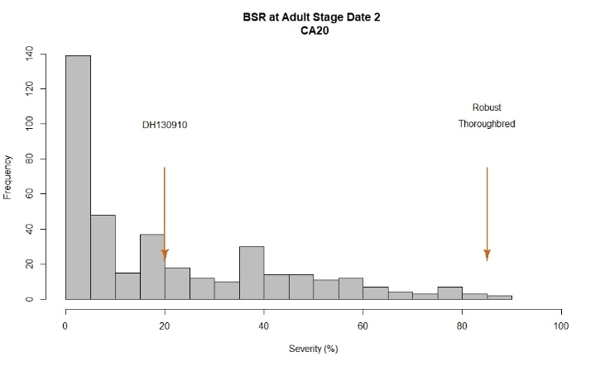
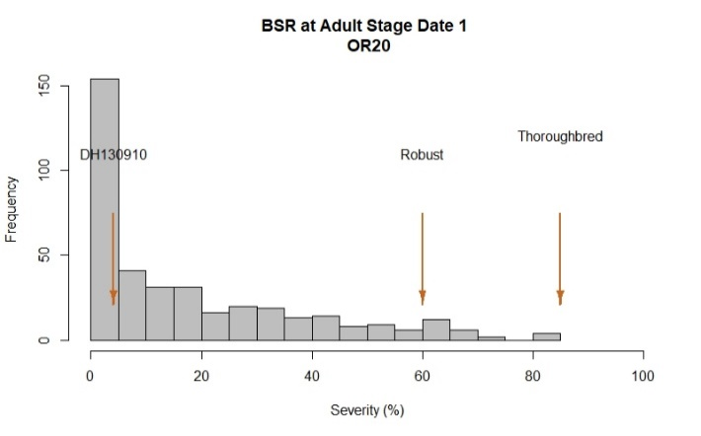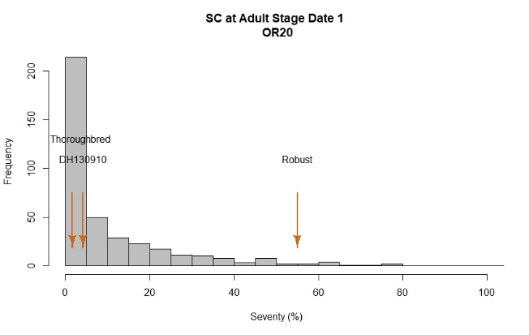

2020 Field Evaluations
At Davis, disease notes were taken two times during the growing season, 10-days apart. At Corvallis, one evaluation was performed, once lines had finished flowering. Corvallis and Davis had similar levels of disease. At both locations, Lightning, Thoroughbred, and Robust were used as checks and exhibited a range of severity values as expected.
At Corvallis BSR severity ranged from 0% to 85%. Robust and Thoroughbred showed the highest severity values with 60% and 85%, respectively. The resistant check Lightning had the lowest value with 4%. A total of 195 lines showed 10% or less disease severity whereas 67 lines had severity values > 40%. 50% of the lines at this location exhibited severity values between 2% and 30%.

At Davis, a range of phenotypic variation was observed among lines and across dates with severity ranging from 0% to 90% by the second screening date. Controls Robust and Thoroughbred showed the highest infection type/severity values both with 9/85%. The resistant check Lightning had the lowest value with 4.5/20%. A total of 150 lines had IT < 3 in Davis whereas 56 lines were rated with IT > 7, similar to the susceptible checks. 50% of the lines at this location had IT values between 1.5 and 6.

Overall, 50% of the lines in this trial exhibited severity values between 3 and 40%. As observed in the histogram, 187 lines had severities < 10% and 106 lines exhibited severities > 40%.

Scald (SC) was evaluated at heading in Corvallis during the 2022 season. SC severity ranged from 0% to 85%. The Cycle III population exhibited variation for susceptibility with 50% of lines having severity values ranging from 0 to 15%. The Robust check was susceptible, with a severity of 55% whereas Lightning and Thoroughbred had severities of 4% and 2%, respectively.

Analysis of variance for BSR and SC

BSR OR20
Severity Date 1
Df Sum Sq Mean Sq F value Pr(>F)
Line 382 317405 831 5.87 < 2e-16 ***
Rep 1 6751 6751 47.69 2.09e-11 ***
Residuals 382 54073 142
---
Signif. codes: 0 ‘***’ 0.001 ‘**’ 0.01 ‘*’ 0.05 ‘.’ 0.1 ‘ ’ 1

SC OR20
Severity Date 1
Df Sum Sq Mean Sq F value Pr(>F)
Line 382 215560 564.3 3.019 <2e-16 ***
Rep 1 45 44.7 0.239 0.625
Residuals 382 71394 186.9
---
Signif. codes: 0 ‘***’ 0.001 ‘**’ 0.01 ‘*’ 0.05 ‘.’ 0.1 ‘ ’ 1

BSR CA20
Infection Type 1
Df Sum Sq Mean Sq F value Pr(>F)
Line 382 3040.0 7.958 3.149 <2e-16 ***
Rep 1 0.6 0.632 0.250 0.617
Residuals 382 965.4 2.527
---
Signif. codes: 0 ‘***’ 0.001 ‘**’ 0.01 ‘*’ 0.05 ‘.’ 0.1 ‘ ’ 1
Infection Type 2
Df Sum Sq Mean Sq F value Pr(>F)
Line 382 5313 13.908 6.927 < 2e-16 ***
Rep 1 27 27.070 13.484 0.000275 ***
Residuals 382 767 2.008
---
Signif. codes: 0 ‘***’ 0.001 ‘**’ 0.01 ‘*’ 0.05 ‘.’ 0.1 ‘ ’ 1
Severity Date 1
Df Sum Sq Mean Sq F value Pr(>F)
Line 382 127077 332.7 2.694 <2e-16 ***
Rep 1 197 196.5 1.592 0.208
Residuals 382 47162 123.5
---
Signif. codes: 0 ‘***’ 0.001 ‘**’ 0.01 ‘*’ 0.05 ‘.’ 0.1 ‘ ’ 1
Severity Date 2
Df Sum Sq Mean Sq F value Pr(>F)
Line 382 392040 1026 6.186 <2e-16 ***
Rep 1 4277 4277 25.778 6e-07 ***
Residuals 382 63379 166
---
Signif. codes: 0 ‘***’ 0.001 ‘**’ 0.01 ‘*’ 0.05 ‘.’ 0.1 ‘ ’ 1

Correlations among rating date and locations for BSR and SC
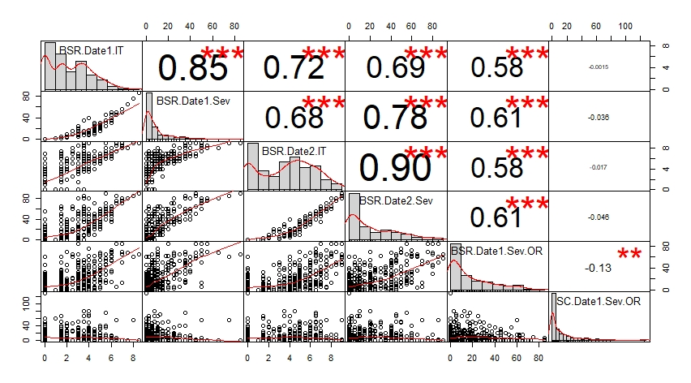

LSD test for dates and diseases

Please see LSD test Cycle III at https://barleyworld.org/barley-stripe-rust-bsr

BLUPs across environments (OR19, OR20, and CA20) for BSR

The best linear unbiased predictions (BLUPs) for each line across three environments (Corvallis 2019, Corvallis 2020 and Davis 2020) for disease severity (%) at adult plant stage were obtained and plotted in a histogram. The susceptible checks Robust and Thoroughbred showed the highest severities with 64% and 75%, respectively. The resistant check Lightning has the lowest severity, at 12%. A total of 161 lines exhibited values ≤ 15% whereas 50 lines were rated with severity ≥ 40%. The heritability of adult plant resistance was 0.57.

Histogram BLUPs

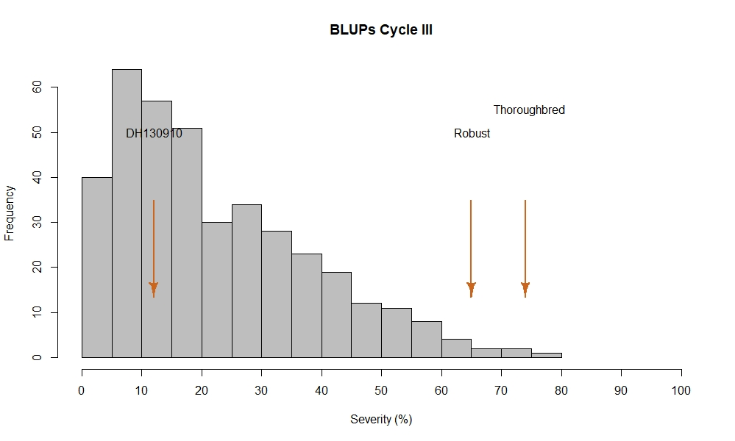

$$H^{2}=0.57$$

Cycle III 2021 – Oregon data

Heading Date and Vernalization sensitivity; Corvallis, OR
Histogram distribution for spring planting
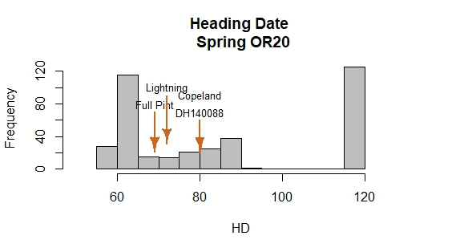
2021 Field Evaluations to determine vernalization requirements
Evaluation for spring-planted heading date as a measure of vernalization sensitivity was conducted at Corvallis, OR. Lines were planted on April 1, 2020 and evaluated when 50% of lines in a plot showed the first awns.
One set of lines reached flowering between 50 and 90 days after planting (DAP). In this trial, the 4 checks flowered as expected, with Lightning and Full Pint heading earlier than Copeland and DH140008.
Another set of lines did not reach flowering by the end of the experiment (150 DAP) and were assumed to have a vernalization requirement for the transition from the vegetative to reproductive stages. Lines that flowered during the experiment were selected to be spring planted in MN and WA for stem rust evaluation.

Correlations among heading dates across locations and planting dates
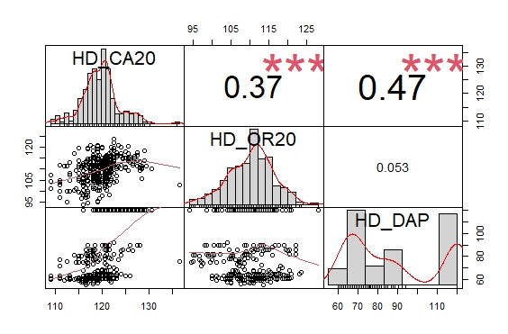
Cycle III 2021-22 – Minnesota and Washington Stem Rust (SR) data
Reaction to SR at Seedling and adult plant stages; Saint Paul, MN and Pullman, WA
Histogram distribution at seedling stage

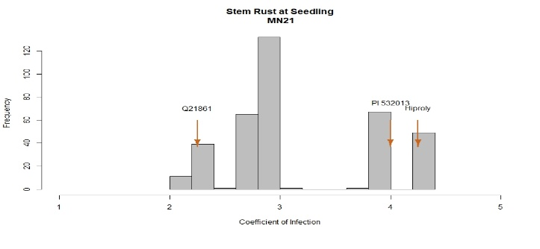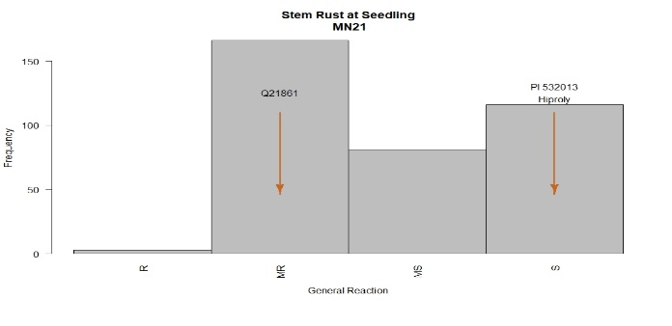
Histogram distribution at adult stage

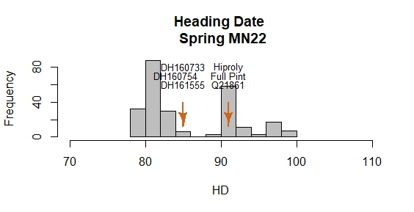
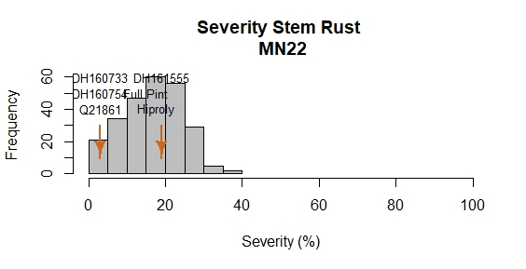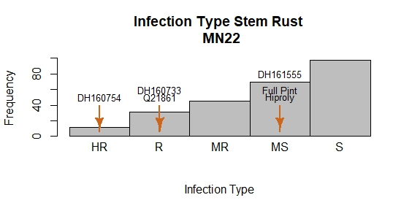
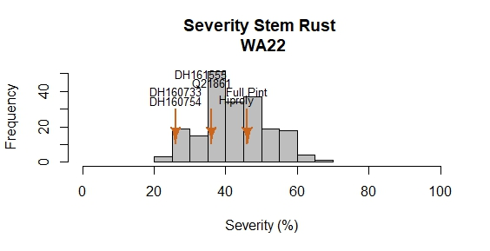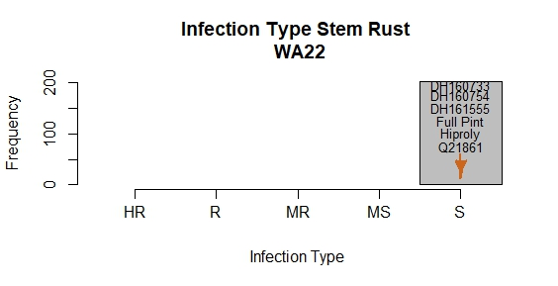

2022 Stem Rust Evaluations at seedling and adult stages

Lines that were not vernalization sensitive were evaluated for stem rust at Saint Paul, MN and Spillman, WA at the seedling and adult stages to determine disease severity and infection type. At the seedling stage, lines exhibited a unimodal distribution with coefficients of infection values ranging from 2 to 4.5. The resistant check Q21816 showed moderate resistance and the susceptible checks, PI532013 and Hiproly exhibited high levels of susceptibility. Few lines were completely resistant based on general reaction rate. A large number of lines exhibited moderate resistance, similar to the resistant check Q21816. On the other hand, ~ 180 lines exhibited moderate to complete susceptibility, similar to the susceptible checks PI532013 and Hiproly.

At the adult plant stage, stem rust was evaluated on barley main stems on a plot basis. At Saint Paul, disease severity values ranged from 0 to 40%. Resistant checks Q21816, DH160733, and DH160754, exhibited similar severity values. Q21816, DH160733, and DH160754 were significantly different from the susceptible checks Full Pint, Hiproly, and DH161555. In terms of infection type, most of the lines exhibited moderate to complete susceptibility, whereas few lines showed high levels of resistance. At Pullman, stem rust pressure was intense compared to Saint Paul. Lines ranged from 20 to 70% severity. Due to this high disease pressure, all lines were determined to have a susceptible infection type.

Correlations for Stem Rust among sites (MN21, MN22, and WA22)
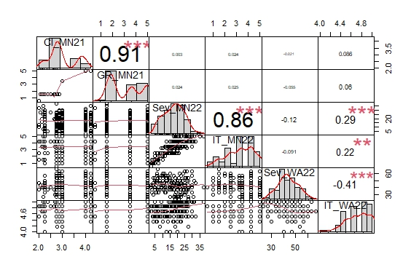

Cycle III – Genome Wide Association Analysis
Heading Date at Corvallis, OR, Davis, CA and Saint Paul, MN
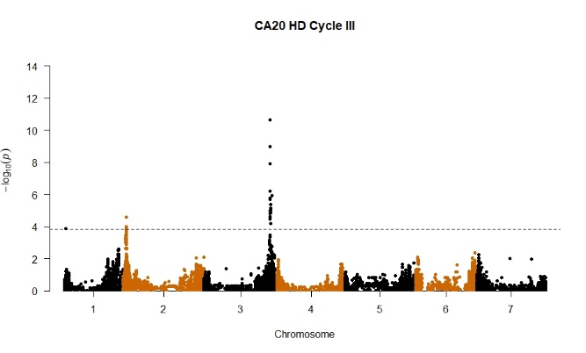
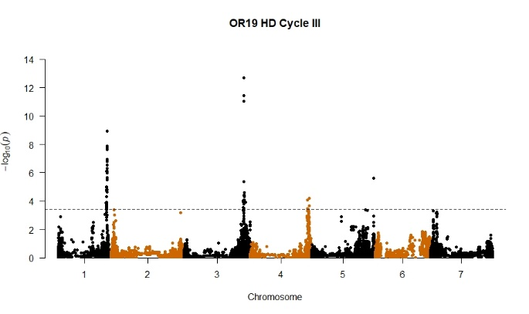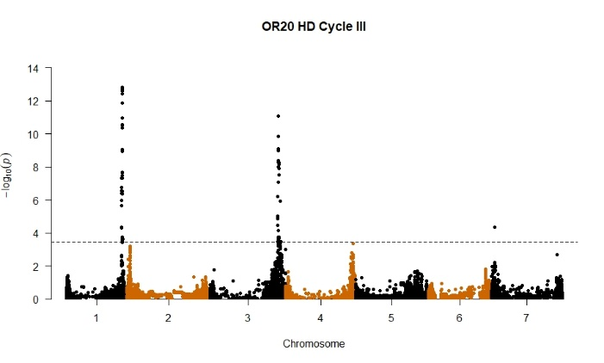
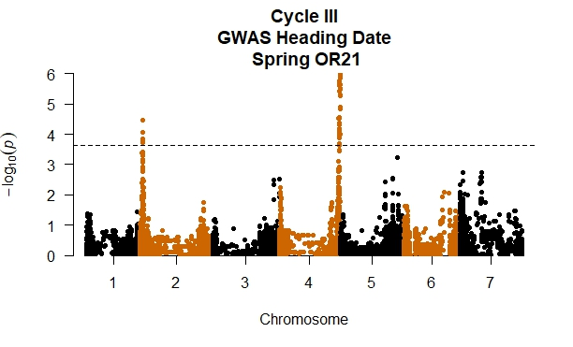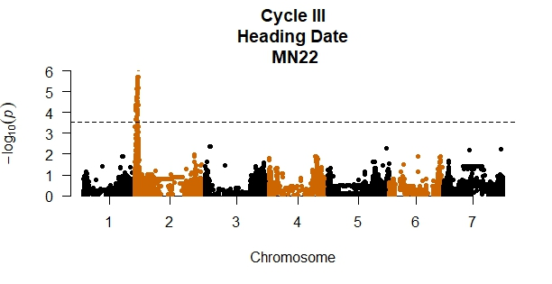
2019-20-21-22 Field Evaluations for Heading Date.
Lines were evaluated for heading date at Davis, CA, Corvallis, OR and Saint Paul, MN. To determine the genetic architecture controlling flowering time on this panel, an association analysis was performed using ~50K SNP markers across the barley genome. Heading date was evaluated under two conditions, spring and fall planting to determine a) genome regions controlling flowering under both conditions, and b) identify plants with and without vernalization requirements for the transition from vegetative to reproductive growth.

Under fall planting, a large QTL was detected on 3HL during 2019 and 2020 at both Davis and Corvallis, near the reported location of the sdw1/denso gene. The influence of allelic variation at this locus on plant height, heading date, and various agronomic and physiological characteristics has been observed in numerous studies. At Corvallis, an additional major QTL was found on 1HL, near the reported position of Ppd-H2, a short-day sensitivity gene that regulates flowering under short-day conditions. At Davis, an additional major QTL was found on 2HS, near the reported position of Ppd-H1, a long-day sensitivity gene that promotes flowering under long-day conditions.

Lines were evaluated under spring planted conditions in Corvallis, OR in 2021 and Saint Paul, MN in 2022. In 2021, the complete panel was tested for heading to identify lines with and without vernalization sensitivity. In the full panel, two major QTL were detected. The first was observed on 4HL, near Vrn-H2, a major gene associated with the vernalization requirement in barley. A second QTL was observed on 2HS, near the previously described gene Ppd-H2. Lines without vernalization sensitivity were grown at Saint Paul and Pullman. Heading date was recorded only at Saint Paul. At this location, only the QTL attributed to Ppd-H2 was significant.

Barley Stripe Rust at Corvallis, OR, and Davis, CA
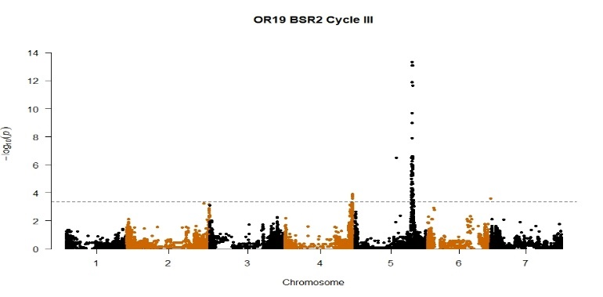
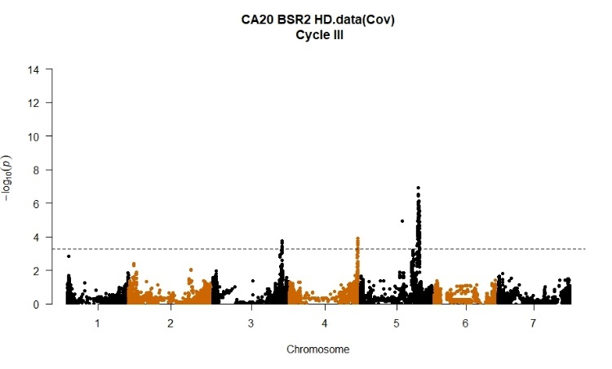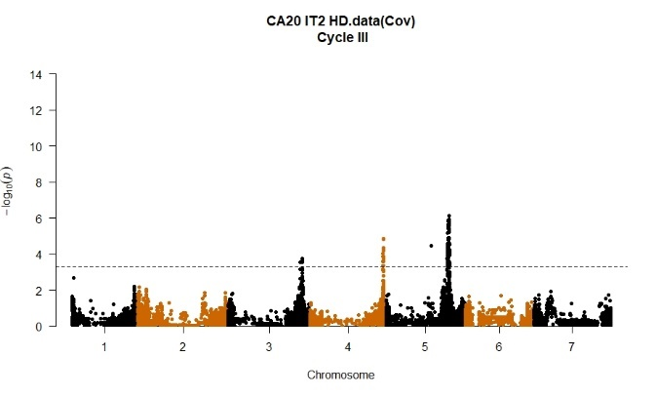
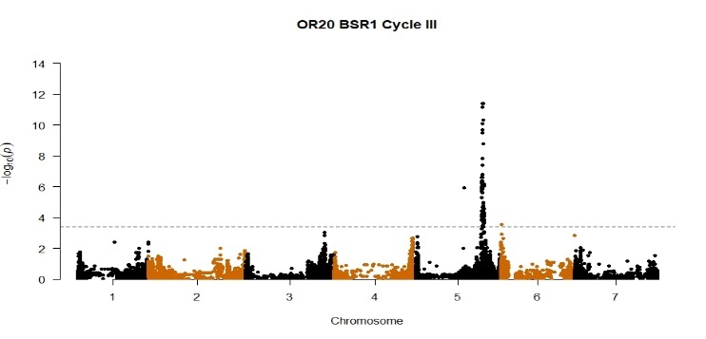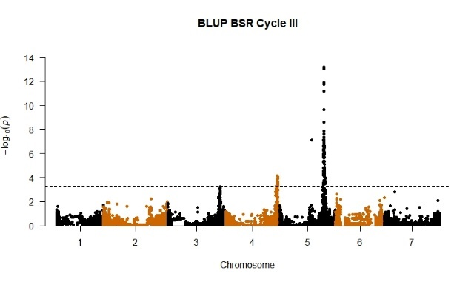

Scald at Corvallis, OR
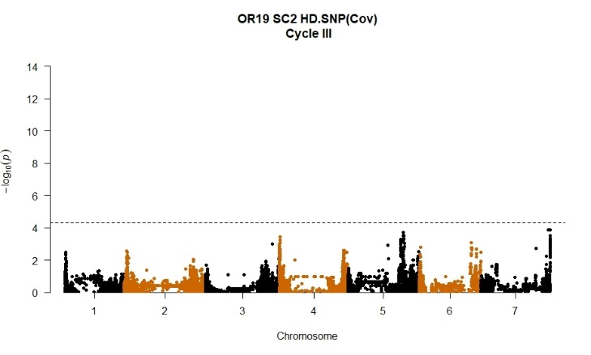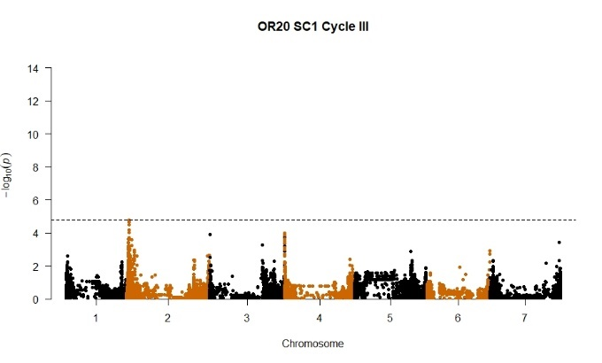

2019-20 Field Evaluations for Barley Stripe Rust and Scald
Lines were evaluated at Corvallis and Davis for barley stripe rust during the 2019 and 2020 seasons. In 2019, a QTL of major effect associated with disease resistance was found on 5HL. A minor QTL was also found on 4HL. In the next year, the 5HL and 4HL QTL were again associated with disease resistance in Davis, CA. An additional minor QTL was observed in Davis on 3HL. The 3HL QTL is probably related to late maturity rather than disease resistance. In Corvallis, only the 5HL QTL was found to have an association with resistance. When phenotypic data was merged across all sites evaluated, the BLUPs obtained from this analysis were used for association analysis. Using these values, only the 5HL and 4HL QTL were observed to have a significant association with resistance.

No QTL was found to be associated with scald resistance. Increased power in the form of novel genetic variance or increased precision of scald severity estimates could assist in identifying markers significantly associated with resistance.

Stem Rust at Saint Paul, MN, and Pullman, WA.
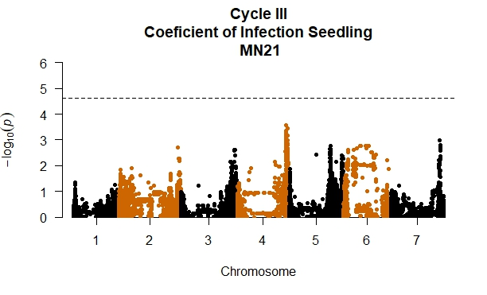
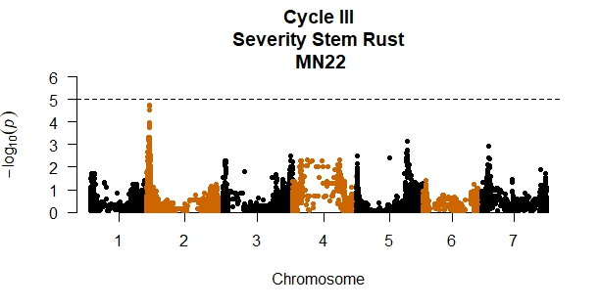
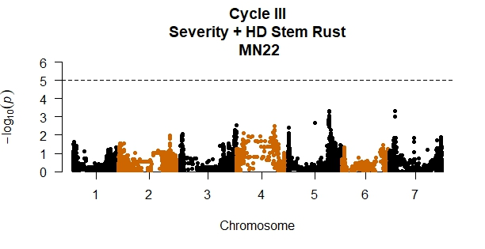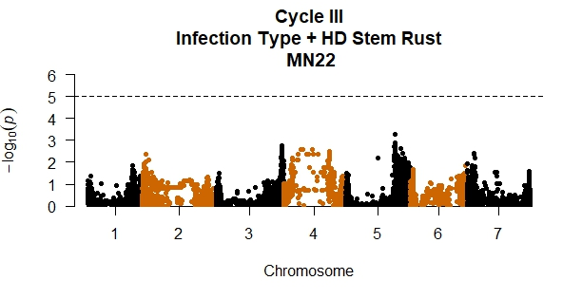
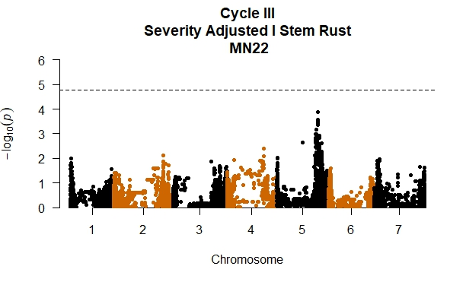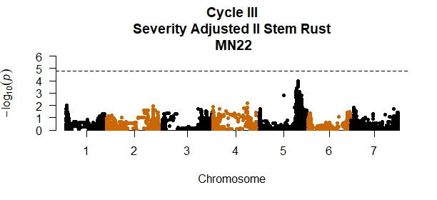
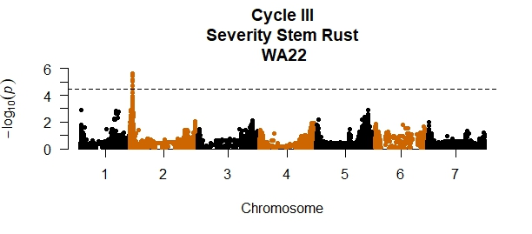
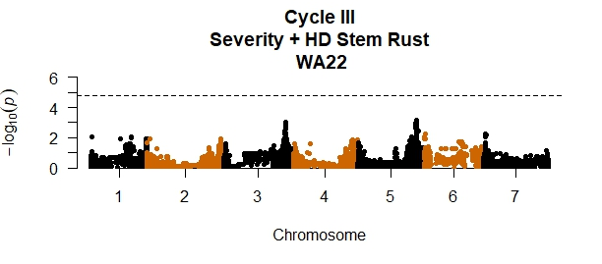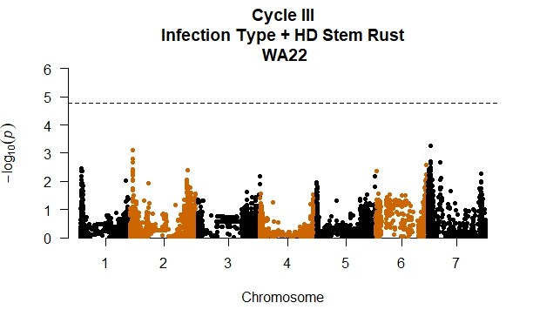

2019-20 Field Evaluations for Stem Rust at seedling and adult stages
Lines were evaluated for stem rust in Saint Paul, MN and Pullman Spillman, WA during the 2021 and 2022 seasons. At the seedling stage, no QTL was observed with coefficient of infection. In 2022, at the adult plant stage, a QTL was observed on 2HS, but it was in the vicinity of Ppd-H1, a gene associated with long-day sensitivity. This suggests that low severity scores were due to escape rather than genetic resistance. Using the most significant SNP associated with Ppd-H1 as a covariate, the association analysis did not show any significant association. Due to the large variation in the field resulting from drought, stem rust means were adjusted using repeated checks across the tested field. Although, no significant QTL was observed, a peak approaching significance was observed on 5H, near a QTL detected in a previous population tested in MN. In WA, the loci associated with long-day sensitivity also appeared to influence disease severity. After correcting for the effect of Ppd-H1, no QTL was observed associated with stem rust resistance.

