Cycle III Preliminary Report
2019 and 2020 harvest seasons
Barley stripe rust and scald

Javier Hernandez, Tanya Filichkin, Scott Fisk, Laura Helgerson, and Patrick Hayes
Barley Project. Oregon State University. Corvallis, Oregon, USA.

Intent and purpose:
This report is intended to summarize analyses of currently available data, point to key findings, and to articulate questions based on these key findings that will be addressed in a forthcoming journal article. These key findings and questions they raise include:

The 5H and 4H barley stripe rust QTLs have been repeatedly identified and reported in OSU germplasm.
- What candidate genes lie under these QTLs?
- What is the basis of allelic variation in these candidate genes?
- What are the positional relationships of these QTLs with QTLs for other traits of key importance – e.g. malting, brewing, and sensory quality; resistance to other diseases; and morphology and phenology?

The 3H scald resistance QTL detected in one year disappears when heading date is used as a covariate. However, heading date does not cause scald.
- What is the basis of the relationship between heading data and scald symptom severity?
- What candidate genes for other traits: e.g. flowering time, plant height, and disease resistance lie under the 3H QTL?
- What is the basis of allelic variation in these candidate genes?

The heritability of scald across years is low and no QTLs were detected when data were combined across years.
- Can the heritability of scald be increased, and if so, how?
- If heritability cannot be increased, could this mean that all genotypes have similar basal levels of resistance, but that local environmental effects, morphology, and/or phenology lead to varying degrees of symptom development?

Germplasm:
The Cycle III panel is a germplasm array of 373 doubled haploid lines derived from crosses among 10 parents with resistance to one or more rust diseases (stem, stripe, leaf) and/or scald. The three checks are: Lightning (DH130910), Robust and Thoroughbred. Lightning is resistant to stripe rust and scald; Thoroughbred is susceptible to stripe rust and resistant to scald; Robust is susceptible to stripe rust and scald.

Data sources: The panel was phenotyped for stripe rust and scald using a Randomized Complete Block Design with two replications. Stripe rust was assessed in three environments: Corvallis, OR in 2018/19/2019/20 and Davis, CA in 2019/20. Scald was assessed at Corvallis for two seasons: 2018/19 and 2019/20. The panel was genotyped with the Illumina 50K SNP chip.
Disease assessment procedures:

Stripe rust (incited by Puccinia striiformis f. sp. hordei): Adult plant resistance was assessed based on severity (percentage of leaf area affected with the disease on a plot basis) at Corvallis at two dates; at Davis, both severity and infection type (using the scale of McNeal et al., 1971) were assessed, also at two dates. Natural infection at each location was supplemented with artificial inoculation using local isolates.

Scald (incited by Rhynchosporium commune): Adult plant resistance was assessed based on severity at two dates.

All data:
Please see https://barleyworld.org/barley-stripe-rust-bsr

Publication(s):
In preparation

Funding:
Support provided by USDA-ARS-NACAs for stripe rust and stem rust research.

2019

Phenotypic frequency distributions across dates and diseases for stripe rust (BSR) severity and scald (SC) severity at the adult plant stage; Corvallis, OR. DH130910 = Lightning

The checks behaved as expected for both diseases. Most entries were resistant to moderately resistant to both diseases (severities < 20%).

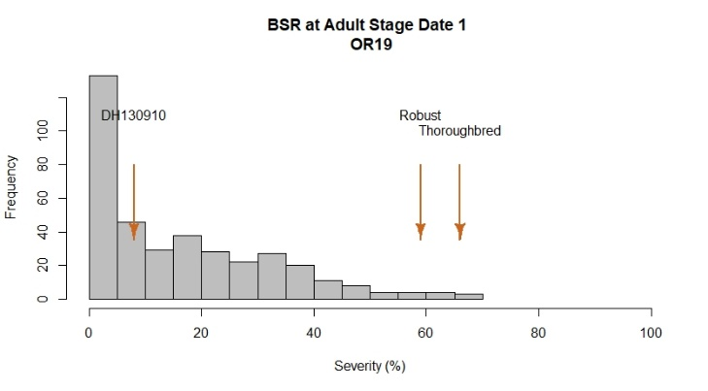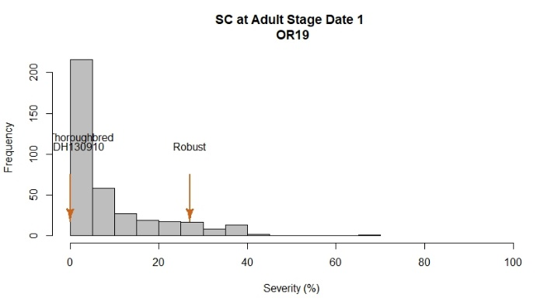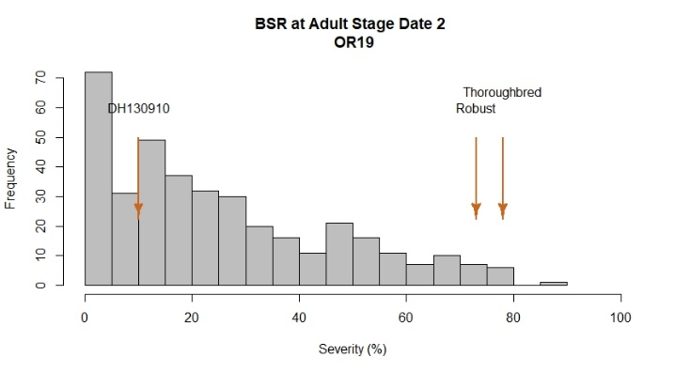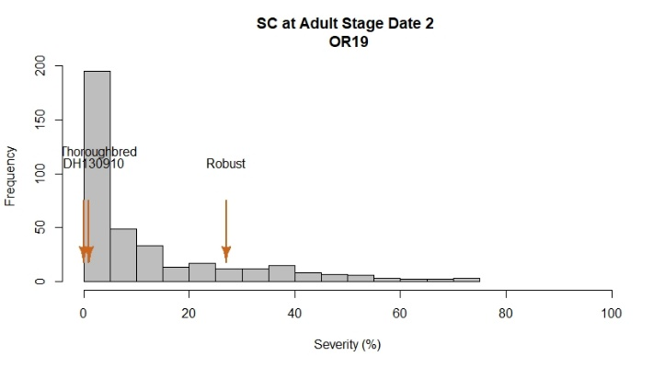

Analyses of variance for BSR and SC

There were highly significant differences between entries for both diseases. Ranked means and LSD tests are available at https://barleyworld.org/barley-stripe-rust-bsr

Severity Date 1
Df Sum Sq Mean Sq F value Pr(>F)
Line 373 196657 527.2 6.314 < 2e-16 ***
Rep 1 600 600.1 7.188 0.00767 **
Residuals 373 31144 83.5
---
Signif. codes: 0 ‘***’ 0.001 ‘**’ 0.01 ‘*’ 0.05 ‘.’ 0.1 ‘ ’ 1
Severity Date 2
Df Sum Sq Mean Sq F value Pr(>F)
Line 373 335900 900.5 8.108 <2e-16 ***
Rep 1 229 229.1 2.063 0.152
Residuals 373 41428 111.1
---
Signif. codes: 0 ‘***’ 0.001 ‘**’ 0.01 ‘*’ 0.05 ‘.’ 0.1 ‘ ’ 1

SC OR19
Severity Date 1
Df Sum Sq Mean Sq F value Pr(>F)
Line 373 90739 243.3 2.001 1.68e-11 ***
Rep 1 2976 2976.0 24.483 1.14e-06 ***
Residuals 373 45340 121.6
---
Signif. codes: 0 ‘***’ 0.001 ‘**’ 0.01 ‘*’ 0.05 ‘.’ 0.1 ‘ ’ 1
Severity Date 2
Df Sum Sq Mean Sq F value Pr(>F)
Line 373 202681 543 1.885 6.46e-10 ***
Rep 1 9261 9261 32.131 2.89e-08 ***
Residuals 373 107513 288
---
Signif. codes: 0 ‘***’ 0.001 ‘**’ 0.01 ‘*’ 0.05 ‘.’ 0.1 ‘ ’ 1

Phenotypic correlations
There were high and positive correlations between rating dates for each of the two diseases, and very low correlations between diseases at either of the rating dates. There was a high correlation between scald and heading date, and low and negative correlation between stripe rust and heading date.

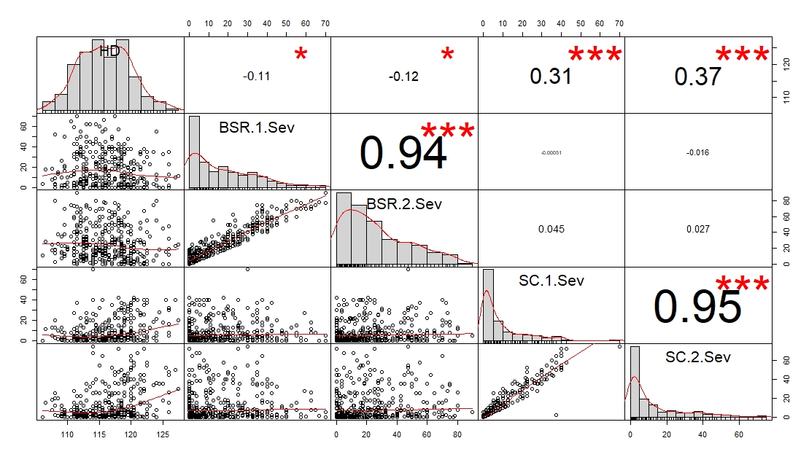

GWAS

For BSR at each of the two dates, the same two QTLs were detected: a large-effect QTL on 5H and a minor QTL on 4H. For SC, a single QTL on 3H was detected at each of the two dates. For HD, two major QTLs were detected: one on 1H and one on 3H. A minor QTL was found on 4H. The SC and HD QTLs on 3H were coincident: therefore the GWAS was also conducted using HD as co-variable.
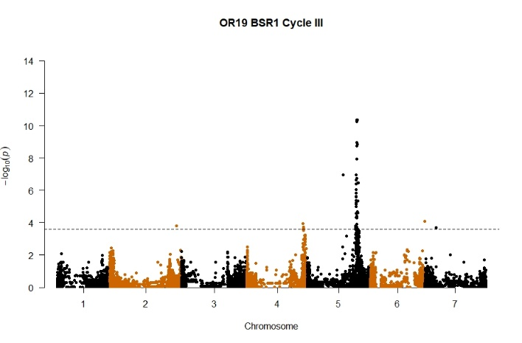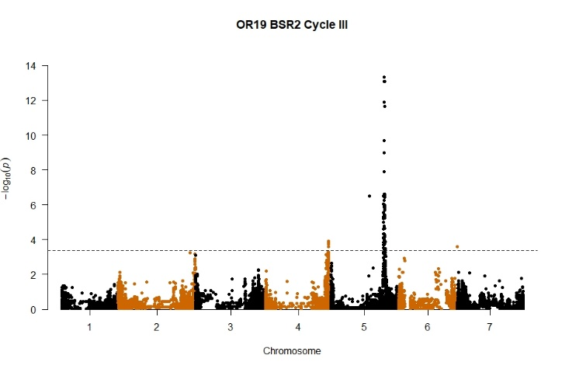
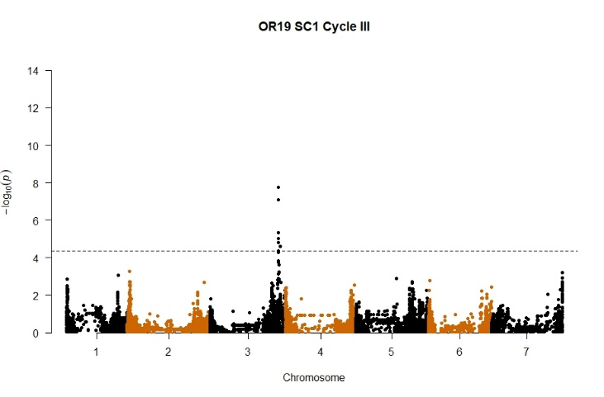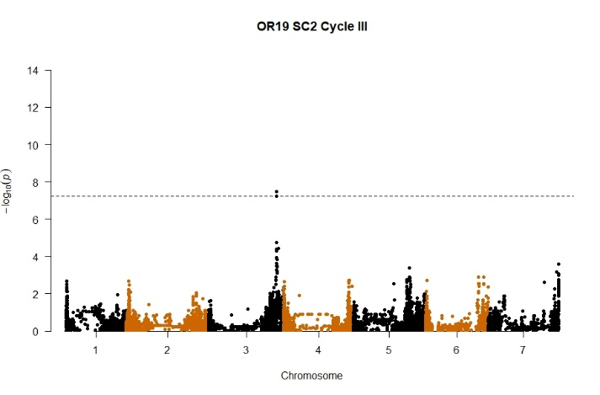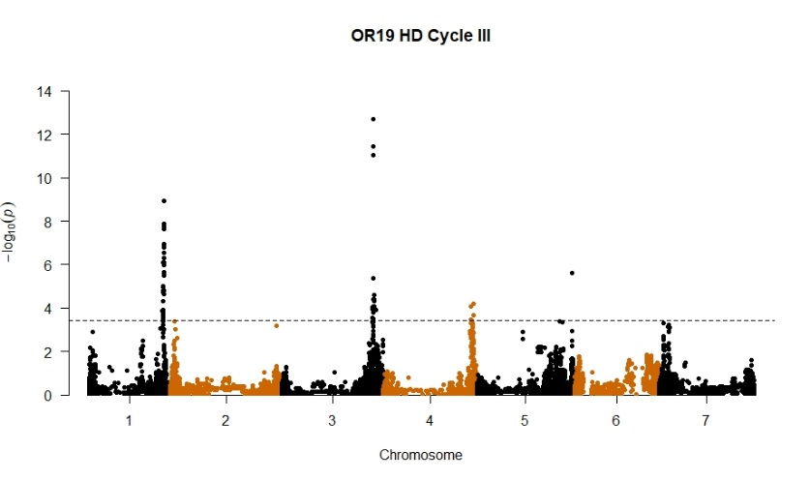

GWAS for SC adjusted for HD

HD was included as co-variate in two ways: (1) using all data and (2) using only the most significant SNP in common for the two traits (JHI-Hv50k-2016-204905, p = 3.22e-8, R2 = 0.08). When all HD data were used, the QTL on 3H was reduced in significance. When the SNP data were used, the peak on 3H disappeared and no other QTL were detected.

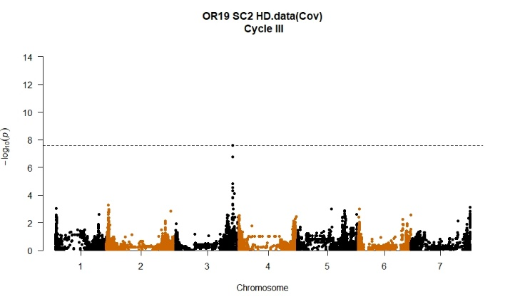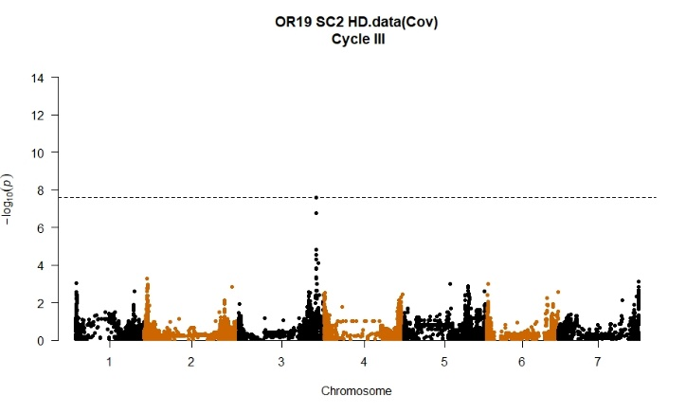

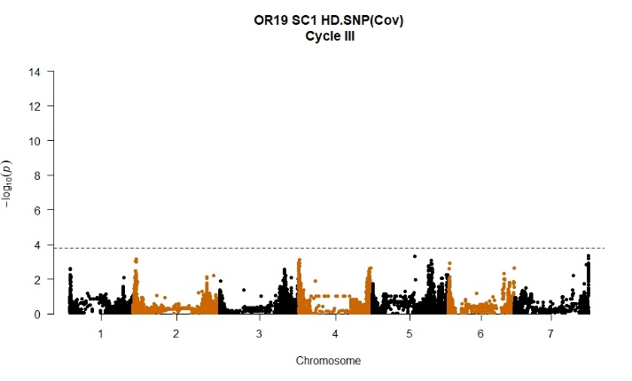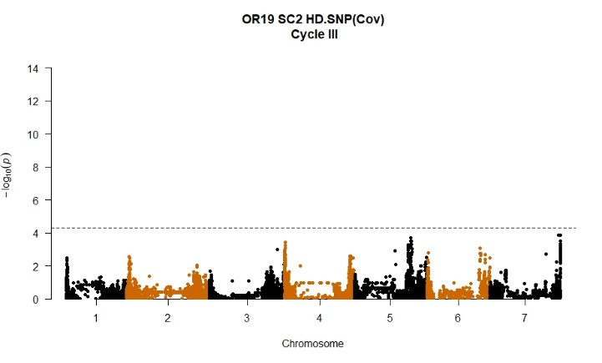

2020

Phenotypic frequency distributions across diseases assessment methods, dates, locations for stripe rust (BSR) at the adult plant stage; Corvallis, OR and Davis, CA and Scald (SC) at
Corvallis, OR. DH130910 = Lightning
For BSR severity, the checks behaved as expected at both locations. Most entries were resistant to moderately resistant (severities < 20%). Lightning and many entries showed intermediate infection types and there were entries with lower infection types than Lightning.
For SC, the checks behaved as expected, and most entries were resistant (severities < 20).

Across years at Corvallis, the frequency distributions for each of the two diseases were very similar.

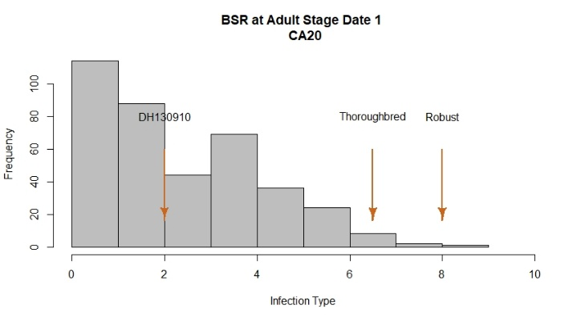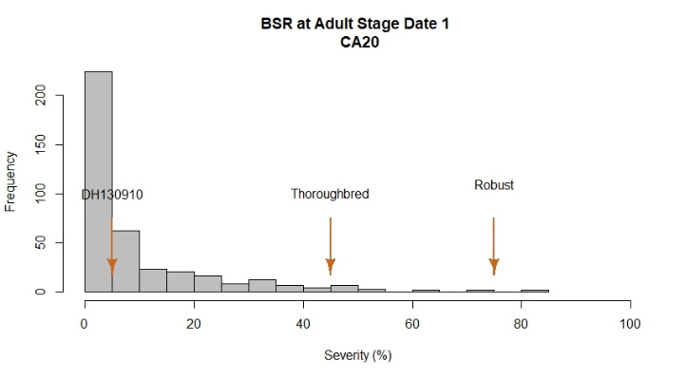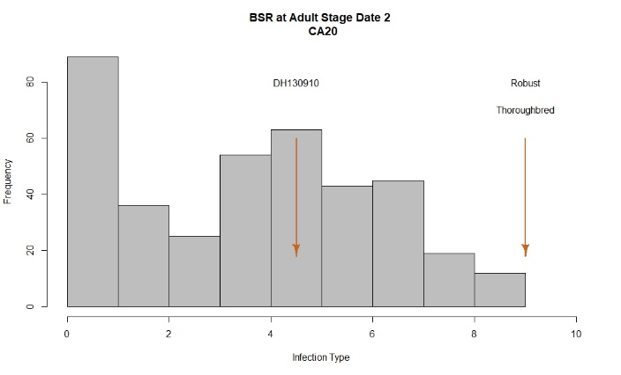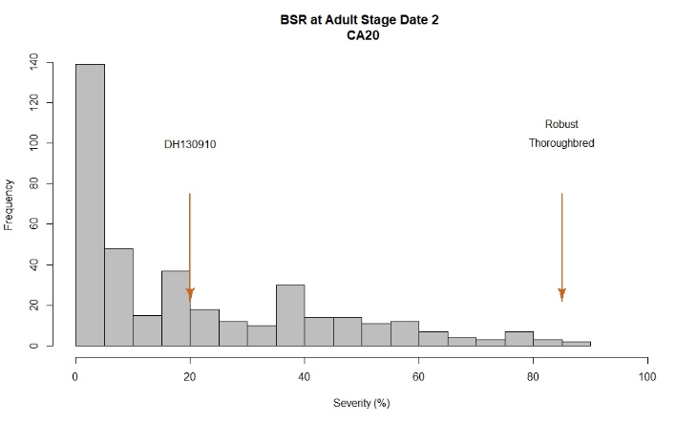
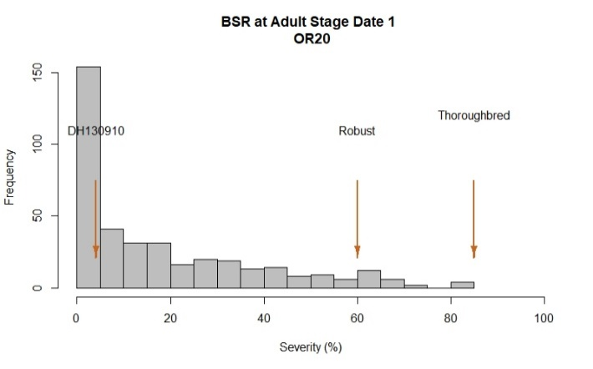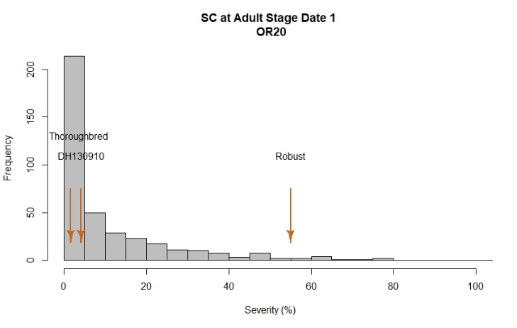
Analyses of variance for BSR and SC

There were highly significant differences between entries for BSR at both locations, and for both assessment methods at Davis. There were highly significant differences between entries for SC at Corvallis. Ranked means and LSD tests are available at https://barleyworld.org/barley-stripe-rust-bsr

BSR OR20
Severity Date 1
Df Sum Sq Mean Sq F value Pr(>F)
Line 382 317405 831 5.87 < 2e-16 ***
Rep 1 6751 6751 47.69 2.09e-11 ***
Residuals 382 54073 142
---
Signif. codes: 0 ‘***’ 0.001 ‘**’ 0.01 ‘*’ 0.05 ‘.’ 0.1 ‘ ’ 1

SC OR20
Severity Date 1
Df Sum Sq Mean Sq F value Pr(>F)
Line 382 215560 564.3 3.019 <2e-16 ***
Rep 1 45 44.7 0.239 0.625
Residuals 382 71394 186.9
---
Signif. codes: 0 ‘***’ 0.001 ‘**’ 0.01 ‘*’ 0.05 ‘.’ 0.1 ‘ ’ 1

BSR CA20
Infection Type 1
Df Sum Sq Mean Sq F value Pr(>F)
Line 382 3040.0 7.958 3.149 <2e-16 ***
Rep 1 0.6 0.632 0.250 0.617
Residuals 382 965.4 2.527
---
Signif. codes: 0 ‘***’ 0.001 ‘**’ 0.01 ‘*’ 0.05 ‘.’ 0.1 ‘ ’ 1
Infection Type 2
Df Sum Sq Mean Sq F value Pr(>F)
Line 382 5313 13.908 6.927 < 2e-16 ***
Rep 1 27 27.070 13.484 0.000275 ***
Residuals 382 767 2.008
---
Signif. codes: 0 ‘***’ 0.001 ‘**’ 0.01 ‘*’ 0.05 ‘.’ 0.1 ‘ ’ 1
Severity Date 1
Df Sum Sq Mean Sq F value Pr(>F)
Line 382 127077 332.7 2.694 <2e-16 ***
Rep 1 197 196.5 1.592 0.208
Residuals 382 47162 123.5
---
Signif. codes: 0 ‘***’ 0.001 ‘**’ 0.01 ‘*’ 0.05 ‘.’ 0.1 ‘ ’ 1
Severity Date 2
Df Sum Sq Mean Sq F value Pr(>F)
Line 382 392040 1026 6.186 <2e-16 ***
Rep 1 4277 4277 25.778 6e-07 ***
Residuals 382 63379 166
---
Signif. codes: 0 ‘***’ 0.001 ‘**’ 0.01 ‘*’ 0.05 ‘.’ 0.1 ‘ ’ 1

Phenotypic correlations
There were moderately high to high and positive correlations between BSR assessment methods and dates at Davis and between severity ratings across locations. The correlations between SC severity and BSR severity/infection type were low within and across locations. Heading date was not correlated with either disease at either location and heading date was not correlated across locations.

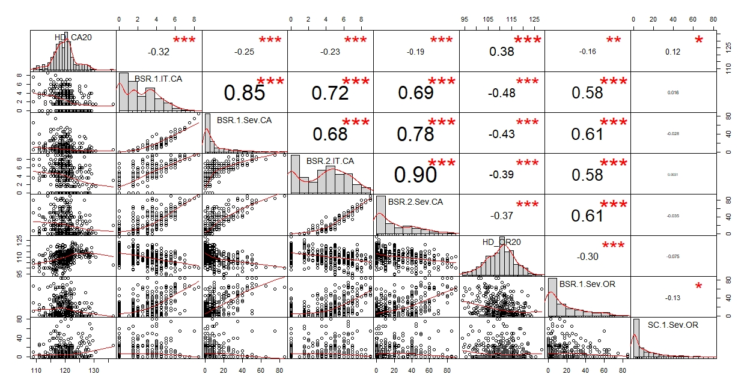

GWAS
For BSR at Corvallis, a large-effect QTL was detected on 5H. For BSR at Davis, QTLs on 3H and 5H were detected at both dates and using both assessment methods. A QTL on 4H was detected in all cases except for the first severity rating.
There were no SC QTLs detected at Corvallis.
HD QTLs were detected on 1H and 3H at Corvallis and on 2H and 3H at Davis. The Davis 3H BSR QTL for severity and infection type was coincident with the QTL for HD: therefore the GWAS was also conducted using HD as co-variable.

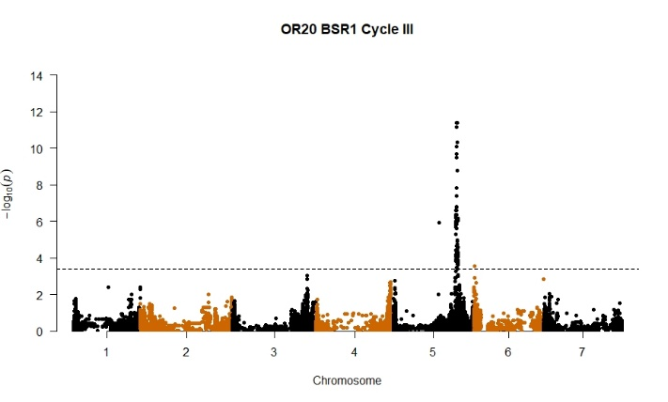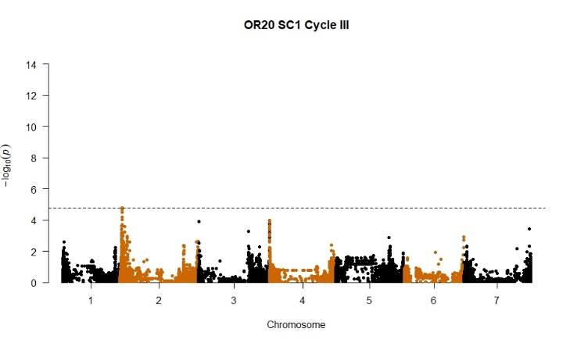

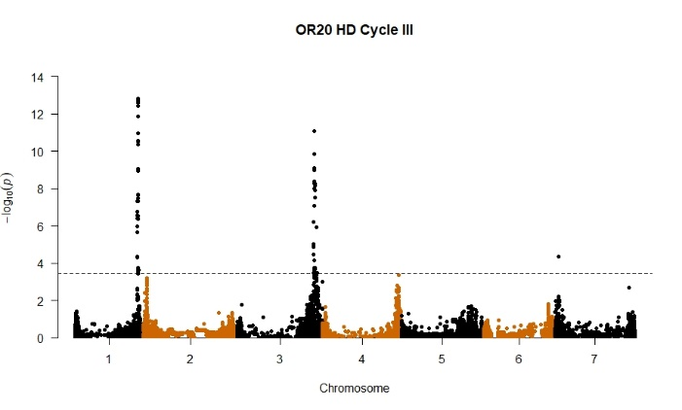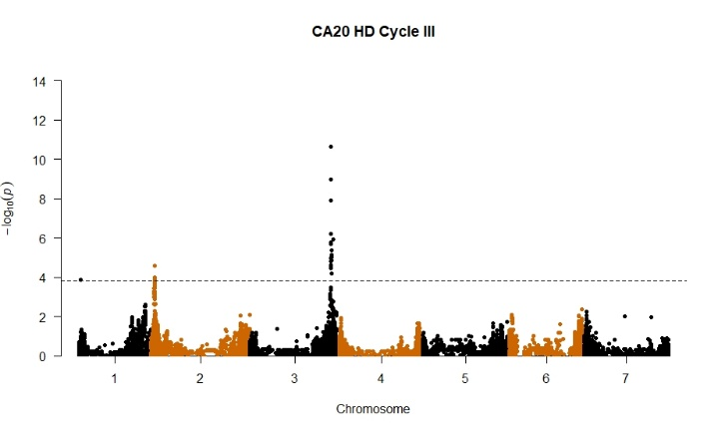

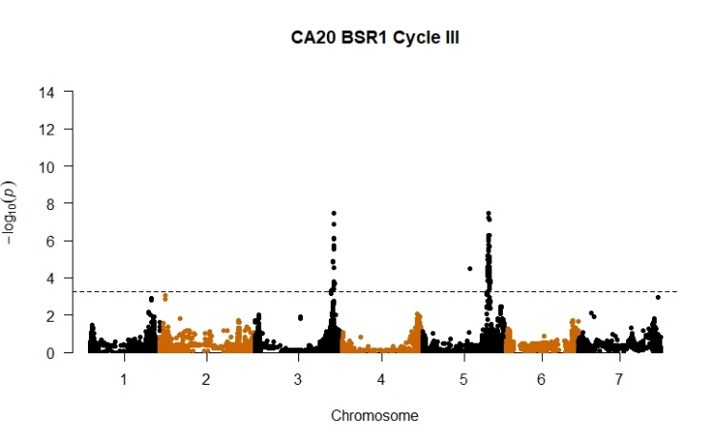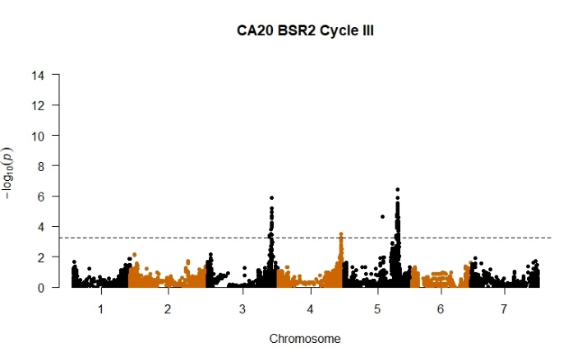
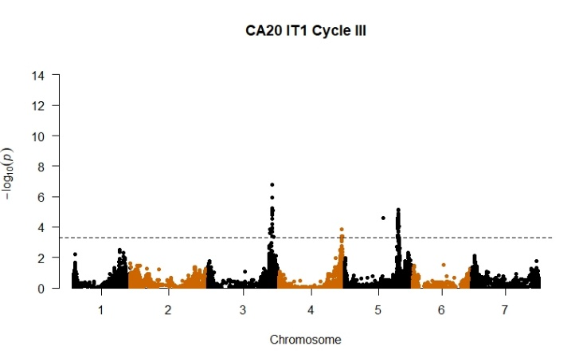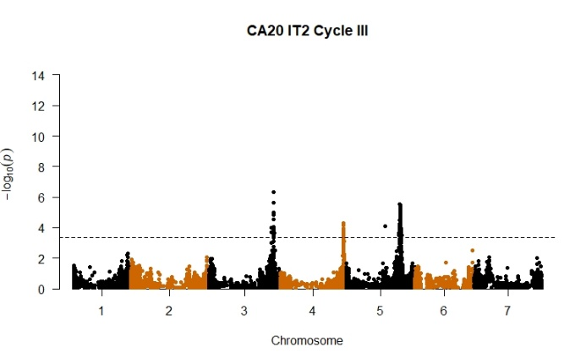

GWAS for BSR severity and IT at Davis adjusted for HD

When HD was included as co-variate using all data, the significance of the 3H QTL was reduced and the significance of the QTL on 5H increased.

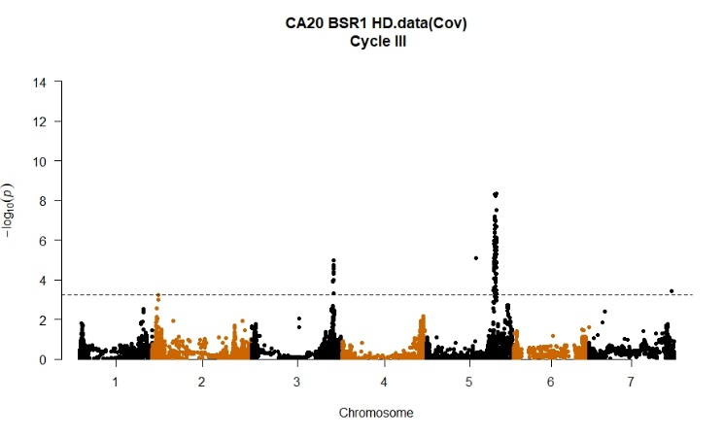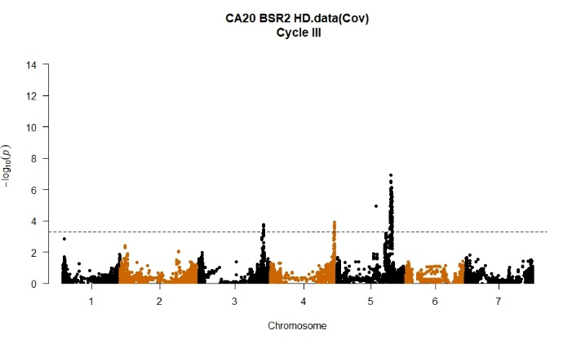

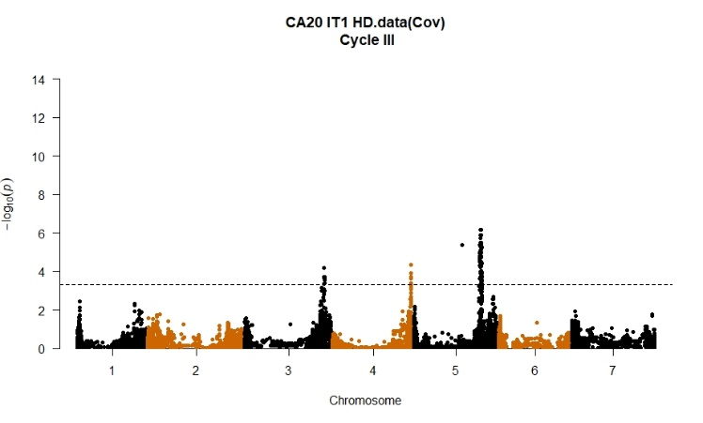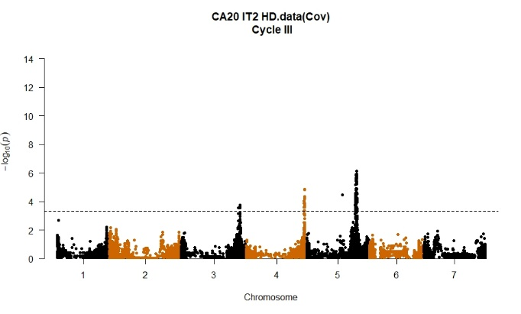

BLUPs across environments (OR19, OR20, and CA20) for BSR

The best linear unbiased predictions (BLUPs) were calculated for each line across three environments - Corvallis 2019, Corvallis 2020 and Davis 2020 - for disease severity

Phenotypic frequency distributions and heritability based on BLUPs for stripe rust (BSR). DH130910 = Lightning.

The checks behaved as expected. Most entries were resistant to moderately resistant (severities < 20%). The heritability was high.

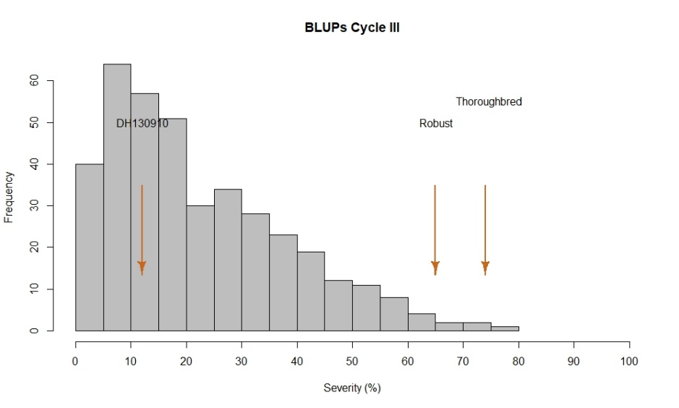
$$H^{2}=0.80$$
GWAS
The largest-effect QTL was on 5H, a minor QTL was detected on 4H. The 3H QTL was at the threshold of significance.

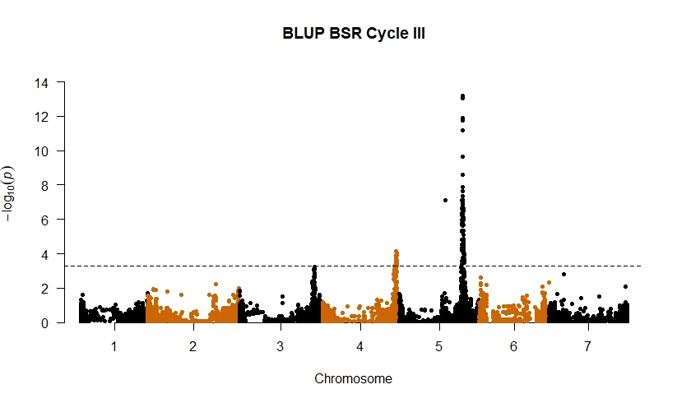

BLUPs across years (OR19, OR20) for SC

The best linear unbiased predictions (BLUPs) were calculated for each line using the data from two years at Corvallis.

Phenotypic frequency distributions and heritability based on BLUPs for scald (SC). DH130910 = Lightning.

The checks behaved as expected. Most entries were resistant (severities < 10%). The heritability was moderate.

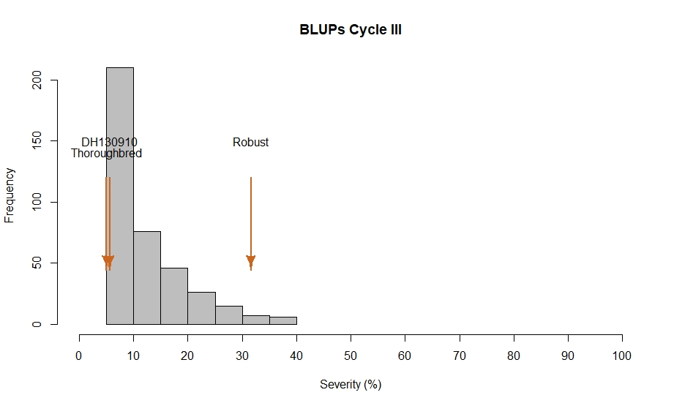
$$H^{2}=0.47$$

GWAS
No QTLs were detected.

