Cycle IV Report

Javier Hernandez, Tanya Filichkin, Scott Fisk, Laura Helgerson, Chris Massman, and Patrick Hayes
Barley Project. Oregon State University. Corvallis, Oregon, USA.

Germplasm:
The Cycle IV germplasm array consists of 661 lines generated from barley crosses among parents with different growth habits and resistance to one or more rust diseases (stem, stripe, leaf), and checks. This trial was grown in a total of three different environments over the 2020-21 and 2021-22 seasons. This report covers heading date, barley stripe rust, and scald data generated across all environments.

Stripe rust and Scald Assessment Procedures:
Rust nurseries were evaluated for adult plant resistance to barley stripe rust (BSR, incited by Puccinia striiformis f. sp. hordei) using both infection type and severity at Davis, CA and only severity at Corvallis, OR. Severity (Sev) was scored as percentage of leaf area affected with the disease on a plot basis, whereas infection type (IT) was recorded according to McNeal et al. (1971). An augmented design with systematic check plots in a Latin-square arrangement was used. For fall planting the checks used were Thoroughbred, Robust, DH140963 and Lightning whereas for spring planting the checks were Copeland, Lightning, DH140088, and Full Pint. At both locations, natural infection was supplemented with artificial inoculation. Scald (SC, incited by Rhynchosporium commune) was evaluated using severity at Corvallis during 2021.

Data:
Please see https://barleyworld.org/barley-stripe-rust-bsr

Publication(s):
Not expected

Funding:
Support provided by USDA-ARS-NACAs for stripe rust and stem rust research.

This report:
In this report, we provide data and analyses on heading date, barley stripe rust and scald resistance in the Cycle IV population.

Cycle III 2020-21 – Oregon and California data

Heading Date for Davis, CA and Corvallis, OR

Histogram distribution across sites for Fall planting

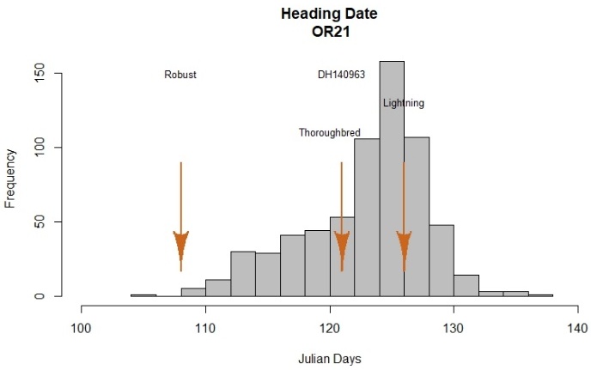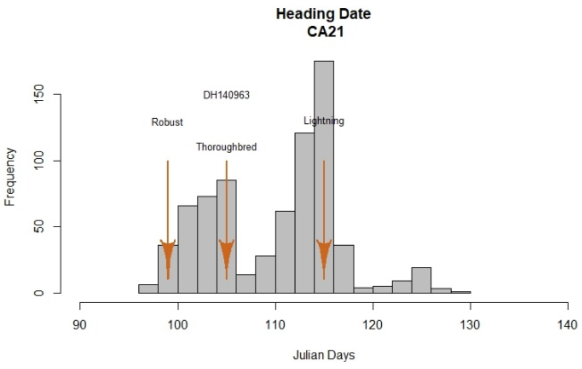

Histogram distribution across sites for Spring planting
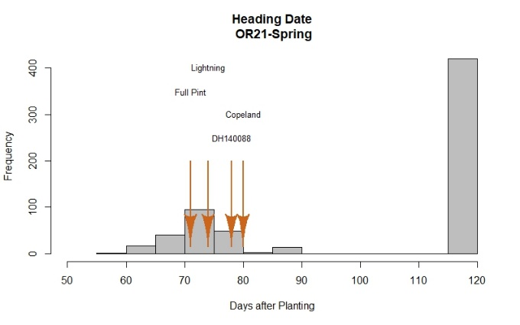*Winter types assigned 120 DAP for reference.

Correlations among sites for heading date

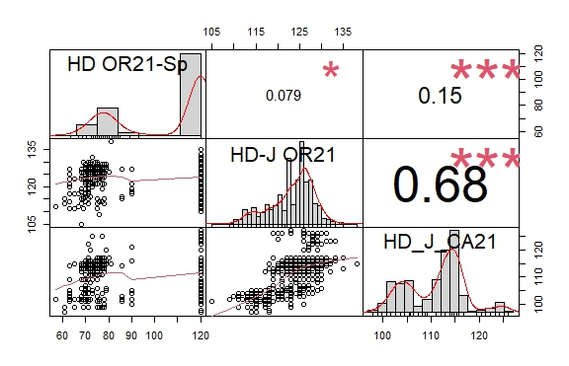
Reaction to BSR and SC at the adult plant stage; Davis, CA and Corvallis, OR

Histogram distribution across dates and diseases
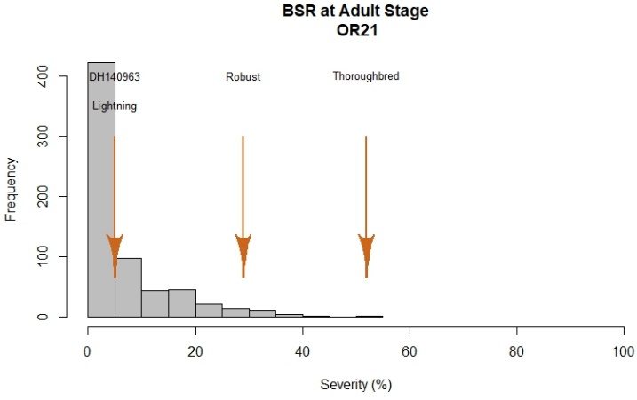

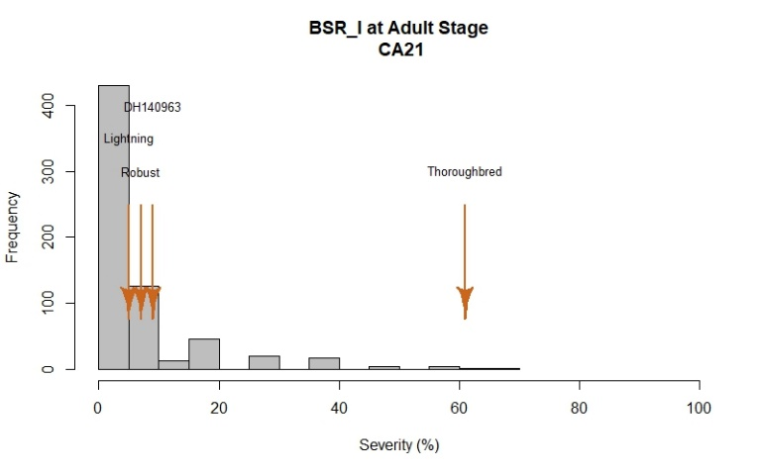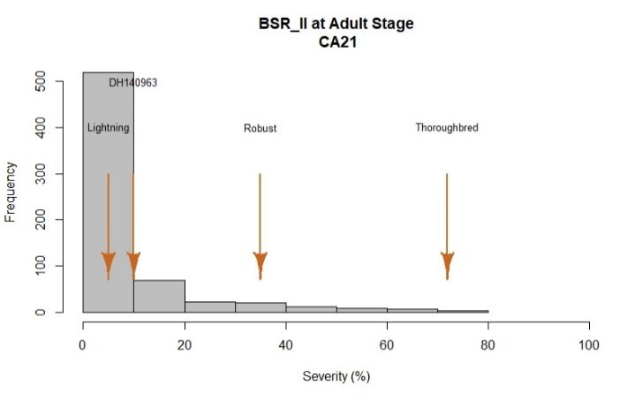

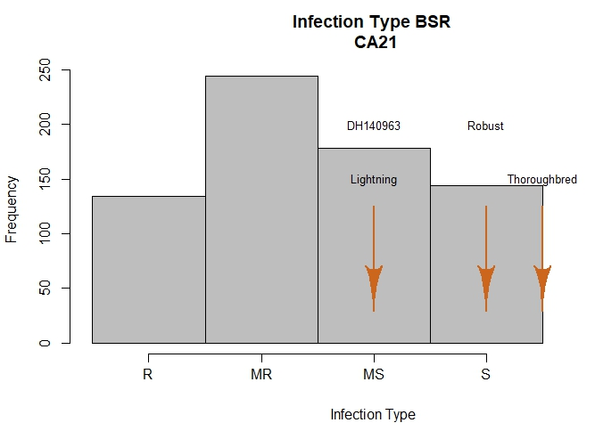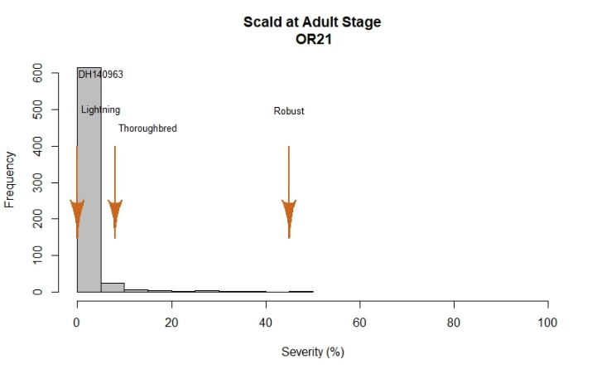

Correlation among sites for BSR
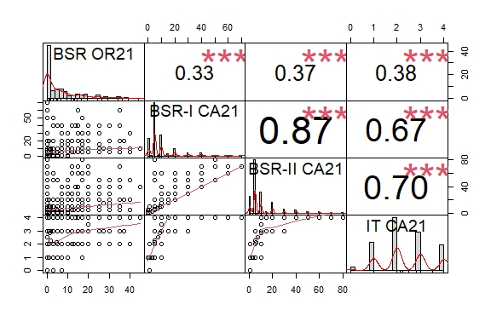

2020-21 BSR Field Evaluations
At Davis, disease notes were taken two times during the growing season at a 10-day interval. At Corvallis, one evaluation was performed once flowering was finished.
Corvallis and Davis had similar levels of disease with the severity plot skewed to the left (low disease). At Corvallis severity ranged from 0% to 52%, with Robust and Thoroughbred showing the highest severity values of 29% and 52%, respectively. The resistant checks DH140963 and Lightning had the lowest value with 1.4% and 4.7%, respectively. As can be noticed in the plot, most of the lines exhibited low values for barley stripe rust. In fact, a total of 606 lines showed 20% or less disease severity whereas 27 lines had severity values > 30%. 50% of the lines at this location exhibited severity values between 1% and 10%.

At Davis, a range of phenotypic variation was observed among lines and across dates. Severity ranged from 0% to 72% by the second screening date. Controls Robust and Thoroughbred showed the highest severity/ infection type values both with 35%/S and 72%/S, respectively. The resistant checks DH140963 and Lightning had the lowest values with 10.5%/MS and 5.8%/MS, respectively. At this location, a total of 613 lines showed 20% or less disease severity whereas 45 lines had severity values > 30%. 50% of the lines at this location exhibited severity values between 5% and 10%.

Infection type: A total of 348 lines displayed a resistant or moderate resistant infection type whereas 266 lines displayed a moderate susceptible or susceptible infection type. Susceptible check lines fell into the moderate susceptible or susceptible categories. 50% of the lines at this location had a moderate resistant or moderate susceptible infection type.

Scald (SC) was evaluated at Corvallis during this season at heading with severity ranging from 0% to 45%. The Cycle IV population showed limited variation for this trait with most of the lines (n=631) exhibiting severity values lower than 10%. The susceptible check Robust showed a severity of 45% (~90% under severe disease pressure is more typical) whereas the other checks ranged from 0 to 8%.

GWAS
The limited phenotypic variation observed for disease resistance did not justify the cost of genotyping. Therefore, GWAS was not conducted.

