Growing OWBs in the greenhouse
You will get optimum growth and development with one-gallon pots. Cone-tainers will work well. See below for details and pictures.
We bottom water – saves lots of time. See pictures.
PLANTING
- Fill pot to the top with soil (see next page for details on soil mix) and water it until it drains out
- Make an indentation in the soil, about ½-1 inch deep (DON’T plant seed too deep or you will have germ problems)
- Place 1 seed in the indentation
- Cover the seed with soil and gently water
*Barley should be up and growing about a week after planting*

GROWING
- Top water the pot for the first several weeks after planting
- Once plants are established and have 3 leaves (2-3 weeks after planting) have the plant treated with Marathon (granular systemic insecticide applied to the top of the soil for aphid and thrip control)
- Switch to bottom watering after Marathon is applied
- Give the pots time to dry out in between watering and only water the pots that are dry. A useful tip is to pick up each pot and feel the weight difference in a wet versus dry pot until you have a better idea of how much water the plants really need
- 1x/week top water the pot to keep the Marathon active
- 1x/week use a diluted mix of fertilizer (NPK 20-20-20) to water with (if the plants need it)
- Hang 1-2 sachets (beneficial insect, thrip predator mite) per pot. Sachets will need to be replaced every month
- Use bamboo stakes and twisties for plant support and control
- Trim off yellowing or discolored leaves and late/unnecessary tillers
- Rough-up top of soil to prevent algae build-up
- Grow trays will need to be cleaned and/or swapped out depending on level of algae build-up
- Monitor for pests and disease, report them to the GH Staff asap (army worms, aphids, spider mites, excessive amounts of thrips (you will always have them), and powdery mildew)
- Planting to harvest will take about 4 months depending on time of year and genotype
- Stop watering once the seed has set and the heads start to yellow
- Plants are ready for harvest and storage when the seeds are hard (you can’t make an indent with your nail)
Containers:
- “1 Gallon Trade Pot”. #1 Deep, 6 3/4" (H) x 6 1/4"(W) http://www.andersonpots.com/products/anderson-black-polycans/
- “Cone-tainers/Tubes”. Deepots, D40H
https://www.stuewe.com/products/deepots.php

Greenhouse Settings:
- Temp: 60F Day, 60F Night (switch to 65F for Winter/Spring)
- Light: HPS fixtures with 16 hr light, 8 hr Dark

POTTING MIX

The goal with this mix is to create a light, well-aerated soil matrix: substitute local ingredients as needed

MM840 1- Bag Professional Potting Soil: 56.6 L
Turface: 1.9 L
Osmocote 335g: NPK 14-14-14, 3-4 mo. release
Lime: 283 g
Pumice: 6.6 L
Perlite: 8.5 L

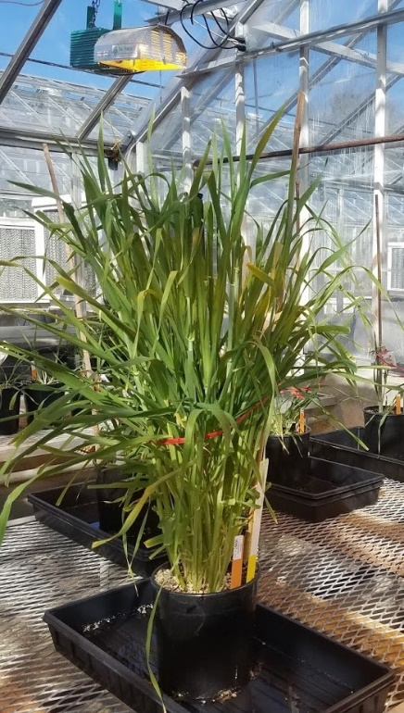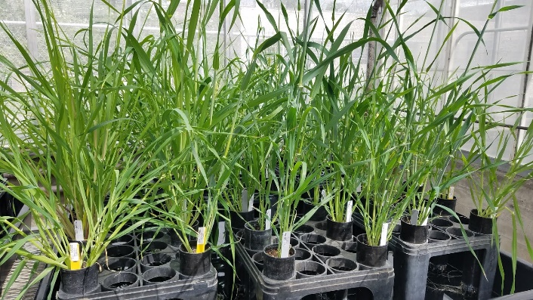

Barley in 1 gallon pot Barley in Cone-tainer tubes

