Favorite Plants
PBG 430 Homework assignments

Overview:
These homework assignments are designed to align your Plant Genetics classroom experiences with your deep and abiding interest in plants.
You will complete each assignment on your favorite plant (please choose an angiosperm or a gymnosperm). However, there may come a time when you cannot find required information on your favorite plant. Therefore, you will likely need a back-up plant to complete some of the assignments. The recommended back-up is the model system plant most closely related to your favorite plant. For example, for dicots – Arabidposis thaliana; for monocots – Oryza sativa; and for gymnosperms – Pinus taeda. You are welcome to choose another back-up plant, but please confirm your choice with the instructor.
Grading:
Each homework will be submitted as a hard copy, in class. Late assignments will be penalized 5 point. The instructor/TA will make corrections on the hard copies. If you make the requested corrections and re-submit, you will be given some of the lost points.
The final homework will be a compilation of all prior homework assignments into a single electronic submission (as a Word document). These compilations will constitute a “genetic flyover” of your favorite plant. These compilations will be shared with your fellow students for peer review.
Citation format:
Please cite all resources used to answer the homework assignments. Follow the citation format used by Science. For examples, see the citations at the end of this paper (and have a look at the paper as well!).

Homework # 1. You and your plants:
On a piece of cardstock/firm paper measuring 22.9 x 30.5 cm (9” x 12”) - folded longitudinally - provide the following:
On the front of the card:
Your name
Favorite plant
Illustration (be creative – hand-drawn preferred)
Common name
Genus and species
Genome formula*
Genome size (Mbp and pg)*
Center(s) of origin
Traits of economic and/or ecological importance
Cool fact
On the back of the card:
Back-up plant
Common name
Genus and species
Genome formula*
Genome size (bp and pg)*

* Go to Kew! (Kew Gardens Plant DNA C-values Database)

An example:
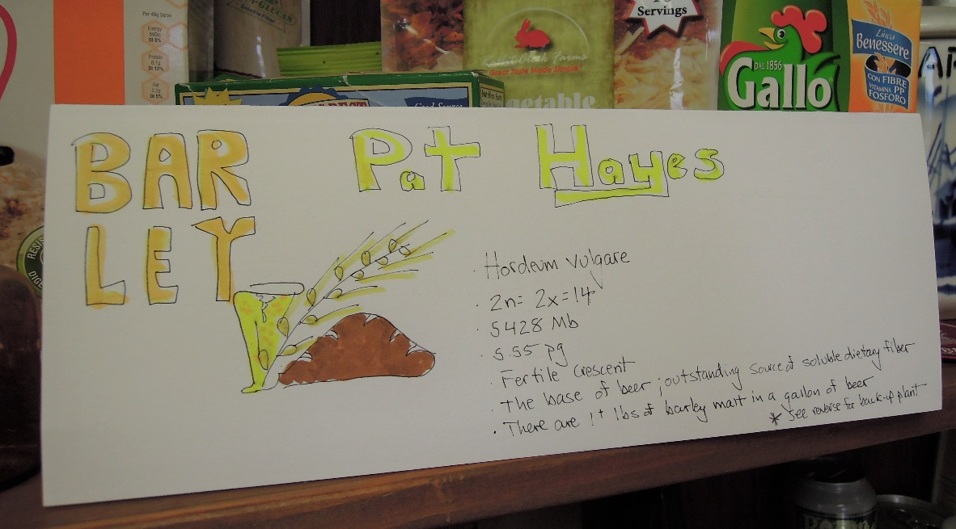

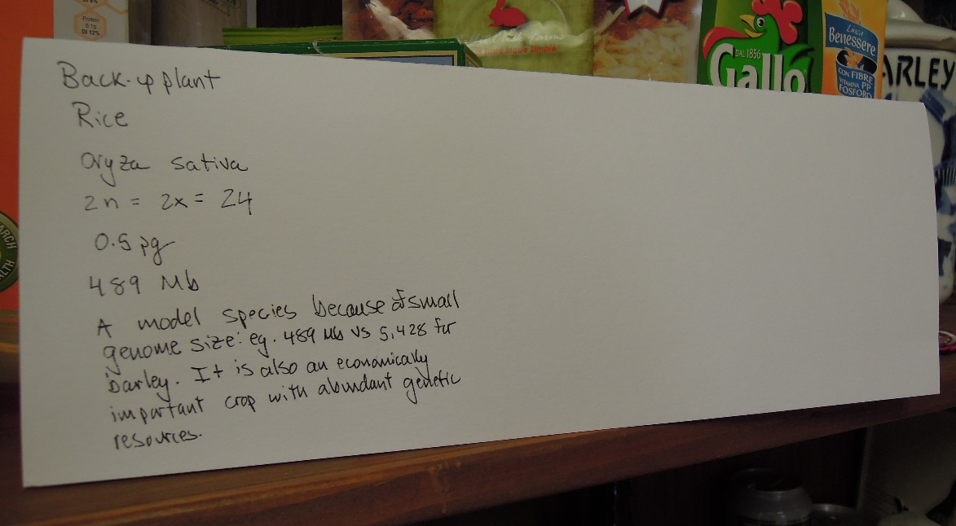
Homework # 2.

Homework # 3.

Homework #4

Homework #5

