KASP and PVP panels
Growth Habit Prediction

Javier Hernandez, Tanya Filichkin, Scott Fisk, Laura Helgerson, and Patrick Hayes
Barley Project. Oregon State University. Corvallis, Oregon, USA.

Cooperators: Jason Fiedler and Mary Osenga, USDA/ARS. Fargo, North Dakota, USA.

Intent and purpose:
The purpose of this report is to summarize the development, implementation, and analysis of molecular markers targeting key genes associated with vernalization and photoperiod sensitivity to predict growth habit (e.g., spring, facultative, or winter) in barley.

All data:
Please see https://barleyworld.org/low-temperature

Germplasm:
The KASP (Kompetitive Allele Specific PCR) panel is a germplasm array of 95 accessions representing spring, facultative and winter growth habit. Entries in the panel are derived from different sources: 12 have been widely described in literature, 33 were selected based on Muñoz-Amatriaín et al. (2020), 39 are from the OSU covered malting barley breeding program and 11 are from the OSU OREI naked diversity panel.

The PVP (Prediction Validation and Produktion) panel is a germplasm array of 96 accessions representing diverse germplasm and growth habits. Fifty entries were derived from the OSU OREI naked diversity panel, 23 were derived the stripe rust and stem rust Cycle panels (Cycles I and II), the AMBA-LTT panel, and the Oregon Wolfe Barley Mapping Population (OWB), and 23 were derived from elite germplasm in the OSU covered malting barley breeding program.

Data sources: Both panels were phenotyped for days to heading (DTH) under greenhouse and field conditions at Corvallis, OR in 2021. Under field conditions, DTH was recorded for each plot, which was estimated as the day when 50% of tillers from a single plot exhibited at least 1 cm of visible awns. For spring sowing, days were expressed as number of days after planting. Under greenhouse conditions, lines were planted in single tubes in an un-replicated experiment where DTH was recorded for each line as the time when awns were visible on the main stem.

Genotyping
The complete panels were genotyped with KASP markers at the USDA-ARS Regional Small Grain Genotyping Laboratory (Fargo, ND). Markers were developed to target specific polymorphisms in, or linked to, the PPD-H1, PPPD-H2, VRN-H1, VRN-H2, and VRN-H2 loci. Polymorphisms were identified by sequence comparison of genome sequences available at NCBI and were used to create KASP markers using PolyMarker software. Briefly, the dominant and recessive alleles were targeted as follows:
PPD-H1
Dominant: functional
Recessive: mutation in the CTT gene domain
PPD-H2
Dominant: functional
Recessive: sequence variants (INDELs) in the coding region
VRN-H1
Dominant: intron 1 deletion
Recessive: intron 1 intact
VRN-H2
Dominant: functional
Recessive: complete deletion of one or more of ZCCT gene family members
VRN-H3
Basis of dominance/recessiveness not complete clear; potential differences due to CNV, promoter and intron INDELs

Expected allele types for each growth habit, based on current and classical literature, are as follows. “Either” indicates a specific allele is not associated with that growth habit, but the allele state in italics is often observed with that growth habit.

 | PPD-H1 | PPD-H2 | VRN-H1 | VRN-H2 | VRN-H3
Spring | Either, Recessive | Either, Dominant | Dominant | Recessive | Either,  Dominant
Facultative | Either,  Dominant | Recessive | Recessive | Recessive | Either, Recessive
Winter | Either, Dominant | Either, Recessive | Recessive | Dominant | Either, Recessive

Publication(s):
In preparation

Funding:
Support provided by the American Malting Barley Association and the Small Grains Genomics Initiative for facultative growth habit, low temperature tolerance and malting quality research.

2021
Phenotypic frequency distributions for days to heading across different conditions (greenhouse and field) at Corvallis, OR 2021

The phenotypic frequency histograms for the KASP panel under greenhouse (without vernalization) and field conditions approximated a normal distribution for the ~ 50% of the population that flowered during the duration of the experiments. The remaining ~ 50% of accessions did not flower under greenhouse (n = 51) or field (n = 52) conditions. Checks covered the whole spectrum of growth habits. The spring check Morex, flowered at 63 and 52 days under field and greenhouse conditions, respectively. The facultative checks Maja and Lightning headed at 78 and 72 days under field conditions and at 87 and 54 days under greenhouse conditions, respectively. The winter checks Thunder and Wintmalt did not flower under greenhouse or field conditions.
The phenotypic frequency histograms for the PVP panel under greenhouse (without vernalization) and field conditions approximated a normal distribution for those entries that flowered during the duration of the experiments. Compared to the KASP panel, there were fewer entries that did not flower (n = 29 and n = 31 under greenhouse and field conditions, respectively). The spring and facultative checks (Full Pint and Lightning, respectively) exhibited similar days to heading in both environments (64 and 65, field; 38 and 40, greenhouse). The winter checks (Thunder and Wintmalt) did not flower in either the greenhouse or the field trials.

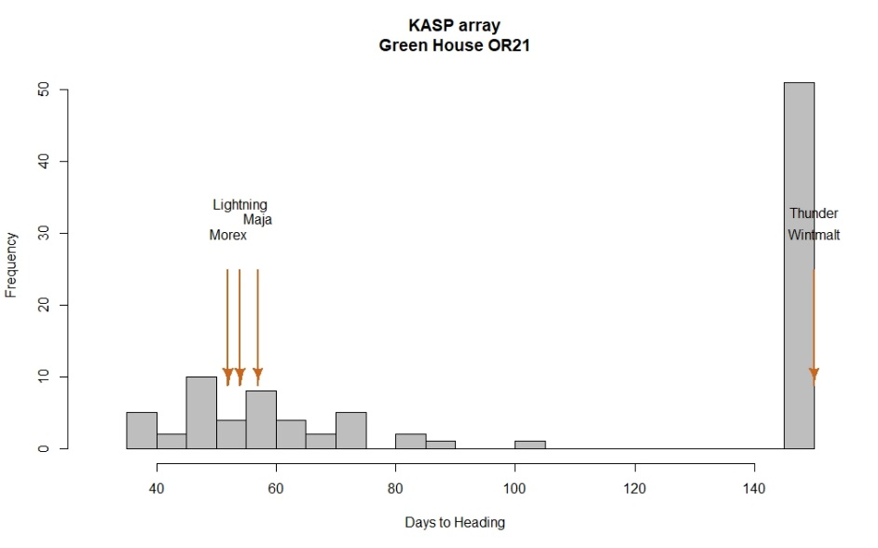
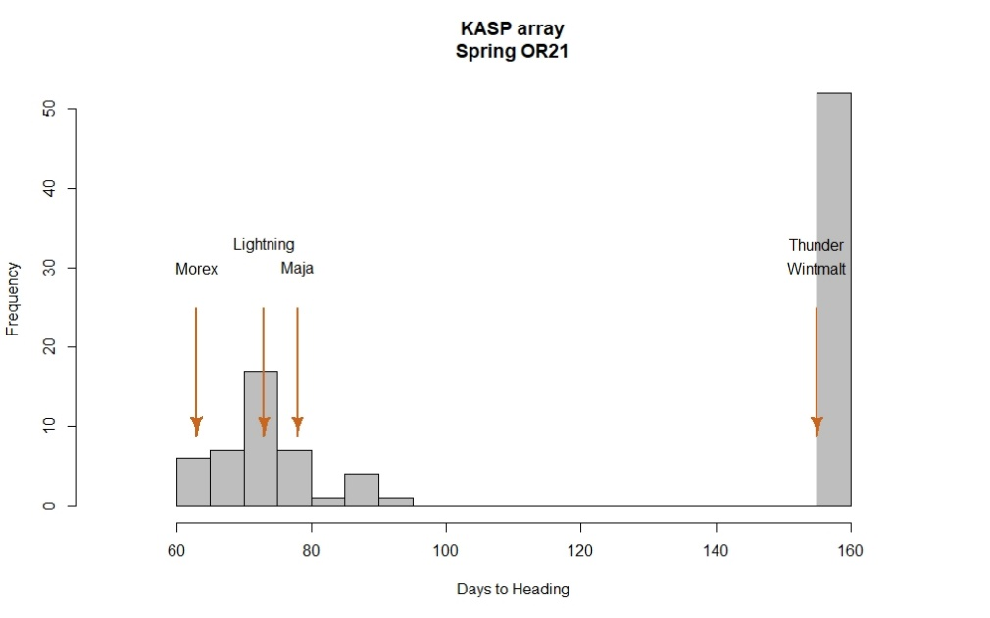
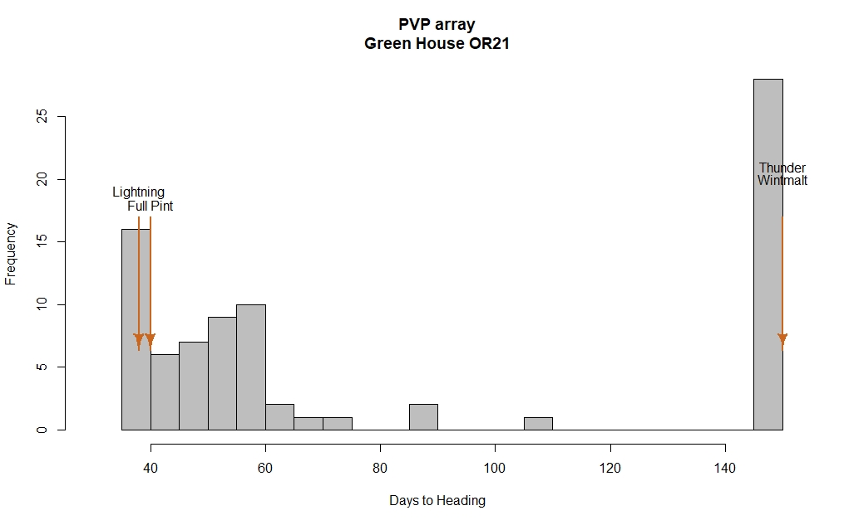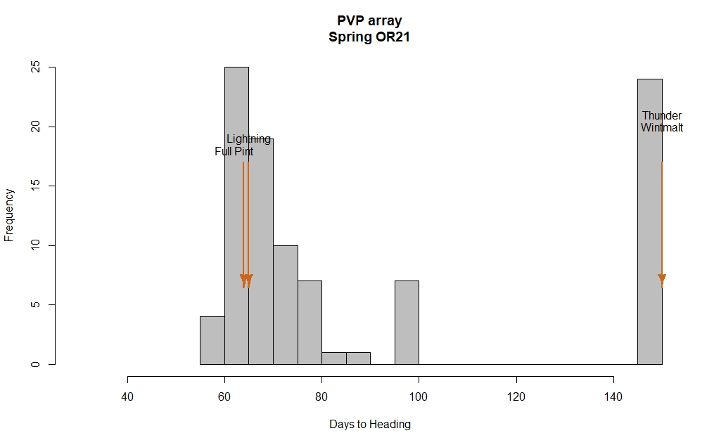
KASP marker development

Based on reported functional polymorphisms in the literature, and gene sequences retrieved from NCBI, KASP markers were designed for VRN and PPD alleles. KASP markers FAM, HEX and Com are shown in Table 1.

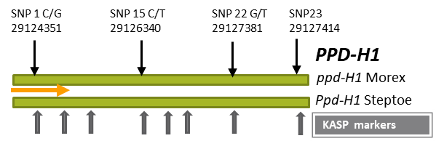

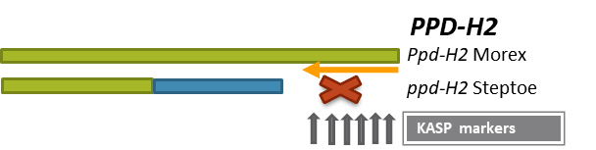
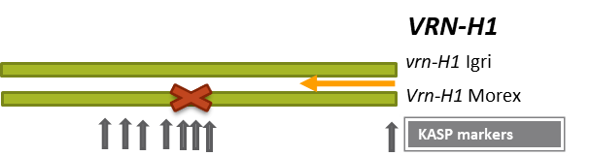

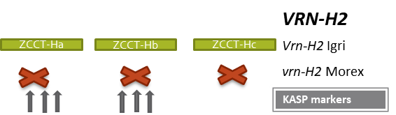
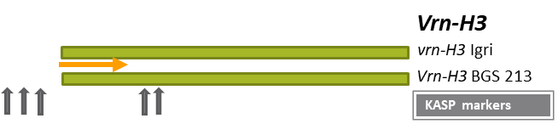

Growth habit prediction based on markers

KASP panel. Based on the genotypic information, 14 Springs (S), 25 Facultative (F), and 56 Winter (W) were predicted across the complete panel (red dots in box plots in the following figures). Heading dates were recorded for each line planted under greenhouse and field conditions (without vernalization). Lines that did not flower were assigned a heading date value of 150. When predicted growth habit was compared with observed heading date, all spring lines were successfully predicted but five predicted facultative and nine predicted winter lines failed to show the predicted growth habit phenotype based on heading date (end of each red arrow in the following figures). Of the five incorrectly predicted facultative lines, four headed under greenhouse conditions but not under field conditions, and all share the same recessive haplotype for PPD-H1, VRN-H1, and VRN-H3. Of the incorrectly predicted winter lines, seven lines flowered in both spring and greenhouse conditions, and two did not flower under greenhouse conditions.

Preliminary conclusions: The markers correctly predict spring growth habit and are useful, but not entirely dependable, for facultative and winter growth habit. Based on the haplotypes for marker alleles, a novel Vrn-H1 allele may be present in the winter lines where the predicted and observed growth habits do not match. For facultative lines, the combination of recessive alleles at ppd-H1, vrn-H1, and vrn-H3 - in the presence of the Vrn-H2 deletion - may be the explanation for the inconsistency between predicted and observed growth habit.

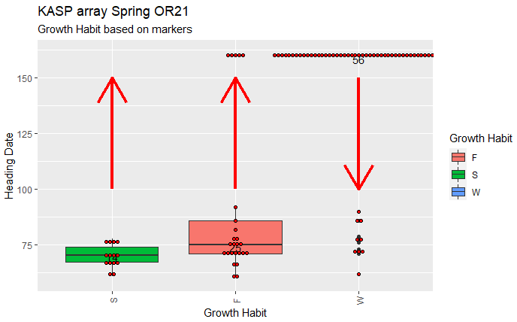

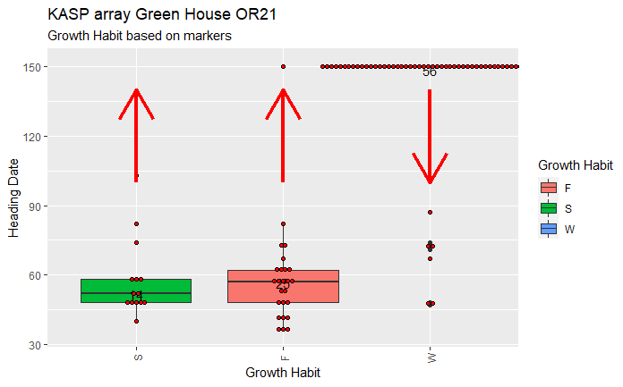

This table shows the predicted growth habit based on allele calls for each of the accessions that were not correctly predicted based on field or green house phenotypes.
Line | Field_21 | GH_21 | Ppd-H1 | Ppd-H2 | Vrn-H1 | Vrn-H2 | Vrn-H3 | Haplotype Ppd-H1, Vrn-H1, VrnH3 | Growth Habit
4Ab08-X03W033-18 | 160 | 150 | Rec | Dom | Rec | Rec | Rec | p1v1v3 | Fac
DH160838 | 160 | 61 | Rec | Dom | Rec | Rec | Rec | p1v1v3 | Fac
DH160839 | 160 | 59 | Rec | Dom | Rec | Rec | Rec | p1v1v3 | Fac
DH160848 | 160 | 64 | Rec | Dom | Rec | Rec | Rec | p1v1v3 | Fac
DH161067 | 160 | 58 | Rec | Dom | Rec | Rec | Rec | p1v1v3 | Fac
10467p7 | 86 | 150 | Dom | Rec | Rec | Dom | Rec | New Vrn1? | Winter
GK_Stramm | 79 | 67 | Rec | Dom | Rec | Dom | Dom | New Vrn1? | Winter
P-721 | 90 | 150 | Dom | Dom | Rec | Dom | Dom | New Vrn1? | Winter
DH141222 | 62 | 48 | Dom | Rec | Rec | Dom | Rec | New Vrn1? | Winter
DH141225 | 86 | 150 | Dom | Rec | Rec | Dom | Rec | New Vrn1? | Winter
Purple Prince | 73 | 74 | Rec | Rec | Rec | Dom | Dom | New Vrn1? | Winter
White Queen | 71 | 47 | Rec | Rec | Rec | Dom | Dom | New Vrn1? | Winter
10.0691 | 76 | 71 | Rec | Rec | Rec | Dom | Dom | New Vrn1? | Winter
10.0655 | 72 | 87 | Dom | Rec | Rec | Dom | Dom | New Vrn1? | Winter

Growth Habit prediction based on markers

PVP panel: Based on the genotypic information, 37 Springs (S), 21 Facultative (F), and 34 Winter (W) lines were predicted (red dots in box plots in the following figures. Four lines were not predicted, as no DNA was obtained from them. Heading dates were recorded for each line planted under green house and field conditions (without vernalization). Lines that did not flower were assigned a heading date of 150. When predicted growth habits were compared with observed heading dates, all spring lines were successfully predicted, but three predicted facultative and six predicted winter lines failed to show the predicted growth habit phenotype based on heading date (end of each red arrow in the following figures). Of the three incorrectly predicted facultative lines, two headed under greenhouse conditions but not under field conditions, and all share the same recessive haplotype for PPD-H1, and VRN-H1. Of the incorrectly predicted winter lines, four flowered under both spring and greenhouse conditions, and two did not flower under greenhouse conditions.

Preliminary conclusions: As in the KASP panel, the markers correctly predict spring growth habit and are useful, but not entirely dependable, for facultative and winter growth habit. Based on the haplotypes for marker alleles, a novel Vrn-H1 allele may be present in the winter lines where the predicted and observed growth habits do not match. For facultative lines, the combination of recessive alleles at ppd-H1, vrn-H1, and vrn-H3 - in the presence of the Vrn-H2 deletion - may be the explanation for the inconsistency between predicted and observed growth habit.

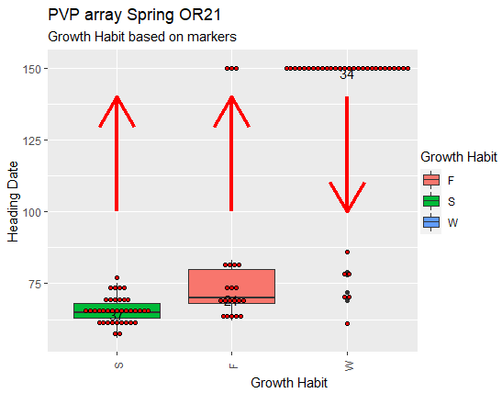

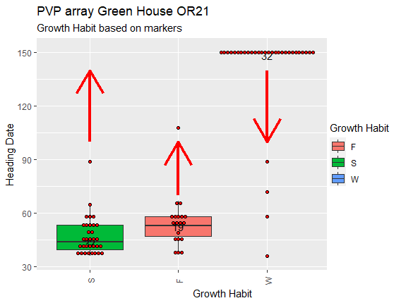

This table shows the predicted growth habit based on allele for each of the accessions that were not correctly predicted based on field or greenhouse phenotypes.

Line | Field_21 | GH_21 | Ppd-H1 | Ppd-H2 | Vrn-H1 | Vrn-H2 | Vrn-H3 | Haplotype Ppd-H1, Vrn-H1, VrnH3 | Growth Habit
DZ100325 | 150 | 108 | Rec | Rec | Rec | Rec | Dom | p1v1V3 | Fac
DH161957 | 150 | 67 | Rec | Dom | Rec | Rec | Rec | p1v1v3 | Fac
DH120293 | 150 | 64 | Rec | Rec | Rec | Rec | Rec | p1v1v3 | Fac
DH141225 | 78 | 150 | Dom | Rec | Rec | Dom | Rec | New Vrn1? | Winter
DH150683 | 86 | 150 | Rec | Rec | Rec | Dom | Rec | New Vrn1? | Winter
DH10.1044 | 61 | 36 | Dom | Rec | Rec | Dom | Rec | New Vrn1? | Winter
10.0691 | 72 | 58 | Rec | Rec | Rec | Dom | Dom | New Vrn1? | Winter
Purple Prince | 69 | 72 | Rec | Rec | Rec | Dom | Dom | New Vrn1? | Winter
DH140068 | 79 | 89 | Rec | Rec | Rec | Dom | Dom | New Vrn1? | Winter

KASP markers
Table 1. KASP marker sequences used for targeting Ppd-H1, Ppd-H2, Vrn-H1, Vrn-H2 and Vrn-H3 genes.

Target | KASP assay | Primer Type | Primer | Allele
Ppd-H1 | Ppd-H1_1 | FAM | GAAGGTGACCAAGTTCATGCTctagcgccatggacaatcaC | Dominant
Ppd-H1 | Ppd-H1_2 | FAM | GAAGGTGACCAAGTTCATGCTctaactgctccttacaagcgT | Dominant
Ppd-H1 | Ppd-H1_3 | FAM | GAAGGTGACCAAGTTCATGCTgaggttatctctccacggT | Dominant
Ppd-H1 | Ppd-H1_1 | HEX | GAAGGTCGGAGTCAACGGATTctagcgccatggacaatcaG | Recessive
Ppd-H1 | Ppd-H1_2 | HEX | GAAGGTCGGAGTCAACGGATTctaactgctccttacaagcgC | Recessive
Ppd-H1 | Ppd-H1_3 | HEX | GAAGGTCGGAGTCAACGGATTgaggttatctctccacggC | Recessive
Ppd-H1 | Ppd-H1_1 | Com | ggaactcctcccagcatcg | Common
Ppd-H1 | Ppd-H1_2 | Com | tcttcaggctcagctcaaga | Common
Ppd-H1 | Ppd-H1_3 | Com | tgcgttaccagagcaggaag | Common
Ppd-H2 | Ppd-H2_1 | FAM | GAAGGTGACCAAGTTCATGCTcaggatctaatcgacaaatatcaaggtC | Dominant
Ppd-H2 | Ppd-H2_2 | FAM | GAAGGTGACCAAGTTCATGCTtgtatacacgtaacgaccttgataT | Dominant
Ppd-H2 | Ppd-H2_3 | FAM | GAAGGTGACCAAGTTCATGCTagagagctaggttgacaaaataacA | Dominant
Ppd-H2 | Ppd-H2_1 | HEX | GAAGGTCGGAGTCAACGGATTcaggatctaatcgacaaatatcaaggtT | Dominant
Ppd-H2 | Ppd-H2_2 | HEX | GAAGGTCGGAGTCAACGGATTtgtatacacgtaacgaccttgataC | Dominant
Ppd-H2 | Ppd-H2_3 | HEX | GAAGGTCGGAGTCAACGGATTagagagctaggttgacaaaataacG | Dominant
Ppd-H2 | Ppd-H2_1 | Com | cgcgatgagggttgtcttattcaccttt | Common
Ppd-H2 | Ppd-H2_2 | Com | acggcccgactactccataa | Common
Ppd-H2 | Ppd-H2_3 | Com | aatggatccgctgcagacat | Common
Vrn-H1 | Vrn-H1_1 | FAM | GAAGGTGACCAAGTTCATGCTtgactgtgcatgtgtggtgA | Recessive
Vrn-H1 | Vrn-H1_2 | FAM | GAAGGTGACCAAGTTCATGCTccgactcagactcaaaaccaG | Recessive
Vrn-H1 | Vrn-H1_3 | FAM | GAAGGTGACCAAGTTCATGCTcacgcaatgcttggaccaG | Recessive
Vrn-H1 | Vrn-H1_1 | HEX | GAAGGTCGGAGTCAACGGATTtgactgtgcatgtgtggtgG | Recessive
Vrn-H1 | Vrn-H1_2 | HEX | GAAGGTCGGAGTCAACGGATTccgactcagactcaaaaccaA | Recessive
Vrn-H1 | Vrn-H1_3 | HEX | GAAGGTCGGAGTCAACGGATTcacgcaatgcttggaccaA | Recessive
Vrn-H1 | Vrn-H1_1 | Com | catagatgcacacacaagcgc | Common
Vrn-H1 | Vrn-H1_2 | Com | gcaggctacatcattagctgc | Common
Vrn-H1 | Vrn-H1_3 | Com | cccctctgtttcaaggtcga | Common
Vrn-H2 | Vrn-H2_1 | FAM | GAAGGTGACCAAGTTCATGCTctccctgtacctcatcaccttC | Dominant
Vrn-H2 | Vrn-H2_2 | FAM | GAAGGTGACCAAGTTCATGCTtggagctgctgtttcatgaA | Dominant
Vrn-H2 | Vrn-H2_3 | FAM | GAAGGTGACCAAGTTCATGCTccaaagaagcgcattgtccaaA | Dominant
Vrn-H2 | Vrn-H2_1 | HEX | GAAGGTCGGAGTCAACGGATTctccctgtacctcatcaccttT | Dominant
Vrn-H2 | Vrn-H2_2 | HEX | GAAGGTCGGAGTCAACGGATTtggagctgctgtttcatgaC | Dominant
Vrn-H2 | Vrn-H2_3 | HEX | GAAGGTCGGAGTCAACGGATTccaaagaagcgcattgtccaaT | Dominant
Vrn-H2 | Vrn-H2_1 | Com | gtggggcctgcctataatcc | Common
Vrn-H2 | Vrn-H2_2 | Com | aattgccaccaccgcagat | Common
Vrn-H2 | Vrn-H2_3 | Com | cacacgcacataatacgcct | Common
Vrn-H3 | Vrn-H3_1 | FAM | GAAGGTGACCAAGTTCATGCTtgatgatgagtgttgccccG | Dominant
Vrn-H3 | Vrn-H3_2 | FAM | GAAGGTGACCAAGTTCATGCTgccctatataaagtggccaccC | Dominant
Vrn-H3 | Vrn-H3_3 | FAM | GAAGGTGACCAAGTTCATGCTtggatctgtctgccgtaataaG | Dominant
Vrn-H3 | Vrn-H3_1 | HEX | GAAGGTCGGAGTCAACGGATTtgatgatgagtgttgccccA | Recessive
Vrn-H3 | Vrn-H3_2 | HEX | GAAGGTCGGAGTCAACGGATTgccctatataaagtggccaccG | Recessive
Vrn-H3 | Vrn-H3_3 | HEX | GAAGGTCGGAGTCAACGGATTtggatctgtctgccgtaataaC | Recessive
Vrn-H3 | Vrn-H3_1 | Com | agcttgcttttcggccctat | Common
Vrn-H3 | Vrn-H3_2 | Com | gctgtgaactgaggaggtgg | Common
Vrn-H3 | Vrn-H3_3 | Com | cggcctagctagaaaccacc | Common

