OSU Barley Education activities Fall 2020
Margaret Halstead, Masters student, is working on multiple lesson plans for different grade levels involving the OWBs and other barleys. Her lesson plans, once finalized, will be available online for your use and adaptation. He first grade lesson plan is almost ready for posting by Oregon Ag in the Classroom. Here is a direct link.
We are growing the OWB-ISS for seed increase as well as for phenotyping phenology traits.
We are crosses amongst OWB-ISS doubled haploids to generate an F2 population to complement the existing Mendelian analysis resources based on doubled haploids.
Pat Hayes and Kelly Vining will feature the OWB linkage exercise in the PBG 620 series. The exercise is available at https://barleyworld.org/main/education
Kelly Vining and Iovanna Pandelova are progressing with the cloning of nud alleles from OWB-D and OWB-R. Iovanna Pandelova has amplified PCR products using primers from Taketa et al. (2008). The first round of PCR was done with a non-proofreading Taq polymerase, as that was all that was available in the lab, and there have been issues with slow delivery from biotech suppliers. As expected, only one of the two parents produced PCR amplicons that could be visualized on an electrophoretic gel. These were cloned into a TOPO TA plasmid vector and prepared for Sanger sequencing. Luckily, a new supply of proofreading Taq polymerase arrived at the lab in time to do another round of PCR and cloning before the sequence data was required by the class. Only clones from PCR with the high-fidelity Taq will be sequenced.
Haley Traini has joined our group – her expertise in education and outreach is much appreciated. https://agsci.oregonstate.edu/users/haley-clement
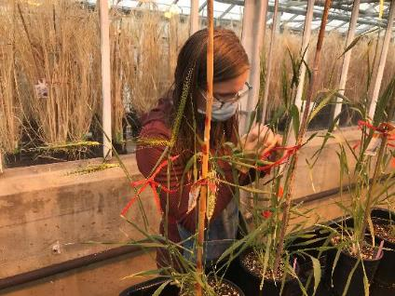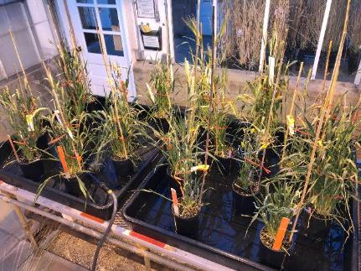
Margaret Halstead crossing OWB-ISS barleys. The OWB ISS growing in the OSU greenhouses

Figure 1. Barley parents OWB-D and OWB-R, which were used for nud allele sequencing

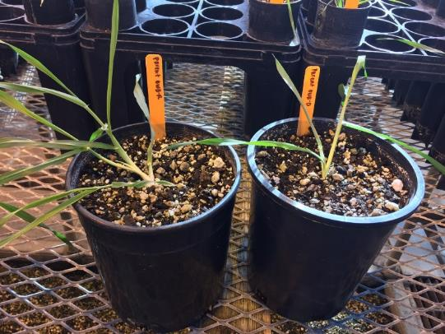
A. B.
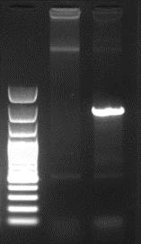
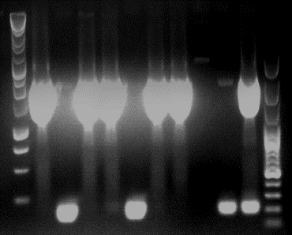
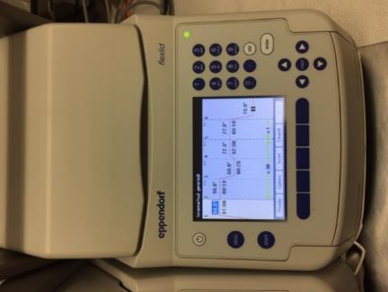
R
D
Colony screen
1500
2000
Figure 2. PCR presence/absence test of nud alleles in two parental genotypes. A. Thermocycler used for PCR. B. Electrophoretic gel showing PCR product in OWB-D parent. C. Colony screen

