PLS154 Assignment 9: Mapping barley traits in the Oregon Wolfe Barley (OWB) population

Barley is diverse crop used for food, feed (animal food), and brewing, and several mutations of the seed and inflorescence determine its suitability for different uses. Two-row barley (Vrs1) has the highest quality for brewing, but six-row barley (vrs1/vrs1) yields more for food or feed. Long awns (Lks2) contribute to photosynthesis but are a deterrent to grazing animals. Hulless seed (“naked barley”; nud/nud) is easily processed into whole grain for human consumption. Waxy endosperm starch (wx/wx) yields barley suitable for specialty food uses like mochi.

The OWB population was developed as an educational tool for plant genetics. Dominant alleles at 9 morphological markers (see picture) were stacked in one parent, and recessive alleles were stacked in a second parent. Then the two parents were crossed and doubled haploids were created using two different methods: the Hordeum bulbosum method, which generates maternal haploids, and anther culture, which generates paternal haploids.

Today we will phenotype a set of 25 lines from the OWB population. Some of these lines have “ISS” designations, which stands for “Interesting and Spectacular Subset” (the barley community has a sense of humor). All the OWB lines have been genotyped for ~2800 markers.

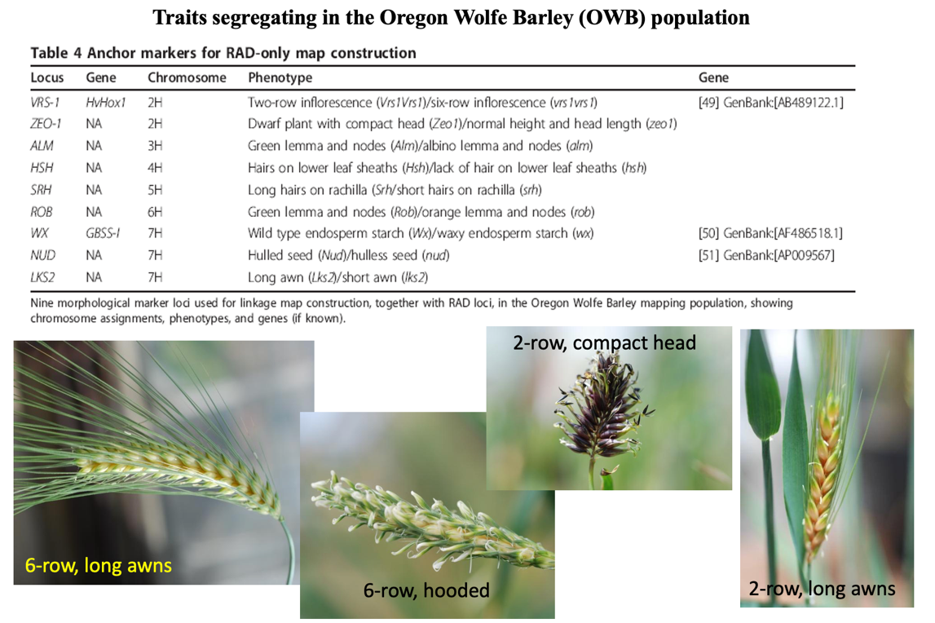

Your task today is to phenotype 25 lines for 3 traits: 1) two-row versus six-row inflorescence; 2) normal head versus compact head; 3) a third trait of your choice from the list above. Enter these phenotypes (in 0/1 format) onto the PHENOTYPES worksheet of the “barley_genos_STUDENT.xls” file, and the MAPPING_RESULTS worksheet should populate with Manhattan plots for each of the four traits. Do not change anything outside the shaded cells in the PHENOTYPES worksheet, and you should not have to change anything at all in the MAPPING_RESULTS WORKSHEET.
What is going on under the hood: The MAPPING RESULTS worksheet contains genotype data in numeric (0/1/2) format for ~2800 markers. Notice that each marker has a chromosome number and cM position that define its position on the genetic map. When you enter your phenotype data in numeric format (0/1), formulas calculate the correlation between the phenotype numbers and each genetic marker. Each correlation has a p-value associated with it, and the -log10(p-values) are displayed on the Manhattan plot.

Identifying your most significant marker: Hover your cursor over the point on the Manhattan plot with the lowest p-value (highest -log10(p-value)). This should identify the number of the data point, which corresponds to the row in the data sheet; scroll down to this row to identify the chromosome and cM position of the marker.

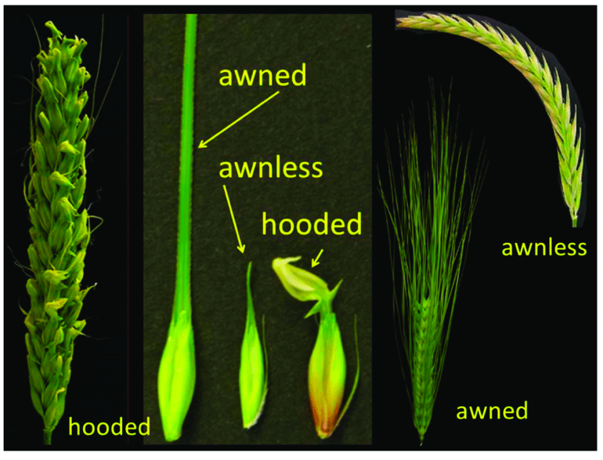
The hooded trait also appears to be segregating in the OWB population, and could be scored for question #3.

- Identify the chromosome and cM position of your most significant marker for the 2ROW trait and include a screenshot of the Manhattan plot. Is this result consistent with the information provided? (1 point)

- Identify the chromosome and cM position of your most significant marker for the (compact) HEAD trait and include a screenshot of the Manhattan plot. Is this result consistent with the information provided? (1 point)

- Pick a third trait from the list above and score it. Carefully explain how you scored it –this can be on an ordinal or quantitative scale. Identify the chromosome and cM position of your most significant marker for the trait, include a screenshot of the Manhattan plot, and state whether this result is consistent with the information provided, if applicable. (2 points)

- The OWB population was created by generating maternal and paternal doubled haploids from a single cross (F₁). Do the maternal and paternal DHs have the same cytoplasmic genes? Explain why or why not. (1 point).

