Stripe rust NACA report, 2016 harvest
The Facultative/Winter 2 row malting GWAS panel
Corvallis, OR; Davis, CA; Pullman, WA and Mt Vernon, WA
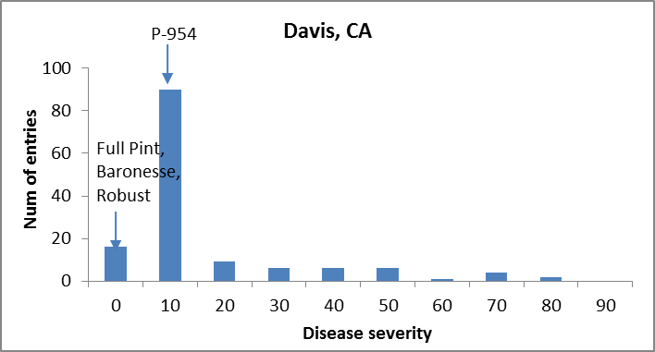
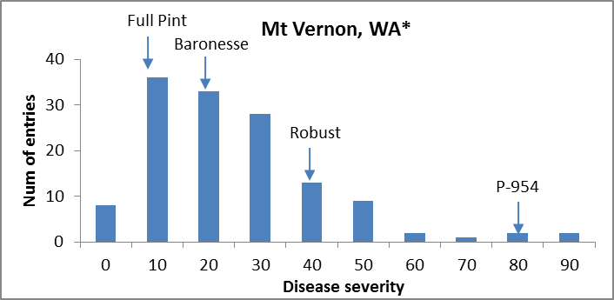

* @ Mt Vernon, WA trial was not replicated.

Facultative/Winter – ANOVA

Davis, CA
Response: Log
Df Sum Sq Mean Sq F value Pr(>F)
Line 139 2.45796 0.017683 2.9638 2.325e-10 ***
Rep 1 0.12025 0.120249 20.1545 1.494e-05 ***
Residuals 138 0.82336 0.005966
---
Signif. codes: 0 ‘***’ 0.001 ‘**’ 0.01 ‘*’ 0.05 ‘.’ 0.1 ‘ ’ 1
H_{b} = 0.66

