Stripe rust NACA report, 2016 harvest
The Facultative/Winter 2 row malting GWAS panel
Corvallis, OR; Davis, CA; Pullman, WA and Mt Vernon, WA
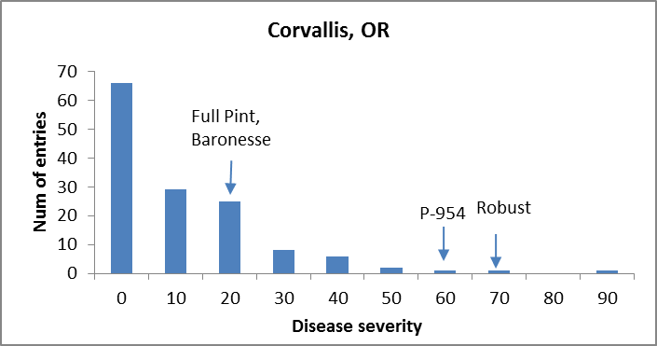

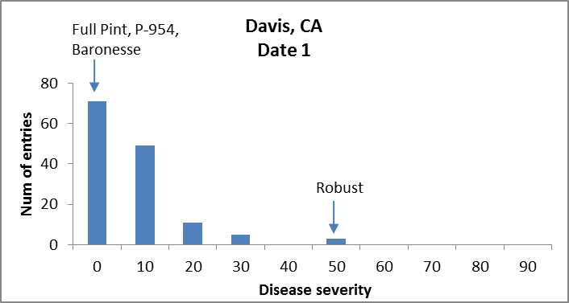

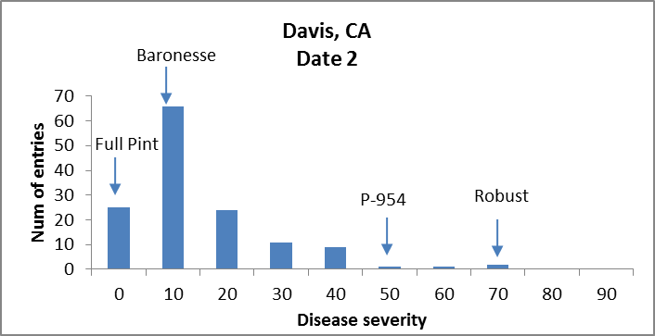

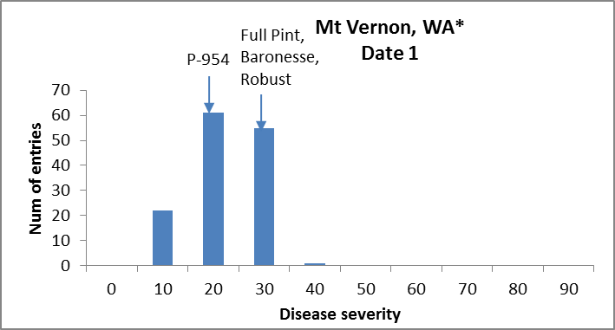

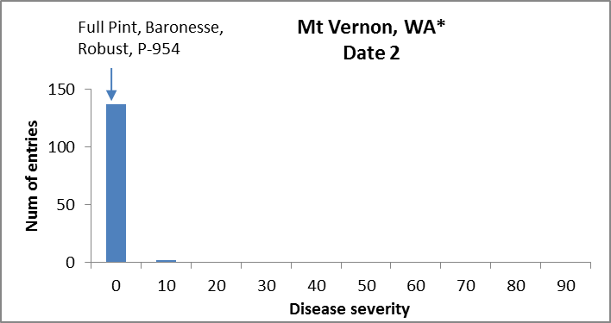

* @ Mt Vernon, WA trials were not replicated.

Facultative/Winter – ANOVAS

Corvallis, OR
Df Sum Sq Mean Sq F value Pr(>F)
Line 138 2.01554 0.0146053 3.5182 1.167e-13 ***
Rep 1 0.00000 0.0000000 0.0000 0.9998
Residuals 148 0.61439 0.0041513
---
Signif. codes: 0 ‘***’ 0.001 ‘**’ 0.01 ‘*’ 0.05 ‘.’ 0.1 ‘ ’ 1
H_{b} = 0.71

Davis, CA Date 1
Df Sum Sq Mean Sq F value Pr(>F)
Line 137 0.92527 0.0067538 3.3314 4.134e-12 ***
Rep 1 0.00226 0.0022604 1.1150 0.2929
Residuals 137 0.27774 0.0020273
---
Signif. codes: 0 ‘***’ 0.001 ‘**’ 0.01 ‘*’ 0.05 ‘.’ 0.1 ‘ ’1
H_{b} = 0.69

Davis, CA Date 2
Df Sum Sq Mean Sq F value Pr(>F)
Line 137 1.70151 0.012420 2.6353 1.385e-08 ***
Rep 1 0.15152 0.151518 32.1495 8.123e-08 ***
Residuals 137 0.64567 0.004713
---
Signif. codes: 0 ‘***’ 0.001 ‘**’ 0.01 ‘*’ 0.05 ‘.’ 0.1 ‘ ’1
H_{b} = 0.62

