Stripe rust NACA report, 2016 harvest
The multi-rust resistance Cycle 1 population
Corvallis, OR; Davis, CA; Pullman and Mt Vernon, WA
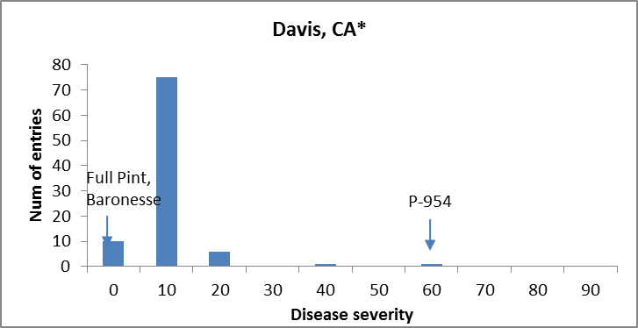

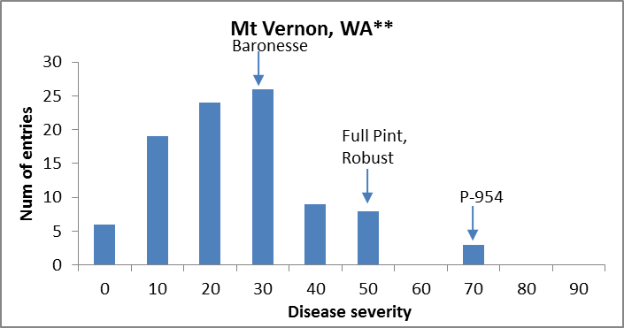

* @ Davis, CA leaf rust not rated on Robust.
** @ Mt Vernon, WA trial was not replicated.

Multi-rust – ANOVA

Davis, CA
Df Sum Sq Mean Sq F value Pr(>F)
Line 93 0.41129 0.0044225 4.3326 6.489e-12 ***
Rep 1 0.00240 0.0024035 2.3546 0.1283
Residuals 93 0.09493 0.0010208
---
Signif. codes: 0 ‘***’ 0.001 ‘**’ 0.01 ‘*’ 0.05 ‘.’ 0.1 ‘ ’
H_{b} = 0.76

